Supplementary Information for:
Evidence of wet-dry cycles and mega-droughts in the Eemian climate of southeast Australia.

Authors:
^{1#}Hamish McGowan, ²Micheline Campbell, ²John Nikolaus Callow, ¹Andrew Lowry and ³Henri Wong
¹Atmospheric Observations Research Group, The University of Queensland, Brisbane, Australia.
²School of Agriculture and Environment, The University of Western Australia, Perth, Australia.
³Australian Nuclear Science and Technology Organisation, Lucas Heights, Sydney, Australia.

Introduction
This supporting information provides:
Table S1 presents details of the eight uranium series dates obtained for stalagmite GC001. The age model was developed using the StalAge algorithm of Scholz and Hoffmann, [2011]. Ensemble means for the 8 dates and their ± 2δ output from the StalAge algorithm are presented in Table S2 and shown graphically in Figure S1.

Table S1. Uranium series dating results for 8 sub-samples milled from stalagmite GC001 with ages shown in years BP (1950) with ± 2σ, and respective year BCE.

Note: Ratios listed in the table refer to activity ratios normalized to the corresponding ratios measured for the secular-equilibrium HU-1 standard. ²³⁰Th ages are calculated using Isoplot/Ex 3.75 [Ludwig, 2012], using decay constants of Cheng et al., [2000]. Non-radiogenic ²³⁰Th correction was applied assuming non-radiogenic 230Th/232Th atomic ratio = 4.4±2.2 x 10⁻⁶ (bulk-earth value), and ²³⁸U, ²³⁴U, ²³²Th and ²³⁰Th are in secular equilibrium. Non-radiogenic ²³⁰Th correction results in large age error magnification for samples with low ²³⁰Th/²³²Th ratios. uncorr. and corr. denote uncorrected and corrected.

Table S2. Presented ages (rounded to nearest year) are the original corrected ²³⁰Th age in years (BP) and mean ages from a 30 iteration ensemble from StalAge. Standard 2δ are also presented.
Depth from tip of GC001 (mm) | Original corrected ²³⁰Th Age years (BP) | +/- 2δ years | Corrected StalAge mean ²³⁰Th Age years (BP) (n=30)
23 | 103289 | 484 | 103113
60 | 104030 | 818 | 104601
100 | 106521 | 897 | 106191
140 | 118254 | 927 | 117968
178 | 119115 | 526 | 119285
220 | 120859 | 845 | 120933
260 | 123312 | 1593 | 122476
292 | 123251 | 709 | 123514

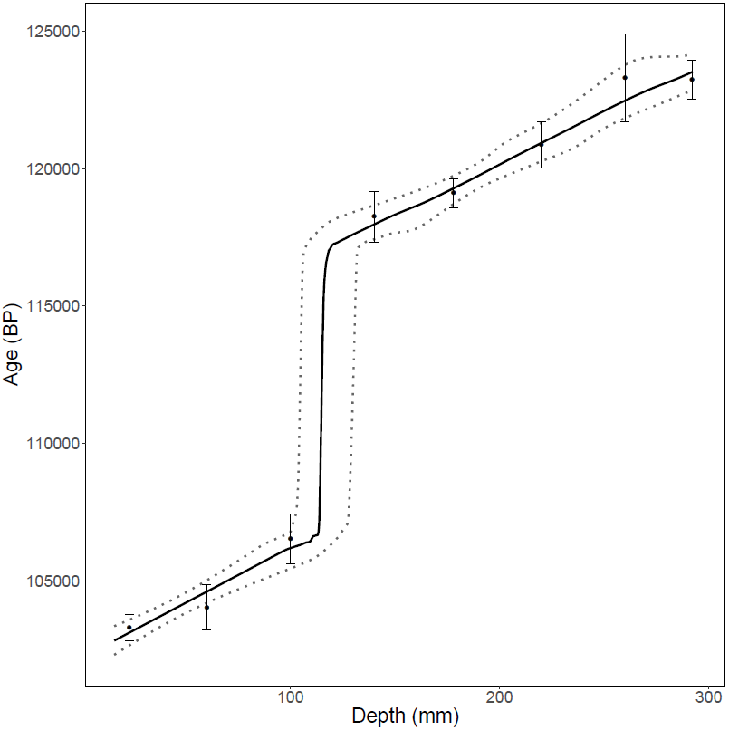
Figure S1. Final age model (solid black line) for GC001 developed using the StalAge algorithm [Scholz and Hoffmann, 2011] for the entire length of the stalagmite with 95%-confidence limits shown as dashed lines.

