Supplementary Material for:
Fire-induced shifts in stalagmite organic matter mapped using Synchrotron infrared microspectroscopy
Liza K. McDonough¹, Micheline Campbell³, Pauline C. Treble^{1,3}, Christopher Marjo², Silvia Frisia^{3,4}, Jitraporn Vongsvivut⁵, Annaleise R. Klein⁵, Viktoria Kovacs-Kis⁶, Andy Baker³

¹ Australian Nuclear Science and Technology Organisation (ANSTO), New Illawarra Rd, Lucas Heights, NSW, 2234, Australia
² Mark Wainwright Analytical Centre, UNSW Sydney, Sydney, NSW, 2052, Australia
³ School of Biological, Earth and Environmental Sciences, UNSW Sydney, NSW, 2052, Australia
⁴ School of Environmental and Life Sciences, University of Newcastle, NSW 2308, Australia
⁵ ANSTO - Australian Synchrotron, Clayton, VIC 3168, Australia
⁶ HUN-REN Centre for Energy Research, Konkoly-Thege Miklós u 29-33, H-1121 Budapest, Hungary

*Corresponding author: lizam@ansto.gov.au

Contents:
Supplementary Figures S1 – S6
Supplementary Table S1

Supplementary Figures
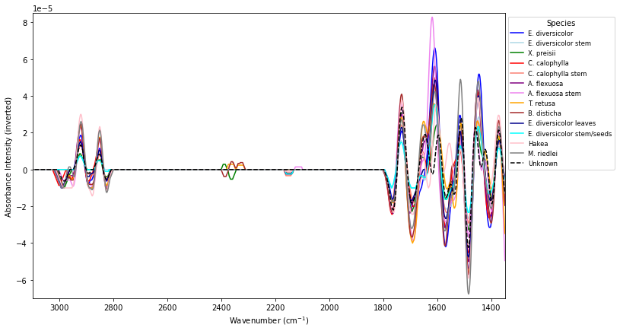
Fig. S1. Inverted second derivative FT-IR spectra of various species of vegetation collected from Golgotha, Western Australia and used as vegetation endmembers.

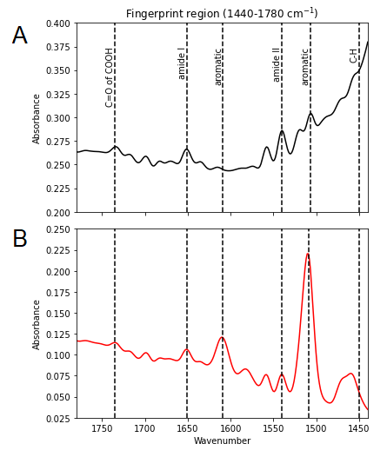
Fig. S2. Representative FT-IR spectrum of the fingerprint region for A) YD-S2, shown as black line, and B) spectrum from Epofix (Struers) epoxy used to mount the thick section, shown as red line.

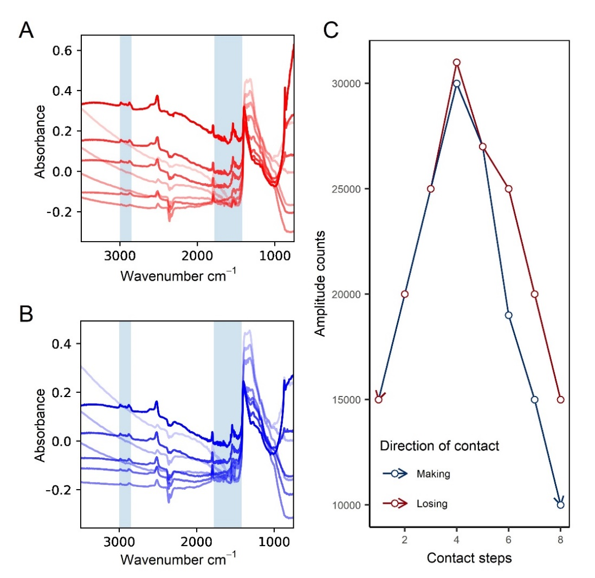
Fig. S3. Plots showing the change in infrared spectra occurring whilst A) slowly increasing, and B) slowly decreasing the pressure of the macro-ATR Ge crystal on the YD-S2 thick section by hand. Increasing pressure between the Ge crystal and the sample is demonstrated by a darkening of the spectra in A. Decreasing pressure between the Ge crystal and the sample is demonstrated by a lightening of the spectra in B. An increase in smaller peaks is observed with increasing pressure, along with a decline in the main calcite peak height at 1405cm-1. The blue shaded regions represent the C-H stretching region (2800-3050 cm⁻¹) and the fingerprint region (1420-1780 cm⁻¹) and shows that the organic matter peaks in the regions are larger and more defined with increasing contact pressure. C) shows the change in amplitude counts when making and losing manual contact between the sample and the Ge crystal (blue and red lines respectively).

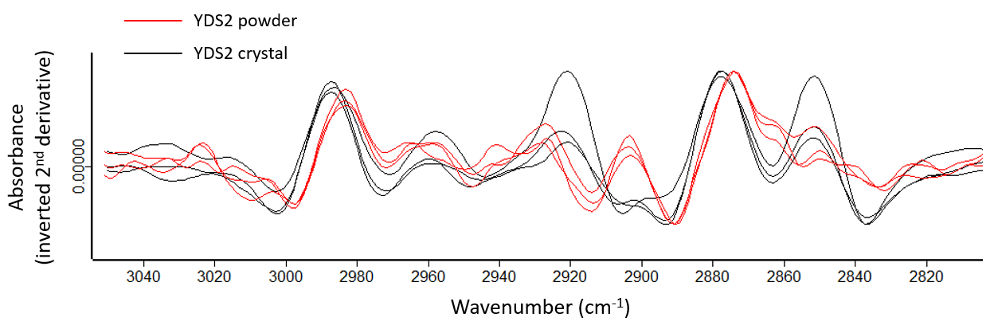
Fig. S4. Plot comparing three YD-S2 powder samples (red) and three YDS2 crystal samples (black). Powdered YDS2 samples show CO₃ peaks occurring at 2983 cm-1 and 2873 cm-1, equivalent to the peak locations observed in CaCO₃ reference spectra shown in Figure 1C. Crystal YD-S2 sample shows CO₃ peaks at higher wavenumbers (2987 cm⁻¹ and 2877 cm⁻¹ respectively).
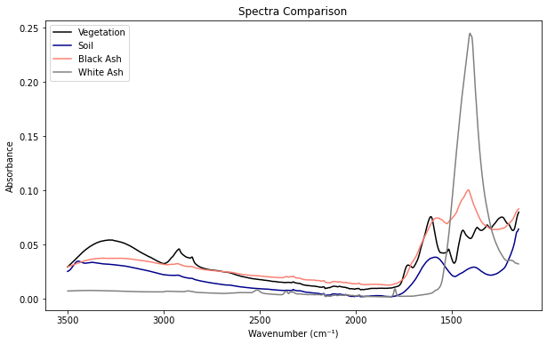
Fig. S5. Example representative spectra from vegetation powder, soil, black ash and white ash.

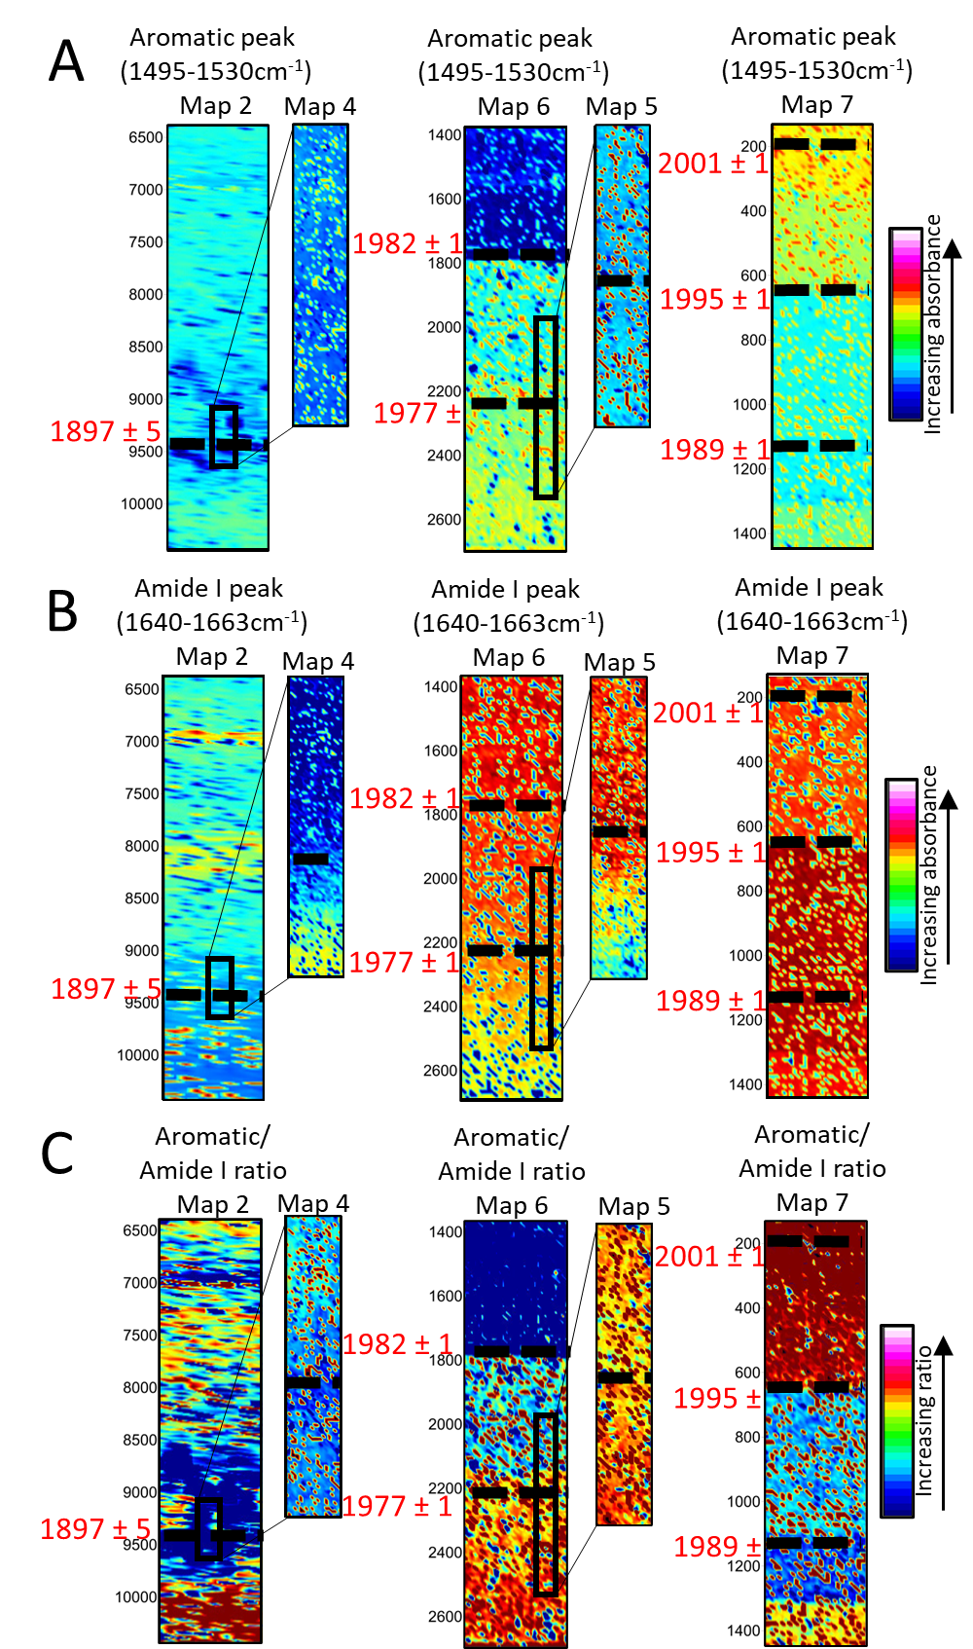
Fig. S6. Chemical maps showing the inverted second derivative peak intensity of A) the aromatic band observed at 1495 cm-1 – 1530 cm⁻¹ and the B) amide I band observed at 1640 cm-1 - 1663 cm⁻¹ for Map 2 (low-resolution) and Map 4 (high-resolution), Map 6 (low-resolution) and Map 5 (high-resolution), and Map 7 (low resolution). High-resolution regions of Map 2 and Map 6 are indicated by the black rectangle in the low-resolution maps. C) shows maps of the ratio of the aromatic/amide I peaks. Map 6 covers the 1977 and 1982 fire events, Map 2 covers the 1897 fire event, and Map 7 covers the 1989, 1995, and 2001 fire events. N.B: Distance from top (µm) represents distance from the youngest end of the stalagmite. Low- and high-resolution maps were performed under separate experiment and the high resolution position shown is approximate.
Supplementary Tables

Table S1 - Coefficients (coef), standard errors (std err), p-values (P>|z|), upper and lower confidence intervals (0.025 and 0.975 respectively) for predictor variables and interaction terms (shown in italics) for robust regression models.
 | coef | std err | z | P>|z| | [0.025 | 0.975]
CH₃ model
C=O of COOH | 0.349 | 0.089 | 3.914 | 0.000 | 0.174 | 0.524
asCH2 | 0.629 | 0.072 | 8.722 | 0.000 | 0.487 | 0.770
aromatic | 0.025 | 0.063 | 0.392 | 0.695 | -0.099 | 0.149
amide II | -0.059 | 0.021 | -2.788 | 0.005 | -0.101 | -0.018
amide I | 0.247 | 0.092 | 2.700 | 0.007 | 0.068 | 0.427
C=O of COOH asCH2 | 0.002 | 0.000 | 4.463 | 0.000 | 0.001 | 0.003
C=O of COOH aromatic | 0.004 | 0.001 | 7.818 | 0.000 | 0.003 | 0.005
C=O of COOH amide II | -0.003 | 0.000 | -6.558 | 0.000 | -0.004 | -0.002
C=O of COOH amide I | -0.002 | 0.000 | -5.696 | 0.000 | -0.003 | -0.002
asCH2 aromatic | -0.001 | 0.000 | -3.797 | 0.000 | -0.002 | -0.001
asCH2 amide II | 0.000 | 0.000 | 0.596 | 0.551 | -0.001 | 0.001
asCH2 amide I | 0.001 | 0.000 | 1.106 | 0.269 | 0.000 | 0.001
aromatic amide II | 0.001 | 0.000 | 5.520 | 0.000 | 0.001 | 0.002
aromatic amide I | -0.004 | 0.000 | -9.988 | 0.000 | -0.005 | -0.003
amide II amide I | 0.001 | 0.000 | 1.594 | 0.111 | 0.000 | 0.002
CH₂ model
C=O of COOH | 0.409 | 0.097 | 4.235 | 0.000 | 0.220 | 0.598
asCH3 | 0.080 | 0.060 | 1.318 | 0.187 | -0.039 | 0.198
aromatic | 0.418 | 0.067 | 6.249 | 0.000 | 0.287 | 0.549
amide II | -0.189 | 0.022 | -8.596 | 0.000 | -0.232 | -0.146
amide I | 0.194 | 0.090 | 2.165 | 0.030 | 0.018 | 0.370
C=O of COOH asCH3 | -0.001 | 0.000 | -3.222 | 0.001 | -0.002 | 0.000
C=O of COOH aromatic | 0.003 | 0.001 | 4.079 | 0.000 | 0.001 | 0.004
C=O of COOH amide II | -0.005 | 0.001 | -8.668 | 0.000 | -0.006 | -0.004
C=O of COOH amide I | -0.003 | 0.000 | -6.496 | 0.000 | -0.003 | -0.002
asCH3 aromatic | -0.005 | 0.000 | -11.908 | 0.000 | -0.006 | -0.004
asCH3 amide II | 0.008 | 0.000 | 19.361 | 0.000 | 0.008 | 0.009
asCH3 amide I | 0.005 | 0.000 | 10.928 | 0.000 | 0.004 | 0.006
aromatic amide II | 0.000 | 0.000 | -1.147 | 0.251 | -0.001 | 0.000
aromatic amide I | 0.000 | 0.000 | -0.605 | 0.545 | -0.001 | 0.001
amide II amide I | 0.000 | 0.000 | -0.100 | 0.920 | -0.001 | 0.001
C=O of COOH model
asCH2 | 0.683 | 0.116 | 5.904 | 0.000 | 0.456 | 0.910
asCH3 | -0.363 | 0.088 | -4.129 | 0.000 | -0.535 | -0.191
aromatic | 0.528 | 0.075 | 7.022 | 0.000 | 0.380 | 0.675
amide II | 0.024 | 0.028 | 0.871 | 0.383 | -0.030 | 0.078
amide I | 0.507 | 0.069 | 7.305 | 0.000 | 0.371 | 0.643
asCH2 asCH3 | -0.001 | 0.000 | -3.215 | 0.001 | -0.002 | 0.000
asCH2 aromatic | 0.010 | 0.001 | 13.661 | 0.000 | 0.008 | 0.011
asCH2 amide II | -0.010 | 0.001 | -10.852 | 0.000 | -0.012 | -0.008
asCH2 amide I | -0.010 | 0.001 | -17.933 | 0.000 | -0.011 | -0.009
asCH3 aromatic | -0.009 | 0.001 | -13.951 | 0.000 | -0.011 | -0.008
asCH3 amide II | 0.010 | 0.001 | 13.082 | 0.000 | 0.009 | 0.012
asCH3 amide I | 0.011 | 0.001 | 17.134 | 0.000 | 0.010 | 0.012
aromatic amide II | -0.004 | 0.000 | -10.656 | 0.000 | -0.004 | -0.003
aromatic amide I | -0.001 | 0.000 | -4.091 | 0.000 | -0.002 | -0.001
amide II amide I | 0.004 | 0.000 | 8.315 | 0.000 | 0.003 | 0.004
aromatic model
C=O of COOH | 0.377 | 0.164 | 2.294 | 0.022 | 0.055 | 0.699
asCH2 | -0.177 | 0.183 | -0.967 | 0.334 | -0.536 | 0.182
asCH3 | 0.169 | 0.148 | 1.143 | 0.253 | -0.121 | 0.460
amide II | 0.128 | 0.021 | 6.252 | 0.000 | 0.088 | 0.168
amide I | 0.522 | 0.165 | 3.161 | 0.002 | 0.198 | 0.845
C=O of COOH asCH2 | 0.004 | 0.002 | 2.710 | 0.007 | 0.001 | 0.008
C=O of COOH asCH3 | -0.005 | 0.001 | -3.481 | 0.000 | -0.007 | -0.002
C=O of COOH amide II | -0.006 | 0.001 | -6.784 | 0.000 | -0.008 | -0.004
C=O of COOH amide I | 0.003 | 0.001 | 4.910 | 0.000 | 0.002 | 0.004
asCH2 asCH3 | 0.000 | 0.000 | 0.066 | 0.948 | -0.001 | 0.001
asCH2 amide II | 0.003 | 0.001 | 2.348 | 0.019 | 0.000 | 0.005
asCH2 amide I | -0.005 | 0.001 | -3.820 | 0.000 | -0.007 | -0.002
asCH3 amide II | 0.006 | 0.001 | 6.476 | 0.000 | 0.004 | 0.008
asCH3 amide I | -0.002 | 0.001 | -1.180 | 0.238 | -0.004 | 0.001
amide II amide I | 0.003 | 0.001 | 3.571 | 0.000 | 0.001 | 0.004
amide II model
C=O of COOH | 1.088 | 0.148 | 7.375 | 0.000 | 0.799 | 1.378
asCH2 | -0.421 | 0.152 | -2.777 | 0.005 | -0.718 | -0.124
asCH3 | -0.635 | 0.139 | -4.564 | 0.000 | -0.908 | -0.362
aromatic | 2.442 | 0.060 | 40.777 | 0.000 | 2.325 | 2.559
amide I | -0.798 | 0.172 | -4.650 | 0.000 | -1.135 | -0.462
C=O of COOH asCH2 | 0.013 | 0.002 | 6.601 | 0.000 | 0.009 | 0.017
C=O of COOH asCH3 | -0.013 | 0.002 | -8.271 | 0.000 | -0.016 | -0.010
C=O of COOH aromatic | -0.009 | 0.001 | -7.259 | 0.000 | -0.012 | -0.007
C=O of COOH amide I | -0.001 | 0.001 | -1.688 | 0.091 | -0.003 | 0.000
asCH2 asCH3 | 0.002 | 0.001 | 2.423 | 0.015 | 0.000 | 0.003
asCH2 aromatic | -0.006 | 0.001 | -5.893 | 0.000 | -0.008 | -0.004
asCH2 amide I | -0.006 | 0.001 | -3.851 | 0.000 | -0.009 | -0.003
asCH3 aromatic | 0.003 | 0.001 | 2.454 | 0.014 | 0.001 | 0.005
asCH3 amide I | 0.011 | 0.002 | 6.826 | 0.000 | 0.007 | 0.013
aromatic amide I | 0.000 | 0.001 | 0.457 | 0.647 | -0.001 | 0.002
amide I model
C=O of COOH | 0.496 | 0.098 | 5.059 | 0.000 | 0.304 | 0.688
asCH2 | 1.374 | 0.144 | 9.563 | 0.000 | 1.092 | 1.655
asCH3 | -0.694 | 0.123 | -5.648 | 0.000 | -0.935 | -0.453
aromatic | 0.073 | 0.090 | 0.814 | 0.416 | -0.103 | 0.250
amide II | -0.198 | 0.031 | -6.325 | 0.000 | -0.259 | -0.136
C=O of COOH asCH2 | 0.002 | 0.001 | 1.552 | 0.121 | 0.000 | 0.003
C=O of COOH asCH3 | -0.001 | 0.001 | -1.357 | 0.175 | -0.003 | 0.001
C=O of COOH aromatic | 0.001 | 0.001 | 1.158 | 0.247 | -0.001 | 0.002
C=O of COOH amide II | 0.000 | 0.001 | -0.297 | 0.766 | -0.001 | 0.001
asCH2 asCH3 | 0.000 | 0.001 | 0.562 | 0.574 | -0.001 | 0.001
asCH2 aromatic | -0.001 | 0.001 | -0.572 | 0.568 | -0.002 | 0.001
asCH2 amide II | -0.007 | 0.001 | -6.452 | 0.000 | -0.010 | -0.005
asCH3 aromatic | -0.002 | 0.001 | -1.866 | 0.062 | -0.003 | 0.000
asCH3 amide II | 0.002 | 0.001 | 2.042 | 0.041 | 0.000 | 0.004
aromatic amide II | 0.004 | 0.000 | 9.895 | 0.000 | 0.003 | 0.005

