Supplementary Material
Unveiling the anisotropy and mechanism of magnetic alignment of graphene in polymer composites for efficient absorption of THz radiations (0.3 – 3.0 THz)
Premika Govindaraj¹, Sleeba Varghese^{2,3}, Anna Sokolova⁴, Molong Han⁵, Saulius Juodkazis^{5,6}, Dominique Appadoo⁷, Franz Konstantin Fuss⁸, Nisa Salim¹, Nishar Hameed^{1*}
¹ School of Engineering, Swinburne University of Technology, Melbourne, Victoria, 3122, Australia.
² Department of Mathematics, School of Science, Computing and Engineering Technologies, Swinburne University of Technology, Melbourne, Victoria, 3122, Australia.
³ Sorbonne Université, CNRS, Physico-chimie des Électrolytes et Nanosystèmes Interfaciaux, PHENIX, F-75005 Paris, France.
⁴ Australian Centre for Neutron Scattering, ANSTO, Lucas Heights, New South Wales, 2234, Australia
⁵ Optical Sciences Center, Faculty of Science, Engineering and Technology, Swinburne University of Technology, Hawthorn VIC, 3122, Australia
⁶ Laser Center, Vilnius University, Sauletekio 10, Vilnius, Lithuania
⁷ Australian Synchrotron Company Ltd., Blackburn Road, Clayton, VIC 3168, Australia
⁸ Chair of Biomechanics, Faculty of Engineering Science, University of Bayreuth, Bayreuth, D-95447, Germany.
S1. Electrochemical exfoliation of graphene:
The three-electrode system was used for the exfoliation process. The HOPG sheet as a standard electrode, platinum electrode as a counter electrode, Ag/AgCl as reference electrode and 0.1M (NH₄)₂SO₄ as electrolyte solution were used. The experimental setup for the exfoliation process is shown in Figure 3.3 (a). On applying a direct current (DC) voltage of +6.5 V to the three-electrode system, a potential of 2.9-3.0 V was applied on the HOPG sheet (as shown in Figure 3.3 (c)). Unlike the two-electrode system, the three-electrode system shows the exact voltage applied to the graphite sheet during exfoliation. The graphite flakes began to dissociate and disperse into the electrolyte solution. The voltage was kept constant until the sheet was completely exfoliated. The exfoliated graphite was then collected by vacuum filtration, washed to remove the residual ions, freeze-dried and stored for further analysis. The yield of the final product was more than 75% with respect to the total weight of the initial HOPG sheet.
On applying voltage, the reduction of water molecules occurs at the cathode resulting in (OH⁻) hydroxyl ions. These ions attack the graphite sheet, resulting in oxidation and depolarization along the edges and grain boundaries. Further the sulphate ions present in the electrolyte intercalate the graphite layers and also undergo reduction due to water molecules. Thus, the reduction and oxidation process result in the generation of gaseous species such as SO₂, O₂ etc, as evidenced by the evolution of gas bubbles during the electrochemical process (as shown in Figure S1).
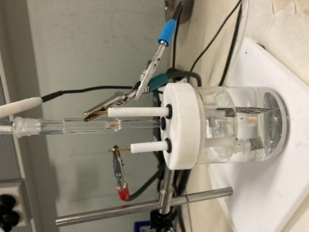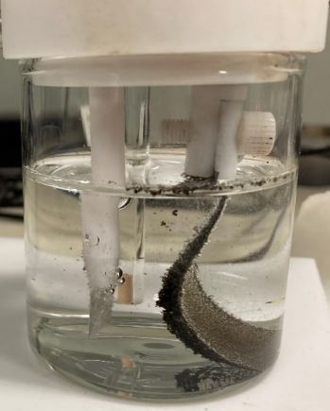
(b)
(a)
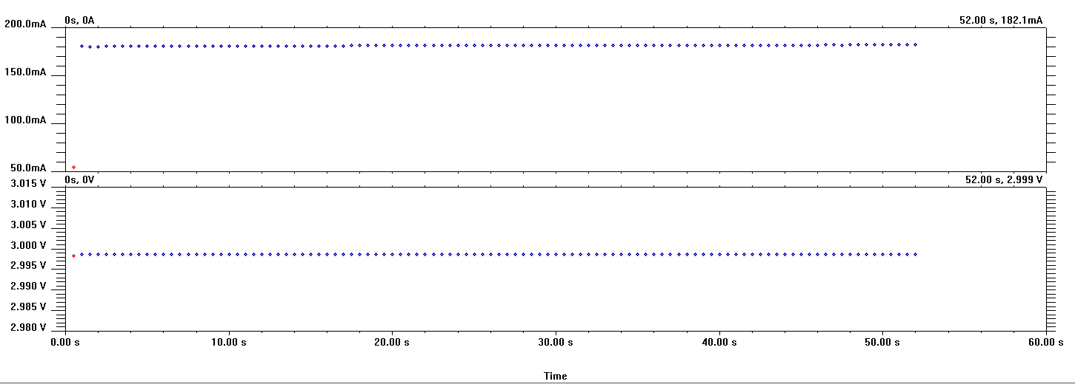Figure S1. (a) Experimental setup of the anodic exfoliation process. (b) Evolution of gas bubbles due to the intercalation of negative ions (c) Snapshot of the voltage applied to the working electrode in a 3 – electrochemical cell during exfoliation.
(c)
S1. Preparation of aligned graphene composite films using magnetic field.
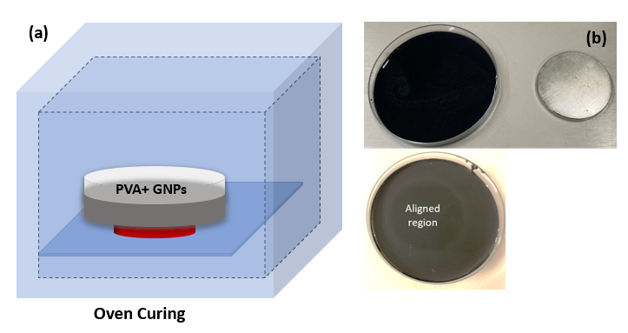
Figure S2. (a) Schematic for the synthesis of Graphene/PVA composites by magnetic alignment. (b) Graphene-aligned PVA dried films.
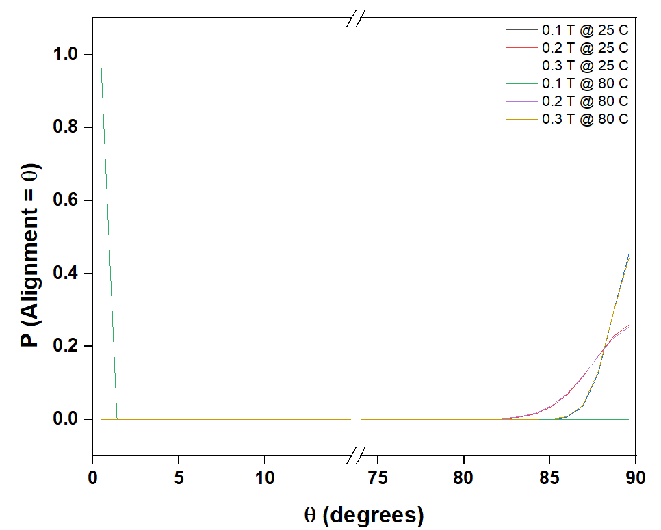

Figure S3: Probability of graphene flakes to be in different orientational angles under different magnetic fields at (a) 25 ºC and (b) 80 ºC.
Table S1 Summary of scattering data and anisotropy factor at different temperature.
Temperature  ºC | q  Å⁻¹ | I(q_{y}) | I(q_{z}) | A(q) | Avg. A(q) | Std.
10 | 0.002 | 45.46 | 24.83 | 0.29 | 0.44 | 0.11
10 | 0.003 | 27.27 | 11.20 | 0.42 | 0.44 | 0.11
10 | 0.004 | 12.04 | 4.69 | 0.44 | 0.44 | 0.11
10 | 0.005 | 4.83 | 2.50 | 0.32 | 0.44 | 0.11
10 | 0.006 | 2.90 | 0.78 | 0.57 | 0.44 | 0.11
10 | 0.007 | 2.37 | 0.76 | 0.51 | 0.44 | 0.11
10 | 0.008 | 1.13 | 0.33 | 0.55 | 0.44 | 0.11
10 | 0.009 | 0.99 | 0.52 | 0.31 | 0.44 | 0.11
10 | 0.01 | 0.50 | 0.16 | 0.51 | 0.44 | 0.11
25 | 0.002 | 54.11 | 19.64 | 0.47 | 0.43 | 0.06
25 | 0.003 | 36.57 | 12.33 | 0.50 | 0.43 | 0.06
25 | 0.004 | 12.50 | 5.46 | 0.39 | 0.43 | 0.06
25 | 0.005 | 5.73 | 2.51 | 0.39 | 0.43 | 0.06
25 | 0.006 | 3.60 | 1.59 | 0.39 | 0.43 | 0.06
25 | 0.007 | 2.74 | 1.28 | 0.36 | 0.43 | 0.06
25 | 0.008 | 1.62 | 0.57 | 0.48 | 0.43 | 0.06
25 | 0.009 | 1.12 | 0.54 | 0.35 | 0.43 | 0.06
25 | 0.01 | 0.62 | 0.20 | 0.51 | 0.43 | 0.06
80 | 0.002 | 59.00 | 23.35 | 0.43 | 0.43 | 0.06
80 | 0.003 | 14.70 | 6.16 | 0.41 | 0.43 | 0.06
80 | 0.004 | 9.75 | 4.08 | 0.41 | 0.43 | 0.06
80 | 0.005 | 6.33 | 2.59 | 0.42 | 0.43 | 0.06
80 | 0.006 | 3.37 | 1.15 | 0.49 | 0.43 | 0.06
80 | 0.007 | 2.58 | 0.92 | 0.47 | 0.43 | 0.06
80 | 0.008 | 1.55 | 0.73 | 0.36 | 0.43 | 0.06
80 | 0.009 | 0.93 | 0.44 | 0.36 | 0.43 | 0.06
80 | 0.01 | 0.34 | 0.10 | 0.54 | 0.43 | 0.06

Table S2 Summary of scattering data and anisotropy factor at different graphene concentration.
Graphene Concentration wt% | q  Å⁻¹ | I(q_{y}) | I(q_{z}) | A(q) | Avg . A(q) | Std.
1 | 0.002 | 83.67 | 29.74 | 0.48 | 0.41 | 0.08
1 | 0.003 | 27.59 | 13.46 | 0.34 | 0.41 | 0.08
1 | 0.004 | 11.36 | 4.70 | 0.41 | 0.41 | 0.08
1 | 0.005 | 6.12 | 3.09 | 0.33 | 0.41 | 0.08
1 | 0.006 | 3.85 | 1.58 | 0.42 | 0.41 | 0.08
1 | 0.007 | 2.61 | 0.93 | 0.47 | 0.41 | 0.08
1 | 0.008 | 1.62 | 0.77 | 0.36 | 0.41 | 0.08
1 | 0.009 | 1.19 | 0.59 | 0.34 | 0.41 | 0.08
1 | 0.01 | 0.45 | 0.13 | 0.55 | 0.41 | 0.08
5 | 0.002 | 83.85 | 20.73 | 0.60 | 0.65 | 0.04
5 | 0.003 | 35.28 | 7.86 | 0.64 | 0.65 | 0.04
5 | 0.004 | 20.42 | 4.47 | 0.64 | 0.65 | 0.04
5 | 0.005 | 15.16 | 3.83 | 0.60 | 0.65 | 0.04
5 | 0.006 | 7.81 | 1.38 | 0.70 | 0.65 | 0.04
5 | 0.007 | 4.90 | 0.88 | 0.70 | 0.65 | 0.04
5 | 0.008 | 3.06 | 0.70 | 0.63 | 0.65 | 0.04
5 | 0.009 | 2.51 | 0.60 | 0.61 | 0.65 | 0.04
5 | 0.01 | 1.56 | 0.26 | 0.71 | 0.65 | 0.04
15 | 0.002 | 458.24 | 55.60 | 0.78 | 0.70 | 0.08
15 | 0.003 | 177.86 | 31.96 | 0.70 | 0.70 | 0.08
15 | 0.004 | 98.66 | 17.32 | 0.70 | 0.70 | 0.08
15 | 0.005 | 45.60 | 8.20 | 0.70 | 0.70 | 0.08
15 | 0.006 | 28.47 | 5.09 | 0.70 | 0.70 | 0.08
15 | 0.007 | 18.82 | 3.20 | 0.71 | 0.70 | 0.08
15 | 0.008 | 11.93 | 2.04 | 0.71 | 0.70 | 0.08
15 | 0.009 | 8.64 | 2.80 | 0.51 | 0.70 | 0.08
15 | 0.01 | 3.24 | 0.42 | 0.77 | 0.70 | 0.08

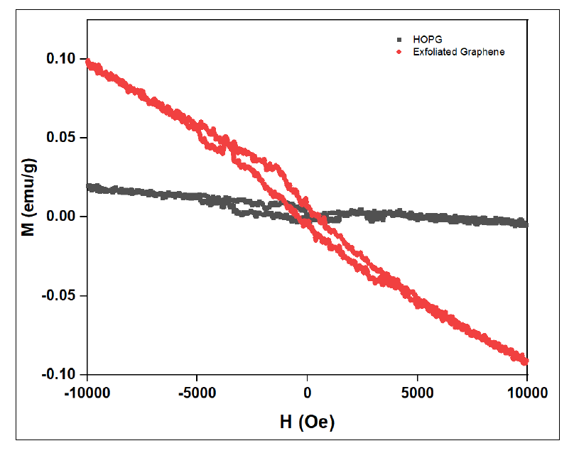Figure S4: Magnetic moments as a function of applied field, measure in HOPG (red) and powder form of graphene flakes (blue) at 300K temperature.
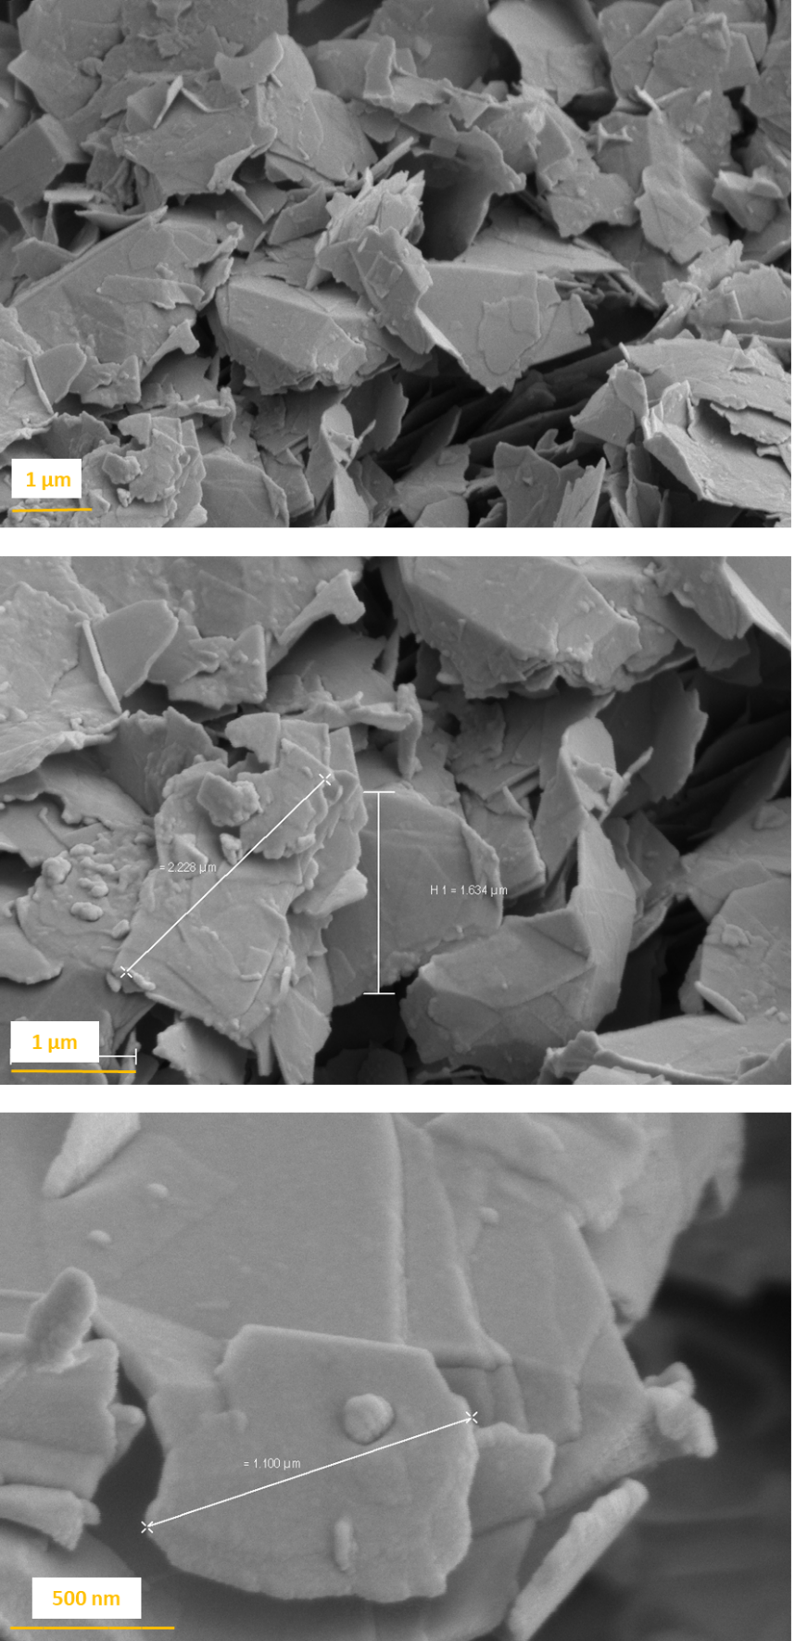
Figure S5: SEM image of electrochemically exfoliated graphene flakes at different magnifications (a) 10 kX, (b) 8 kX and (c) 45 kX.

Movie
Movie S1 shows the real-time response of graphene flakes dispersed in PVA solution in the presence of out-of-plane magnetic field of 0.1T using a neodymiun magnet. The movie depicts the alignment or orientation of graphene flakes in the presence of magnetic field by form dark (centre of magnet) and bright field (edge of magnet).

