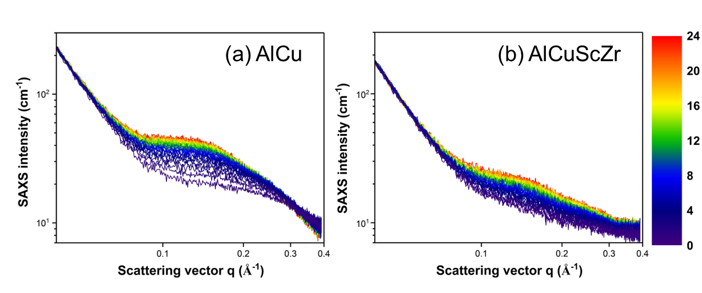
Fig. S1 In-situ SAXS signals of AlCu (a) and AlCuScZr (b) alloys during natural ageing.

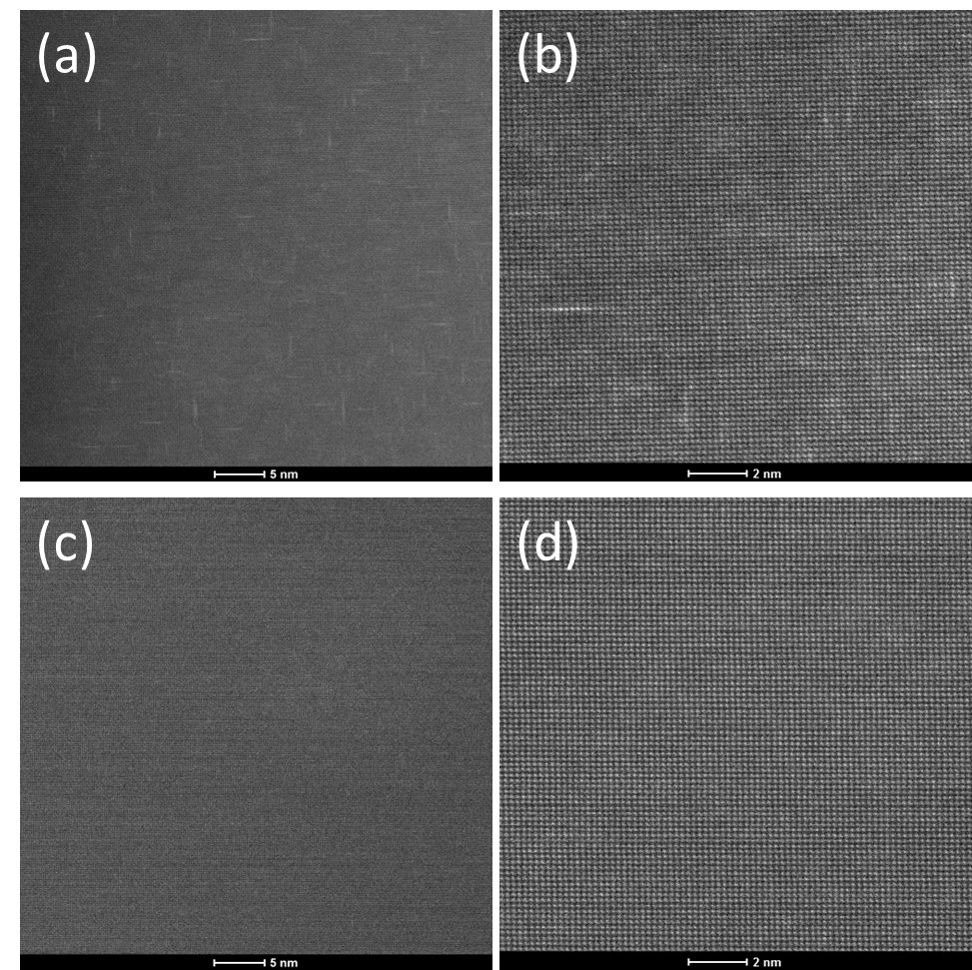
Fig. S2 HR-TEM for (a) & (b) the AlCu alloy after natural ageing for 24h; (c) and (d) the AlCuScZr alloy after natural ageing for 24h.

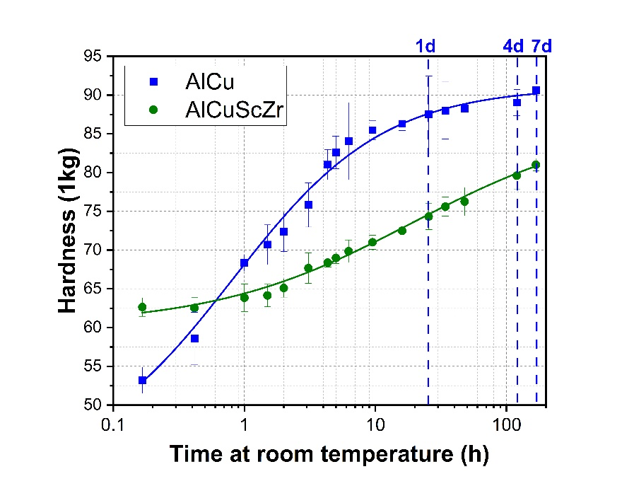
Fig. S3 Hardness evolution of AlCu (blue squares) and AlCuScZr (green circles) alloys during natural ageing.

