Supplementary Material 1 – Further sample collection details
At all sample sites, physicochemical parameters including temperature, specific conductance (SC), pH, Eh and dissolved oxygen (DO) were continuously monitored in a flow cell during pumping. Samples were collected once three bore volumes had been purged and/or physicochemical parameters stabilisation was achieved and had been recorded. Unless stated otherwise, all samples were filtered through a 0.45 μm filter prior to collection. With exception of the SO₄²⁻ and N₂O sample collection, all collection bottles/vials were rinsed with the filtered sample water three times prior to filling. Once collected, all samples were sealed with tape to minimise potential atmospheric exchange prior to analysis.
Water samples for anion and δ²H-H₂O and δ¹⁸O-H₂O analyses were stored in 60 mL high-density polyethylene (HDPE) bottles and 30 mL HDPE bottles, respectively. Samples for ¹⁴C and ³⁶Cl analysis were collected in 1 L narrow mouth HDPE bottles. Samples for ³H analysis were collected in 2 L HDPE bottles. Samples for cation analysis were collected in 60 mL HDPE bottles and acidified with ultrapure ~70% nitric acid (HNO₃). The water for δ¹³C-DIC was further filtered through a 0.22 μm filter and stored in 12 mL Exetainer vials. The samples outlined above were refrigerated at 4℃.
Samples for δ¹³C-DOC were filtered through a 0.22 μm filter and stored in a 60 mL HDPE bottle, and frozen within 12 hours of collection. Samples for δ¹⁵N-NO₃⁻ and δ¹⁸O-NO₃⁻ were filtered to 0.1 µm and stored in 60 mL HDPE bottles, and frozen within 12 hours of collection.
Prior to dissolved SO₄²⁻ collection for isotopic analyses, redox conditions (Eh and field HS⁻) were assessed in the field to avoid samples having undergone significant isotope fractionation. Samples were collected in an in-line closed system with sample filtered through a 0.45 μm high-capacity filter and then passed through an ion-exchange column packed with 22 g of (AmberliteTM IRA458 CL). The resin was conditioned with a 3M KCl solution, prior to field deployment, using methods in Carmody et al. (1998). The volume of groundwater passed through the columns varied and was adapted from a field sulfate turbidimetric analysis (Hanna Instruments). A maximum volume of ~3-10 L was passed through the columns. Sulfate was eluted using a 3M KCl solution upon return to the laboratory. The eluted solution was acidified with 50% (v/v) HCl-ultrapure water to a pH of ~3 to prevent precipitation of carbonates, then dissolved SO₄²⁻ was fixed as BaSO₄ by addition of 1M BaCl₂ solution. The BaSO₄ was rinsed thoroughly, dried and micronised for subsequent analysis.

Supplementary Material 2 – Extended EIA dataset
Table S2-1. Extended EIA dataset.
Sample | Bore ID | Latitude | Longitude | Sampling  date | Screen  lithology | Screened interval  (m) | Screen  midpoint  (m) | SWL  (m) | Head | Alkalinity  (mg/L  CaCO3) | HCO3  (mg/L) | Temperature  (℃) | SC  (us/cm3) | TDS  (mg/L) | DO  (mg/L) | pH | ORP | Fe2+  (mg/L) | Eh  (V)
NogGW1 | 13020030 | -23.526392 | 148.141234 | 25/10/2018 | Alluvium | 15.5 - 16.4 | 15.95 | 10.46 | 168.27 | 491 | 599.0 | 28.93 | 4688 | 3152.5 | 0.19 | 6.94 | 45.4 | 0.04 | 0.2454
NogGW2 | 13020089 | -23.522012 | 148.130371 | 25/10/2018 | Tertiary Basalt | 17 - 18 | 17.5 | 6.415 | 175.715 | 758.3 | 925.1 | 25.95 | 3880 | 3021.8 | 0.49 | 6.95 | 95.6 | 0 | 0.2956
NogGW3 | 13020087 | -23.513314 | 148.112325 | 26/10/2018 | Tertiary Basalt | 19.5 - 20.5 | 20 | 9.3 | 190.9 | 565.2 | 689.5 | 25.12 | 1639 | 1383.8 | 0.74 | 7.26 | 57.7 | 0.03 | 0.2577
NogGW4 | 13020106 | -23.51078 | 148.09392 | 26/10/2018 | Tertiary Basalt | 22.3 - 23.3 | 22.8 | 12.63 | 194.16 | 343.9 | 419.6 | 27.35 | 739 | 648.9 | 3.31 | 7.31 | 112.5 | 0.01 | 0.3125
NogGW5 | 13020086 | -23.508189 | 148.070748 | 26/10/2018 | Tertiary Basalt | 29.1 - 30.1 | 29.6 | 17.69 | 195.21 | 483.2 | 589.5 | 27.47 | 2372 | 1652.9 | 4.43 | 6.89 | 83.2 | 0 | 0.2832
NogGW6 | 13020090 | -23.497287 | 148.056347 | 27/10/2018 | Tertiary Basalt | 16.5 - 17.5 | 17 | 4.77 | 185.73 | 430.7 | 525.5 | 27.06 | 1908 | 1541.5 | 1.4 | 7.29 | 108.9 | 0 | 0.3089
NogGW7 | 13020107 | -23.492198 | 148.072989 | 27/10/2018 | Tertiary Basalt | 8.8 - 9.8 | 9.3 | 3.23 | 192.84 | 379.2 | 462.6 | 24.4 | 1337 | 1061.1 | 5.13 | 7.05 | 111.4 | 0 | 0.3114
NogGW8 | 13020096 | -23.474511 | 148.079923 | 27/10/2018 | Tertiary Basalt | 8.6 - 9.6 | 9.1 | 2.16 | 191.63 | 284.4 | 347.0 | 25.87 | 668 | 568.0 | 0.46 | 7.7 | 41.8 | 0.01 | 0.2418
NogGW9 | 13020108 | -23.464976 | 148.114916 | 27/10/2018 | Tertiary Basalt | 14.5 - 15.5 | 15 | 7.32 | 187.22 | 180.2 | 219.8 | 27.34 | 454 | 436.7 | 0.24 | 6.37 | 28.1 | 0.05 | 0.2281
NogGW10 | 13020041 | -23.534435 | 148.083898 | 28/10/2018 | Tertiary Basalt | 5.9 - 6.9 | 6.4 | 3.19 | 192.97 | 206.3 | 251.7 | 23.95 | 445 | 394.7 | 0.4 | 7.55 | 88.9 | 0 | 0.2889
NogGW11 | 13020114A | -23.573472 | 148.212586 | 28/10/2018 | Tertiary Basalt | 27.15 - 29.85 | 28.5 | 10.23 | 178.23 | 685.8 | 836.7 | 26.44 | 4191 | 3054.1 | 0.24 | 6.87 | 62.7 | 0 | 0.2627
NogGW12 | 13020116 | -23.565155 | 148.214809 | 28/10/2018 | Alluvium | 11.8 - 15 | 13.4 | 10.03 | 173.71 | 118.9 | 145.1 | 27.15 | 1855 | 1136.4 | 1.3 | 5.95 | 98 | 0 | 0.2980
NogGW13 | 13020165 | -23.437927 | 148.330536 | 28/10/2018 | Alluvium | 13.2 - 15 | 14.1 | 13.67 | 147.65 | 648.4 | 791.0 | 28.18 | 5274 | 3371.9 | 0.54 | 6.83 | -229.8 | 0.28 | -0.0298
NogGW14 | 13020035 | -23.441963 | 148.147643 | 29/10/2018 | Alluvium | 14.3 - 15.2 | 14.75 | 10.44 | 164.66 | 426.1 | 519.8 | 27.43 | 5138 | 3379.2 | 2.44 | 7.13 | 133.2 | 0 | 0.3332
NogGW15 | 13020111 | -23.466321 | 148.155576 | 29/10/2018 | Tertiary Basalt | 28.6 - 29.6 | 29.1 | 20.73 | 166.74 | 238.5 | 291.0 | 29.96 | 589 | 488.7 | 0.34 | 7.54 | -91.9 | 0 | 0.1081
NogGW16 | 13020207 | -23.579372 | 148.087368 | 29/10/2018 | Aldeberan Sandstone | 33.4 - 39.4 | 36.4 | 11.44 | 182.07 | 226.9 | 276.8 | 25.66 | 2472 | 1554.0 | 0.12 | 6.39 | -21.9 | 2.93 | 0.1781
NogGW17 | 13020208 | -23.383363 | 148.187026 | 30/10/2018 | Tertiary Sandstone | 94.3 - 96.3 | 95.3 | 41.06 | 156.5 | 423.4 | 516.5 | 28.24 | 1377 | 1096.2 | 0.18 | 8.2 | 57.7 | 0 | 0.2577
NogGW18 | 13020032A | -23.489577 | 148.150822 | 30/10/2018 | Tertiary Basalt | 23.1 - 24 | 23.55 | 4.95 | 172.42 | 329.1 | 401.5 | 24.5 | 1640 | 1190.1 | 0.96 | 7.12 | -116.2 | 0 | 0.0838
NogGW19 | 13020092 | -23.469339 | 148.082512 | 31/10/2018 | Tertiary Basalt | 29.1 - 30.1 | 29.6 | 3.13 | 182.16 | 703.5 | 858.3 | 26.12 | 2145 | 1734.1 | 2.61 | 7.1 | 23.8 | 0 | 0.2238
NogGW20 | 13020072 | -23.497912 | 148.084566 | 31/10/2018 | Tertiary Basalt | 11.7 - 12.7 | 12.2 | 8.83 | 193.44 | 349.9 | 426.9 | 25.38 | 1300 | 979.1 | 4.05 | 6.98 | 57.2 | 0 | 0.2572
NogGW21 | 90322 | -23.51648 | 148.163423 | 31/10/2018 | Alluvium | 18.5 - 22 | 20.25 | n.d. | n.d. | 755.6 | 921.8 | 26.41 | 5285 | 3746.5 | 0.37 | 6.98 | 75.9 | 0 | 0.2759
NogGW22 | 13020101 | -23.538764 | 148.115059 | 1/11/2018 | Tertiary Basalt | 17.6 - 18.6 | 18.1 | 5.61 | 180.17 | 512.9 | 625.7 | 24.65 | 2329 | 1716.8 | 0.98 | 6.99 | 56.7 | 0.04 | 0.2567
NogGW23 | Private Bore | -23.378087 | 148.306553 | 1/11/2018 | Unknown | n.d. | n.d | n.d. | n.d. | 526.7 | 642.6 | 26.05 | 1214 | 1033.0 | 0.2 | 7.06 | 39.9 | 0 | 0.2399
NogGW24 | 13020117A | -23.50732 | 148.265605 | 1/11/2018 | Alluvium | 14 - 17 | 15.5 | 12.97 | 159.42 | 25.8 | 31.5 | 27.6 | 719 | 520.5 | 6.43 | 5.52 | 151.1 | 0.05 | 0.3511
NogSW1-04 | N/A | -23.658105 | 148.074308 | 29/10/2018 | N/A | N/A | N/A | N/A | N/A | 138.6 | 169.1 | 30.62 | 356 | 231 | 9.05 | 8.27 | 67.1 | 0 | 0.27
NogSW2-04 | N/A | -23.531183 | 148.167295 | 29/10/2018 | N/A | N/A | N/A | N/A | N/A | 145 | 176.9 | 28.19 | 420 | 273 | 5.61 | 7.58 | 74.5 | 0 | 0.27
NogSW3-04 | N/A | -23.5131 | 148.207067 | 30/10/2018 | N/A | N/A | N/A | N/A | N/A | 134.7 | 164.3 | 28.34 | 462 | 300 | 6.22 | 7.76 | 92.7 | 0 | 0.29
NogSW5-04 | N/A | -23.432029 | 148.331279 | 30/10/2018 | N/A | N/A | N/A | N/A | N/A | 141.9 | 173.1 | 27.1 | 472 | 307 | 5.75 | 7.82 | 112.4 | 0 | 0.31
n.d. not determined (sample concentration below quantification limit).
N/A not applicable.

Table S2-1. Extended EIA dataset (continued).
Sample | Bore ID | Water-type | F⁻ (mg/L) | Cl⁻(mg/L) | SO₄²⁻(mg/L) | Br⁻(mg/L) | PO₄³⁻(mg/L) | Ca  (mg/L) | Fe  (mg/L) | K  (mg/L) | Li  (mg/L) | Mg  (mg/L) | Na  (mg/L) | P  (mg/L) | S  (mg/L) | Si  (mg/L) | Ba (µg/L) | Mn (µg/L) | Sr (µg/L) | DOC  (mg/L) | NO₂⁻(mg/L N) | NO₃⁻ (mg/L N) | NH₃-N  (mg/L  N)
NogGW1 | 13020030 | Na-Cl | 0.39 | 1250 | 290 | 2.79 | <1 | 75.8 | <0.005 | 6.19 | 0.023 | 323 | 430 | 0.08 | 102 | 29.5 | 109 | 308 | 1430 | 1.53 | <0.02 | 9.46 | 0.000
NogGW2 | 13020089 | Na-HCO3 | 0.21 | 766 | 396 | 1.69 | <1 | 93.8 | <0.005 | 5.9 | 0.017 | 279 | 367 | 0.04 | 138 | 26.8 | 15 | <1 | 1410 | 1.10 | <0.02 | 4.70 | 0.000
NogGW3 | 13020087 | Na-HCO3 | 0.12 | 199 | 63.8 | 0.58 | <1 | 42 | 0.02 | 2.26 | 0.006 | 80.6 | 216 | 0.04 | 24 | 23.4 | 29 | <1 | 853 | 0.81 | <0.02 | 9.37 | 0.000
NogGW4 | 13020106 | Na-HCO3 | 0.53 | 28.1 | 12.1 | 0.16 | <1 | 23.2 | <0.005 | 0.99 | 0.002 | 41 | 82.2 | 0.06 | 4.7 | 27.9 | 3 | 9 | 265 | 0.77 | <0.02 | 1.83 | 0.000
NogGW5 | 13020086 | Na-HCO3 | 0.04 | 476 | 61.4 | 1.44 | <1 | 100 | <0.005 | 4.55 | 0.005 | 136 | 176 | 0.03 | 23.2 | 26.3 | 21 | <1 | 1270 | 0.57 | <0.02 | 12.90 | 0.000
NogGW6 | 13020090 | Na-HCO3 | 0.31 | 200 | 252 | 1.13 | <1 | 33.6 | <0.005 | 0.82 | 0.019 | 43.9 | 309 | 0.01 | 95.1 | 20.6 | 17 | 4 | 515 | 0.72 | <0.02 | 13.32 | 0.000
NogGW7 | 13020107 | Ca-HCO3 | 0.14 | 187 | 46.6 | 0.84 | <1 | 107 | <0.005 | 0.83 | 0.005 | 75.6 | 72 | 0.01 | 17.1 | 26 | 9 | <1 | 849 | 1.08 | <0.02 | 14.57 | 0.000
NogGW8 | 13020096 | Na-HCO3 | 0.45 | 35.9 | 7.11 | 0.2 | <1 | 16.9 | <0.005 | 0.06 | 0.004 | 20.7 | 95.9 | 0.01 | 2.8 | 35.4 | 7 | <1 | 273 | 0.64 | <0.02 | 1.20 | 0.000
NogGW9 | 13020108 | Na-HCO3 | 0.29 | 38.8 | 14.2 | 0.23 | <1 | 3.66 | 0.067 | 0.27 | 0.005 | 4.16 | 107 | 0.5 | 5.4 | 42.1 | 9 | 119 | 51 | 2.06 | <0.02 | <0.02 | 0.000
NogGW10 | 13020041 | Ca-HCO3 | 0.3 | 25.4 | 5.83 | 0.18 | <1 | 30.8 | <0.005 | 0.35 | 0.004 | 28 | 27.3 | 0.03 | 2.3 | 21.3 | 3 | 2 | 308 | 2.14 | <0.02 | 0.20 | 0.000
NogGW11 | 13020114A | Na-Cl | 0.22 | 1010 | 184 | 2.43 | <1 | 90.3 | <0.005 | 7.96 | 0.054 | 128 | 679 | 0.06 | 72.6 | 33.8 | 57 | <1 | 1320 | 1.13 | <0.02 | 1.72 | 0.000
NogGW12 | 13020116 | Na-Cl | 0.08 | 479 | 30.5 | 1.21 | <1 | 16.2 | 0.348 | 1.8 | 0.043 | 22.2 | 307 | 0.7 | 11.8 | 46.7 | 45 | 24 | 272 | 3.25 | <0.02 | 16.44 | 0.009
NogGW13 | 13020165 | Na-Cl | 0.31 | 1390 | 95.6 | 3.9 | <1 | 225 | 0.292 | 3.56 | 0.04 | 214 | 572 | 0.3 | 38 | 34.2 | 124 | 690 | 2790 | 1.46 | <0.02 | <0.02 | 0.000
NogGW14 | 13020035 | Na-Cl | 0.36 | 1450 | 184 | 2.87 | <1 | 81.6 | 0.011 | 4.71 | 0.049 | 171 | 824 | 0.2 | 73.3 | 37.9 | 42 | 9 | 1580 | 1.54 | <0.02 | 6.26 | 0.000
NogGW15 | 13020111 | Na-HCO3 | 0.33 | 45.5 | 6.85 | 0.22 | <1 | 22.2 | 0.023 | 0.8 | 0.003 | 39.7 | 54.1 | 0.06 | 2.7 | 23.8 | 12 | 36 | 276 | 2.62 | 0.03 | 0.23 | 0.009
NogGW16 | 13020207 | Na-Cl | 0.16 | 639 | 112 | 1.89 | <1 | 99.5 | 3.09 | 26.5 | 0.082 | 111 | 234 | 0.03 | 41.4 | 7.4 | 99 | 102 | 946 | 0.42 | <0.02 | <0.02 | 0.112
NogGW17 | 13020208 | Na-HCO3 | 0.12 | 165 | 68.5 | 0.56 | <1 | 6.31 | 0.006 | 6.02 | 0.049 | 8.19 | 285 | 0.07 | 26.1 | 13.5 | 53 | 5 | 197 | 1.95 | <0.02 | <0.02 | 0.335
NogGW18 | 13020032A | Na-HCO3 | 0.29 | 303 | 76.5 | 1.13 | <1 | 68.1 | 0.15 | 0.84 | 0.014 | 111 | 122 | 0.02 | 28.1 | 30.6 | 24 | 19 | 917 | 1.13 | 0.02 | 10.34 | 0.000
NogGW19 | 13020092 | Na-HCO3 | 0.15 | 224 | 42.4 | 0.99 | <1 | 25.7 | 0.011 | 5.08 | 0.025 | 52.1 | 380 | 0.08 | 16.9 | 28.9 | 50 | <1 | 470 | 1.21 | <0.02 | 22.36 | 0.000
NogGW20 | 13020072 | Na-HCO3 | 0.23 | 163 | 22.5 | 0.89 | <1 | 66.7 | 0.008 | 0.46 | 0.004 | 69.9 | 99.1 | 0.03 | 8.5 | 31.9 | 1 | <1 | 1000 | 0.67 | <0.02 | 19.87 | 0.000
NogGW21 | 90322 | Na-Cl | 0.23 | 1090 | 424 | 2.65 | <1 | 102 | <0.005 | 5.76 | 0.062 | 198 | 804 | 0.2 | 147 | 30.2 | 85 | 105 | 1930 | 1.07 | <0.02 | 4.16 | 0.000
NogGW22 | 13020101 | Na-HCO3 | 0.24 | 383 | 116 | 1.2 | <1 | 74.2 | 0.01 | 5.85 | 0.02 | 127 | 251 | 0.04 | 44.3 | 30.4 | 22 | 4 | 823 | 1.22 | <0.02 | 12.87 | 0.000
NogGW23 | Private Bore | Na-HCO3 | 0.24 | 101 | 10.5 | 0.39 | <1 | 43.9 | 0.007 | 4.57 | 0.012 | 79.7 | 117 | 0.04 | 4.3 | 28.3 | 23 | 3 | 490 | 0.37 | <0.02 | <0.02 | 0.000
NogGW24 | 13020117A | Na-Cl | 0.06 | 88.3 | 84.1 | 0.35 | <1 | 10.5 | 0.023 | 5.82 | 0.035 | 14.2 | 102 | 0.04 | 29.1 | 46.3 | 35 | 3 | 188 | 1.27 | <0.02 | 24.39 | 0.000
NogSW1-04 | N/A | Na-HCO3 | 0.28 | 21.6 | 5.34 | 0.15 | <1 | 26.1 | <0.005 | 9.05 | 0.002 | 11.9 | 26.2 | 0.09 | 2.1 | 4 | 54 | <1 | 277 | 5.2 | <0.02 | <0.02 | 0.000
NogSW2-04 | N/A | Na-HCO3 | 0.29 | 36.7 | 8.86 | 0.18 | <1 | 27.4 | <0.005 | 9.06 | 0.002 | 13.9 | 34.9 | 0.1 | 3.5 | 3.9 | 42 | 27 | 298 | 5.2 | <0.02 | <0.02 | 0.025
NogSW3-04 | N/A | Na-HCO3 | 0.28 | 48.2 | 12.2 | 0.21 | <1 | 28 | <0.005 | 9.13 | 0.002 | 14.6 | 40 | 0.1 | 4.6 | 3.9 | 45 | 7 | 313 | 5.4 | <0.02 | <0.02 | 0.022
NogSW5-04 | N/A | Na-HCO3 | 0.28 | 51.3 | 12.9 | 0.22 | <1 | 28.4 | <0.005 | 9.15 | 0.002 | 15.3 | 40.7 | 0.1 | 5 | 3.9 | 59 | 5 | 327 | 5.5 | <0.02 | <0.02 | 0.002
n.d. not determined (sample concentration below quantification limit).
N/A not applicable.

Table S2-1. Extended EIA dataset (continued).
Sample | Bore ID | Water-type | δ²H-H₂O (‰) | δ¹⁸O-H₂O (‰) | δ¹³C-DIC (‰) | δ¹³C-DOC (‰) | δ¹⁵N-NO₃⁻ (‰) | δ¹⁸O-NO₃⁻ (‰) | δ³⁴S-SO₄²⁻ (‰) | δ¹⁸O-SO₄²⁻ (‰) | ³H (TU) | ³H age (years BP) | ³⁶Cl/Cl (×10⁻¹⁵) | DEN^{a)} (%) | Groundwater cluster
NogGW1 | 13020030 | Na-Cl | -14.3 | -1.8 | -12.8 | -27.1 | +12.4 | +13.2 | +10.6 | +13.1 | 0.48 | <40-50 | 81.3 | 80.6 | Mixed
NogGW2 | 13020089 | Na-HCO3 | -20.5 | -2.9 | -12.7 | -26.8 | +9.9 | +7.5 | +6.8 | +11.9 | 0.22 | <40-50 | 77.5 | 71.3 | Mixed
NogGW3 | 13020087 | Na-HCO3 | -8.9 | -1.0 | -11.8 | -25.8 | +7.2 | +7.0 | +8.8 | +13.8 | 0.49 | <40-50 | 74.3 | 56.3 | Mixed
NogGW4 | 13020106 | Na-HCO3 | -11.8 | -1.3 | -9.7 | -26.0 | +5.1 | +4.2 | +8.8 | +15.4 | 0.85 | <40-50 | 156.2 | 0.0 | Leakage-dominated
NogGW5 | 13020086 | Na-HCO3 | -22.2 | -3.0 | -10.7 | -26.4 | +5.8 | +4.6 | +11.6 | +12 | 0.16 | <40-50 | 76.5 | 45.6 | Mixed
NogGW6 | 13020090 | Na-HCO3 | -10.6 | -1.1 | -9.7 | -25.5 | +16.8 | +16.1 | +15.2 | +13.2 | 0.42 | <40-50 | 146.5 | 90.3 | Mixed
NogGW7 | 13020107 | Ca-HCO3 | -17.9 | -2.5 | -10.9 | -17.2 | +3.5 | +5.2 | +6.4 | +17.6 | 0.43 | <40-50 | 106.1 | 22.1 | Mixed
NogGW8 | 13020096 | Na-HCO3 | -5.7 | -0.3 | -9.4 | -26.3 | +10.3 | +9.7 | +7.0 | +16.1 | 1.10 | <40-50 | 142.2 | 57.4 | Leakage-dominated
NogGW9 | 13020108 | Na-HCO3 | -5.5 | -0.2 | -13.1 | -25.6 | n.d. | n.d. | +4.7 | +16.7 | 0.90 | <40-50 | 170.0 | N/A | Leakage-dominated
NogGW10 | 13020041 | Ca-HCO3 | +0.9 | +1.2 | -8.6 | -24.6 | +19.6 | +24.8 | +7.6 | +19.0 | 1.55 | <40-50 | 163.0 | 90.7 | Leakage-dominated
NogGW11 | 13020114A | Na-Cl | -14.6 | -1.9 | -12.5 | -26.7 | +17.0 | +15.4 | +15.2 | +9.6 | 0.42 | <40-50 | 79.1 | 90.6 | Mixed
NogGW12 | 13020116 | Na-Cl | -7.1 | -0.8 | -14.5 | -26.7 | +6.2 | +7.7 | n.d. | n.d. | 1.11 | <40-50 | 91.4 | 48.9 | Mixed
NogGW13 | 13020165 | Na-Cl | -13.1 | -1.9 | -13.6 | -23.4 | n.d. | n.d. | +3.9 | +12.1 | 0.59 | <40-50 | 72.8 | N/A | Mixed
NogGW14 | 13020035 | Na-Cl | -9.5 | -1.1 | -11.8 | -29.7 | +14.1 | +11.5 | +10.9 | +13.1 | 0.50 | <40-50 | 81.2 | 85.1 | Mixed
NogGW15 | 13020111 | Na-HCO3 | -0.4 | +0.8 | -9.8 | -20.3 | +18.8 | +20.3 | n.d. | n.d. | 1.42 | <40-50 | 152.5 | 89.4 | Leakage-dominated
NogGW16 | 13020207 | Na-Cl | -31.9 | -5.1 | -14.6 | -27.4 | n.d. | n.d. | +9.0 | +11.6 | 0.05 | >40-50 | 79.8 | N/A | Pre-irrigation
NogGW17 | 13020208 | Na-HCO3 | -28.6 | -4.6 | -9.0 | -32.6 | n.d. | n.d. | n.d. | n.d. | 0.06 | >40-50 | 72.8 | N/A | Pre-irrigation
NogGW18 | 13020032A | Na-HCO3 | -15.5 | -2.0 | -9.4 | -26.3 | +6.8 | +8.0 | +11.0 | +13.8 | 0.67 | <40-50 | 86.9 | 53.5 | Mixed
NogGW19 | 13020092 | Na-HCO3 | -15.3 | -2.0 | -12.6 | -26.1 | +10.2 | +10.1 | n.d. | n.d. | 0.34 | <40-50 | 107.0 | 72.7 | Mixed
NogGW20 | 13020072 | Na-HCO3 | -16.7 | -2.3 | -9.7 | -25.8 | +3.9 | +6.1 | n.d. | n.d. | 0.52 | <40-50 | 109.8 | 26.8 | Mixed
NogGW21 | 90322 | Na-Cl | -18.4 | -2.7 | -12.3 | -25.9 | +18.5 | +14.3 | +6.7 | +11.3 | 0.54 | <40-50 | 86.4 | 92.5 | Mixed
NogGW22 | 13020101 | Na-HCO3 | -14.1 | -1.9 | -11.5 | -28.6 | +6.0 | +5.5 | +11.7 | +13.1 | 0.53 | <40-50 | 86.6 | 47.3 | Mixed
NogGW23 | Private Bore | Na-HCO3 | -34.4 | -5.2 | -8.6 | -26.8 | n.d. | n.d. | n.d. | n.d. | 0.10 | >40-50 | 90.8 | N/A | Pre-irrigation
NogGW24 | 13020117A | Na-Cl | -15.3 | -2.3 | -15.2 | -25.1 | +1.9 | +5.0 | n.d. | n.d. | 0.99 | <40-50 | 116.3 | 0.0 | Mixed
NogSW1-04 | N/A | Na-HCO3 | +11.3 | +2.9 | -3.5 | -24.9 | n.d. | n.d. | n.d. | n.d. | 1.82 | Modern | 159.2 | N/A | N/A
NogSW2-04 | N/A | Na-HCO3 | +9.6 | +2.5 | -5.7 | -24.1 | n.d. | n.d. | n.d. | n.d. | 1.99 | Modern | 140.2 | N/A | N/A
NogSW3-04 | N/A | Na-HCO3 | +8.0 | +2.2 | -6.0 | -24.6 | n.d. | n.d. | n.d. | n.d. | 1.96 | Modern | 122.8 | N/A | N/A
NogSW5-04 | N/A | Na-HCO3 | +7.6 | +2.2 | -6.6 | -24.5 | n.d. | n.d. | n.d. | n.d. | 1.93 | Modern | 109.6 | N/A | N/A
^{a)} Calculated using Equation 2.
n.d. not determined (sample concentration below quantification limit).
N/A not applicable.

Supplementary Material 3 – Hierarchical cluster analysis
R software (R Core Team, 2017) was used to determine which hierarchical clustering method was best suited to measure similarity between groundwater samples. This approach has been outlined in https://uc-r.github.io/hc_clustering. The variables of δ²H-H₂O, δ¹⁸O-H₂O, δ¹³C-DIC, ³H, ³⁶Cl/Cl and NO₃⁻ were used in the method, as these were interpreted to best reflect groundwater residence times, recharge sources and distribution of NO₃⁻.
Ward’s minimum variance method, which uses the squared Euclidean distances as a measure of similarity, gives the best clustering structure within the EIA groundwater dataset. Similar applications of Ward’s method for clustering to hydrogeochemical data can be found in Lambrakis et al. (2004) and Swanson et al. (2001). The derived dendogram, which depicts the cluster structures, is shown in Fig. S3-1.
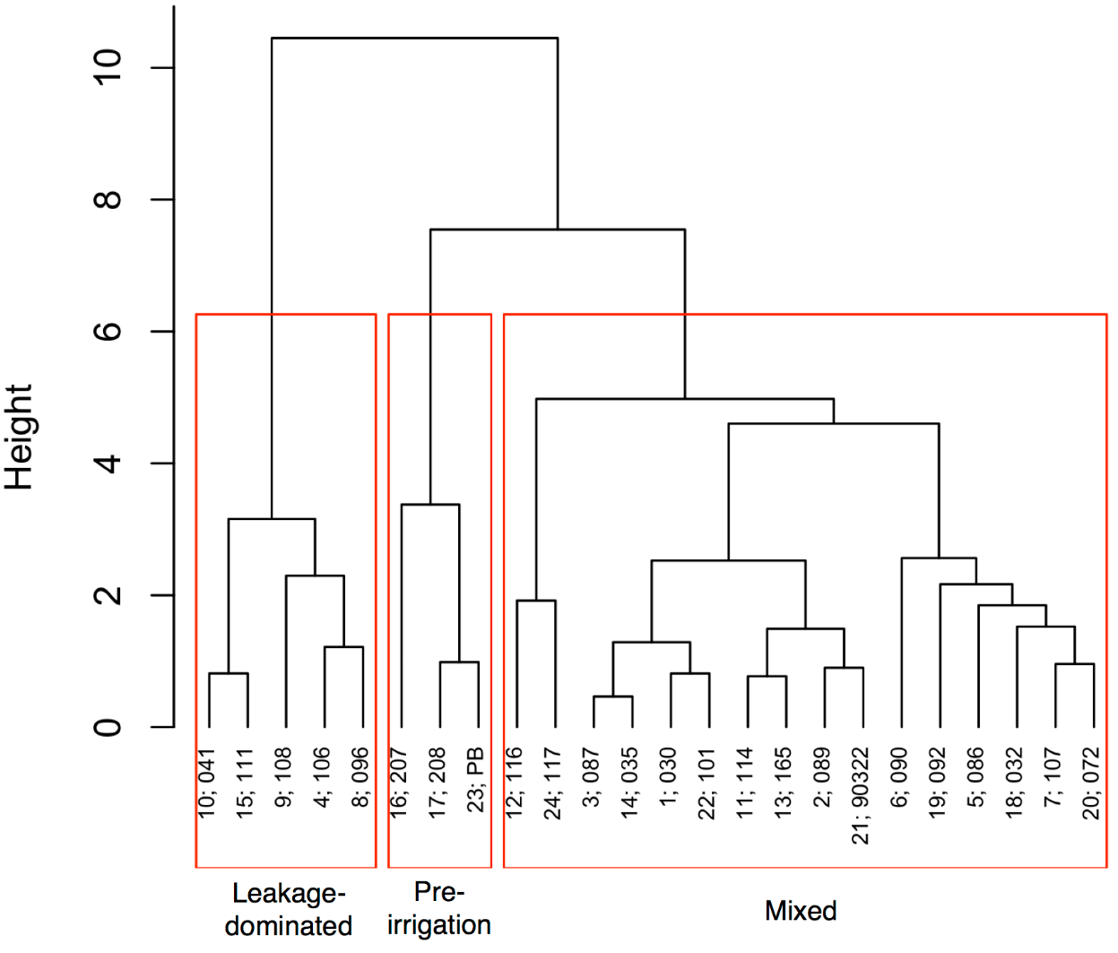
Fig. S3-1. Dendogram derived from Ward’s minimum variance method of hierarchical clustering. The different groundwater clusters are indicated.

Supplementary Material 4 – Supporting evidence for EIA groundwater hydrogeochemical processes
Figs. S4-1 to S4-3 are used as supporting evidence in this study.
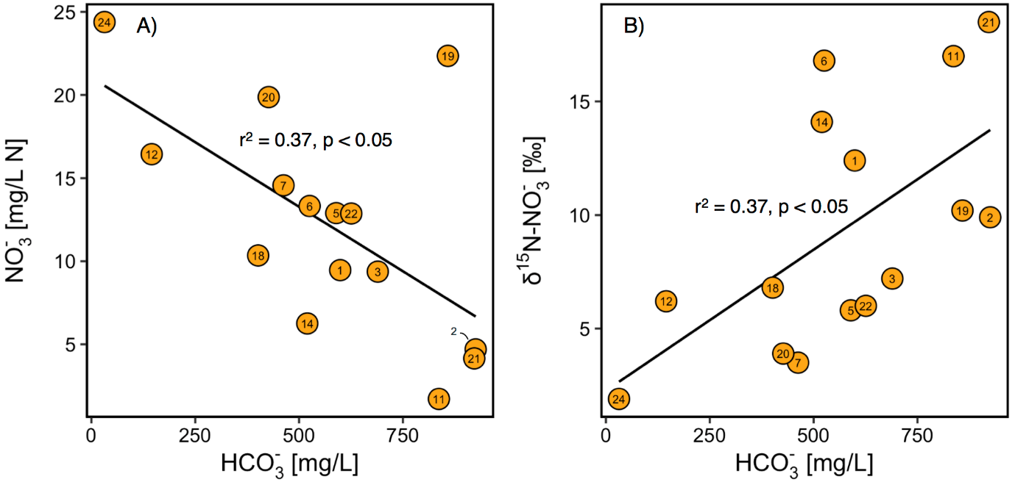
Fig. S4-1. Relationship between NO₃⁻ and HCO₃⁻ (a) and δ¹⁵N-NO₃⁻ and HCO₃⁻ (b) in the mixed groundwater cluster.
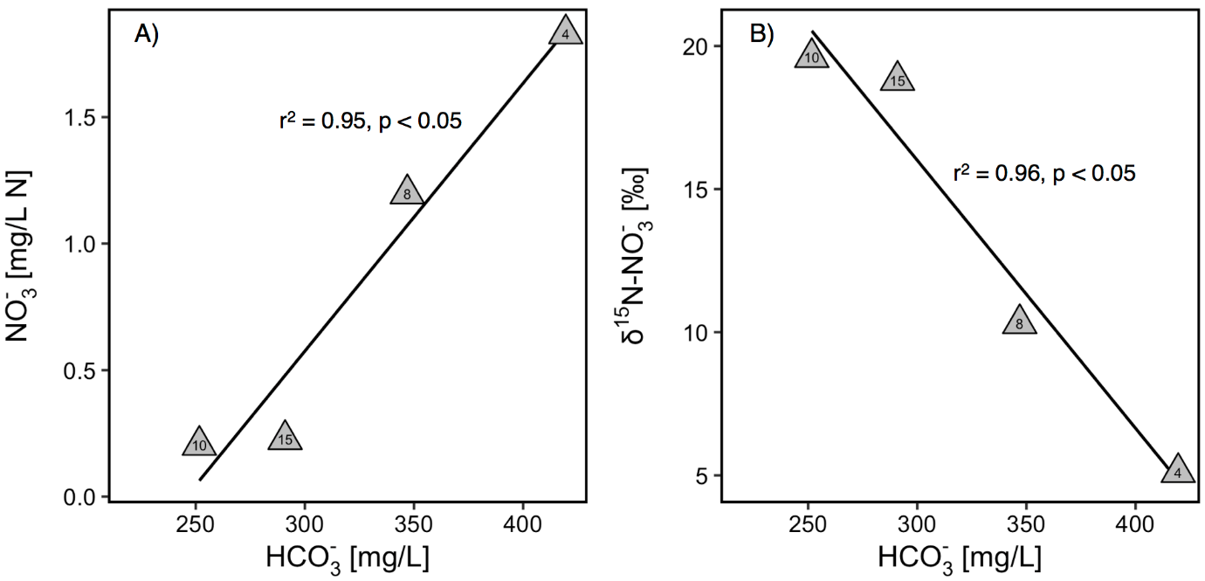
Fig. S4-2. Relationship between NO₃⁻ and HCO₃⁻ (a) and δ¹⁵N-NO₃⁻ and HCO₃⁻ (b) in the leakage-dominated groundwater cluster.
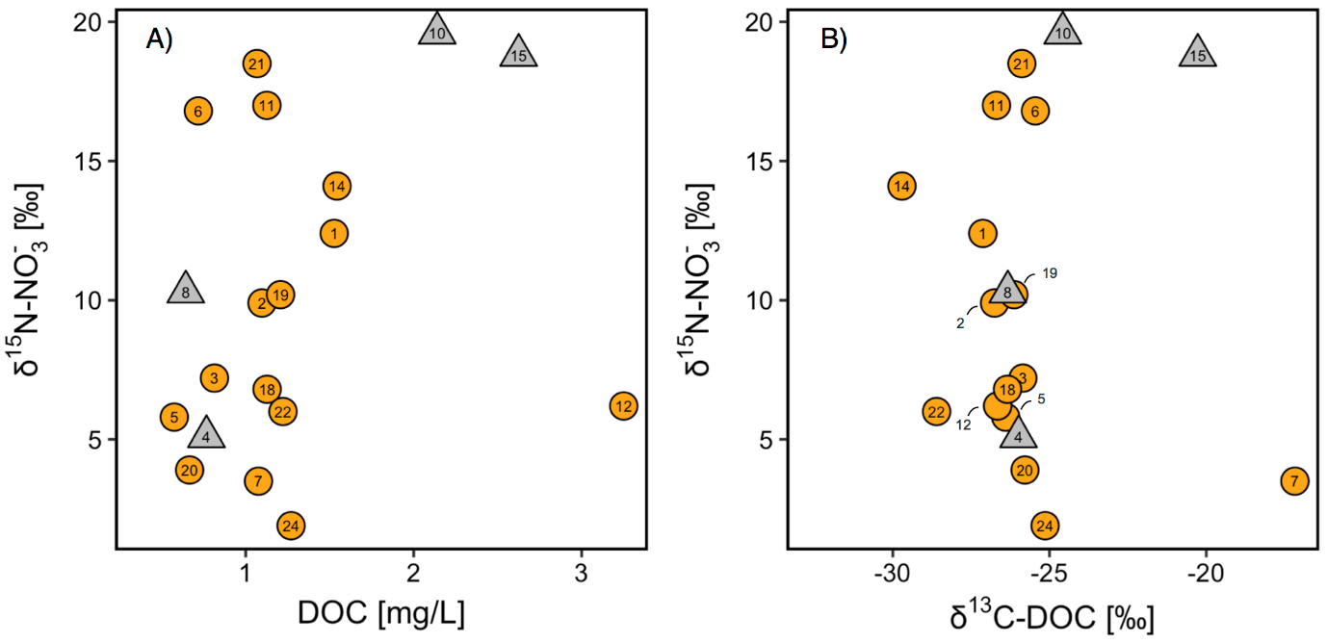
Fig. S4-3. Relationship between δ¹⁵N-NO₃⁻ and DOC (a) and δ¹⁵N-NO₃⁻ and δ¹³C-DOC (b) in the mixed and leakage-dominated groundwater clusters.

REFERENCES
Carmody, R.W., Plummer, N., Busenberg, E. and Coplen, T.B., 1998. Methods for collection of dissolved sulfate and sulfide and analysis of their sulfur isotopic composition (No. 97-234). US Geological Survey.
R Core Team.: R: A language and environment for statistical computing. R Foundation for Statistical Computing, Vienna, Austria. URL https://www.R-project.org/, 2017.

