Figure 1C. NMR data.
Refer to …\Raw files\NMR\Fig1C\PNAtemp
/10 2 ºC
/12 12 ºC
/14 20 ºC
/15 25 ºC
Refer to …\Raw files\NMR\Fig1C\moRNAtemp
/10 2 ºC
/12 12 ºC
/14 20 ºC
/15 25 ºC

Figure 1D. DLS of 50 µM refolded PNA^{tet}
Diameter(nm) | % Number
0.0401934 | 0
0.0532214 | 0
0.0704723 | 0
0.0933148 | 0
0.123561 | 0
0.163612 | 0
0.216644 | 0
0.286865 | 0
0.379848 | 0
0.50297 | 0
0.665999 | 0
0.881872 | 0
1.16772 | 0
1.54621 | 0
2.04739 | 0
2.71102 | 15.8745
3.58976 | 84.1255
4.75332 | 0
6.29403 | 0
8.33414 | 0
11.0355 | 0
14.6125 | 0
19.3489 | 0
25.6205 | 0
33.925 | 0
44.9213 | 0
59.4818 | 0
78.7618 | 0
104.291 | 0
138.095 | 0
182.857 | 0
242.127 | 0
320.609 | 0
424.529 | 1.30E-10
562.133 | 1.02E-10
744.339 | 0

Figure 2A raw data.
For raw data and binding curve fitting values, refer to “MST raw data and fitting curves. xlsx”.
Figure 2B raw data.
Individual KD of each replicate and folds of affinity changes in presence of PNA^{tet}, PNA^{tetS}, PNA^{tetL} and PNA^{tetN}, relative to the average affinity of “no PNA” control.
vs. PNA1.5 and 4 |  |  |  | vs. PNA1.5 and 4
replicates | no PNA | 5 uM PNAtetL |  | replicates | no PNA | 5 uM PNAtetL
1 | 112.54 | 371.34 |  | 1 | 1.01 | 3.33
2 | 132.285 | 295.24 |  | 2 | 1.19 | 2.65
3 | 89.502 | 317.29 |  | 3 | 0.80 | 2.85
average | 111.44
vs. PNA3 and 9 |  |  |  | vs. PNA3 and 9
replicates | no PNA | 5 uM PNAtetS | 5 uM PNAtetN | replicates | no PNA | 5 uM PNAtetS | 5 uM PNAtetN
1 | 315.03 | 256.76 | 241.51 | 1 | 0.87 | 0.71 | 0.67
2 | 403.54 | 170.5 | 352.49 | 2 | 1.11 | 0.47 | 0.97
3 | 368.42 | 258.2 | 437.62 | 3 | 1.02 | 0.71 | 1.21
average | 362.33
vs. PNA1.5 |  |  |  | vs. PNA1.5
replicates | no PNA | 5 uM PNAtet |  | replicates | no PNA | 5 uM PNAtet
1 | 78.002 | 207.97 |  | 1 | 0.94 | 2.51
2 | 87.292 | 207.82 |  | 2 | 1.05 | 2.50
3 | 83.681 | 247.13 |  | 3 | 1.01 | 2.98
average | 82.99

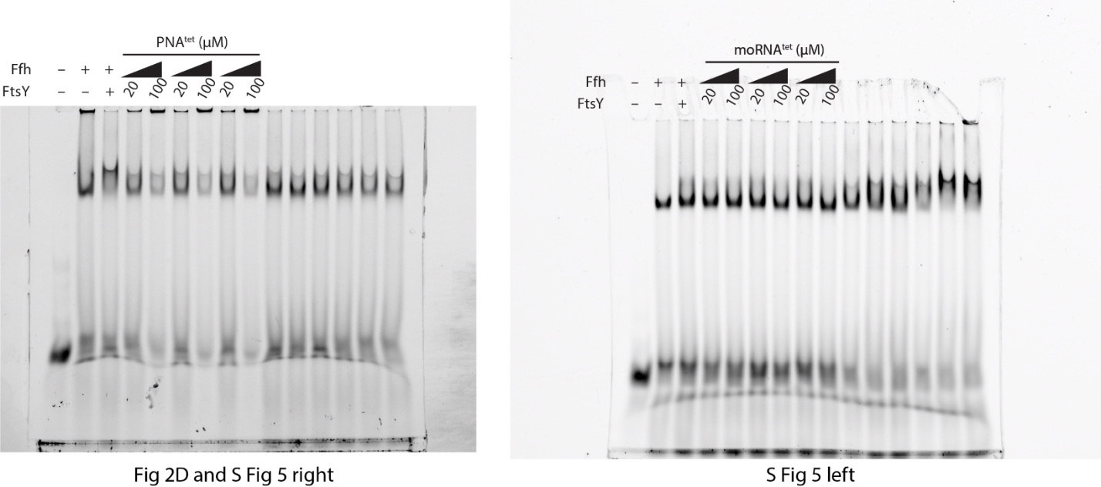
Figure 2C, SFig5 uncropped EMSA gel image.

Figure 3A-E. SPR data
refer to …\Raw files\MST and SPR data\Raw_Data_For_All_SPR_Figures

Figure 3F-G. NMR data
refer to …\Raw files\NMR\Fig3FG

Figure 4A-B. SPR data
refer to …\Raw files\MST and SPR data\Raw_Data_For_All_SPR_Figures

Figure 4C. NMR data
refer to …\Raw files\NMR\Fig4C\ak220119_Nsp9_PNA
/12 Nsp9 alone
/14 Nsp9 + PNA^{tet} 1:1
SFig 1A. CD spectra
…\Raw files\CD
SFig 2-4. NMR data
SFig 2, refer to …\Raw files\NMR\Sfig2
SFig 3, refer to …\Raw files\NMR\Sfig3
SFig 4, refer to …\Raw files\NMR\SFig4_NOESY PNA
SFig 5. uncropped EMSA gel images are shown above.
SFig 5A. HPLC profile
refer to …\Raw files\HPLC
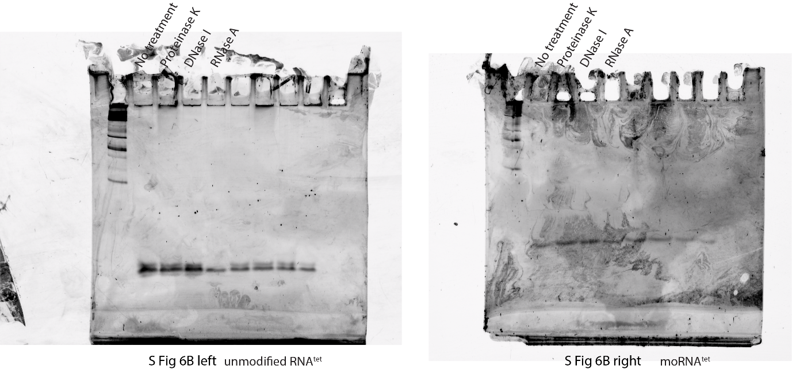
SFig 5B. uncropped gel image:

SFig 7A & 8. NMR data
BMRB deposition 52588
refer to …\Raw files\NMR\Sfig78
SFig 9. SPR data.
refer to …\Raw files\MST and SPR data\Raw_Data_For_All_SPR_Figures

