A new evidence base to document millennial changes in coastal vegetation
Nicole R. Foster^{1.}, Alice R. Jones^{1.}, Oscar Serrano^{2.}, Anna Lafratta^{3.}, Paul S. Lavery^{3.}, Kor-jent van Dijk^{1.}, Ed Biffin^{4.}, Bronwyn M. Gillanders^{1.}, Jennifer Young^{5.}, Pere Masque^{3,6.}, Patricia S. Gadd^{7.}, Geraldine E. Jacobsen^{7.}, Atun Zawadzki^{7.}, Andria Greene^{8.}, Michelle Waycott^{1,4.}
1. School of Biological Sciences and Environment Institute, University of Adelaide, Adelaide, SA 5005, Australia
2. Centro de Estudios Avanzados de Blanes, Consejo Superior de Investigaciones Científicas. Blanes, Spain.
3. School of Sciences & Centre for Marine Ecosystems Research, Edith Cowan University, 270 Joondalup Drive, Joondalup, WA 6027, Australia.
4. Botanic Gardens and State Herbarium of South Australia, Adelaide, SA 5005, Australia
5. College of Science and Engineering, Flinders University, GPO Box 2100, Adelaide, SA 5001, Australia
6. International Atomic Energy Agency, 4a Quai Antoine 1er, Principality of Monaco 98000, Monaco.
7. Australian Nuclear Science and Technology Organisation, Lucas Heights, NSW 2234, Australia
8. Department of Applied Environmental Science, California State University, Monterey Bay, Seaside, CA 93955, United States

Supplementary Material
Table S1. List of target chloroplast gene regions screened for as ‘on target’ in the bait set used to target capture eDNA.
Gene | Name | Target coordinates of Avicennia marina genome (Genbank: MN307164)
psbA | photosystem II protein D1 | 479-1,537
matK | maturase K | 2032-3621
psbK | photosystem II protein K | 7389-7574
atpF | ATP synthase CF0 subunit I | 11640-12894
atpH | ATP synthase CF0 subunit III | 13262-13507
atpI | ATP synthase CF0 subunit IV | 14508-15242
psbD | photosystem II protein D2 | 32868-33929
psbZ | photosystem II protein Z | 35955-36143
rbcL | ribulose-1,5-bisphosphate carboxylase/oxygenase large subunit | 55048-56508
atpB | ATP synthase CF1 beta subunit | 52774-54270
accD | acetyl-CoA carboxylase carboxyltransferase beta subunit | 57200-58681
petA | cytochrome f | 62219-63181
psbE-psbF | photosystem II cytochrome b559 alpha subunit/photosystem II cytochrome b559 beta subunit | 64710-64965
psbN-psbH | photosystem II protein N/photosystem II phosphoprotein | 74136-74594
petD | cytochrome b6/f complex subunit IV | 76279-77493
rpl14-rpl16 | ribosomal protein L14/ribosomal protein L16 | 80938-82228
rpoC1 | β subunit of RNA polymerase | 20713-23539
ndhK | NADH-plastoquinone oxidoreductase subunit K | 49046-49723
ndhF | NADH-plastoquinone oxidoreductase subunit 5 | 124837-127068
ndhC | NADH-plastoquinone oxidoreductase subunit 3 | 49779-50141

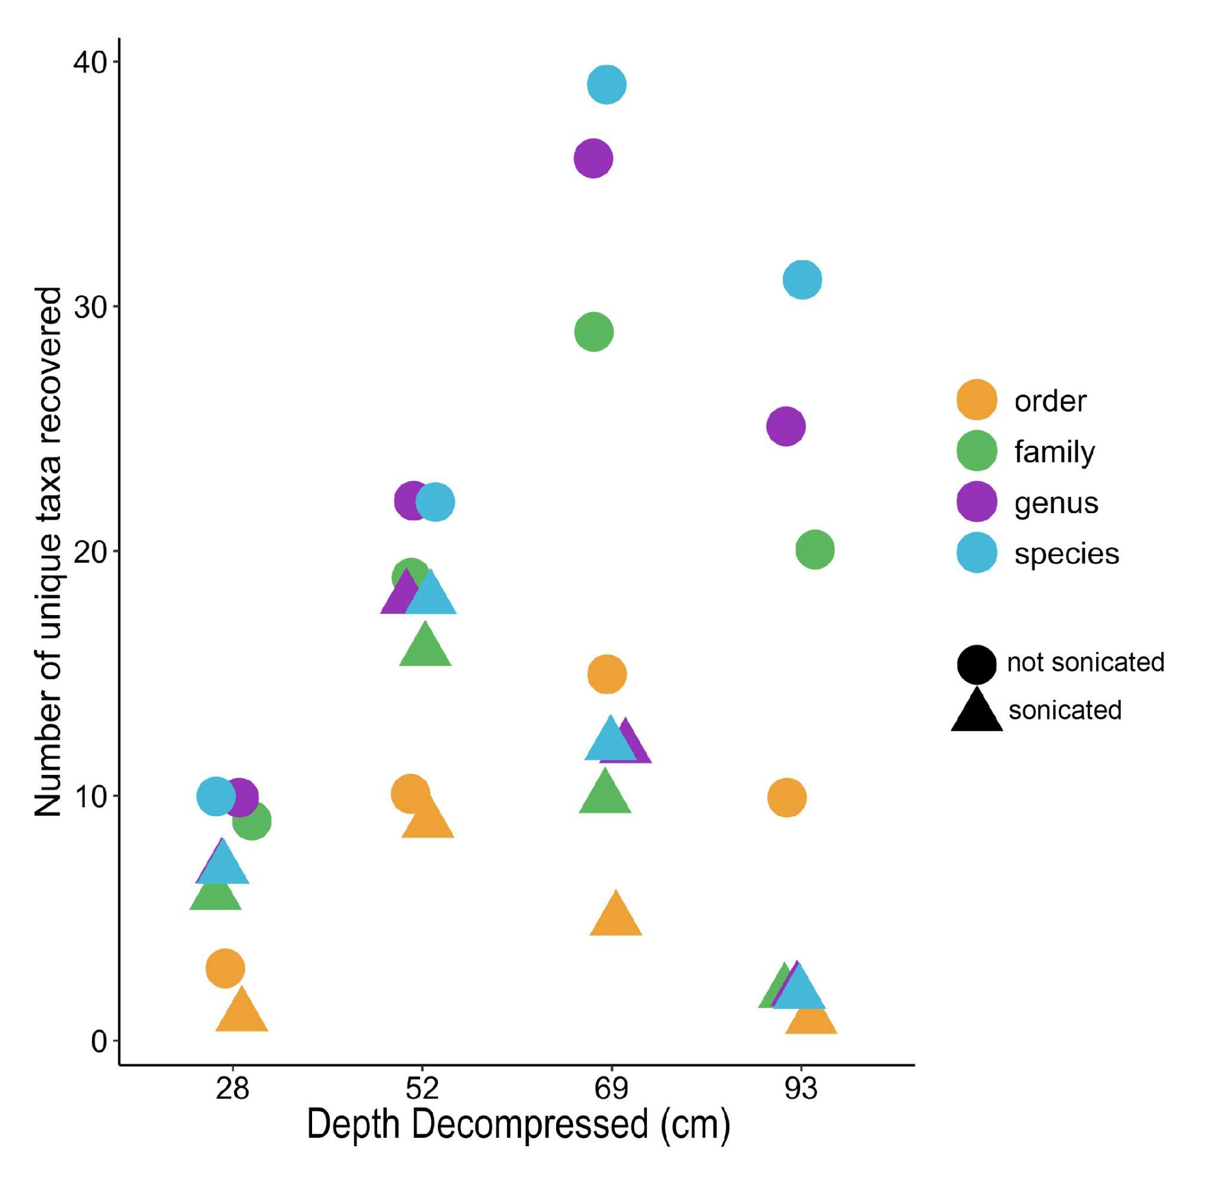
Figure S1. Results of the sonication trial on Core 1 to determine whether extracted sediment DNA required sonication prior to library preparation and targeted capture. Colours indicate the taxonomic resolution achieved by the sample and shapes indicate whether the sample had been sonicated or not. The number of unique taxa recovered (prior to filtering) is on the y-axis and depth decompressed (cm) is on the x-axis. The more degraded DNA in deeper sections (i.e., at 69 and 93 cm) of the core was more impacted by sonication where the number of unique taxa was substantially lower than non-sonicated samples. Although shallower sections of the core were not as impacted by sonication, the DNA recovered was not sonicated in any soil sample in this study.

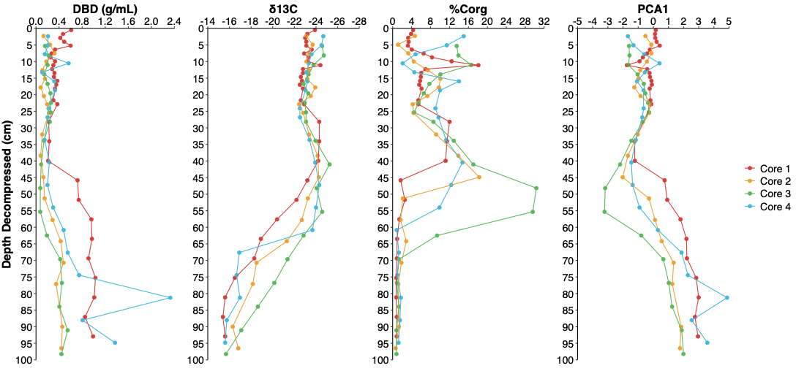

Figure S2. Results of Dry Bulk Density in g/mL (DBD), stable organic carbon isotope composition (δ¹³C) and % organic carbon content (%Corg) conducted on all four soil cores and plotted against decompressed depth. The far-right plot shows the results of the Principal Components Analysis on these variables across all four cores, where PC1 explained 74% of the variance. The PC1 scores obtained for each core are plotted separately. Colours indicate cores.

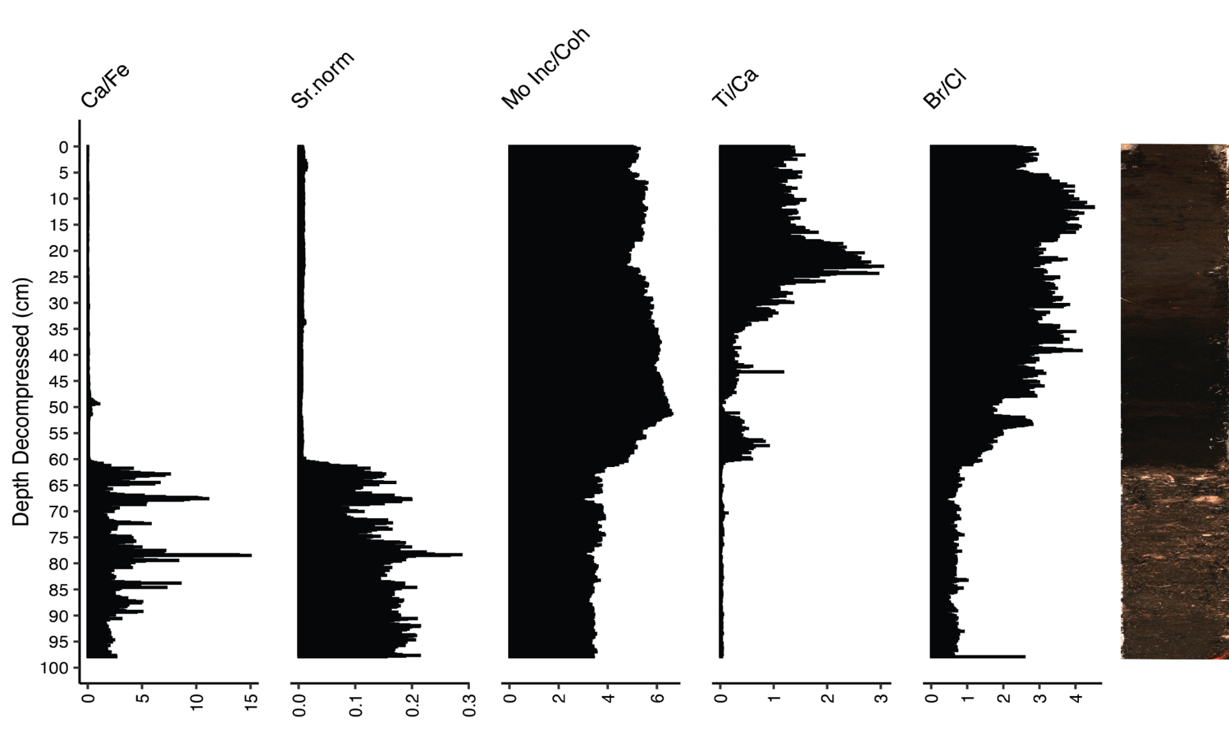
Figure S3. X-ray Fluorescence (XRF) results for the soil core designated Core 3. Element ratios represented here are Calcium/Iron (Ca/Fe), Strontium (Sr) (normalised to Molybdenum incoherent + coherent scattering), Molybdenum Compton (incoherent) and Rayleigh (coherent) scattering (Moly ratio), Titanium/Calcium (Ti/Ca) and Bromine/Chlorine (Br/Cl). A high-resolution photograph of Core 3 is provided (far right), taken at 200 μm resolution.
Table S2. Principal Component Analysis results for DBD, δ¹³C and %C_{org} and elements Ca/Fe, Sr, Moly ratio, Ti/Ca, Br/Cl (XRF). The variables included in the analysis are on the left and the R, R² and percent contributions to Principal Component 1 are recorded.
Variables | R | R² | Contribution to PC1
DBD, δ¹³C and %C_{org}
DBD | 0.86 | 0.74 | 33.41
δ¹³C | 0.90 | 0.81 | 36.50
%C_{org} | -0.82 | 0.67 | 30.09
XRF
Ca/Fe | 0.86 | 0.74 | 19.43
Sr.norm | 0.96 | 0.92 | 24.01
Mo Inc/Coh | -0.90 | 0.83 | 21.38
Ti/Ca | -0.70 | 0.49 | 12.68
Br/Cl | -0.93 | 0.86 | 22.49

Table S3. Output of ¹⁴C dating results for each soil core. Radiocarbon ages are calibrated against the Southern Hemisphere calibration curve SHCal20. Where marine influence is identified, a mixed SHCal20/Marine20 calibration is used. Marine calibrations included a local marine reservoir correction ΔR using https://delta-r-calc.jcu.io/ . Calibrations were done using OxCal 4.4.4 using a P-Sequence deposition model. Calibrated ages provide both unmodelled and modelled age ranges and median values and refer to cal BP where before present is 1950.
Core ID | Decompressed Depth (cm) | δ¹³C (‰) | Percent Modern Carbon (pMC, 1σ) | Conventional Radiocarbon age (yr BP, 1σ) | % Marine | Unmodelled Calibrated age range  (cal yr BP, 68.3%) | Unmodelled Calibrated Age range  (cal yr BP, 95.4%) | Modelled Calibrated age range  (cal yr BP, 68.3%) | Modelled Calibrated Age range  (cal yr BP, 95.4%) | Median Modelled Calibrated Age (cal yr BP)
Core 1 | 24.64 | -22.9 | 98.24 ± 0.32 | 143 ± 26 | - | 252 -… | 259 -… | 255 - 9 | 261 - 3 | 103
Core 1 | 35.24 | -24.3 | 95.29 ± 0.28 | 388 ± 24 | - | 487 - 328 | 492 - 322 | 455 - 325 | 486 - 320 | 371
Core 1 | 48.19 | -23.2 | 94.06 ± 0.27 | 492 ± 23 | - | 515 - 495 | 531 - 490 | 516 - 496 | 531 - 490 | 506
Core 1 | 63.50 | -18.9 | 72.82 ± 0.21 | 2548 ± 23 | 50% | 2461 - 2341 | 2667 - 2301 | 2446 - 2338 | 2608 - 2181 | 2391
Core 1 | 91.76 | -15.6 | 68.53 ± 0.33 | 3036 ± 39 | 65% | 3024 - 2846 | 3111 - 2796 | 3054 - 2868 | 3145 - 2781 | 2958
Core 2 | 32 | -23.0 | 98.61 ± 0.26 | 110 ± 25 | - | 240 - 25 | 252 -… | 136 - 22 | 243 - 3 | 55
Core 2 | 51.3 | -24.2 | 93.18 ± 0.29 | 570 ± 25 | - | 548 - 522 | 621 - 507 | 550 - 522 | 622 - 508 | 537
Core 2 | 77.1 | -17.3 | 71.33 ± 0.22 | 2,715 ± 25 | 50% | 2725 - 2543 | 2751 - 2486 | 2724 - 2540 | 2748 - 2471 | 2624
Core 2 | 96.5 | -13.3 | 62.30 ± 0.21 | 3,800 ± 30 | 75% | 3959 - 3763 | 4065 - 3680 | 3908 - 3722 | 4049 - 3630 | 3908
Core 3 | 33.89 | -25.1 | 98.24 ± 0.24 | 145 ± 20 | - | 252 -… | 256 -… | 252 - 3 | 256 - 3 | 94
Core 3 | 98.24 | -15.4 | 67.43 ± 0.20 | 3,165 ± 25 | 65% | 3184 - 3010 | 3311 - 2935 | 3205 - 3026 | 3319 - 2941 | 3109
Core 4 | 33.64 | -23.2 | 97.28 ± 0.25 | 220 ± 20 | - | 280 - 150 | 286 - 143 | 214 - 148 | 286 - 142 | 187
Core 4 | 54.04 | -24.1 | 93.71 ± 0.24 | 520 ± 20 | - | 523 - 504 | 535 - 498 | 524 - 505 | 535 - 499 | 516
Core 4 | 94.84 | -14.7 | 60.57 ± 0.20 | 4,030 ± 30 | 70% | 4287 - 4089 | 4380 - 3995 | 4280 - 4086 | 4379 - 3985 | 4179

