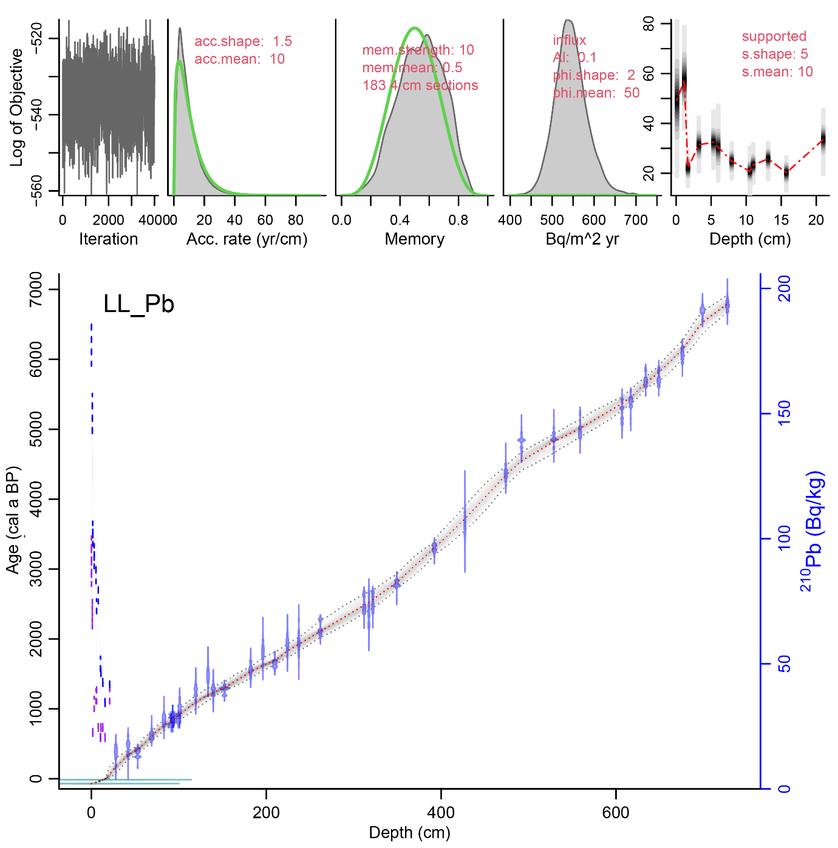
Supplementary Figure 1: A Bayesian age-depth model for the full composite 728 cm sediment profile was constructed using new and previously published radiocarbon dates chronology from Duxbury et al. (2024) using the rplum package in R (Aquino-López et al., 2018; Blaauw and Christen, 2011).

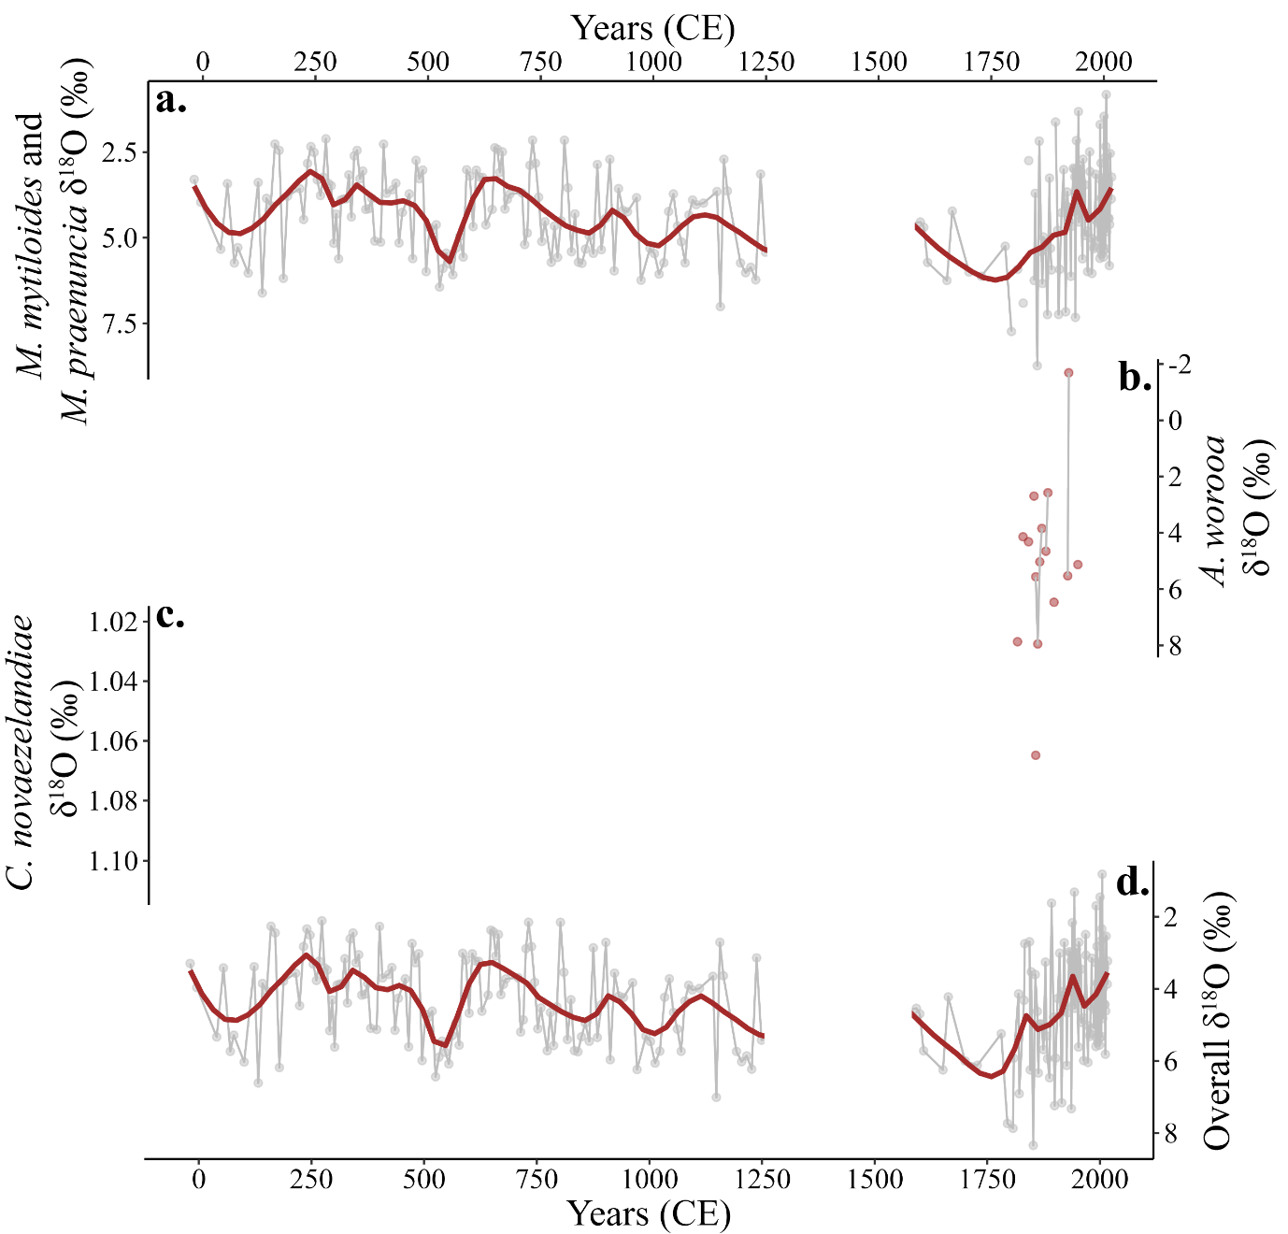
Supplementary Figure 2: Raw δ¹⁸O values for Mytilocypris mytiloides and Mytilocypris praenuncia (combined), Alboa worooa, and Candonocypris novaezelandiae are plotted sequentially in panels in a, b, and c, respectively. A normalized graph of all data is presented in panel d.

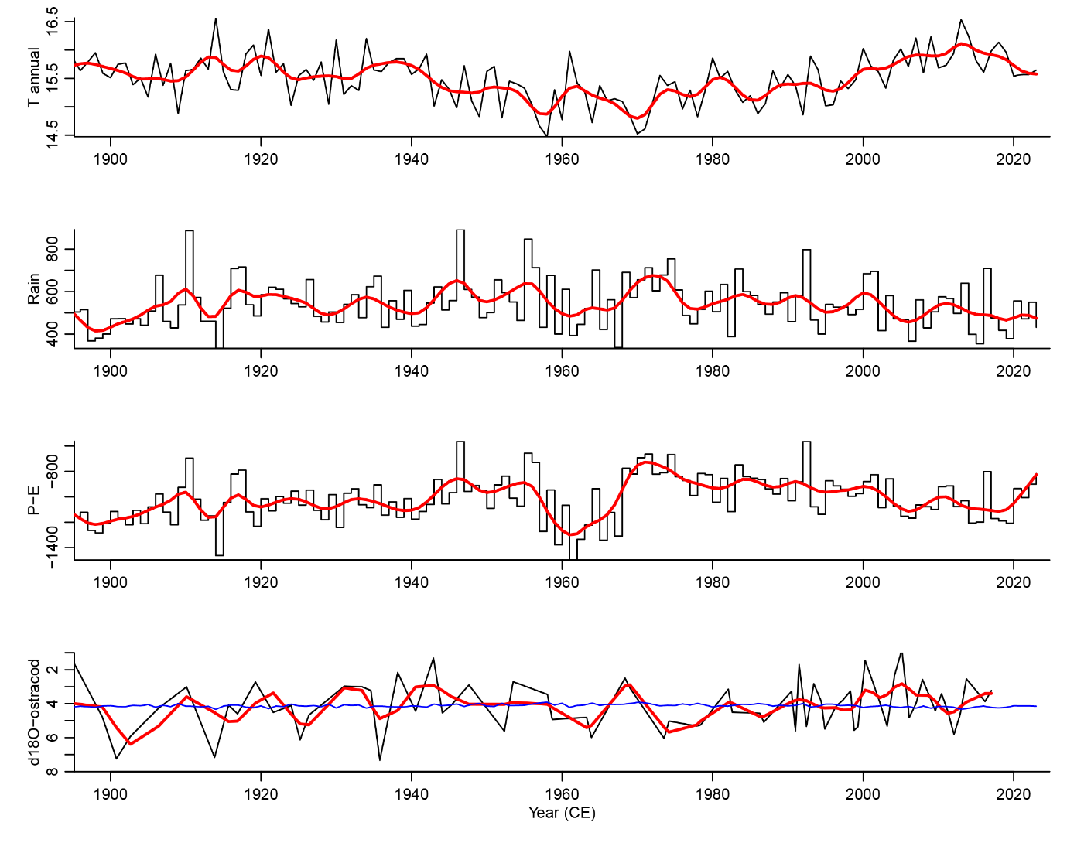
Supplementary Figure 3: The effect of temperature on potential δ¹⁸O_{ostracod} was calculated by multiplying the annual mean average air temperature (MAAT) anomaly by the ostracod-water oxygen isotope temperature coefficient 0.21, following Devriendt et al. (2017), who used data from Beck et al. (2005) and Decrouy et al. (2011). The MAAT anomaly was calculated as the annual MAAT minus the average MAAT for the entire instrumental period, 1890-2023 CE. These values were then added to the average δ¹⁸O value for sedimentary ostracods dated to be younger than 1900 CE to facilitate comparison between observed δ¹⁸O and the potential effect of inter-annual temperature change.

