Supplementary Information

Potential of blended byproduct caps for management of bauxite residues: how do texture and weathering impact geochemistry?
Golam Taki ^{a, *}, Pauline F. Grierson ^{b}, Helen E. A. Brand ^{c}, Daniel V. Murphy ^{a, d}, Talitha C. Santini ª
ª School of Agriculture and Environment, The University of Western Australia, 35 Stirling Highway, Crawley, Western Australia, 6009, Australia
^{b} School of Biological Sciences, The University of Western Australia, 35 Stirling Highway, Crawley, Western Australia, 6009, Australia
^{c} Australian Synchrotron, ANSTO, 800 Blackburn Road, Clayton, Victoria, 3168, Australia
^{d} Soils West, Centre for Sustainable Farming Systems, Food Futures Institute, Murdoch University, 90 South Street, Murdoch, Western Australia, 6150, Australia
* Corresponding author. Email: golam.taki@research.uwa.edu.au, Phone: +61 410 534 817.

1. Particle size (PS) analysis
Particle size (PS) analysis was undertaken following the method of dispersion-pipette method (Bowman and Hukta, 2002). This method is similar to the Australian Standard (AS 2839 C6.1 C6.2) with minor modifications. Briefly, bauxite residues were first sieved to < 2 mm. A sample (10 g) was pretreated with 10 mL hydrogen peroxide (30% H₂O₂) in a beaker overnight to remove organic matter. The mixture was then diluted with 50 mL of deionized (DI) water and heated until all organic matter was removed. Once cool, samples were transferred into a milkshake cup, 10 mL dispersing agent (Na-hexametaphosphate + NaOH) added and mixed using a milkshake for 10 minutes. Mixtures were then carefully poured into a 500 mL measuring cylinder and the volume adjusted to 500 mL using DI water. After thoroughly mixing the solution, two samples of the silt + clay fraction sample were collected from 5 cm depth from the suspension surface and transferred into a pie tin. As the room temperature was 23 °C, the silt + clay sample was collected after 2 minutes 14 seconds. Following the first sampling time, clay fraction sample was collected after 3 hours 42 minutes from the similar depth and transfer into pie tin. Both samples were oven dried at 105 °C for overnight and then the dry sample weight was recorded to calculate the sand, silt and clay fraction.

2. Saturation experiment for bauxite residue sand
Each pot was prepared with 2.25 kg soil. Each pot of bauxite residue fines without any byproduct received 220 mL water, whereas BRS without any byproduct received 200 mL water every day during the wetting cycle. Which means each kg of BRS received 8.88 mL less water than BRF every day, 62.1 mL water per week, and 559.4 mL less water over the nine week leaching period.
For the saturation experiment, previously leached 100 g dry BRS was taken into a 120 mL vial (run triplicated), then 55.95 mL water was added and kept for 48 hours. Samples were then filtered with a Buchner funnel, dried and pH was measured. pH of BRS sand decreased from 10.20 to 10.08 (Table S3.6). Again, we measured the pH of all BRF, BRS+BRS and BRS samples to compare the accuracy.

4. References
Bowman, G.M., Hutka, J., 2002. Particle Size Analysis, in: Coughlan, K.K., Cresswell, H.H., McKenzie, N.N. (Eds.), Soil Physical Measurement and Interpretation for Land Evaluation. CSIRO Publishing, Melbourne, pp. 224-239.

Table S1: Particle size distribution of the treatments before (Initial) and after (Final) leaching and their texture according to USDA texture triangle.
Residue texture | Byproduct type | Initial |  |  |  | Final
Residue texture | Byproduct type | Clay (%) | Silt (%) | Sand (%) | Texture | Clay (%) | Silt (%) | Sand (%) | Texture
Bauxite residue fines | BRF | 17.31 | 23.68 | 59.01 | sandy loam (SL) | 19.55 | 21.50 | 58.95 | sandy loam (SL)
Bauxite residue fines | BRF+FA | 13.40 | 24.01 | 62.59 | sandy loam (SL) | 13.38 | 17.92 | 68.70 | sandy loam (SL)
Bauxite residue fines | BRF+EM | 18.04 | 19.57 | 62.39 | sandy loam (SL) | 14.95 | 20.78 | 64.27 | sandy loam (SL)
Bauxite residue fines | BRF+SW | 16.97 | 25.84 | 57.19 | sandy loam (SL) | 12.53 | 21.80 | 65.67 | sandy loam (SL)
Bauxite residue fines | Combined | 16.94 | 23.26 | 59.79 | sandy loam (SL) | 15.95 | 20.00 | 64.05 | sandy loam (SL)
Bauxite residue fines + bauxite residue sand | BRF+BRS | 17.83 | 21.90 | 60.27 | sandy loam (SL) | 14.63 | 19.43 | 65.94 | sandy loam (SL)
Bauxite residue fines + bauxite residue sand | BRF+BRS+FA | 15.48 | 23.59 | 60.93 | sandy loam (SL) | 11.12 | 20.02 | 68.86 | sandy loam (SL)
Bauxite residue fines + bauxite residue sand | BRF+BRS+EM | 19.86 | 23.17 | 56.97 | sandy loam (SL) | 13.09 | 20.64 | 66.27 | sandy loam (SL)
Bauxite residue fines + bauxite residue sand | BRF+BRS+SW | 17.98 | 26.33 | 55.69 | sandy loam (SL) | 14.84 | 23.13 | 62.03 | sandy loam (SL)
Bauxite residue fines + bauxite residue sand | Combined | 19.34 | 18.58 | 62.08 | sandy loam (SL) | 14.72 | 19.80 | 65.48 | sandy loam (SL)
Bauxite residue sand | BRS | 4.81 | 3.54 | 91.65 | sand (S) | 3.54 | 1.77 | 94.70 | sand (S)
Bauxite residue sand | BRS+FA | 5.60 | 3.05 | 91.35 | sand (S) | 2.03 | 3.29 | 94.68 | sand (S)
Bauxite residue sand | BRS+EM | 6.55 | 2.02 | 91.43 | sand (S) | 3.03 | 1.26 | 95.71 | sand (S)
Bauxite residue sand | BRS+SW | 5.32 | 3.29 | 91.38 | sand (S) | 3.74 | 2.24 | 94.02 | sand (S)
Bauxite residue sand | Combined | 4.81 | 1.77 | 93.41 | sand (S) | 2.27 | 3.53 | 94.20 | sand (S)

Table S2: ANOVA summary with F-value of measured chemical properties of treated and untreated residue solids. ns’, ‘*’, ‘**’ and ‘***’ denotes non-significant, P ≤ 0.05, P ≤ 0.01 and P ≤ 0.001, respectively.
 | DF | pH | EC | CEC | OC | N | Pi | Po
Texture (T) | 2 | 13.57*** | 101.18*** | 38.59*** | 11.98*** | 22.79*** | 4634.93*** | 22.85***
Byproduct Type (BT) | 4 | 19.25*** | ns | Ns | 1888.72*** | 57.72*** | 32.08*** | 22.64***
Leaching (L) | 1 | 1109.14*** | 2040.87*** | 496.09*** | ns | 6.71* | 3528.70*** | 20.42***
T x L | 2 | 12.88*** | 138.72*** | 150.01*** | ns | ns | 825.16*** | 16.03***
T x BT | 8 | ns | ns | Ns | 3.37** | ns | 7.13*** | 2.45*
BT x L | 4 | 14.64*** | ns | Ns | ns | 4.56** | 3.79** | 7.77***
T x BT x L | 8 | ns | ns | Ns | 2.31* | ns | 2.61* | 2.60*

Table S2: Continued…
Source | DF |  | Al | Ca | Fe | Na | S | Si | Ti | K | P | Mo | V
Texture (T) |  | 2 | 454.54*** | 4304.21*** | 1168.63*** | 661.35*** | 579.33*** | 43.41** | 6321.13*** | 590.46** | 624.85*** | ns | 152.85***
Byproduct Type (BT) |  | 4 | 4.84** | 5.65*** | 74.61*** | 13.31*** | 20.49*** | 84.51*** | 44.95*** | 8.50*** | ns | ns | 75.27***
Leaching (L) |  | 1 | ns | ns | 199.44*** | 3623.31*** | 107.21*** | ns | 16.34*** | 15.93*** | ns | 11.96*** | 86.55***
T x L |  | 2 | ns | ns | 5.26** | 86.17*** | ns | ns | 5.92** | 3.22* | ns | ns | ns
T x BT |  | 8 | ns | ns | ns | ns | ns | ns | 3.40** | ns | ns | ns | ns
BT x L |  | 4 | ns | ns | 2.13* | 2.63* | ns | ns | ns | ns | ns | ns | ns
T x BT x L |  | 8 | ns | ns | ns | ns | ns | ns | ns | ns | ns | ns | ns

Table S3: Mineral concentrations in composite (n=3) blended byproduct caps before (Initial) and after (Final) column leaching. All the values are in weight percentage (wt %).
Texture | Treatment | Al oxyhydroxides |  |  |  | Fe oxyhydroxides |  |  |  |  |  | Si oxides
Texture | Treatment | Corundum |  | Gibbsite |  | Goethite |  | Hematite |  | Magnetite |  | Quartz |  | Mullite
Texture | Treatment | Initial | Final | Initial | Final | Initial | Final | Initial | Final | Initial | Final | Initial | Final | Initial | Final
Bauxite residue fines | BRF | 5.97 | 6.19 | 2.43 | 2.35 | 33.23 | 32.22 | 33.34 | 33.29 | 3.64 | 3.90 | 9.19 | 10.66 | - | -
Bauxite residue fines | BRF+FA | 3.99 | 4.24 | 2.13 | 2.31 | 31.04 | 32.72 | 31.99 | 32.80 | 3.67 | 3.54 | 12.89 | 12.32 | 0.80 | 0.68
Bauxite residue fines | BRF+EM | 4.77 | 5.69 | 2.45 | 2.38 | 33.71 | 33.16 | 33.63 | 33.65 | 3.76 | 3.87 | 9.83 | 10.42 | - | -
Bauxite residue fines | BRF+SW | 3.00 | 4.66 | 2.63 | 2.29 | 34.54 | 33.23 | 34.03 | 33.95 | 3.47 | 3.73 | 9.20 | 9.98 | - | -
Bauxite residue fines | Combined | 6.66 | 6.35 | 1.94 | 2.19 | 31.98 | 31.15 | 31.40 | 32.02 | 3.29 | 3.69 | 11.40 | 11.54 | 0.70 | 0.75
Bauxite residue fines + bauxite residue sand | BRF+BRS | 2.89 | 3.99 | 2.14 | 2.23 | 38.48 | 36.94 | 33.11 | 33.00 | 2.64 | 3.01 | 7.82 | 10.54 | - | -
Bauxite residue fines + bauxite residue sand | BRF+BRS+FA | 3.94 | 3.17 | 2.11 | 2.26 | 35.73 | 37.57 | 32.44 | 34.00 | 2.86 | 2.82 | 10.77 | 8.60 | 0.63 | 0.57
Bauxite residue fines + bauxite residue sand | BRF+BRS+EM | 2.92 | 4.11 | 2.08 | 2.13 | 39.31 | 38.16 | 33.20 | 33.37 | 2.46 | 2.72 | 6.85 | 8.15 | - | -
Bauxite residue fines + bauxite residue sand | BRF+BRS+SW | 4.01 | 4.07 | 2.08 | 2.23 | 38.79 | 39.73 | 32.79 | 34.10 | 2.45 | 2.56 | 7.79 | 6.94 | - | -
Bauxite residue fines + bauxite residue sand | Combined | 2.35 | 3.01 | 2.04 | 2.32 | 38.29 | 37.58 | 32.43 | 32.09 | 2.50 | 2.54 | 10.43 | 11.37 | 0.53 | 0.57
Bauxite residue sand | BRS | 3.67 | 3.38 | 1.75 | 1.59 | 36.55 | 36.18 | 37.70 | 39.10 | 3.26 | 3.46 | 11.30 | 10.27 | - | -
Bauxite residue sand | BRS+FA | 2.85 | 3.32 | 1.68 | 1.59 | 35.62 | 34.80 | 37.13 | 38.43 | 3.23 | 3.47 | 13.46 | 12.57 | 0.62 | 0.72
Bauxite residue sand | BRS+EM | 2.43 | 2.18 | 1.61 | 1.76 | 37.34 | 36.41 | 38.58 | 39.47 | 3.12 | 3.46 | 11.09 | 10.79 | - | -
Bauxite residue sand | BRS+SW | 2.59 | 3.00 | 1.73 | 1.78 | 37.65 | 36.34 | 38.02 | 39.47 | 2.91 | 3.47 | 11.20 | 11.21 | - | -
Bauxite residue sand | Combined | 3.50 | 1.88 | 1.33 | 1.63 | 34.42 | 34.96 | 36.87 | 37.98 | 3.17 | 3.37 | 14.04 | 13.79 | 0.73 | 0.81

Table S3: Continued…
Texture | Treatment | Ti oxides |  |  |  |  |  | Calcite |  | Sodalite
Texture | Treatment | Anatase |  | Ilmenite |  | Rutile
Texture | Treatment | Initial | Final | Initial | Final | Initial | Final | Initial | Final | Initial | Final
Bauxite residue fines | BRF | 1.72 | 1.78 | 3.02 | 3.11 | 2.15 | 2.13 | 3.38 | 2.51 | 1.92 | 1.87
Bauxite residue fines | BRF+FA | 1.79 | 1.75 | 4.00 | 3.06 | 2.75 | 2.11 | 3.16 | 2.52 | 1.78 | 1.94
Bauxite residue fines | BRF+EM | 1.81 | 1.74 | 2.87 | 3.12 | 1.73 | 1.69 | 3.34 | 2.30 | 2.11 | 1.98
Bauxite residue fines | BRF+SW | 1.94 | 1.84 | 3.12 | 3.37 | 1.98 | 2.38 | 3.84 | 2.57 | 2.24 | 2.00
Bauxite residue fines | Combined | 1.78 | 1.70 | 2.80 | 3.20 | 2.63 | 3.10 | 3.42 | 2.41 | 2.00 | 1.89
Bauxite residue fines + bauxite residue sand | BRF+BRS | 1.56 | 1.52 | 3.80 | 2.99 | 1.89 | 1.72 | 3.48 | 2.20 | 2.19 | 1.86
Bauxite residue fines + bauxite residue sand | BRF+BRS+FA | 1.59 | 1.60 | 2.90 | 3.14 | 1.78 | 1.94 | 3.28 | 2.37 | 1.98 | 1.96
Bauxite residue fines + bauxite residue sand | BRF+BRS+EM | 1.57 | 1.48 | 3.05 | 3.28 | 2.48 | 2.42 | 3.75 | 2.35 | 2.32 | 1.84
Bauxite residue fines + bauxite residue sand | BRF+BRS+SW | 1.44 | 1.59 | 3.44 | 3.09 | 1.81 | 1.54 | 3.35 | 2.27 | 2.06 | 1.88
Bauxite residue fines + bauxite residue sand | Combined | 1.43 | 1.47 | 2.92 | 3.07 | 1.70 | 1.88 | 3.31 | 2.31 | 2.08 | 1.81
Bauxite residue sand | BRS | 0.62 | 0.65 | 2.47 | 2.53 | 2.19 | 2.57 | - | - | 0.49 | 0.27
Bauxite residue sand | BRS+FA | 0.52 | 0.63 | 2.67 | 2.27 | 1.79 | 1.80 | - | - | 0.43 | 0.40
Bauxite residue sand | BRS+EM | 0.64 | 0.70 | 2.79 | 2.69 | 1.92 | 2.26 | - | - | 0.48 | 0.28
Bauxite residue sand | BRS+SW | 0.69 | 0.64 | 2.71 | 2.28 | 2.04 | 1.52 | - | - | 0.46 | 0.29
Bauxite residue sand | Combined | 0.65 | 0.62 | 2.44 | 2.38 | 2.35 | 2.23 | - | - | 0.51 | 0.36

Table S4: Exchangeable sodium percentage, sodium absorption ratio and exchangeable cations (Mg and Na) of byproduct treated and untreated bauxite residues before (Initial) and after (Final) leaching. Due to high water extractable Na in the solution, initial exchangeable Na, ESP, and SAR values could not be calculated. Therefore, two-way ANOVA was performed only with final data. ns’, ‘*’, ‘**’ and ‘***’ denotes non-significant, P ≤ 0.05, P ≤ 0.01 and P ≤ 0.001, respectively.
Texture | Treatment | ESP (%) |  | SAR (%) |  | Exchangeable cations (cmolc kg⁻¹)
 |  |  |  |  |  | Mg |  | Na
Texture | Treatment | Initial | Final | Initial | Final | Initial | Final | Initial | Final
Bauxite residue fines | BRF | 16.45 ± 0.89 | 17.95 ± 5.11 | 1.51 ± 0.11 | 1.59 ± 0.61 | 0.51 ± 0.01 | 0.33 ± 0.01 | 5.8 ± 0.43 | 2.7 ± 0.02
Bauxite residue fines | BRF+FA | 14.58 ± 0.63 | 10.03 ± 0.19 | 1.27 ± 0.05 | 0.7 ± 0.02 | 0.52 ± 0 | 0.31 ± 0.01 | 4.7 ± 0.15 | 2.18 ± 0.09
Bauxite residue fines | BRF+EM | 14.84 ± 1.03 | 8.08 ± 0.66 | 1.34 ± 0.11 | 0.55 ± 0.06 | 0.52 ± 0.01 | 0.26 ± 0.02 | 5.12 ± 0.44 | 1.75 ± 0.21
Bauxite residue fines | BRF+SW | 17.08 ± 0.63 | 10.58 ± 0.51 | 1.66 ± 0.08 | 0.75 ± 0.04 | 0.56 ± 0.02 | 0.3 ± 0.01 | 6.72 ± 0.32 | 2.37 ± 0.12
Bauxite residue fines | Combined | 12.25 ± 1.96 | 14.3 ± 5.62 | 1.03 ± 0.19 | 1.23 ± 0.62 | 0.5 ± 0.02 | 0.3 ± 0.03 | 3.76 ± 0.7 | 1.43 ± 0.02
Bauxite residue fines bauxite residue sand | BRF+BRS | 15.68 ± 1.13 | 11.5 ± 0.62 | 1.32 ± 0.12 | 0.84 ± 0.04 | 0.37 ± 0.03 | 0.29 ± 0.01 | 4.65 ± 0.47 | 2.69 ± 0.14
Bauxite residue fines bauxite residue sand | BRF+BRS+FA | 15.91 ± 0.76 | 11.5 ± 1.41 | 1.33 ± 0.08 | 0.77 ± 0.09 | 0.41 ± 0.01 | 0.27 ± 0.01 | 4.65 ± 0.33 | 2.3 ± 0.24
Bauxite residue fines bauxite residue sand | BRF+BRS+EM | 14.57 ± 0.38 | 9.65 ± 0.57 | 1.21 ± 0.04 | 0.67 ± 0.03 | 0.4 ± 0.02 | 0.26 ± 0 | 4.25 ± 0.13 | 2.12 ± 0.09
Bauxite residue fines bauxite residue sand | BRF+BRS+SW | 18.41 ± 2.74 | 10.39 ± 0.53 | 1.62 ± 0.23 | 0.77 ± 0.04 | 0.42 ± 0.05 | 0.29 ± 0.01 | 5.72 ± 0.65 | 2.52 ± 0.1
Bauxite residue fines bauxite residue sand | Combined | 21.1 ± 8.71 | 9.1 ± 0.44 | 2.22 ± 1.14 | 0.61 ± 0.02 | 0.43 ± 0.01 | 0.25 ± 0.01 | 3.34 ± 0.57 | 1.88 ± 0.01
Bauxite residue sand | BRS | * | 27.52 ± 2.4 | * | 0.61 ± 0.04 | 0 ± 0 | 0.01 ± 0 | * | 4.15 ± 0.02
Bauxite residue sand | BRS+FA | * | 30.78 ± 1.9 | * | 0.69 ± 0.06 | 0.01 ± 0 | 0.03 ± 0 | * | 3.47 ± 0.21
Bauxite residue sand | BRS+EM | * | 18.57 ± 1.57 | * | 0.3 ± 0.03 | 0.01 ± 0 | 0.02 ± 0 | * | 3.09 ± 0.12
Bauxite residue sand | BRS+SW | * | 28.23 ± 1.47 | * | 0.58 ± 0.05 | 0.01 ± 0 | 0.01 ± 0.01 | * | 3.94 ± 0.21
Bauxite residue sand | Combined | * | 7.33 ± 0.93 | * | 0.11 ± 0.02 | 0.02 ± 0 | 0.02 ± 0 | * | 2.68 ± 0.12
ANOVA
Residue texture |  |  | 3.70*** |  | 0.36* |  |  |  | 0.22***
Byproduct type |  |  | 4.76** |  | ns |  |  |  | 0.28***
Residue texture x Byproduct type |  |  | 8.25** |  | ns |  |  |  | ns

Table S5: ANOVA summary with F-values for measured chemical properties of treated and untreated residues leachate. ns’, ‘*’, ‘**’ and ‘***’ denotes non-significant, P ≤ 0.05, P ≤ 0.01 and P ≤ 0.001, respectively.
 | DF | pH | EC
Texture (T) | 2 | 126.34*** | 185.76***
Byproduct Type (BT) | 4 | 626.12*** | 2.42*
Time | 8 | 71.04*** | 2290.55***
T x Time | 16 | 3.29*** | 185.55***
T x BT | 8 | 4.21*** | ns
BT x Time | 32 | ns | 5.23***
T x BT x Time | 64 | ns | ns

Table S5: Continued…
 | DF | Al | Ca | Fe | Na | S | Si | Ti | K | P | Mo | V
Texture (T) | 2 | 320.44*** | 211.13*** | ns | 240.17*** | 15.84*** | 2254.69*** | 4.49* | 165.81*** | 53.22*** | 161.42*** | 79.47***
Byproduct Type (BT) | 4 | 138.57*** | 63.69*** | 106*** | 5.09*** | ns | 24.79*** | 68.74*** | 13.68*** | 5.12*** | 5.14*** | 191.16***
Time | 1 | 493.01*** | 385.88*** | 21.65*** | 2309.01*** | 597.47*** | 10941.95*** | 58.87*** | 1706.06*** | 781.90*** | 1297.26*** | 614.86***
T x Time | 2 | 105.41*** | 230.82*** | 8.26*** | 252.78*** | 15.66*** | 2868.67*** | 16.66*** | 196.37*** | 10.24*** | 161.72*** | 100.35***
T x BT | 8 | 16.18*** | 29.28*** | 8.02*** | ns | ns | 42.46*** | ns | 7.98*** | 18.34*** | ns | 10.56***
BT x Time | 4 | 22.72*** | 40.79*** | 18.63*** | 5.20*** | ns | 31.92*** | 25.05*** | 12.61*** | 33.85*** | 5.07*** | 103.28***
T x BT x Time | 8 | 5.22*** | 36.06*** | 16.38*** | ns | ns | 41.24*** | 9.36*** | 7.70*** | 14.37*** | ns | 22.66***

Table S6: pH values of different bauxite residues after leaching (measured during saturation experiment) and BRS after 48 hours saturation.
Sample name | Replicate 1 | Replicate 2 | Replicate 3 | Average pH
BRF | 9.98 | 10.03 | 10.02 | 10.01
BRF+BRS | 9.95 | 9.94 | 9.95 | 9.95
BRS | 10.20 | 10.18 | 10.23 | 10.20
BRS (after 48 saturation) | 10.08 | 10.07 | 10.1 | 10.08
BRS leachate (after 48 saturation) | 9.48 | 9.7 | 9.29 | 9.49

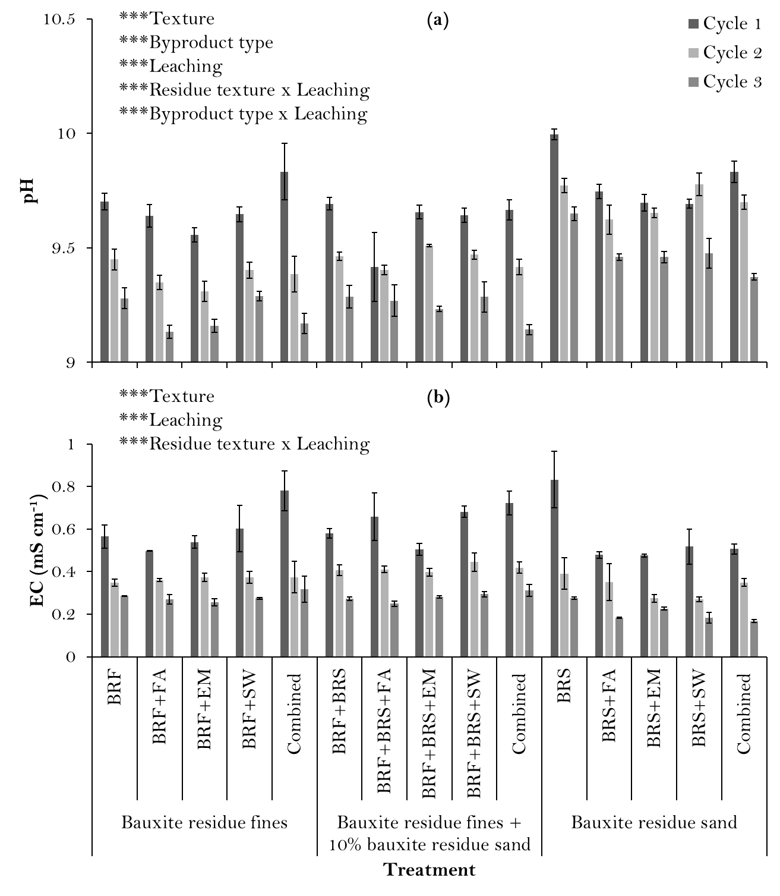
Figure S1: pH (a) and EC (b) of byproduct treated and untreated bauxite residues (collected from top of each column) after finishing one cycle (six weeks, three weeks wet and three weeks dry). Bars are the means ± standard error (n=3).

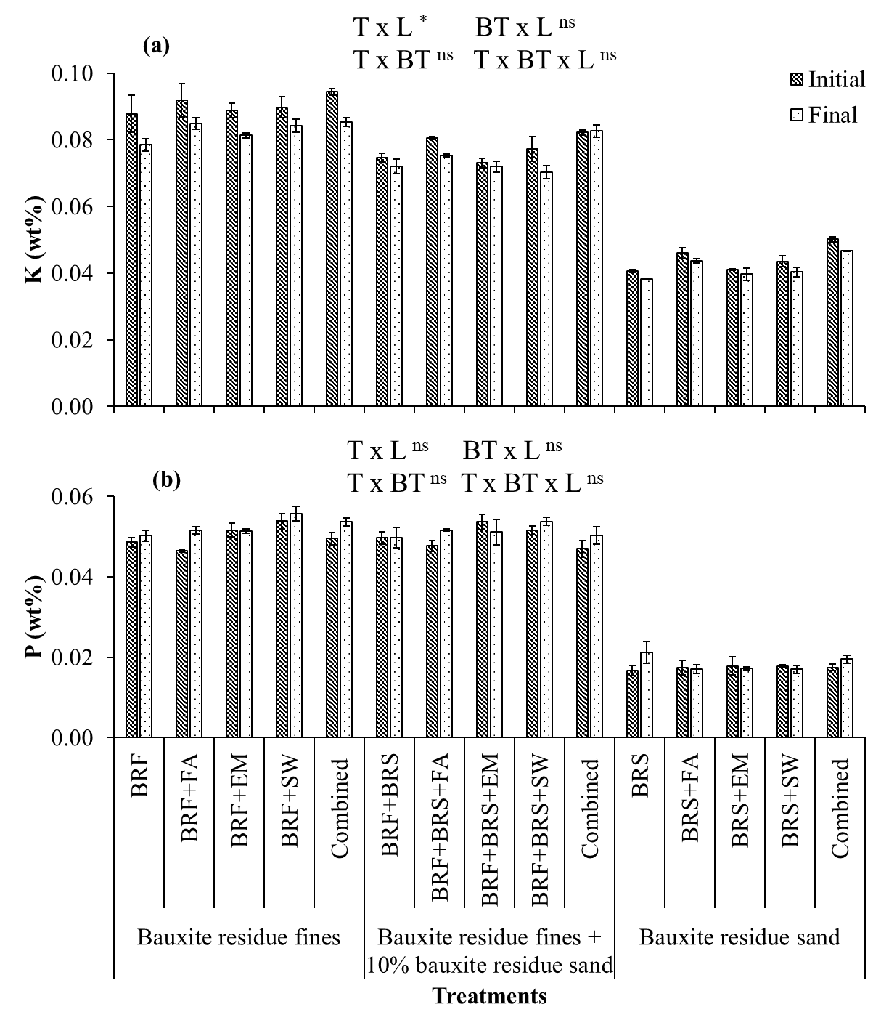
Figure S2: Concentration of P (a) and K (b) of blended byproduct caps before (Initial) and after (Final) column leaching. Bars are the means ± standard error (n=3). A three-way ANOVA was performed to compare Texture (T), Byproduct Type (BT), and Leaching (L). The levels of significance for the T × L, T × BT, BT × L, and T × BT × L effects are reported as follows: * P ≤ 0.05; ** P ≤ 0.01; *** P ≤ 0.001; ns, not significant. A summary of statistical analysis is given in Supplementary Table S2.
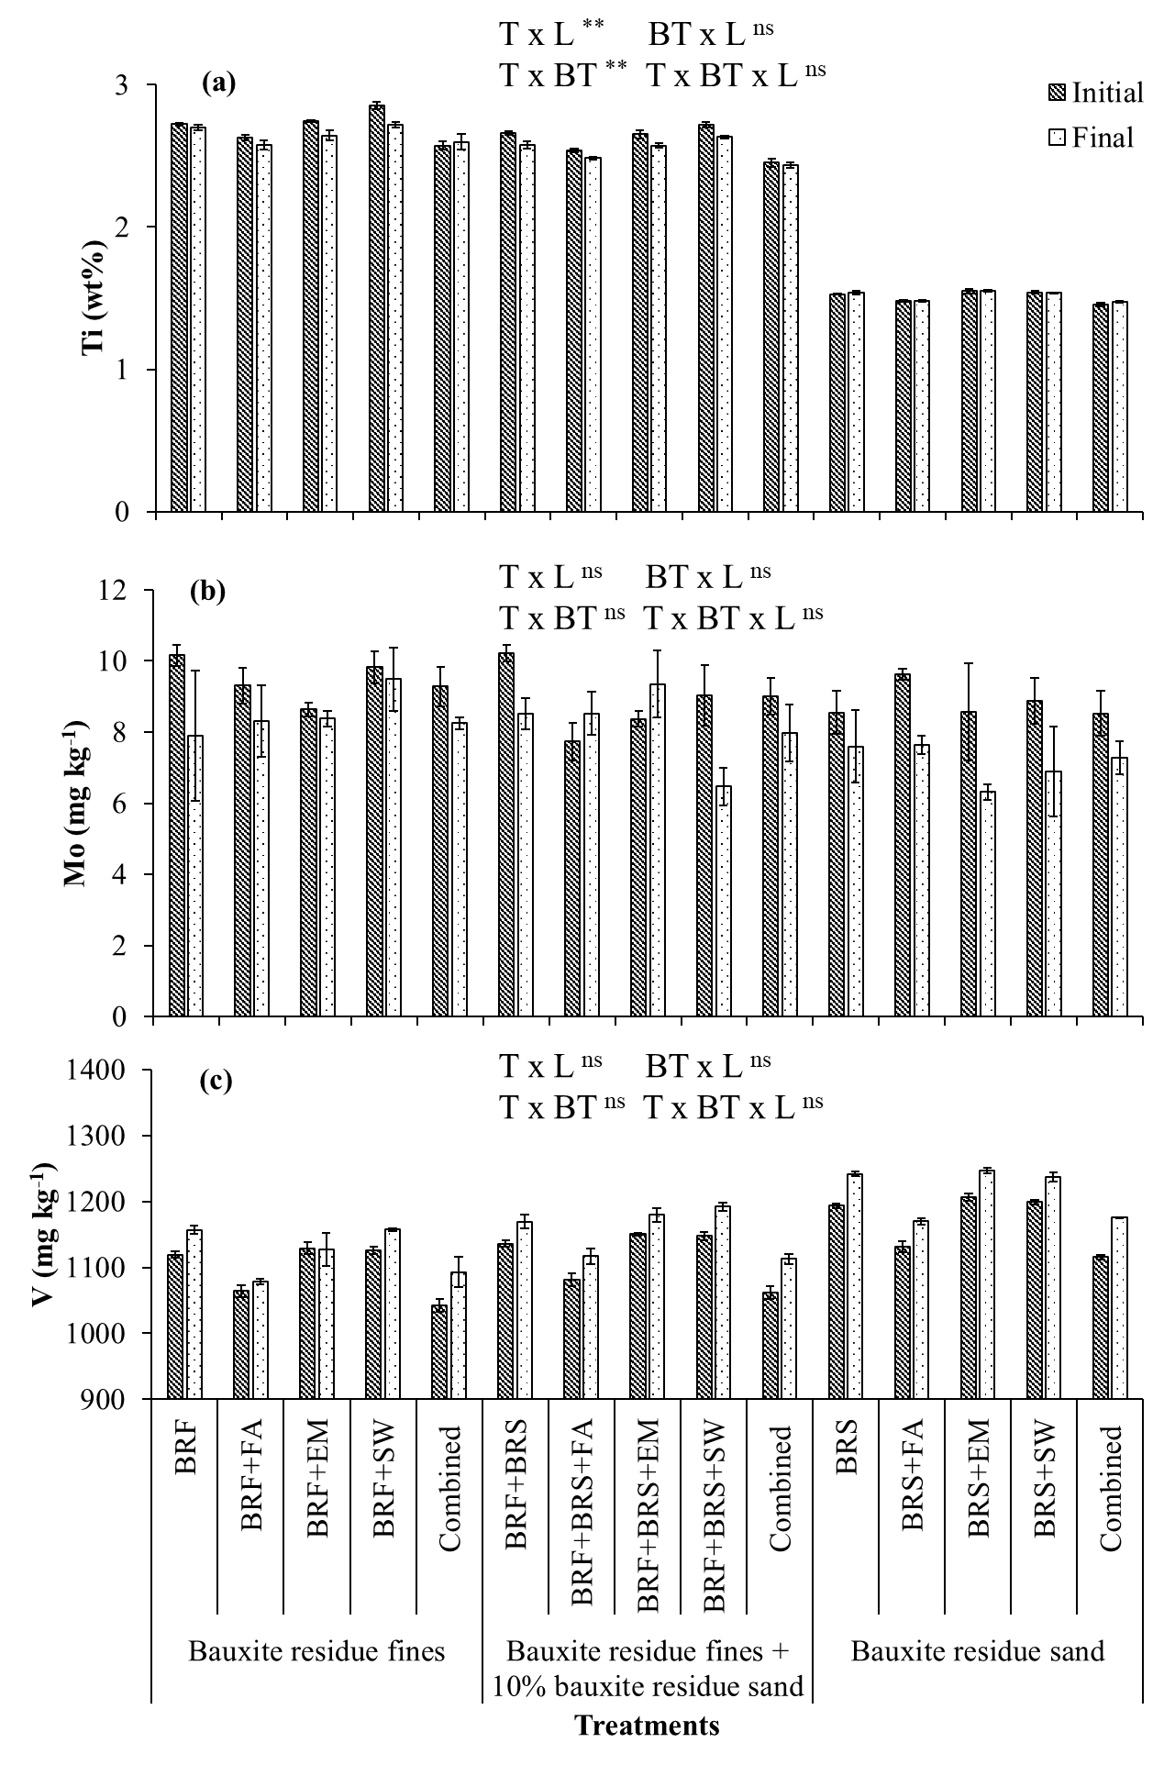
Figure S3: Concentration of Ti (a), Mo (b) and V (c) of blended byproduct caps before (Initial) and after (Final) column leaching. Bars are the means ± standard error (n=3). A three-way ANOVA was performed to compare Texture (T), Byproduct Type (BT), and Leaching (L). The levels of significance for the T × L, T × BT, BT × L, and T × BT × L effects are reported as follows: * P ≤ 0.05; ** P ≤ 0.01; *** P ≤ 0.001; ns, not significant. A summary of statistical analysis is given in Supplementary Table S2.
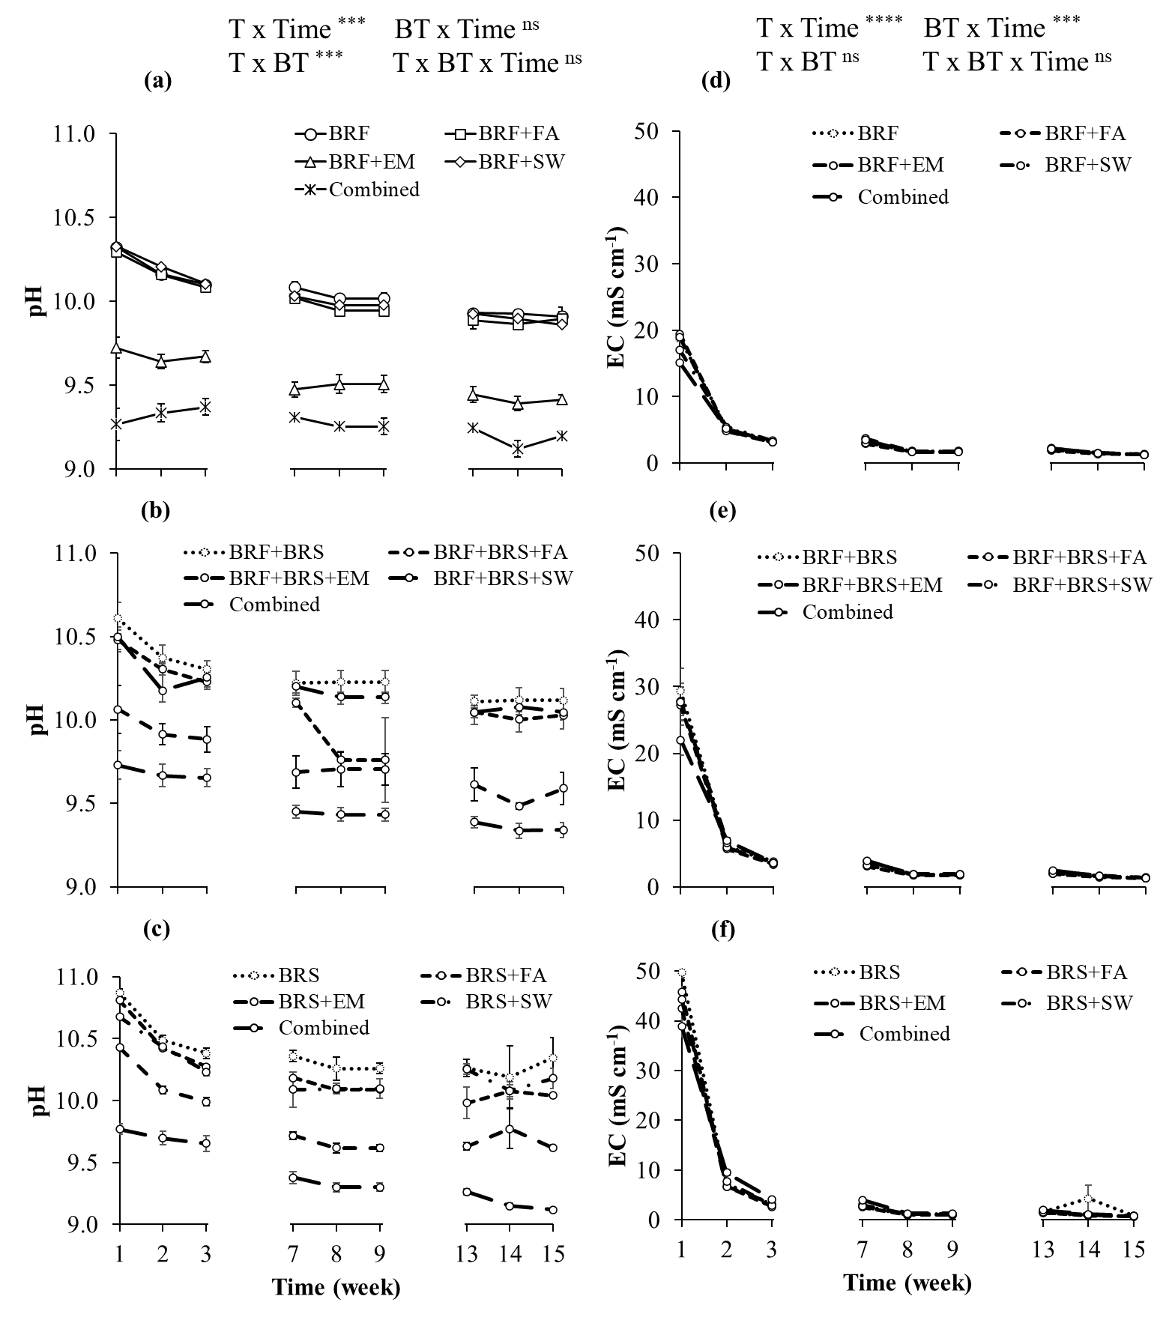
Figure S4: pH (a-c) and EC (d-f) of blended byproduct caps leachate over time. Lines are the means ± standard error (n= 3). A three-way ANOVA was performed to compare Texture (T), Byproduct Type (BT), and Time. The levels of significance for the T × Time, T × BT, BT × Time, and T × BT × Time effects are reported as follows: * P ≤ 0.05; ** P ≤ 0.01; *** P ≤ 0.001; ns, not significant. A summary of statistical analysis is given in Supplementary Table S5.
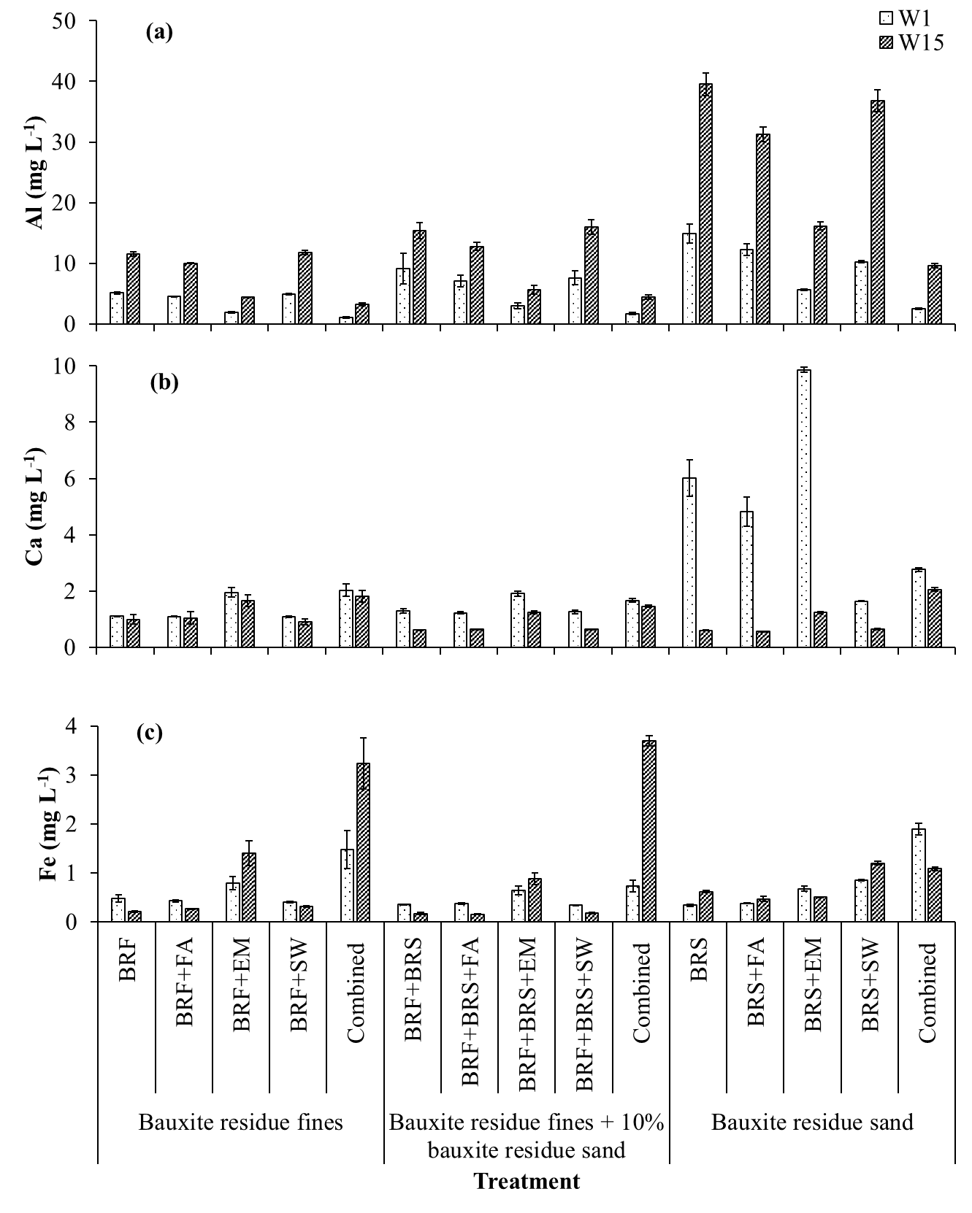
Figure S5: Concentration of Al (a), Ca (b) and Fe (c) of blended byproduct caps leachate over time. Bars are the means ± standard error (n=3). A three-way ANOVA was performed to compare Texture (T), Byproduct Type (BT), and Time. The levels of significance for the T × Time, T × BT, BT × Time, and T × BT × Time effects are reported as follows: * P ≤ 0.05; ** P ≤ 0.01; *** P ≤ 0.001; ns, not significant. A summary of statistical analysis is given in Supplementary Table S5.
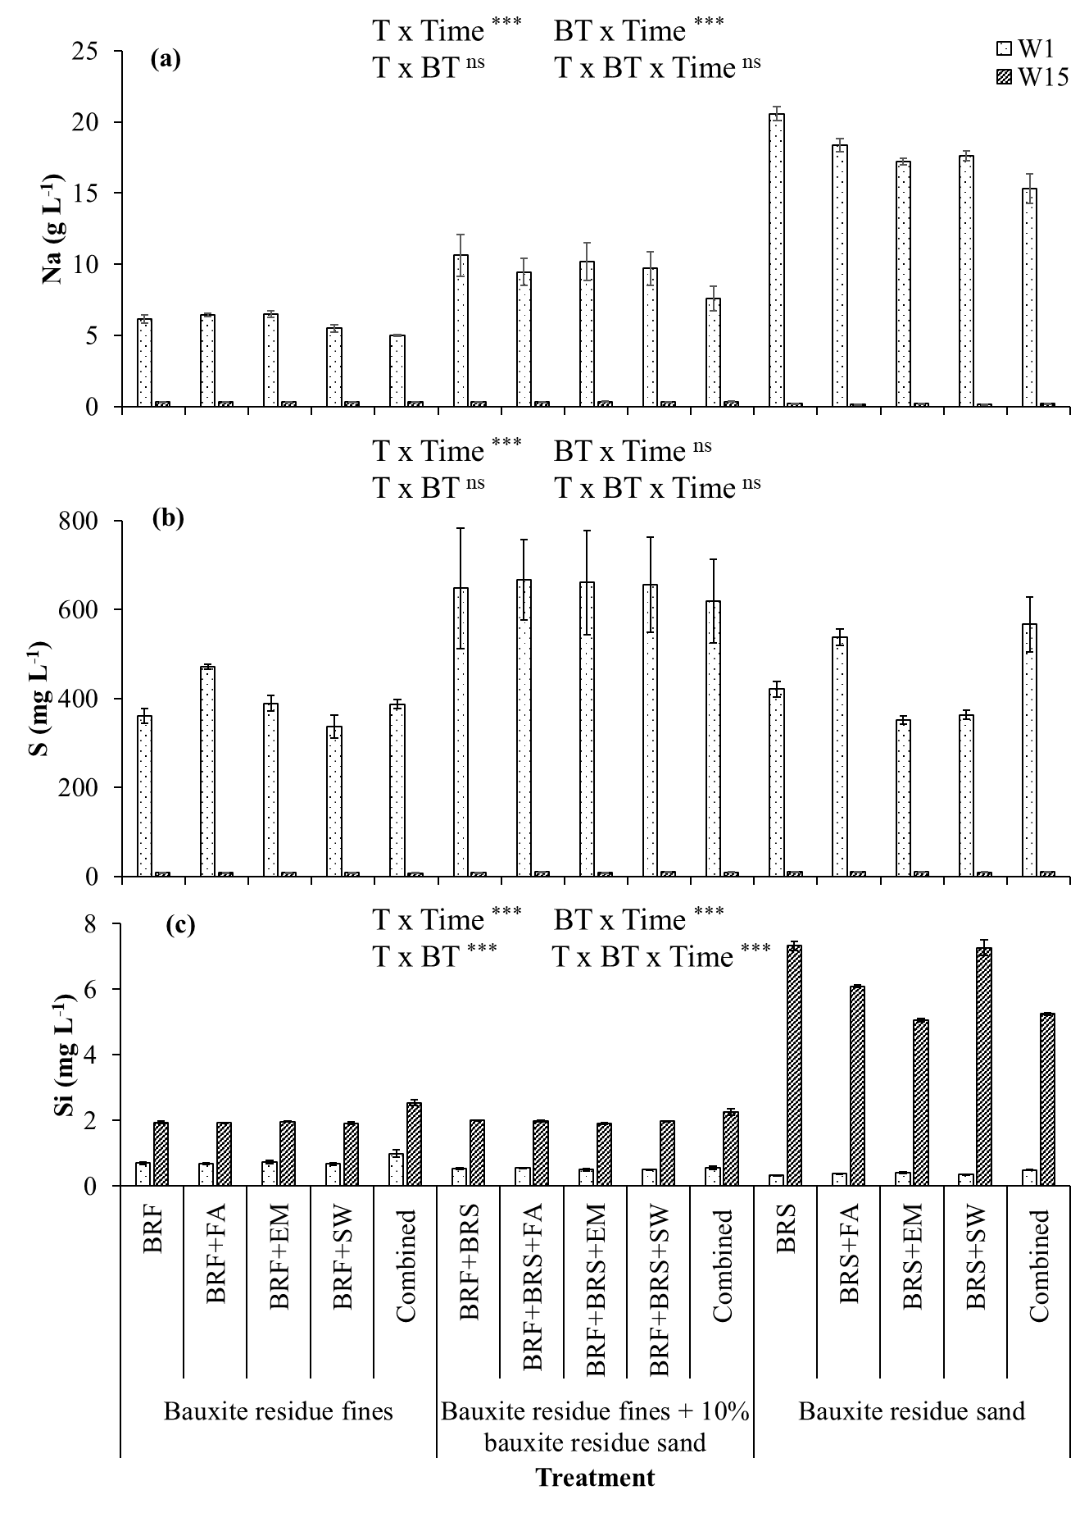
Figure S6: Concentration of Na (a), S (b) and Si (c) of blended byproduct caps leachate over time. Bars are the means ± standard error (n=3). A three-way ANOVA was performed to compare Texture (T), Byproduct Type (BT), and Time. The levels of significance for the T × Time, T × BT, BT × Time, and T × BT × Time effects are reported as follows: * P ≤ 0.05; ** P ≤ 0.01; *** P ≤ 0.001; ns, not significant. A summary of statistical analysis is given in Supplementary Table S5.
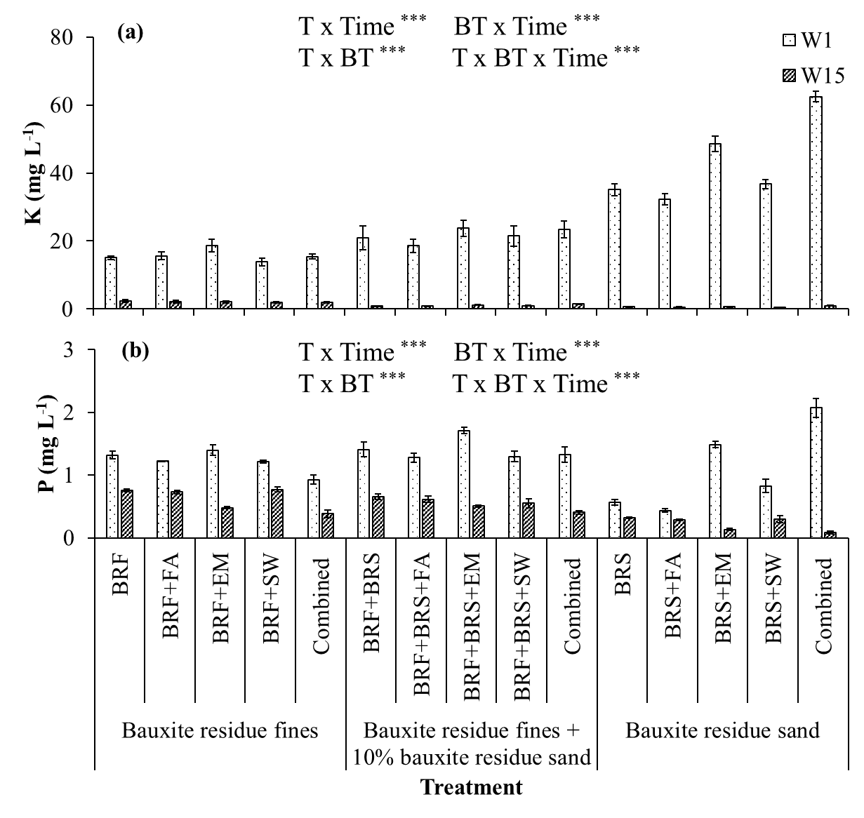
Figure S7: Concentration of K (a) and P (b) of blended byproduct caps leachate over time. Bars are the means ± standard error (n=3). A three-way ANOVA was performed to compare Texture (T), Byproduct Type (BT), and Time. The levels of significance for the T × Time, T × BT, BT × Time, and T × BT × Time effects are reported as follows: * P ≤ 0.05; ** P ≤ 0.01; *** P ≤ 0.001; ns, not significant. A summary of statistical analysis is given in Supplementary Table S5.
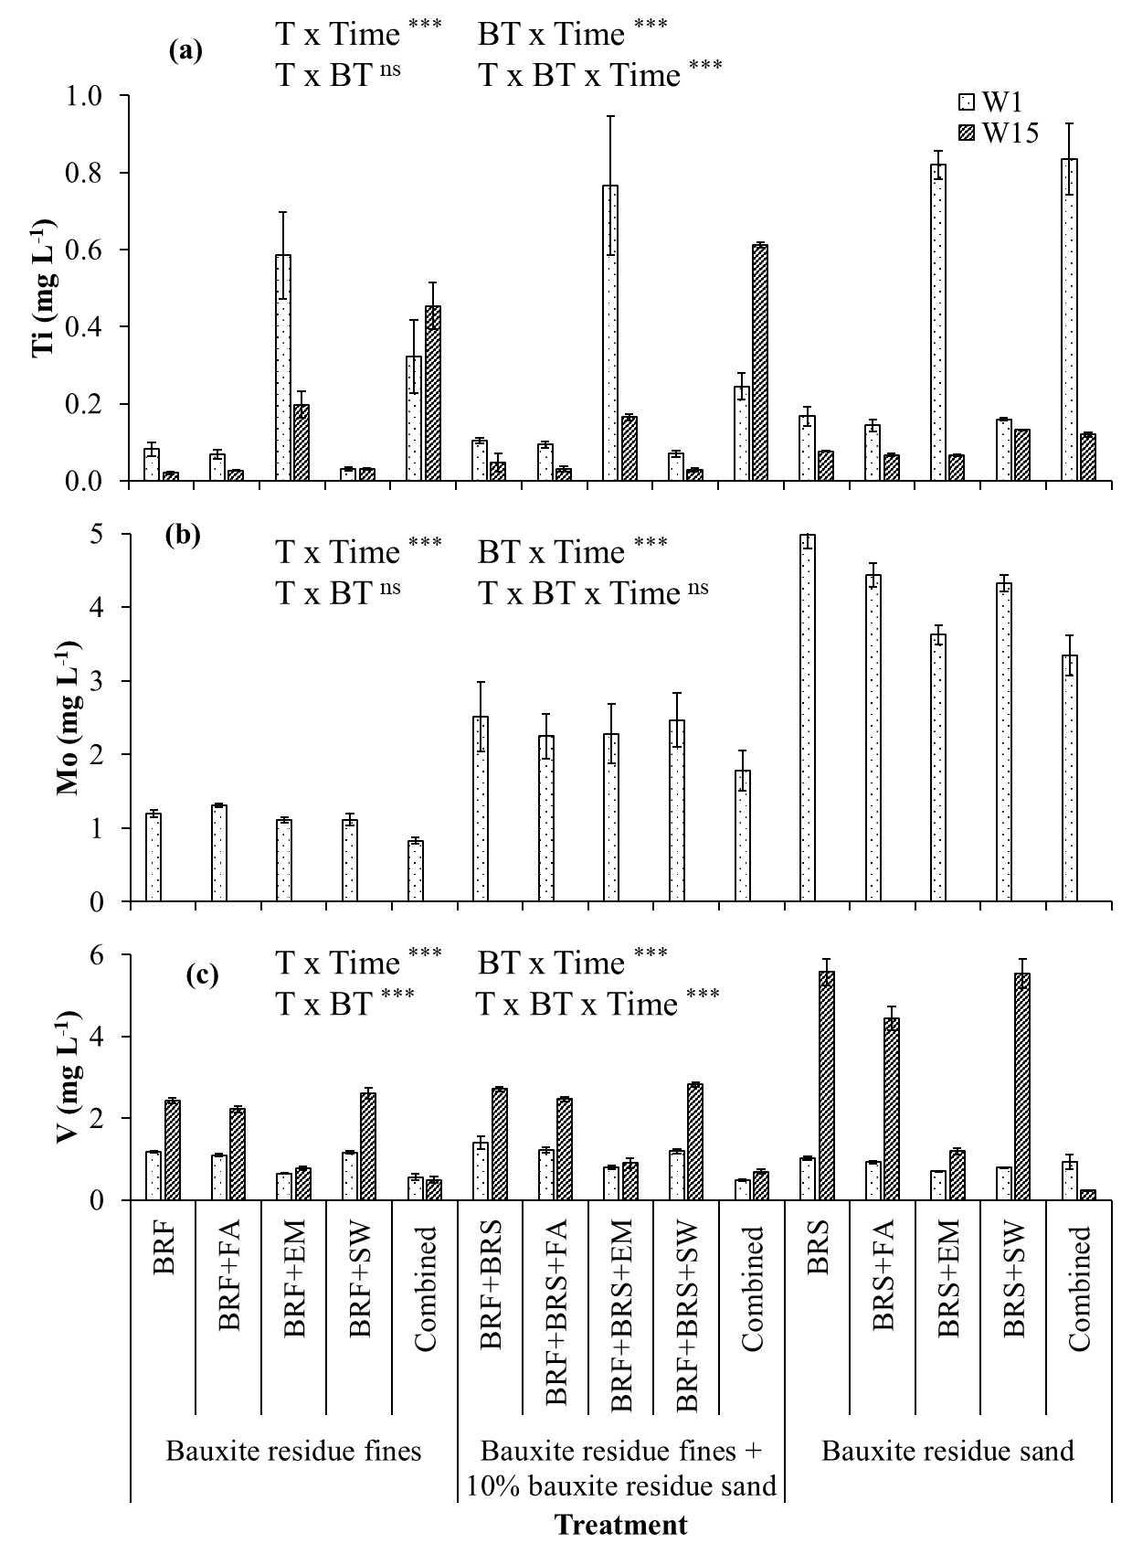
Figure S8: Concentration of Ti (a), Mo (b) and V (c) of blended byproduct caps leachate over time. Bars are the means ± standard error (n=3). A three-way ANOVA was performed to compare Texture (T), Byproduct Type (BT), and Time. The levels of significance for the T × Time, T × BT, BT × Time, and T × BT × Time effects are reported as follows: * P ≤ 0.05; ** P ≤ 0.01; *** P ≤ 0.001; ns, not significant. A summary of statistical analysis is given in Supplementary Table S5.

