Supplementary Information

Nanoparticles of Uranium and Rare Earth Elements in Polymetallic Mine Waste

Table 1S: Alpha diversity indices calculated for microbial communities across different sampling sites and depths. Shannon’s diversity reflects species richness and evenness (in bold); Simpson’s index indicates dominance and diversity (values closer to 1 indicate higher diversity); Simpson’s Reciprocal Index provides an intuitive measure of diversity (higher values = greater diversity); Berger–Parker index represents dominance of the most abundant taxa (higher values = greater dominance); and Fisher’s alpha reflects species richness independent of sample size.
Alpha Diversity Tests | MP0S | MP1S | MP3S | NO-6B | MP4 (0-10) cm | MP4 (10-20)cm | MP4 (20-30) cm | MP4 (30-50) cm
Shannon's diversity | 3.475 | 3.764 | 3.559 | 3.263 | 3.475 | 2.423 | 2.221 | 2.016
Simpson's index of diversity | 0.921 | 0.96 | 0.953 | 0.937 | 0.921 | 0.864 | 0.845 | 0.764
Simpson's Reciprocal Index | 12.597 | 25.25 | 21.216 | 15.819 | 12.597 | 7.342 | 6.467 | 4.242
Berger-parker's diversity | 0.229 | 0.11 | 0.125 | 0.17 | 0.229 | 0.273 | 0.245 | 0.438
Fisher's index | 18.448 | 14.515 | 12.281 | 5.398 | 18.448 | 6.349 | 3.896 | 4.967

Figure S1: Bar chart showing Shannon diversity indices across sampling sites and depth intervals. Higher diversity is observed in surface samples (MP0S, MP1S, MP3S, NO-6B, and MP4 at 0–10 cm), while a progressive decline in diversity index with depth
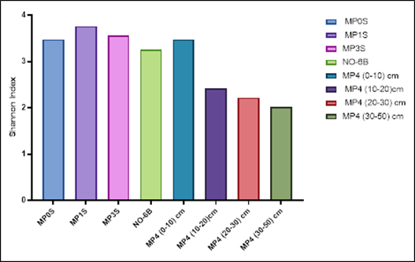

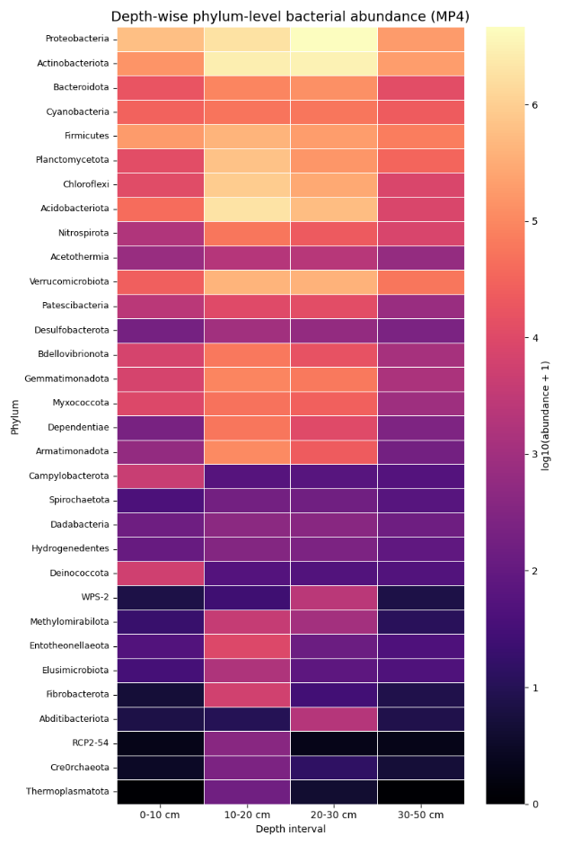
Figure S2: Depth-wise variation in phylum-level bacterial community composition at site MP4. The heatmap shows relative abundances (log10-transformed) of dominant bacterial phyla across four depth intervals (0–10, 10–20, 20–30, and 30–50 cm). Surface layers exhibit higher abundance and diversity of major phyla such as Proteobacteria, Actinobacteriota, and Acidobacteriota, while deeper layers show a general decline in abundance and a shift toward fewer dominant taxa, indicating depth-dependent structuring of microbial communities.

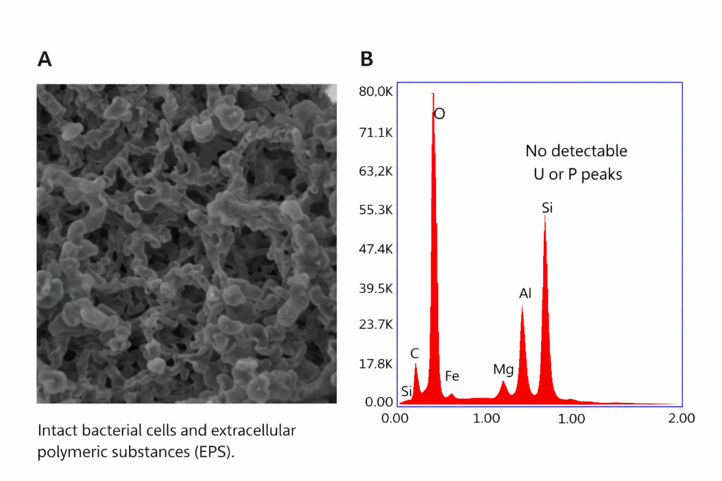
Figure S3: (A) Scanning electron microscopy (SEM) image of the biological negative control showing intact bacterial cells and associated extracellular polymeric substances (EPS). (B) Corresponding EDS spectrum confirming the presence of only cells materials, absence of detectable uranium (U) or phosphorus (P). Detected elements (Fe, Al, Si, Mg) are most likely derived from background signals associated with the SEM mount/stub and silicon wafer.

