Supporting Information
Using neutron diffraction to explore lithium displacement within cubic phase stabilised Ga-doped Li_{6.75}La₃Zr_{1.75}Ta_{0.25}O₁₂ lithium garnet oxides.
Timothy Daniel Christopher,^{1,2} Tianhang Zhang,^{3,4} Saifang Huang,^{3,5}Zoran Zujovic,^{1,6} Maxim Avdeev,^{7,8} Peng Cao,^{2,3} Tilo Söhnel^{1,2,*}

- School of Chemical Sciences and Centre for Green Chemical Science, University of Auckland, Private Bag 92019, Auckland 1142, New Zealand
- MacDiarmid Institute for Advanced Materials and Nanotechnology, Victoria University of Wellington, PO Box 600, Wellington 6140, New Zealand
- Department of Chemical and Materials Engineering, University of Auckland, Private Bag 92019, Auckland 1142, New Zealand
- School of Materials Science and Technology, Beijing Key Laboratory of Materials, Utilisation of Nonmetallic Minerals and Solid Wastes, National Laboratory of Mineral Materials, China University of Geosciences (Beijing), Beijing 100083, P. R. China
- School of Materials Science and Engineering, Jiangsu University of Science and Technology, Zhenjiang, 212003, P. R. China
- The NMR Centre, Faculty of Science, University of Auckland, Auckland, Private Bag 92019, Auckland 1010, New Zealand
- School of Chemistry, The University of Sydney, Sydney, New South Wales 2006, Australia
- Australian Nuclear Science and Technology Organisation, Lucas Heights, New South Wales 2234, Australia
*To whom correspondence should be addressed; e-mail: t.soehnel@auckland.ac.nz.

Table S1. A summary of X-ray refinements for the Li_{6.45−3𝑥}Ga_{𝑥}La₃Zr_{1.75}T_{a0.25}O₁₂ series from x = 0 to 0.5
Gallium Content (x) | Phase(s) and Percentage | LGO Cubic  Lattice Constant (Å) | R_{p} | R_{wp}
0 | LLZTO – Cubic : 58(2)%, LLZO – Tetragonal : 42(2) % | 12.93803(78) | 6.28 | 8.13
0.1 | Li_{6.45−3𝑥}Ga_{𝑥}La₃Zr_{1.75}Ta_{0.25}O₁₂ : 99.35(1.2)%, La₂O₃ : 0.65(15) % | 12.95044(17) | 6.80 | 8.63
0.2 | Li_{6.45−3𝑥}Ga_{𝑥}La₃Zr_{1.75}Ta_{0.25}O₁₂ : 99.4(1.2)%, La₂O₃ : 0.65(15) % | 12.95551(10) | 6.03 | 7.57
0.3 | Li_{6.45−3𝑥}Ga_{𝑥}La₃Zr_{1.75}Ta_{0.25}O₁₂ : 99.0(7) %, La₂O₃ :1.0(1) %) | 12.95516(12) | 6.63 | 5.6
0.4 | Li_{6.45−3𝑥}Ga_{𝑥}La₃Zr_{1.75}Ta_{0.25}O₁₂ :98.97(71) %, La₂O₃ : 1.15(68) % | 12.95940(11) | 6.27 | 7.94
0.5 | Li_{6.45−3𝑥}Ga_{𝑥}La₃Zr_{1.75}Ta_{0.25}O₁₂ : 96.8(7)%, La₂O₃: 0.75 (9)%, La₂Zr₂O₇ : 2.42 (12) | 12.96059(13) | 6.66 | 8.42

Table S2. A summary of neutron refinements for the Li_{6.45−3𝑥}Ga_{𝑥}La₃Zr_{1.75}T_{a0.25}O₁₂ series from x = 0 to 0.5
Gallium Content (x) | Temperature (°C) | Cubic Lattice Constant (Å) | R_{bragg} | R_{p} | R_{wp}
0.1 | 25 | 12.9556(2) | 3.75 | 2.76 | 3.57
0.1 | 200 | 13.0016(2) | 3.63 | 3.06 | 4.07
0.1 | 400 | 13.04238(24) | 4.50 | 3.16 | 4.27
0.1 | 600 | 13.08337(29) | 4.19 | 3.03 | 4.20
0.2 | 25 | 12.95980(14) | 3.37 | 2.61 | 3.30
0.2 | 200 | 13.00414(16) | 3.30 | 2.81 | 3.61
0.2 | 400 | 13.04361(19) | 3.86 | 2.81 | 3.65
0.2 | 600 | 13.08355(22) | 3.71 | 2.65 | 3.49
0.3 | 25 | 12.95829(21) | 4.87 | 2.86 | 3.66
0.3 | 200 | 13.00091(22) | 4.44 | 3.27 | 4.15
0.3 | 400 | 13.03919(25) | 4.86 | 3.46 | 4.55
0.3 | 600 | 13.07999(29) | 5.02 | 3.25 | 4.39
0.4 | 25 | 12.96144(16) | 3.69 | 2.88 | 3.53
0.4 | 200 | 12.99862(19) | 4.10 | 3.15 | 4.05
0.4 | 400 | 13.03688(22) | 4.64 | 3.05 | 4.05
0.4 | 600 | 13.07657(25) | 4.78 | 2.97 | 3.93
0.5 | 25 | 12.95442(19) | 4.17 | 3.79 | 5.15
0.5 | 200 | 12.99909(22) | 4.37 | 3.48 | 4.61
0.5 | 400 | 13.03849(26) | 4.84 | 3.36 | 4.62
0.5 | 600 | 13.07875(29) | 5.22 | 3.16 | 4.37

Figure S1. ⁷Li NMR spectrum of Li_{6.75-3x}La₃Zr_{1.75}Ta_{0.25}O₁₂ x = 0.5. The sidebands are denoted by asterisks.

⁷Li NMR spectrum is shown in Figure S1. The spectrum reveals a broad single peak at δ = 0.6 ppm flanked by the sidebands observed on either side, indicating the presence of ⁷Li within the lithium garnet system of Li_{6.75-3x}La₃Zr_{1.75}Ta_{0.25}O₁₂, x = 0.5.

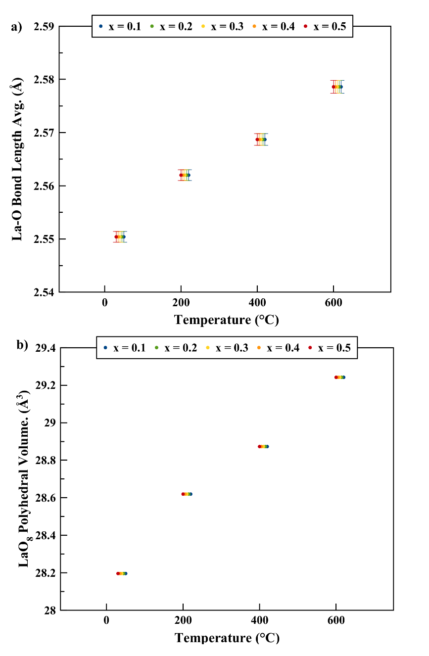
Figure S2. (a) Average lanthanum to oxygen bond lengths (Å) and (b) LaO₈ polyhedral volumes (Å³) versus temperature (°C) for Li_{6.75-3x}Ga_{x}Zr_{1.75}Ta_{0.25}O₁₂. Datasets staggered for clarity.

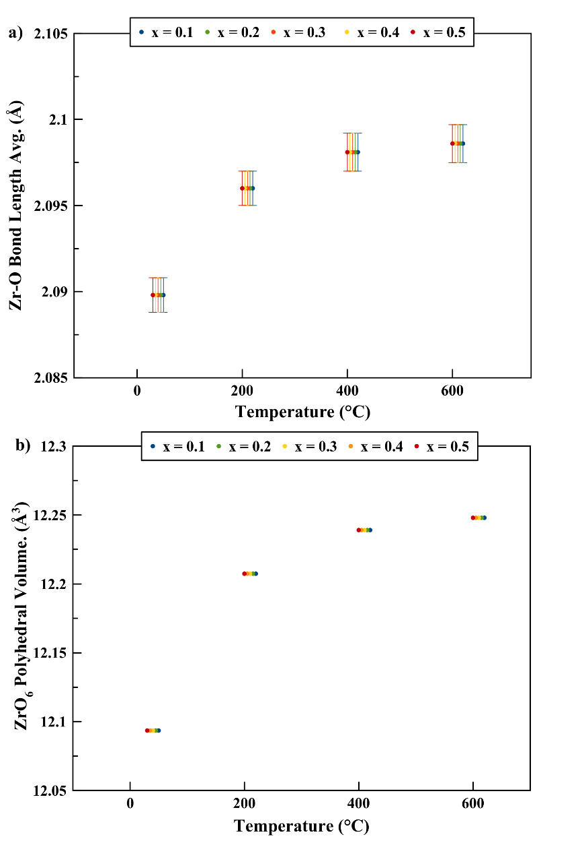
Figure S3. (a) Average zirconium to oxygen bond lengths (Å) and (b) ZrO₆ polyhedral volumes (Å³) versus temperature (°C) for Li_{6.75-3x}Ga_{x}Zr_{1.75}Ta_{0.25}O₁₂. Zirconium represents the 7:1 ratio of zirconium to tantalum in the 16 a site. Datasets staggered for clarity.

