Supporting Information
Rapid Evaluation of Cation Exchange Resins for Radiolanthanide Separations
Jessica Veliscek-Carolanª, Paul Pellegriniª, Leena Burgessª, Ilkay Chironiª, Flora Mansourª*
ªAustralian Nuclear Science and Technology Organisation (ANSTO), Lucas Heights, NSW 2234, Australia
*mansourf@ansto.gov.au
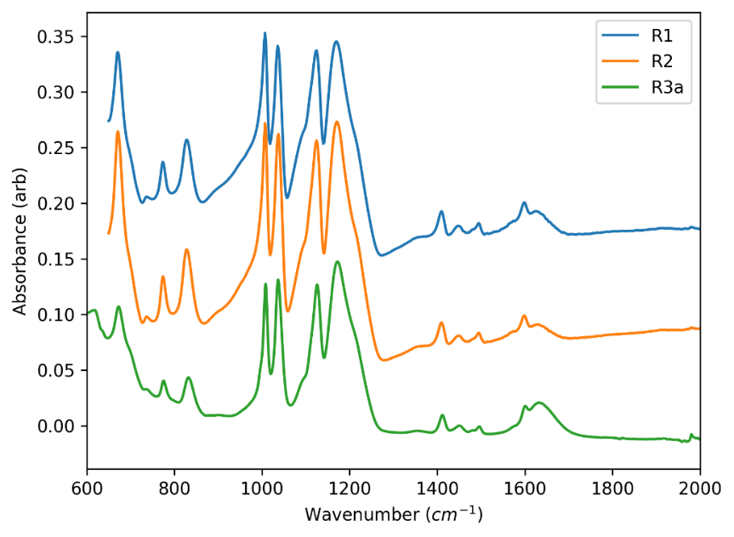
Figure S1. FTIR spectra of type A resins. Spectra are offset for clarity.

Time (minutes)
Figure S2. Separation of 200µM Tb³⁺ from 229 mg Gd³⁺ (Type A resin R1) Impurity of Ho³⁺ and additional Dy³⁺ from Gd₂(NO₃)₃ detected and overlaps with Dy³⁺ peak

Time (minutes)
Figure S3. Chromatogram of lanthanide separation utalising R4a

Time (minutes)
Figure S4. Chromatogram of lanthanide separation utalizing R4b resin (1) Dysposium, (2) Terbium, (3) Gadolinium

Time (minutes)
Figure S5. Chromatogram of lanthanide separation utalising R5 resin (1) Dysposium, (2) Terbium, (3) Gadolinium.

Time (minutes)
Figure S6. Chromatogram of lanthanide separation utalising R7 resin (1) Dysposium, (2) Terbium, (3) Gadolinium

Time (minutes)
Figure S7. Chromatogram of lanthanide separation utalising R9 resin (1) Dysposium, (2) Terbium, (3) Gadolinium

Time (minutes)
Figure S8. Chromatogram of lanthanide separation utalising R10 resin (1) Dysposium, (2) Terbium, (3) Gadolinium

Table S9. Selectivity and theoretical plate values of cation exchange resins (resins which co-eluted are not included in table values)
Resin | α |  | N
Resin | Dy/Tb | Tb/Gd | Tb
R1 | 2.36 | 1.67 | 1146
R2 | 2.58 | 2.62 | 4953
R3a | 2.35 | 1.35 | 4953
R3b | 2.10 | 1.90 | 216
R4b | 3.19 | 2.62 | 25
R6a | 2.17 | 2.31 | 300
R6b | 2.62 | 2.75 | 199
R6c | 1.78 | 1.83 | 119
R6d | 2.58 | 1.89 | 114
R8 | 3.07 | 1.38 | 383

