Temperature and hydrological change in central Australia through the last glacial cycle: Insights from clumped isotope analysis of lacustrine molluscs
Supplementary material

Data tables
Table S.1: Averaged daily temperature data for central Australian weather station collected from 1950-2022. Weather observations was using the SILO Australian climate database (http://www.longpaddock.qld.gov.au/silo).
Location | Latitude | Longitude | Maximum | Minimum | Average
 |  |  | °C | °C | °C
Andamooka | –30.449 | 137.1692 | 27.31 | 13.52 | 20.41
Arkaroola | –30.311 | 139.3357 | 25.49 | 11.55 | 18.52
Marree (Clayton) | –29.2781 | 138.3823 | 28.84 | 13.83 | 21.34
Marree (Farina) | –30.066 | 138.2739 | 27.80 | 13.26 | 20.53
Mount Barry Station | –28.2415 | 134.9899 | 27.11 | 12.61 | 19.86
Mount Eba | –30.1809 | 135.6629 | 28.82 | 14.34 | 21.58
Muloorina Station | –29.239 | 137.9058 | 29.20 | 14.05 | 21.62
Todmoren | –27.1391 | 134.7575 | 29.20 | 14.43 | 21.81
MEAN |  |  | 27.97 | 13.45 | 20.71
MEDIAN |  |  | 28.31 | 13.68 | 20.93

Table S.2: Site location and sample details for analysed lake mollusc samples.
Sample ID | Lab code | Sample type | Age | Shell used | Coordinates | Elevation
 |  |  | ka or ka cal BP |  |  | (m) AHD
Salt Creek
LCP1 0.45 | Shell-1 | Corbicula australis | <33.4 (2.9)^{b} | 1 | S 29° 56′22.45″ E 140° 6′46.86″ | 10.0
LCP1 0.8 | Shell-2 | Coxiella sp. | <33.4 (2.9)^{b} | 20 | S 29° 56′22.45″ E 140° 6′46.86″ | 9.6
LCP1 0.96 | Shell-3 | Corbicula australis | <33.4 (2.9)^{b} | 2 | S 29° 56′22.45″ E 140° 6′46.86″ | 9.4
LCP2 0.85 | Shell-4 | Coxiella sp. | 41.4 (0.2) | 20 | S 29° 56′23.55″ E 140° 6′56.12″ | 8.4
Lake Callabonna
CallaSpit 0.5 | Shell-5 | Corbicula australis | 196 (12) | 1 | S 29°49'3.99" E 140° 3'0.76" | 20
CSP1 1.0 | Shell-6 | Coxiella sp.ª | 47.1 (4.1)^{b} | 20 | S 29° 48′25.67″ E 140° 4′19.69″ | 14.4
CSP1 1.05 | Shell-7 | Coxiella sp. | 48.4 (4.2)^{b} | 20 | S 29° 48′25.67″ E 140° 4′19.69″ | 14.4
CSP1 2.0 | Shell-8 | Coxiella sp.ª | 49.5 (0.9)^{b} | 10 | S 29° 48′25.67″ E 140° 4′19.69″ | 13.4
Lake Frome
LFP1 1.5 | Shell-9 | Corbicula australis | <63.7 (6.9)^{b} | 1 | S 30° 23′13.31″ E 139° 49′27.47″ | 14.7
LFP1 1.3 | Shell-10 | Coxiella sp. | 46.1 (0.3) | 10 | S 30° 23′13.31″ E 139° 49′27.47″ | 14.9
LFP1 2.1 | Shell-11 | Corbicula australis | >68.2 (4.2)^{b} | 1 | S 30° 23′13.31″ E 139° 49′27.47″ | 14.1
Kati Thanda-Lake Eyre
WPLE P4B | Shell-12 | Coxiella sp. | 70.0 (4.0)^{c} | 18 | S 29° 2′16.15″ E 137° 37′45.31″ | –3.8
LEHP S1 0.35 | Shell-13 | Coxiella sp.ª | Near-modern^{d} | 7 | S 28° 44′27.07″ E 137° 15′33.01″ | –13
LEHS_76 | Shell-14 | Coxiella sp.ª | 39.7 (0.8)^{d} | 2 | S 28° 47′34.05″ E 137° 14′36.83″ | –11.2
LEHP_114 | Shell-15 | Corbicula australis | 35.8 (0.2)^{d} | 1 | S 28° 47′34.05″ E 137° 14′36.83″ | –12
Western Australia
Esperance 8_18 | Shell-17 | Coxiella glauerti | Modern | 3 | S 33° 29'51.55" E 122° 24'00.63" | –
Esperance 3_18 | Shell-18 | Coxiella pyrrhostoma | Modern | 3 | S 33° 28'53.8752" E 121° 41'48.6672" | –
Esperance 4_18 | Shell-19 | Coxiella pyrrhostoma | Modern | 3 | S 33° 30'58.6544" E 121° 52'32.9383" | –
Green Head 2 | Shell-20 | Coxiella striatula | Modern | 5 | S 29° 59'14.3520" E 114° 59'12.8220" | –
Esperance 14_20 | Shell-21 | Coxiella pyrrhostoma | Modern | 3 | S 33° 04'55.1532" E 121° 41'07.4364" | –
Esperance 4_20 | Shell-22 | Coxiella pyrrhostoma | Modern | 3 | S 33° 30'58.7412" E 121° 52'34.7628" | –
Esperance 11_20 | Shell-23 | Coxiella glauerti | Modern | 3 | S 33° 32'04.8120" E 122° 25'42.4452" | –
Esperance 3_20 | Shell-25 | Coxiella pyrrhostoma | Modern | 3 | S 33° 28'53.8752" E 121° 41'48.6672" | –
Esperance 7_20 | Shell-26 | Coxiella sp. | Modern | 3 | S 33° 32'25.3176" E 122° 25'50.2129" | –
Esperance 22_21 | Shell-27 | Coxiella glauerti | Modern | 3 | Not recorded | –
ªbroken shell fragments
^{b}reported in Cohen et al. (2012)
^{c}reported in Cohen et al. (2022)
^{d}reported in Cohen et al. (2017)

Table S.3: Modern Western Australian Coxiella sample details. All samples were collected as living specimens. Water temperature values were recorded at the time of sample collection. Weather observations for calculating MAAT were taken from the SILO Australian climate database (http://www.longpaddock.qld.gov.au/silo).
Sample ID | Lab code | Sample type | Collection date | Water T | Observed MAAT
 |  |  |  | °C | °C
Esperance 8_18 | Shell-17 | Coxiella glauerti | 14/08/2018 | 18.0 | 17.3
Esperance 3_18 | Shell-18 | Coxiella pyrrhostoma | 14/08/2018 | 18.4 | 17.3
Esperance 4_18 | Shell-19 | Coxiella pyrrhostoma | 14/08/2018 | 17.4 | 17.3
Green Head 2 | Shell-20 | Coxiella striatula | 30/07/2019 | 18.3 | 19.5
Esperance 14_20 | Shell-21 | Coxiella pyrrhostoma | 14/08/2020 | 21.1 | 17.5
Esperance 4_20 | Shell-22 | Coxiella pyrrhostoma | 14/08/2020 | 18.8 | 17.5
Esperance 11_20 | Shell-23 | Coxiella glauerti | 1508/2020 | 17.8 | 17.5
Esperance 3_20 | Shell-25 | Coxiella pyrrhostoma | 12/09/2020 | 18.3 | 17.5
Esperance 7_20 | Shell-26 | Coxiella sp. | 13/09/2020 | 17.1 | 17.5
Esperance 22_21 | Shell-27 | Coxiella glauerti | 18/08/2021 | 18.3 | 17.1

Table S.4: Semi-quantitative XRD data for ancient central Australian mollusc samples
Sample ID | Sample type | % Aragonite | % Calcite
Salt Creek
LCP1 0.45 | Corbicula australis | 96.85 | 3.15
LCP1 0.8 | Coxiella sp. | 83.66 | 16.34
LCP1 0.96 | Corbicula australis | – | –
LCP2 0.85 | Coxiella sp. | 98.85 | 1.15
Lake Callabonna
CallaSpit 0.5 | Corbicula australis | 97.67 | 2.33
CSP1 1.0 | Coxiella sp. | – | –
CSP1 1.05 | Coxiella sp. | 94.96 | 5.04
CSP1 2.0 | Coxiella sp. | – | –
Lake Frome
LFP1 1.5 | Corbicula australis | 95.90 | 4.10
LFP1 1.3 | Coxiella sp. | 92.38 | 7.62
LFP1 2.1 | Corbicula australis | 95.57 | 4.43
Kati Thanda-Lake Eyre
WPLE P4B | Coxiella sp. | 94.40 | 5.60
LEHP S1 0.35 | Coxiella sp. | 97.10 | 2.90
LEHS_76 | Coxiella spª | – | –
LEHP_114 | Corbicula australis | 93.46 | 6.54

Table S.5: Reconstructed lacustrine mollusc shell growth temperatures and estimated MAAT. Shell precipitation temperatures were calculated using the Δ₄₇ temperature equation of Anderson et al. (2021), with MAAT calculated using the lake T(Δ₄₇)-MAAT calibration of Hren & Sheldon (2012).
Sample ID | Sample type | n | Δ₄₇ | Errorª | 95% CL | Δ₄₇ calculated T | Errorª | 95% CL
 |  |  | ‰ (I-CDES) |  |  | °C
Salt Creek
LCP1 0.45 | Corbicula australis | 10 | 0.6173 | 0.0039 | ± 0.0076 | 17.6 | 1.2 | ± 2.3
LCP1 0.8 | Coxiella sp. | 8 | 0.6142 | 0.0063 | ± 0.0124 | 18.5 | 2.0 | ± 3.9
LCP1 0.96 | Corbicula australis | 8 | 0.6268 | 0.0054 | ± 0.0106 | 14.6 | 1.7 | ± 3.3
LCP2 0.85 | Coxiella sp. | 10 | 0.6128 | 0.0052 | ± 0.0102 | 19.0 | 1.7 | ± 3.3
Lake Callabonna
CallaSpit 0.5 | Corbicula australis | 10 | 0.6123 | 0.0048 | ± 0.0095 | 19.2 | 1.5 | ± 2.9
CSP1 1.0 | Coxiella sp. | 7 | 0.6185 | 0.0090 | ± 0.0178 | 17.2 | 2.8 | ± 5.5
CSP1 1.05 | Coxiella sp. | 8 | 0.6251 | 0.0059 | ± 0.0116 | 15.1 | 1.8 | ± 3.5
CSP1 2.0 | Coxiella | 7 | 0.6232 | 0.0035 | ± 0.0069 | 15.7 | 1.1 | ± 2.2
Lake Frome
LFP1 1.5 | Corbicula australis | 10 | 0.6053 | 0.0054 | ± 0.0105 | 21.4 | 1.8 | ± 3.5
LFP1 1.3 | Coxiella sp. | 10 | 0.6196 | 0.0057 | ± 0.0111 | 16.8 | 1.8 | ± 3.5
LFP1 2.1 | Corbicula australis | 10 | 0.6068 | 0.0038 | ± 0.0075 | 20.9 | 1.2 | ± 2.4
Kati Thanda-Lake Eyre
WPLE P4B | Coxiella sp. | 9 | 0.5999 | 0.0052 | ± 0.0102 | 23.2 | 1.7 | ± 3.3
LEHP S1 0.35 | Coxiella sp. | 8 | 0.6051 | 0.0059 | ± 0.0116 | 21.5 | 1.9 | ± 3.7
LEHS_76^{b} | Coxiella sp. | 4 | – | – | – | – | – | –
LEHP_114 | Corbicula australis | 10 | 0.6237 | 0.0033 | ± 0.0065 | 15.5 | 1.0 | ± 2.0
Western Australia
Esperance 8_18 | Coxiella glauerti | 8 | 0.6189 | 0.0064 | ± 0.0082 | 17.1 | 2.0 | ± 3.9
Esperance 3_18 | Coxiella pyrrhostoma | 9 | 0.6211 | 0.0042 | ± 0.0126 | 16.4 | 1.3 | ± 2.5
Esperance 4_18 | Coxiella pyrrhostoma | 7 | 0.6062 | 0.0069 | ± 0.0136 | 21.1 | 2.3 | ± 4.5
Green Head 2 | Coxiella striatula | 6 | 0.6132 | 0.0058 | ± 0.0113 | 18.8 | 1.9 | ± 3.7
Esperance 14_20 | Coxiella pyrrhostoma | 6 | 0.5944 | 0.0032 | ± 0.0063 | 25.1 | 1.1 | ± 2.2
Esperance 4_20 | Coxiella pyrrhostoma | 8 | 0.6203 | 0.0062 | ± 0.0122 | 16.6 | 1.9 | ± 3.7
Esperance 11_20 | Coxiella glauerti | 7 | 0.6150 | 0.0047 | ± 0.0093 | 18.3 | 1.5 | ± 2.9
Esperance 3_20 | Coxiella pyrrhostoma | 10 | 0.6151 | 0.0052 | ± 0.0103 | 18.2 | 1.7 | ± 3.3
Esperance 7_20 | Coxiella sp. | 6 | 0.6207 | 0.0050 | ± 0.0098 | 16.5 | 1.6 | ± 3.1
Esperance 22_21 | Coxiella glauerti | 6 | 0.6239 | 0.0044 | ± 0.0087 | 15.5 | 1.4 | ± 2.7
ªerrors reported as ± 1 standard error (S.E.), which were calculated using long-term reproducibility of analysed ETH standards
^{b}insufficient carbonate material for Δ₄₇

Table S.5 (continued).
Sample ID | Sample type | MAAT | Errorª | 95% CL | δ¹⁸O_{water} | Errorª | 95% CL
 |  | °C |  |  | ‰ VSMOW
Salt Creek
LCP1 0.45 | Corbicula australis | 16.1 | 1.4 | ± 2.7 | –2.6 | 0.3 | ± 0.6
LCP1 0.8 | Coxiella sp. | 17.2 | 2.2 | ± 4.3 | 1.1 | 0.4 | ± 0.8
LCP1 0.96 | Corbicula australis | 12.7 | 1.8 | ± 3.5 | –0.9 | 0.4 | ± 0.8
LCP2 0.85 | Coxiella sp. | 17.6 | 1.9 | ± 3.7 | 3.9 | 0.4 | ± 0.8
Lake Callabonna
CallaSpit 0.5 | Corbicula australis | 17.8 | 1.7 | ± 3.3 | –0.4 | 0.3 | ± 0.6
CSP1 1.0 | Coxiella sp. | 15.7 | 3.2 | ± 6.2 | 1.7 | 0.6 | ± 1.2
CSP1 1.05 | Coxiella sp. | 13.3 | 2.0 | ± 3.9 | 1.0 | 0.4 | ± 0.8
CSP1 2.0 | Coxiella | 14.0 | 1.3 | ± 2.5 | 2.0 | 0.2 | ± 0.4
Lake Frome
LFP1 1.5 | Corbicula australis | 19.8 | 2.1 | ± 4.1 | 3.7 | 0.4 | ± 0.8
LFP1 1.3 | Coxiella sp. | 15.3 | 2.0 | ± 3.9 | 1.6 | 0.4 | ± 0.8
LFP1 2.1 | Corbicula australis | 19.4 | 1.5 | ± 2.9 | 2.1 | 0.3 | ± 0.6
Kati Thanda-Lake Eyre
WPLE P4B | Coxiella sp. | 21.2 | 1.9 | ± 3.7 | 1.8 | 0.4 | ± 0.8
LEHP S1 0.35 | Coxiella sp. | 19.9 | 2.1 | ± 4.1 | 2.2 | 0.4 | ± 0.8
LEHS_76^{b} | Coxiella sp. | – | – | – | – | – | –
LEHP_114 | Corbicula australis | 13.8 | 1.2 | ± 2.4 | 1.8 | 0.4 | ± 0.8
Western Australia
Esperance 8_18 | Coxiella glauerti | 15.6 | 2.2 | ± 4.3 | 1.4 | 0.4 | ± 0.8
Esperance 3_18 | Coxiella pyrrhostoma | 14.8 | 1.4 | ± 2.7 | 0.8 | 0.9 | ± 1.8
Esperance 4_18 | Coxiella pyrrhostoma | 19.6 | 2.5 | ± 4.9 | 1.6 | 0.8 | ± 1.6
Green Head 2 | Coxiella striatula | 17.5 | 2.0 | ± 3.9 | 2.4 | 0.8 | ± 1.6
Esperance 14_20 | Coxiella pyrrhostoma | 22.4 | 1.2 | ± 2.4 | 2.4 | 0.4 | ± 0.8
Esperance 4_20 | Coxiella pyrrhostoma | 15.1 | 2.1 | ± 4.1 | 1.6 | 0.8 | ± 1.6
Esperance 11_20 | Coxiella glauerti | 16.9 | 1.6 | ± 3.1 | 1.5 | 0.6 | ± 1.2
Esperance 3_20 | Coxiella pyrrhostoma | 16.9 | 1.8 | ± 3.5 | 1.3 | 0.7 | ± 1.4
Esperance 7_20 | Coxiella sp. | 15.0 | 1.7 | ± 3.3 | 1.0 | 0.7 | ± 1.4
Esperance 22_21 | Coxiella glauerti | 13.8 | 1.5 | ± 2.9 | 2.1 | 0.6 | ± 1.2
ªerrors reported as ± 1 standard error (S.E.), which were calculated using long-term reproducibility of analysed ETH standards
^{b}insufficient carbonate material for Δ₄₇

Table S.6: Observed and Δ₄₇-derived water and air temperatures from modern Western Australian Coxiella sample details. Water temperature values were recorded at the time of sample collection and observed MAAT was calculated using weather observations from the SILO Australian climate database (http://www.longpaddock.qld.gov.au/silo). Further details on Δ₄₇ measurements and calculated temperatures for the samples can be found in Table S.5.
Sample ID | Sample type | Collection date | Water T (°C) |  | MAAT (°C)
 |  |  | Observed | Calculated | Observed | Calculated
Esperance 8_18 | Coxiella glauerti | 14/08/2018 | 18.0 | 17.1 | 17.3 | 15.6
Esperance 3_18 | Coxiella pyrrhostoma | 14/08/2018 | 18.4 | 16.4 | 17.3 | 14.8
Esperance 4_18 | Coxiella pyrrhostoma | 14/08/2018 | 17.4 | 21.1 | 17.3 | 19.6
Green Head 2 | Coxiella striatula | 30/07/2019 | 18.3 | 18.8 | 19.5 | 17.5
Esperance 14_20 | Coxiella pyrrhostoma | 14/08/2020 | 21.1 | 25.1 | 17.5 | 22.4
Esperance 4_20 | Coxiella pyrrhostoma | 14/08/2020 | 18.8 | 16.6 | 17.5 | 15.1
Esperance 11_20 | Coxiella glauerti | 1508/2020 | 17.8 | 18.3 | 17.5 | 16.9
Esperance 3_20 | Coxiella pyrrhostoma | 12/09/2020 | 18.3 | 18.2 | 17.5 | 16.9
Esperance 7_20 | Coxiella sp. | 13/09/2020 | 17.1 | 16.5 | 17.5 | 15.0
Esperance 22_21 | Coxiella glauerti | 18/08/2021 | 18.3 | 15.5 | 17.1 | 13.8
Averageª |  |  | 18.4 | 18.3 | 17.4 | 16.7
ªaverage temperatures are for Esperance samples only

Table S.7: Stable hydrogen and oxygen ratios for Belt Bay lake water.
Sample ID | δ²H | Errorª | δ¹⁸O | Errorª
 | ‰ SMOW |  | ‰ SMOW
LkEyr-a | 0.45 | 0.55 | 2.60 | 0.13
LkEyr-b | 2.05 | 0.14 | 2.69 | 0.01
LkEyr-c | 2.36 | 0.25 | 2.77 | 0.09
Average | 1.62 | 0.31 | 2.69 | 0.08
ªerrors reported as ± 1 standard error (S.E.)
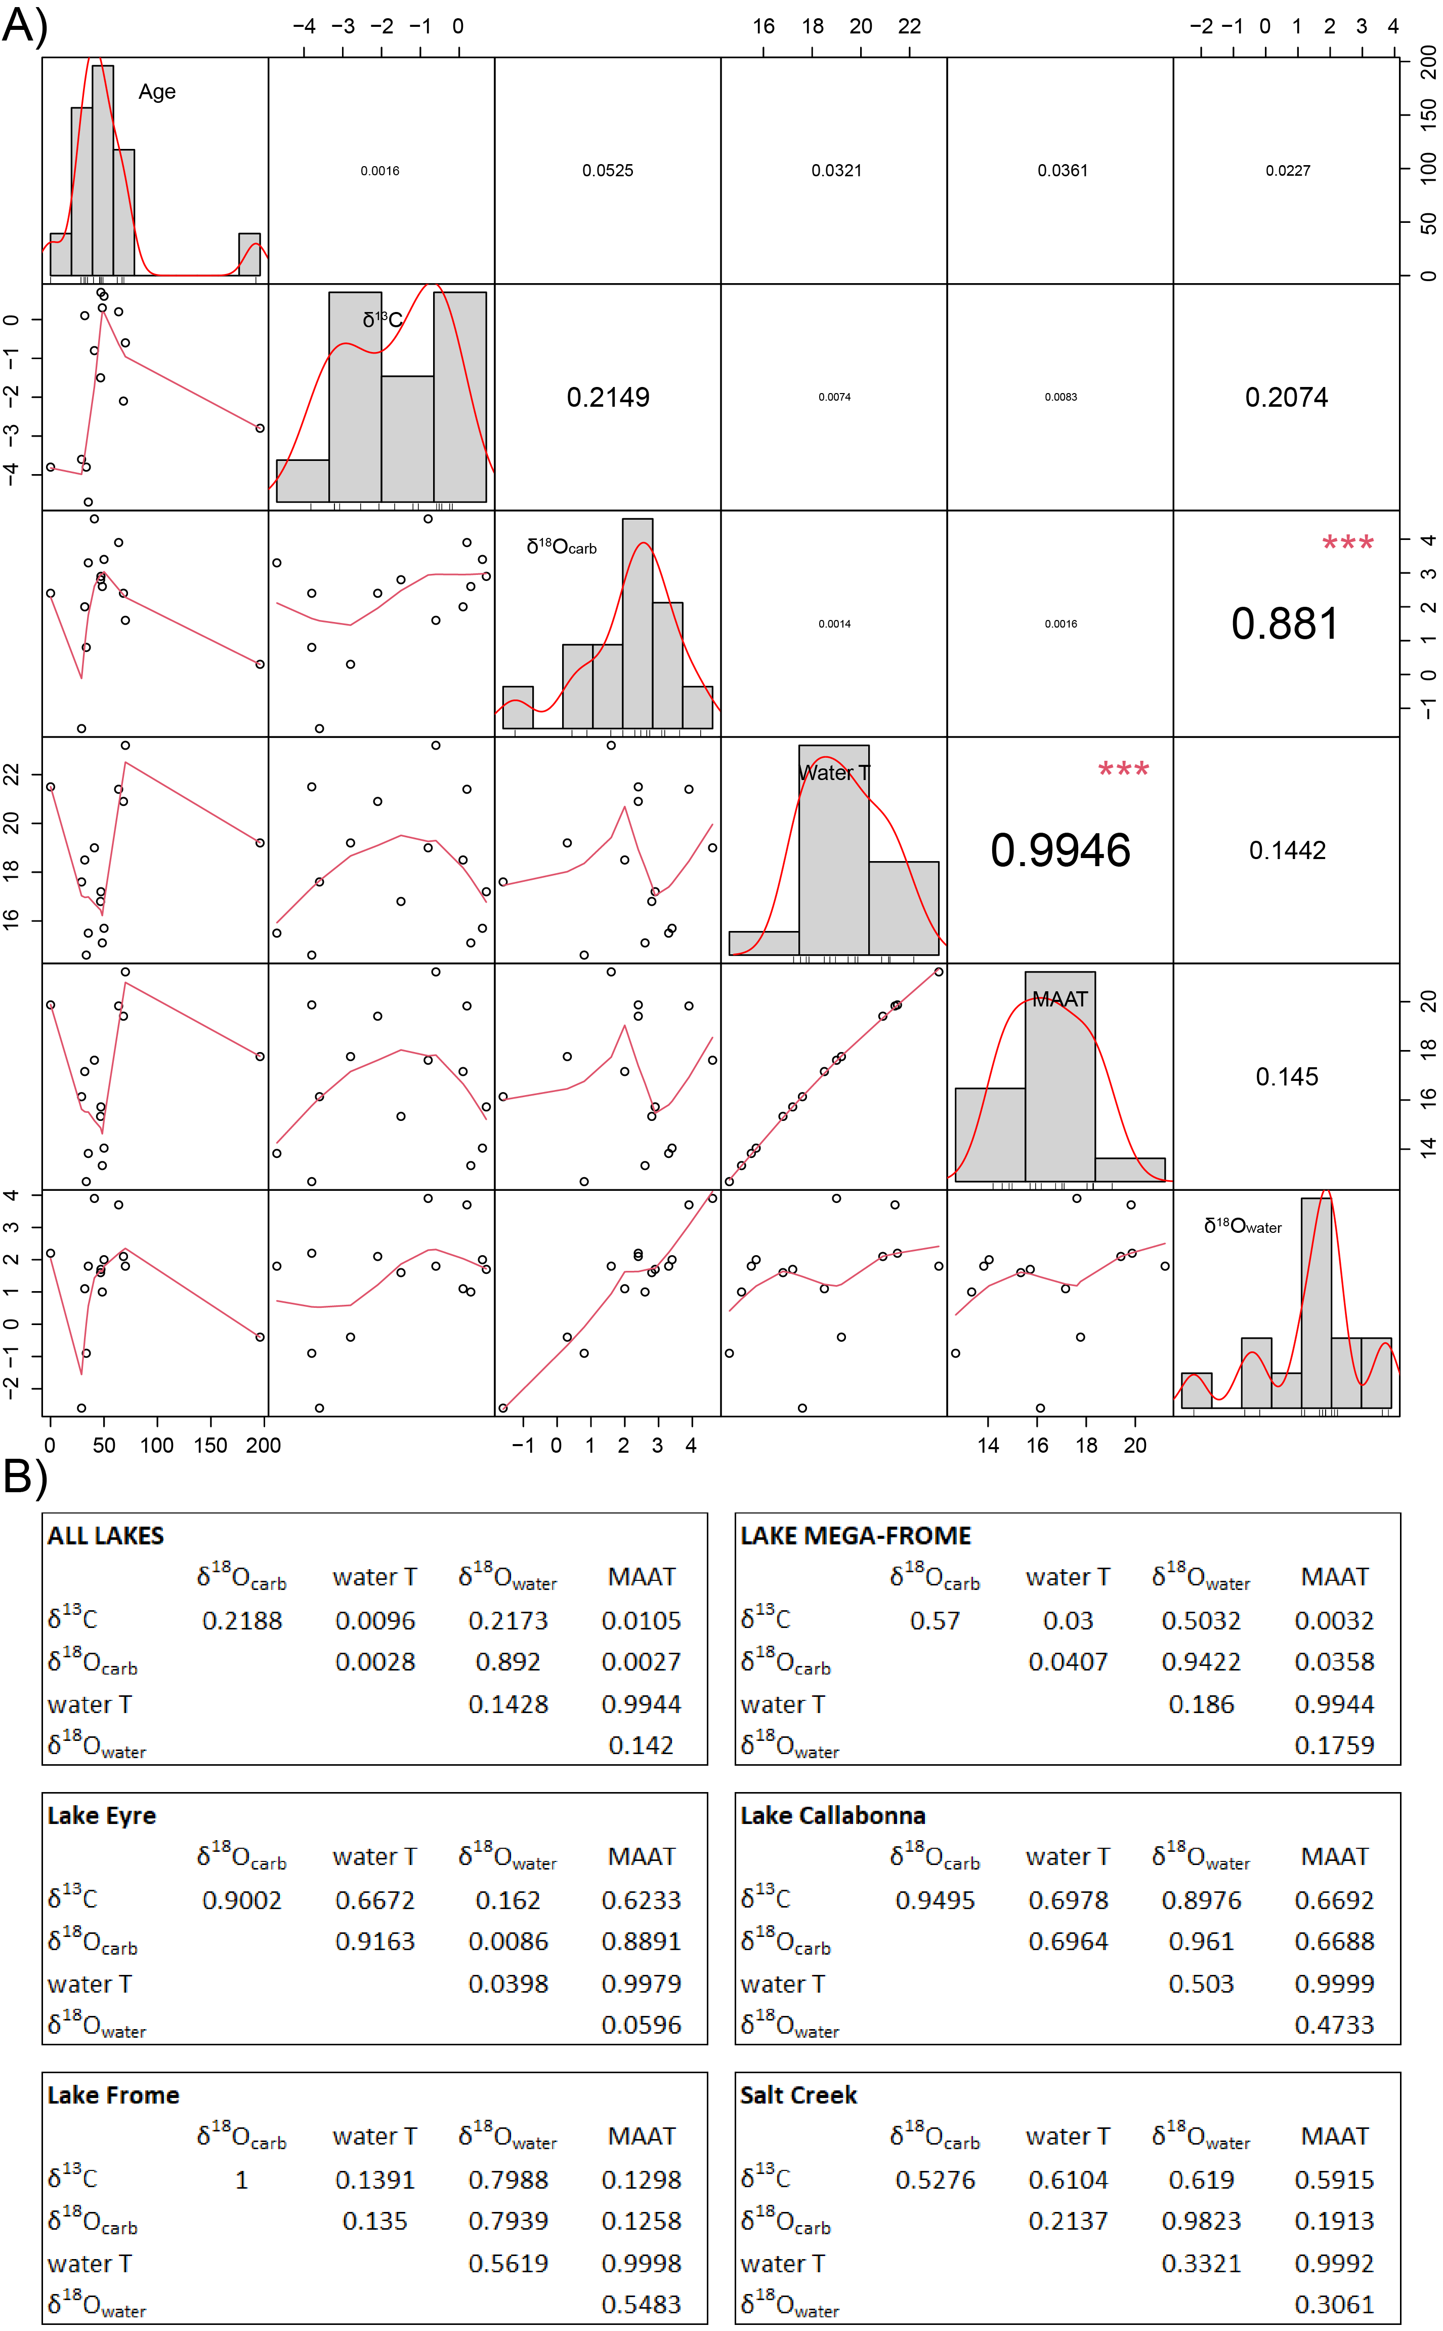

Figure S.1: A) Scatterplots, histograms, and R² values for all shell samples, with red asterisks indicating variables with a strong correlation; and B) correlation matrices (R² values) for each studied lake site.

Supplementary Note 1: Single-grain TT-OSL dating methods
Sample collection and preparation
Sample LC19-10 was collected from a pit that was excavated into the upper 80 cm of the +20.8m AHD shoreline at Lake Callabonna. The sample was taken from the shell-rich gravel deposits located 55 cm beneath the shoreline surface using a metal tube, and was immediately sealed with light-proof plastic upon extraction. Approximately 100 g of additional bulk sediment was collected from within a 1 cm radius of the sample tube position for dosimetry and water content assessments.

The purified quartz fraction was extracted from the unexposed portions of the optical dating sample under safe light conditions (630 nm LEDs, <0.15 μW/cm² power density at sample position) at the University of Adelaide. The 90–125 μm fraction was prepared for burial dose estimation using standard procedures (Aitken, 1998). Sediment samples were initially sieved to isolate the fine sand fraction (90–300 µm). Organics and carbonates were then eliminated using concentrated (30%) hydrogen peroxide (H₂O₂) and hydrochloric (HCl) acid digestion. Quartz grains were isolated using heavy liquid (LST lithium heteropolytungstate) density ranges of 2.62 g/cm³ to 2.72 g/cm³. The 90–125 µm quartz fraction was then sieved and etched with hydrofluoric (HF) acid to remove the alpha-irradiated external layers (48% HF digestion for 40 min). Etched grains were subsequently washed in 30% hydrochloric acid to remove any precipitated fluorides and re-sieved using a 63 µm sieve to eliminate any disaggregated grains.

Equivalent dose (D_{e}) estimation
Single-grain TT-OSL measurements were made using a Risø TL-DA-20 reader equipped with blue LEDs (470 nm, maximum power of 102 mW/cm2), infrared LEDs (peak emission 850 nm, maximum power of 302 mW/cm2), and a 10 mW Nd:YVO4 single-grain laser attachment emitting at 532 nm (maximum power of ~50 W/cm²). Ultraviolet TT-OSL signals were detected using an Electron Tubes PDM 9107B photomultiplier tube fitted with 7.5 mm-thick Hoya U-340 filters. The sample was irradiated with a mounted ⁹⁰Sr/⁹⁰Y beta source that had been calibrated to administer known doses to multi-grain aliquots and single-grain discs (average single-grain dose rates at the time of measurement = 0.09 Gy/s). For single-grain measurements, spatial variations in the beta dose rates across the disc plane were taken into account by undertaking hole-specific calibrations using gamma-irradiated quartz.

TT-OSL measurements were made on 90-125 μm quartz grains loaded into single-grain aluminium discs with 300 µm-deep holes, resulting in an average of ~18 grains being placed in each grain-hole position (assuming a uniform grain size distribution) (Arnold et al., 2012a). This measurement configuration was chosen because it has been shown that quartz samples from a range of locations typically contain relatively low proportions of TT‐OSL‐producing grains (e.g. Arnold et al., 2014; Demuro et al., 2014, 2019a, 2019b); this approach therefore offers a practical means of enhancing the number of usable D_{e} values per disc while minimising any ‘pseudo’ single‐grain averaging effects. For the sample analysed in this study, the vast majority (75%; Table S.6) of grain‐hole positions measured using this pseudo‐single‐grain approach still produced TT‐OSL signals that are statistically indistinguishable from background, which suggests close approximation to true single‐grain resolution and minimal influences of multi‐grain averaging effects (Demuro et al., 2013).

Table S.6: Single-grain TT-OSL classification statistics for the dose recovery and natural D_{e} measurements. The proportion of grains that were rejected from final D_{e} estimation after applying the various SAR quality assurance criteria are shown in rows 5-12. These criteria were applied to each single-grain measurement in the order listed. T_{n} = natural test dose signal response; L_{n}/T_{n} = sensitivity-corrected natural signal response; L_{x}/T_{x} = sensitivity-corrected regenerative-dose signal response; I_{max} = saturation OSL intensity of the fitted dose response curve.
Sample name | LC19-10 | LC19-10
SAR measurement type | TT-OSL D_{e} | TT-OSL  Dose-recovery
Total measured grains (n) | 1600 | 800
Grains rejected for failing SAR quality assurance criteria (%)
T_{n} <3σ background | 75 | 75
Recycling ratio ≠ 1 at ±2σ | 3 | 2
OSL-IR depletion ratio <1 at ±2σ | 0 | 0
0 Gy L_{x}/T_{x} >5% L_{n}/T_{n} | 0 | 0
Non-intersecting grains (L_{n}/T_{n} > dose response curve saturation) | <1 | <1
Saturated grains (L_{n}/T_{n} ≥ dose response curve I_{max} at ±2σ) | 0 | 0
Anomalous dose response / unable to perform Monte Carlo fit | 15 | 16
Slowly decaying OSL signal (T_{n} or T_{x} signals >background after 1.5 s of OSL stimulation) | <1 | <1
Sum of rejected grains (%) | 94 | 93
Sum of accepted grains (%) | 6 | 7

Single-grain TT-OSL De values have been obtained using the single-aliquot regenerative dose (SAR) protocol shown in Table S.7. A total of 1600 single-grain De measurements were made for sample LC19-10. Single-grain TT-OSL D_{e} values were calculated by integrating the first 0.08 s of stimulation and subtracting a late-light background from the last 0.25 s. The single-grain TT-OSL dose-response curves are generally characterised by continued signal growth at high doses (10²-10³ Gy) and are typically well-represented by a single saturating exponential function (e.g. Fig. S.2).

Table S.7: TT-OSL SAR protocol used for D_{e} determination. The SAR measurement cycle was repeated for the natural dose, three different sized regenerative doses, a 0 Gy regenerative dose (to measure OSL signal recuperation) and a replicate of the first regenerative dose cycle (to assess the suitability of the test dose sensitivity correction). The OSL IR depletion ratio of Duller (2003) was measured separately and used to check for the presence of feldspar contaminants. L_{x} = regenerative dose signal response; L_{n} = natural dose signal response; T_{x} = test dose signal response for a laboratory dose cycle T_{n} = test dose signal response for the natural dose cycle.
Step | Treatment | Signal
1 | Dose (natural or laboratory)
2 | Preheat 1 (PH₁ = 260ºC for 10 s)
3 | Single-grain OSL stimulation (125ºC for 3 s)
4 | Preheat 2 (PH₂ = 260ºC for 10 s)
5 | Single-grain TT-OSL stimulation (125ºC for 3 s) | L_{n} or L_{x}
6 | OSL stimulation (280ºC for 400 s)
7 | Test dose (150 Gy)
8 | Preheat 3 (PH₃ = 260ºC for 10 s)
9 | Single-grain OSL stimulation (125ºC for 3 s)
10 | Preheat 4 (PH₄ = 260ºC for 10 s)
11 | Single-grain TT-OSL stimulation (125ºC for 3 s) | T_{n} or T_{x}
12 | OSL stimulation (290ºC for 400 s)
13 | Repeat measurement cycle for different sized regenerative doses

Single-grain TT-OSL D_{e} estimates were only included in the final age calculation if they satisfied a series of standard quality assurance criteria (Table S.6). Single-grain TT-OSL D_{e} estimates were rejected from further consideration if they exhibited one or more of the following properties: (i) weak TT-OSL signals (i.e., the net intensity of the natural test-dose signal, T_{n}, was less than three times the standard deviation of the late-light background signal); (ii) poor recycling ratios (i.e., the ratios of sensitivity-corrected luminescence response (L_{x}/T_{x}) for two identical regenerative doses were not consistent with unity at 2σ); (iii) high levels of signal recuperation (i.e., the sensitivity-corrected luminescence response of the 0 Gy regenerative-dose point amounted to more than 5% of the sensitivity-corrected natural signal response (L_{n}/T_{n}) at 2σ); (iv) poorly defined or non-monotonic dose-response curves (i.e., those displaying no discernible dose-response curve, or a zero (flat) or negative response with increasing dose) and dose-response curves displaying very scattered L_{x}/T_{x} values (i.e., those that could not be successfully fitted with the Monte Carlo procedure and, hence, did not yield finite D_{e} values and uncertainty ranges); (v) saturated or non-intersecting natural TT-OSL signals (i.e., L_{n}/T_{n} values equal to, or greater than, the Imax saturation limit of the dose-response curve at 2σ); (vi) contamination by feldspar grains or inclusions (i.e., the ratio of the L_{x}/T_{x} values obtained from two identical regenerative doses measured with and without prior IR stimulation (OSL IR depletion ratio; Duller, 2003) was less than unity at 2σ); vii) slowly decaying signals that correspond to slow OSL component carry-over from previous OSL stimulation rather than genuine thermal transfer of charge into the fast OSL trap (i.e., their T_{n} or T_{x} signals did not reach background after 1.5 s of laser stimulation; see McInerney et al., 2022). In the case of criterion (vi), feldspar contamination was checked by measuring the OSL IR depletion ratio separately and in the standard manner for single-grain OSL measurements, i.e., by measuring two conventional single-grain OSL SAR cycles (as opposed to two single-grain TT-OSL SAR cycles) with and without IR stimulation. The TT-OSL grain classification statistics obtained for each sample after applying these quality assurance criteria are summarised in Table S.6.

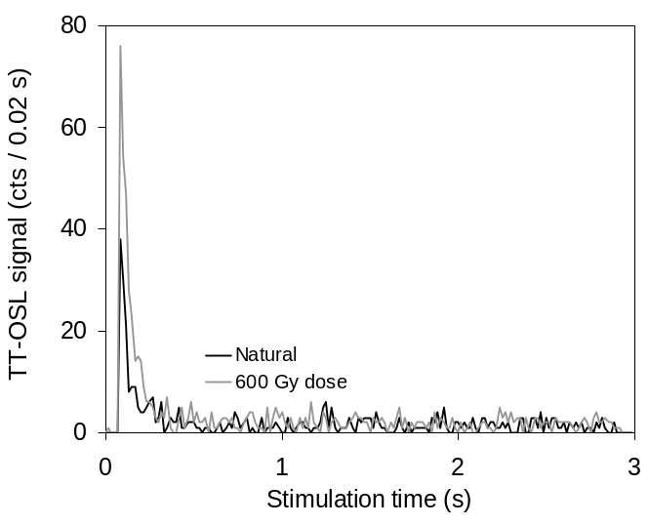
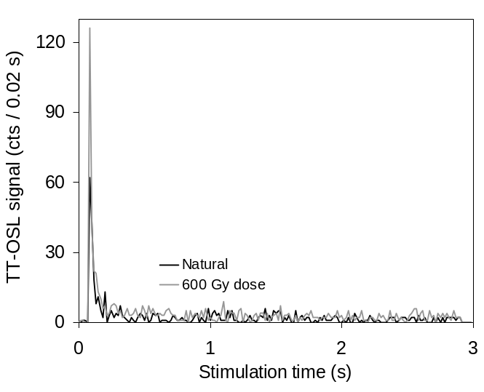
(b)
(a)
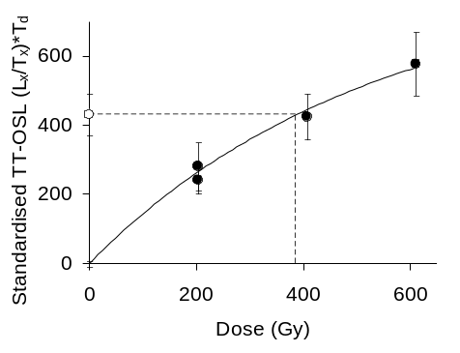
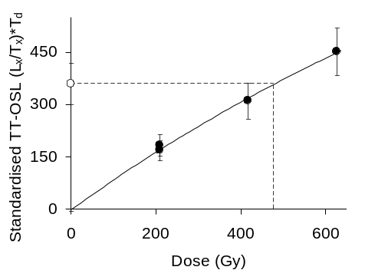
D₀ = 520 ± 120 Gy

D_{e} = 390 ± 111 Gy
D₀ = 1470 ± 390 Gy

D_{e} = 488 ± 91 Gy

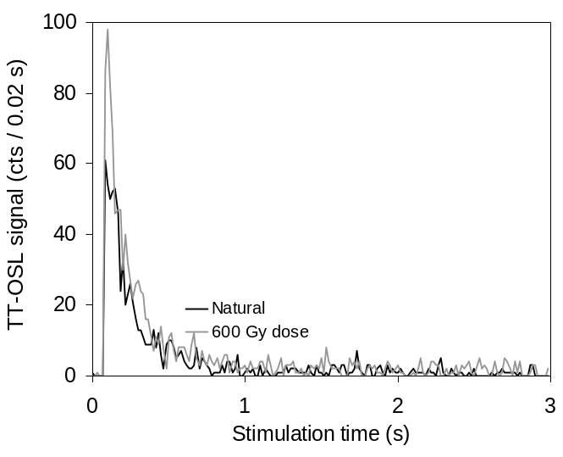
(d)
(c)
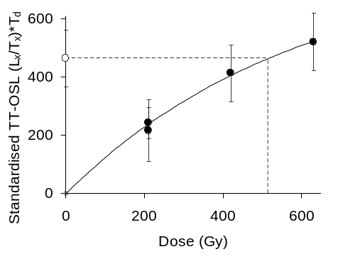
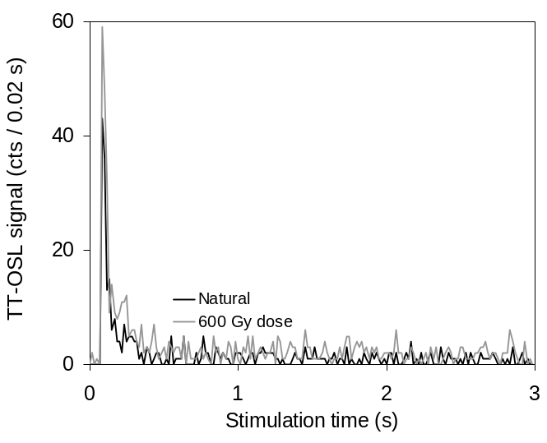
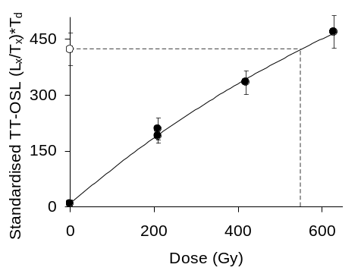
D₀ = 600 ± 205 Gy

D_{e} = 535 ± 157 Gy
D₀ = 1040 ± 290 Gy

D_{e} = 554 ± 70 Gy

Figure S.2: Representative single-grain TT-OSL decay and dose-response curves. In the insets, the open circle denotes the sensitivity-corrected natural signal, and filled circles denote the sensitivity-corrected regenerative dose signals. The D₀ value characterises the rate of signal saturation with respect to administered dose and equates to the dose value for which the saturating exponential dose-response curve slope is 1/e (or ~ 0.37) of its initial value.

Individual D_{e} estimates are presented with their 1σ error ranges, which are derived from three sources of uncertainty: (i) a random uncertainty term arising from photon counting statistics for each TT-OSL measurement, calculated using Eq. 3 of Galbraith (2002); (ii) an empirically determined instrument reproducibility uncertainty of 1.9% for each single-grain measurement (calculated for the specific Risø reader used in this study and following the approach outlined in Jacobs et al., 2006a); and (iii) a dose-response curve fitting uncertainty determined using 1000 iterations of the Monte Carlo method described by Duller (2007) and implemented in Analyst v4.

SAR D_{e} validation tests
The suitability of the single-grain TT-OSL SAR protocol (Table S1) was assessed by performing a dose recovery test on sample LC19-10. For this purpose, a laboratory dose of 520 ± 10 Gy was added on top of the naturally accumulated dose for a subset of 800 grains (unbleached and dosed grains). This approach was adopted owing to the long durations of light exposure needed to bleach natural TT-OSL signals down to low residual levels (e.g., Demuro et al., 2015; Arnold et al., 2019). The dose recovery ratio was calculated by first adding the weighted mean natural TT-OSL D_{e} of the sample (i.e., 518 ± 18 Gy, as shown in Table 2 and determined from 1600 grains) to the weighted mean administered dose of the accepted grain population from the dose recovery test (520 ± 10 Gy). This was used to constrain the combined administered (natural + laboratory) dose being assessed in the dose recovery test. The measured (recovered) weighted mean D_{e} of the unbleached and dosed grains in the dose recovery test (1041 ± 38 Gy) was then divided by the combined administered (natural + laboratory) dose (1038 ± 21 Gy) to derive the measured-to-given dose ratio. A weighted mean TT-OSL measured-to-given dose ratio of 1.00 ± 0.04 was obtained using this approach, which supports the suitability of the chosen measurement conditions for dating this sample.

Dose rate determination
The external gamma and beta dose rates of sample LC19-10 have been calculated using a combination of in situ field gamma-ray spectrometry and low-level beta counting. Field gamma spectrometry measurements were performed at the optical dating sample position and elemental concentrations of K, U, and Th were determined from the field gamma-ray spectra using the ‘energy windows’ method described in Arnold et al. (2012b) and Duval & Arnold (2013). These elemental concentrations were then used to calculate the gamma dose rates, enabling us to capture any spatial heterogeneity in the surrounding (~30 cm diameter) gamma radiation field of each sample. External beta dose rates were determined from measurements made using a Risø GM-25-5 beta counter (Bøtter-Jensen & Mejdahl, 1988) on dried and homogenised, bulk sediments collected directly from the luminescence dating sampling position. This approach was used to ensure that beta dose rates were derived from sample sizes that closely approximate the very short (~2–3 mm) beta particle radiation fields affecting this sample. Background-subtracted count rates were measured for three aliquots of each sample and compared with net count rates obtained simultaneously for a loess sediment standard with known U, Th, and K concentrations (Potts et al., 2003).

The cosmic-ray dose rate was calculated using the approach described in Prescott & Hutton (1994), taking into consideration site altitude, geomagnetic latitude, and density, thickness and geometry of sediment overburden. A small, assumed internal (alpha plus beta) dose rate of 0.03 ± 0.01 Gy / ka has been included in the final dose rate calculation for this sample, based on published ²³⁸U and ²³²Th measurements for etched quartz grains from a range of locations (e.g., Mejdahl, 1987; Bowler et al., 2003; Jacobs et al., 2006b; Pawley et al., 2008; Lewis et al, 2020) and an alpha efficiency factor (a-value) of 0.04 ± 0.01 (Rees-Jones, 1995; Rees-Jones & Tite, 1997).

Radionuclide concentrations and specific activities have been converted to dose rates using the conversion factors given in Readhead (2002) and Guérin et al. (2011) (see footnotes of Table 2 for details), making allowance for beta-dose attenuation (Mejdahl, 1979; Brennan, 2003) and long-term sediment water content (Aitken, 1985; Readhead, 1987). An assumed long-term water content of 2.5% dry sediment weight has been used for the final dose rate calculation based on published values for similar beach and shoreline deposits elsewhere across KT-LE, Lake Callabonna and Lake Frome (Cohen et al., 2012, 2015, 2022; Gliganic et al., 2014, 2015). A 1σ relative uncertainty of 50% (100% at 2σ) has been assigned to the long-term moisture estimate to accommodate any variations in hydrologic conditions during burial.

Supplementary Note 2: Clumped isotope analyses (cont.)
The extremely high precision and accuracy required for clumped isotope analysis was achieved through more extensive carbon dioxide purification than traditional stable isotope analyses (Ghosh et al., 2006; Eiler et al., 2007; Kocken et al., 2019). CO₂ was extracted from mollusc samples by digestion of carbonate with phosphoric acid (H₃PO₃) at a constant temperature of 70°C. CO₂ purification was performed through the vacuum line by a combination of cryogenic and adsorptive means to remove possible contaminants, such as water, O₂, N₂, hydrocarbons, and halocarbons.

Clumped isotope analyses were performed at the University of Adelaide using a Nu Instruments Perspective-IS stable isotope ratio mass spectrometer, interfaced with the Nu Carb carbonate sample preparation system to measure Δ₄₇, δ¹³C, and δ¹⁸O for purified sample gas relative to a working gas of known isotopic composition (δ13C = ~7‰ VPDB, δ18O = ~28‰ VSMOW). Sample aliquots of 350-400 μg of finely powdered carbonate material were measured into individual sample vials and loaded into the Nu Carb sample carousel. Sample digestion was achieved through the injection of ~120 μL of ~104 % H₃PO₄ at 70°C for 10 minutes, before the resulting carbon dioxide progressed into a water trap held at -95°C. CO₂ gas was then passed through a trap packed with PorapakTM Q and cryogenically cooled to -34°C (Petersen et al., 2016). Purified CO₂ was then passed into a cryogenically cooled “frozen finger” and total gas yield was calculated using a pressure transducer before being transferred to a sample cold finger in the mass spectrometer’s dual inlet system.

Sample and reference gas were depleted at a constant rate during analysis, with active vacuum pumping performed at 150°C for 25 minutes to remove any contaminants from the adsorptive trap apparatus between each sample extraction. Measurement of purified CO₂ samples was performed by three acquisitions of sample and reference gas. 20 cycles were performed for each acquisition, with the initial beam set to 50 nA. Each cycle consisting of 20 seconds of integration and 8 seconds of changeover delay, with a total integration time of 1,200 seconds per sample.

Raw sample Δ₄₇ values were calculated using Equation 1, with R_{i} values were derived from the measured δ values for each isotopologue in the sample gas, relative to the working gas:
$$δ^{i}=\left[\frac{R_{i \left(sample gas\right)}}{R_{i \left(working gas\right)}}-1\right]×1000 (Eq. 2)$$

Uncertainty is reported as standard error:
$$σ_{\overline{x}}=\frac{σ}{\sqrt{n}} (Eq. 3)$$
where 𝑛 is the number of replicates.

Following analysis, data was screened for unrealistic raw Δ₄₇ measurements, with potentially contaminated or erroneous data removed from further analysis. Screening criteria included a cutoff for initial sample beam sizes at 100 nA, with smaller beam sizes typically indicating evolved CO2 leaking out of the sample vial. The number of rejected sample acquisition cycles (>10) was also used to screen isotope data. Conversion into the I-CDES reference frame was achieved through calibration of raw Δ₄₇ measurements against measurements of ETH (distributed by S. Bernasconi from ETH Zürich) and New Carrara Marble (NCM) standards (Dennis et al., 2011; Meckler et al., 2014; Bernasconi et al. 2018, 2021). An internal standard (P3) was also used for calibration of sample δ¹⁸O and δ¹³C measurements.

ETH standards 1-3 were used to correct data for pressure baseline (PBL) effects (Bernasconi et al., 2013; Meckler et al., 2014; Petersen et al., 2019) and to normalise raw Δ₄₇ measurements into the absolute reference frame (Dennis et al., 2011) and project into the I-CDES standardisation scheme (Anderson et al., 2021; Bernasconi et al., 2021; Daëron, 2021), with raw data projected into the I-CDES reference frame using the D47crunch python program (Daëron, 2021). ETH-4 was excluded in favour of an additional ETH-3 standards to increase sample Δ₄₇ precision (Kocken et al., 2019). Conversion of raw measurements to the absolute reference frame was necessary to allow inter-laboratory comparison of results (Dennis et al., 2011; Bernasconi et al., 2018; Daëron, 2021). The “IUPAC” (International Union of Pure and Applied Chemistry) parameters for the abundance of heavy carbon and oxygen isotopes in the Vienna Pee Dee Belemnite and Vienna Standard Mean Ocean Water universal standards (as summarised by Brand et al., 2010) were used for the calculation of Δ₄₇ values (Daëron et al., 2016; Schauer et al., 2016; Kelson et al., 2017; Petersen et al., 2019). Precision for each of the analysed standards is shown in Table S.10, with a data processing summary for the combined analytical sessions shown in Table S.10.

Table S.10: Precision for clumped isotope standards.
Standard | n | Δ47_{raw} | Error
 |  | ‰ | ppm
ETH-1 | 55 | –0.6632 | 3.612
ETH-2 | 49 | –0.6556 | 4.148
ETH-3 | 128 | –0.2578 | 1.954
ETH-4 | 8 | –0.4496 | 3.231
NCM | 30 | –0.5460 | 3.783
P3 ANU | 41 | –0.3471 | 3.931

Table S.10: Data processing summary for all analysed samples. Values were calculated using the D47crunch python program (Daëron, 2021).
N samples | 32 (3 + 29)
N analyses | 470 (183 + 287)
Repeatability of d13C_VPDB | 18.0 ppm
Repeatability of d18O_VSMOW | 57.1 ppm
Repeatability of D47 (anchors) | 18.4 ppm
Repeatability of D47 (unknowns) | 18.1 ppm
Repeatability of D47 (all) | 18.2 ppm
Model degrees of freedom | 420
Student's 95% t-factor | 1.97
Standardization method | pooled

10 aliquots were prepared and analysed for each sample, with a total counting time of 12,000 seconds for the combined 10 aliquots. Δ₄₇, δ¹³C, and δ¹⁸O values were calculated as the arithmetic mean average of these 10 aliquots, after excluding any contaminated aliquots. Carbonate δ¹⁸O and δ¹³C values are reported relative to the Vienna Pee Dee belemnite standard (VPDB). Once converted to the absolute reference frame, sample formation temperatures (T(Δ₄₇)) were calculated using the calibration of Anderson et al. (2021):
$$∆_{47}=\left(0.0391±0.0004\right)×\frac{{10}^{6}}{T{(∆}_{47})^{2} }+\left(0.154±0.004\right) (Eq. 4)$$
where T(Δ₄₇) is the temperature in Kelvin (R² = 0.97).

In modern lakes, surface water temperature is consistently higher than mean annual air temperatures (MAAT). To correct for this effect in the palaeo-context, mollusc carbonate precipitation temperatures were converted to MAAT using the transfer function of Hren & Sheldon (2012), which is independent of latitude, elevation, the size of the water body, and annual climatic conditions:
$$MAAT=-0.0318×T_{water}^{2}+2.195×T_{water}-12.607 (Eq. 5)$$
where T_{water} is the mean annual water temperature and both MAAT and T_{water} are in °C (R² = 0.96).

Environmental water oxygen isotope compositions were calculated using the equation of Grossman & Ku (1986) for biogenic aragonite, as modified by Dettman et al. (1999):
$$1000\ln\left(α_{aragonite-water}\right)=2.599×\frac{{10}^{6}}{T^{2}}+0.715 (Eq. 6)$$
where T is degrees Kelvin (R² = 0.94). Environmental water δ¹⁸O values were then calculated using the following equation:
$$α_{aragonite-water}=\frac{\left(1000+δ^{18}O_{aragonite\left(VSMOW\right)}\right)}{\left(1000+δ^{18}O_{water\left(VSMOW\right)}\right)} (Eq. 7)$$
Environmental water δ¹⁸O values are reported relative to the Vienna Standard Mean Ocean Water standard (VSMOW). Errors were fully propagated using the uncertainty from previous Δ47 and T(Δ47) calculations.

Supplementary Note 3: Lake mollusc shells
As well as demarking the extent of ancient lakes, and thus past hydrology, palaeoshorelines preserve carbonate fossil remains, presenting an opportunity to apply Δ₄₇ thermometry for reconstructing past water and air temperatures. These data can be combined with the hydrological record to further unravel the interplay between past climate and hydrology in what is now an arid landscape.

The prosobranch gastropod genus Coxiella – most notably Coxiella (Coxielladda) gilesi – is abundant within the ancient shorelines of central Australian ephemeral lakes. The genus is endemic to Australia and the only gastropod genus to consist exclusively of halophilic species, although live specimens have not been recorded at lakes Callabonna, Frome, or KT-LE (Williams, 1981; Williams & Kokkinn (1988); Williams & Mellor, 1991; Lawrie et al., 2021). Coxiella ecology is poorly understood and individuals cannot be confidently identified to species level, despite its ubiquity and abundance within Australian salt lakes. Coxiella taxonomy has remaining largely unchanged since reviews by Macpherson (1957) and Kendrick (1978) (Williams & Mellor, 1991; Pinder et al., 2002; Timms, 2009; Lawrie et al., 2021). While overlapping geographical ranges are observed for some modern Coxiella species, it is hypothesised that different species rarely occur in the same water body (Lawrie et al., 2021).

Coxiella are osmoconformers, maintaining an internal salinity similar to their environment (Williams & Mellor, 1991). Observations of living individuals imply a salinity range between 10 and 70 gL⁻¹, with maximum and minimum conditions of 0.3 and 130 gL⁻¹, respectively (Timms, 1983; Williams et al., 1990; Williams & Mellor, 1991; Pinder et al., 2005). However, this salinity range does not necessarily indicate the optimal conditions for Coxiella reproduction and completion of their lifecycle (Hammer, 1986). Some species appear to favour different salinities within this range, but the extent to which Coxiella species vary in salinity tolerance is unclear (Lawrie et al., 2021).

The life histories of Coxiella species also remain largely unresolved. Species are dioecious and reproduce sexually, with individuals presumed to live up to 2 years (Williams & Mellor, 1991). Coxiella can aestivate as adults, remaining dormant during dry periods for at least 3 months, although the total time that an individual can survive while aestivated is unknown (De Deckker & Geddes, 1980; Williams, 1985). However, the maximum amount of time must be limited, as Coxiella are absent from episodic salt lakes, such as those in Australia’s arid interior (Williams, 1998). Coxiella diets are also largely unknown, with species hypothesised to feed on benthic algae or detritus (De Deckker, 1982; Bayly, 1993).

The duration for which ephemeral lakes hold water and inundation periodicity are likely important factors for Coxiella distributions (Williams & Mellor, 1991). Ephemerality has been suggested as the reason for Coxiella’s modern-day absence from most of central Australia, although sub-fossil deposits indicate it was once abundant (De Deckker & Last, 1988). Coxiella are not homogenously distributed throughout some lake bodies, with adults observed at depths of up to 6 m and juveniles at depths of up to ~25 m in Lake Bullen Merri, Victoria, which has been speculated to reflect downward migration of juveniles following reproduction in shallow regions (Timms, 1976). Different distributions for adults and juveniles are not apparent for all modern lakes, including the shallow and ephemeral Lake Tallinga, South Australia (Williams & Mellor, 1991). For most ephemeral lakes, Coxiella are more abundant near the shore, implying active movement and/or passive shell displacement (Williams & Mellor, 1991). Upon death, Coxiella are believed to either float or be windblown to shore, where their remains accumulate (De Deckker et al., 2011).

Mollusc shells have previously been used for clumped isotope analysis (Henkes et al., 2013; Wang et al., 2016, 2021; Falster et al., 2019), although no clumped isotope studies have been conducted for central Australian lake shells. Previous work on terrestrial molluscs has shown that clumped isotope temperatures are not always accurate indicators of air temperature, largely due to their bias towards growing in more habitable microhabitats or times of year/day (Falster et al., 2019). For aquatic molluscs, these concerns should not be as marked, since water temperatures are not as variable as air temperatures. However, seasonal or spatial biases still need to be considered.

In these lakes, mollusc growth periods are usually tied to periods of greater algal production and abundant food sources during spring, with lake productivity and molluscan growth generally decreasing with depleted nutrients, excessive temperatures, excessive light (photoinhibition), and high salinity (e.g. Purton & Brasier, 1997; Dettman et al., 1999; Goodwin et al., 2003; Versteegh et al., 2010). It is entirely feasible that this was different for the studied lakes during the last glacial cycle, however it is clear that these lakes underwent episodes of filling and subsequent drying and it is reasonable to assume that the best conditions for molluscan growth would have been during the relatively fresh and productive stages of lake filling.

References
Aitken, M.J., 1985. Thermoluminescence Dating. Academic Press, London.
Aitken, M.J., 1998. An Introduction to Optical Dating: The Dating of Quaternary Sediments by the Use of Photon-Stimulated Luminescence. Oxford University Press, Oxford.
Anderson, N.T., Kelson, J.R., Kele, S., Daëron, M., Bonifacie, M., Horita, J., Mackey, T.J., John, C.M., Kluge, T., Petschnig, P., Jost, A.B., Huntington, K.W., Bernasconi, S.M., Bergmann, K. D., 2021. A unified clumped isotope thermometer calibration (0.5-1000°C) using carbonate-based standardization. Geophysical Research Letters 48. https://doi.org/10.1029/2020GL092069
Arnold, L.J., Demuro, M., Navazo Ruiz, M., 2012a. Empirical insights into multi-grain averaging effects from ‘pseudo’ single-grain OSL measurements. Radiation Measurements 47, 652–658. https://doi.org/10.1016/j.radmeas.2012.02.005
Arnold, L.J., Duval, M., Falguères, C., Bahain, J.-J., Demuro, M., 2012b. Portable gamma spectrometry with cerium-doped lanthanum bromide scintillators: Suitability assessments for luminescence and electron spin resonance dating applications. Radiation Measurements 47, 6–18. https://doi.org/10.1016/j.radmeas.2011.09.001
Arnold, L.J., Demuro, M., Parés, J.M., Arsuaga, J.L., Aranburu, A., Bermúdez de Castro, J.M., Carbonell, E. 2014. Luminescence dating and palaeomagnetic age constraint on hominins from Sima de los Huesos, Atapuerca, Spain. Journal of Human Evolution 67, 85–107. https://doi.org/10.1016/j.jhevol.2013.12.001
Arnold, L.J., Demuro, M., Spooner, N.A., Prideaux, G.J., McDowell, M.C., Camens, A.B., Reed, E.H., Parés, J.M., Arsuaga, J.L., Bermúdez de Castro, J.M., Carbonell, E., 2019. Single-grain TT-OSL bleaching characteristics: Insights from modern analogues and OSL dating comparisons. Quaternary Geochronology 49, 45–51. https://doi.org/10.1016/j.quageo.2018.01.004
Bayly, I., 1993. The fauna of athalassic saline waters in Australia and the Altiplano of South America: comparisons and historical perspectives. Hydrobiologia 267, 225–231. https://doi.org/10.1007/BF00018804
Bernasconi, S.M., Daëron, M., Bergmann, K.D., Bonifacie, M., Meckler, A.N., Affek, H.P., Anderson, N., Bajnai, D., Barkan, E., Beverly, E., Blamart, D., Burgner, L., Calmels, D., Chaduteau, C., Clog, M., Davidheiser-Kroll, B., Davies, A., Dux, F., Eiler, J., Elliott, B., Fetrow, A.C., Fiebig, J., Goldberg, S., Hermoso, M., Huntington, K.W., Hyland, E., Ingalls, M., Jaggi, M., John, C.M., Jost, A.B., Katz, S., Kelson, J., Kluge, T., Kocken, I.J., Laskar, A., Leutert, T.J., Liang, D., Lucarelli, J., Mackey, T.J., Mangenot, X., Meinicke, N., Modestou, S.E., Müller, I.A., Murray, S., Neary, A., Packard, N., Passey, B.H., Pelletier, E., Petersen, S., Piasecki, A., Schauer, A., Snell, K.E., Swart, P.K., Tripati, A., Upadhyay, D., Vennemann, T., Winkelstern, I., Yarian, D., Yoshida, N., Zhang, N., Ziegler, M., 2021. InterCarb: A community effort to improve interlaboratory standardization of the carbonate clumped isotope thermometer using carbonate standards. Geochemistry, Geophysics, Geosystems 22, e2020GC009588. https://doi.org/10.1029/2020GC009588
Bernasconi, S.M., Hu, B., Wacker, U., Fiebig, J., Breitenbach, S.F.M., Rutz, T., 2013. Background effects on Faraday collectors in gas-source mass spectrometry and implications for clumped isotope measurements. Rapid Communications in Mass Spectrometry 27, 603–612. https://doi.org/10.1002/rcm.6490
Bernasconi, S.M., Müller, I.A., Bergmann, K.D., Breitenbach, S.F.M., Fernandez, A., Hodell, D. A., Jaggi, M., Meckler, A. N., Millan, I., Ziegler, M., 2018. Reducing uncertainties in carbonate clumped isotope analysis through consistent carbonate-based standardization. Geochemistry, Geophysics, Geosystems 19, 2895–2914. https://doi.org/10.1029/2017GC007385
Bøtter-Jensen, L., Mejdahl, V., 1988. Assessment of beta dose-rate using a GM multicounter system. International Journal of Radiation Applications and Instrumentation. Part 14, 187–191.
Bowler, J.M., Johnston, H., Olley, J.M., Prescott, J.R., Roberts, R.G., Shawcross, W., Spooner, N.A., 2003. New ages for human occupation and climatic change at Lake Mungo, Australia. Nature 421, 837–840. https://doi.org/10.1038/nature01383
Brennan, B.J., 2003. Beta doses to spherical grains. Radiation Measurements 37, 299–303.
Cohen, T.J., Nanson, G.C., Jansen, J.D., Jones, B.G., Jacobs, Z., Larsen, J.R., May, J.-H., Treble, P., Price, D.M., Smith, A.M., 2012. Late Quaternary mega-lakes fed by the northern and southern river systems of central Australia: Varying moisture sources and increased continental aridity. Palaeogeography, Palaeoclimatology, Palaeoecology 356, 89–108. https://doi.org/10.1016/j.palaeo.2011.06.023
Cohen, T.J., Jansen, J.D., Gliganic, L.A., Larsen, J.R., Nanson, G.C., May, J.-H., Jones, B.G., Price, D.M., 2015. Hydrological transformation coincided with megafaunal extinction in central Australia. Geology 43, 195–198. https://doi.org/10.1130/G36346.1
Cohen, T.J., Arnold, L.J., Gázquez, F., May, J.-H., Marx, S., Jankowski, N., Chivas, A.R., Garcia, A., Cadd, H., Parker, A.G., Jansen, J.D., Fu, X., Waldmann, N., Nanson, G., Jones, B.G., Gadd, P., 2022. Late Quaternary climate change in Australia's arid interior: Evidence from Kati Thanda – Lake Eyre. Quaternary Science Reviews 292, 107635. https://doi.org/10.1016/j.quascirev.2022.107635
Daëron, M., 2021. Full propagation of analytical uncertainties in Δ₄₇ measurements. Geochemistry, Geophysics, Geosystems 22, e2020GC009592. https://doi.org/10.1029/2020GC009592
Daëron, M., Blamart, D., Peral, M., Affek, H.P., 2016. Absolute isotopic abundance ratios and the accuracy of Δ₄₇ measurements. Chemical Geology 442, 83–96. https://doi.org/10.1016/j.chemgeo.2016.08.014
De Deckker, P., 1982. Holocene ostracods, other invertebrates and fish remains from cores of four maar lakes in southeastern Australia. Proceedings of the Royal Society of Victoria 94, 183–220.
De Deckker, P., Geddes, M., 1980. Seasonal fauna of ephemeral saline lakes near the Coorong Lagoon, South Australia. Marine and Freshwater Research 31, 677–699. https://doi.org/10.1071/MF9800677
De Deckker, P., Last, W.M., 1988. Modern dolomite deposition in continental, saline lakes, western Victoria, Australia. Geology 16, 29–32.
De Deckker, P., Magee, J.W., Shelley, J.M.G., 2011. Late Quaternary palaeohydrological changes in the large playa Lake Frome in central Australia, recorded from the Mg/Ca and Sr/Ca in ostracod valves and biotic remains. Journal of Arid Environments 75, 38–50. https://doi.org/10.1016/j.jaridenv.2010.08.004
Defliese, W.F., Hren, M.T., Lohmann, K.C., 2015. Compositional and temperature effects of phosphoric acid fractionation on Δ₄₇ analysis and implications for discrepant calibrations. Chemical Geology 396, 51–60. https://doi.org/10.1016/j.chemgeo.2014.12.018
Demuro, M., Arnold, L.J., Froese, D., Roberts, R.G. 2013. OSL dating of loess bracketing Sheep Creek tephra beds, northwest Canada: Dim and problematic single-grain OSL characteristics and their effect on multi-grain age estimates. Quaternary Geochronology 15, 67–87. https://doi.org/10.1016/j.quageo.2012.11.003
Demuro, M., Arnold, L.J., Parés, J.M., Pérez-González, A., Ortega, A.I., Arsuaga, J.L., Bermúdez De Castro, J.M., Carbonell, E., 2014. New luminescence ages for the Galería Complex archaeological site: Resolving chronological uncertainties on the Acheulean record of the Sierra de Atapuerca, Northern Spain. PLoS ONE 9: e110169. https://doi.org/10.1371/journal.pone.0110169
Demuro, M., Arnold, L.J., Parés, J.M., Sala, R., 2015. Extended-range luminescence chronologies suggest potentially complex bone accumulation histories at the Early-to-Middle Pleistocene palaeontological site of Huéscar-1 (Guadix-Baza basin, Spain). Quaternary International 389, 191–212. https://doi.org/10.1016/j.quaint.2014.08.035
Demuro, M., Arnold, L.J., Aranburu, A., Gómez-Olivencia, A., Arsuaga, J.L., 2019a. Single-grain OSL dating of the Middle Palaeolithic site of Galería de las Estatuas, Atapuerca (Burgos, Spain). Quaternary Geochronology 49, 254–261. https://doi.org/10.1016/j.quageo.2018.02.006
Demuro, M., Arnold, L.J., Aranburu, A., Sala, N., Arsuaga, J.L., 2019b. New bracketing luminescence ages constrain the Sima de los Huesos hominin fossils (Atapuerca, Spain) to MIS 12. Journal of Human Evolution 131, 76–95. https://doi.org/10.1016/j.jhevol.2018.12.003
Dennis, K.J., Affek, H.P., Passey, B.H., Schrag, D.P., Eiler, J.M. (2011). Defining an absolute reference frame for 'clumped' isotope studies of CO₂. Geochimica et Cosmochimica Acta 75, 7117–7131. https://doi.org/10.1016/j.gca.2011.09.025
Dettman, D.L., Reische, A.K., Lohmann, K.C., 1999. Controls on the stable isotope composition of seasonal growth bands in aragonite fresh-water bivalves (unionidae). Geochimica et Cosmochimica Acta 63, 1049–1057. https://doi.org/10.1016/S0016-7037(99)00020-4
Duller, G.A.T., 2003. Distinguishing quartz and feldspar in single grain luminescence measurements. Radiation Measurements 37, 161–165. https://doi.org/10.1016/S1350-4487(02)00170-1
Duller, G.A.T., 2007. Assessing the error on equivalent dose estimates derived from single aliquot regenerative dose measurements. Ancient TL 25, 15–24.
Duval, M., Arnold, L.J. 2013. Field gamma dose-rate assessment in natural sedimentary contexts using LaBr3(Ce) and NaI(Tl) probes: A comparison between the "threshold" and "windows" techniques. Applied Radiation and Isotopes 74, 36–45. https://doi.org/10.1016/j.apradiso.2012.12.006
Eiler, J.M., 2007. “Clumped-isotope” geochemistry – The study of naturally-occurring, multiply-substituted isotopologues. Earth and Planetary Science Letters 262, 309–327. https://doi.org/10.1016/j.epsl.2007.08.020
Falster, G., Tyler, J., Dux, F., Kluge, T., Drysdale, R., Tibby, J., Reed, L., 2019. Clumped isotopes in freshwater snail shells: A new quantitative temperature proxy for Australia, and its application to fossil Glyptophysa shells from Blanche Cave. PhD thesis, University of Adelaide
Galbraith, R.F., 2002. A note on the variance of a background-corrected OSL count. Ancient TL 20, 49–51.
Ghosh, P., Adkins, J., Affek, H., Balta, B., Guo, W., Schauble, E.A., Schrag, D., Eiler, J.M., 2006. ¹³C–¹⁸O bonds in carbonate minerals: A new kind of paleothermometer. Geochimica et Cosmochimica Acta 70, 1439–1456. https://doi.org/10.1016/j.gca.2005.11.014
Gliganic, L.A., Cohen, T.J., May, J.-H., Jansen, J.D., Nanson, G.C., Dosseto, A., Larsen, J.R., Aubert, M., 2014. Late-Holocene climatic variability indicated by three natural archives in arid southern Australia. The Holocene 254, 104–117. https://doi.org/10.1177/0959683613515732
Gliganic, L.A., May, J.-H., Cohen, T.J., 2015. All mixed up: Using single-grain equivalent dose distributions to identify phases of pedogenic mixing on a dryland alluvial fan. Quaternary International 362, 23–33. https://doi.org/10.1016/j.quaint.2014.07.040
Goodwin, D.H., Schöne, B.R., Dettman, D.L., 2003. Resolution and fidelity of oxygen isotopes as paleotemperature proxies in bivalve mollusk shells: Models and observations. Palaios 18, 110–125. https://doi.org/10.1669/0883-1351(2003)18<110:RAFOOI>2.0.CO;2
Guérin, G., Mercier, M., Adamiec, G., 2011. Dose-rate conversion factors: update. Ancient TL 29, 5–8.
Henkes, G.A, Passey, B.H., Wanamaker JR., A.D., Grossman, E.L., Ambrose JR., W.G., Carroll, M.L., 2013. Carbonate clumped isotope compositions of modern marine mollusk and brachiopod shells. Geochimica et Cosmochimica Acta 106, 307–325. https://doi.org/10.1016/j.gca.2012.12.020
Hren, M.T., Sheldon, N.D., 2012. Temporal variations in lake water temperature: Paleoenvironmental implications of lake carbonate δ¹⁸O and temperature records. Earth and Planetary Science Letters 337, 77–84. https://doi.org/10.1016/j.epsl.2012.05.019
Jacobs, Z., Duller, G.A.T., Wintle, A.G., 2006a. Interpretation of single-grain D_{e} distributions and calculation of D_{e}. Radiation Measurements 41, 264–277. https://doi.org/10.1016/j.radmeas.2005.07.027
Jacobs, Z., Duller, G.A.T., Wintle, A.G., Henshilwood, C.S., 2006b Extending the chronology of deposits at Blombos Cave, South Africa, back to 140 ka using optical dating of single and multiple grains of quartz. Journal of Human Evolution 51, 255–273. https://doi.org/10.1016/j.jhevol.2006.03.007
Kelson, J.R., Huntington, K.W., Schauer, A.J., Saenger, C., Lechler, A.R., 2017. Toward a universal carbonate clumped isotope calibration: Diverse synthesis and preparatory methods suggest a single temperature relationship. Geochimica et Cosmochimica Acta 197, 104–131. https://doi.org/10.1016/j.gca.2016.10.010
Kendrick, G.W., 1978. New species of fossil nonmarine molluscs from Western Australia and evidence of late Quaternary climatic change in the Shark Bay district. Journal of the Royal Society of Western Australia 60, 49–60.
Kocken, I.J., Müller, I.A., Ziegler, M., 2019. Optimizing the Use of Carbonate Standards to Minimize Uncertainties in Clumped Isotope Data. Geochemistry, Geophysics, Geosystems 20, 5565–5577. https://doi.org/10.1029/2019GC008545
Lawrie, A.D., Chaplin, J., Pinder, A., 2021. Biology and conservation of the unique and diverse halophilic macroinvertebrates of Australian salt lakes. Marine and Freshwater Research 72, 1553–1576. https://doi.org/10.1071/MF21088
Lewis, R., Tibby, J., Arnold, L.J., Barr, C., Marshall, J., McGregor, G., Gadd, P., Yokoyama, Y., 2020. Insights into subtropical Australian aridity from Welsby Lagoon, North Stradbroke Island, over the past 80,000 years. Quaternary Science reviews 234, 106262. https://doi.org/10.1016/j.quascirev.2020.106262
Macpherson, J., 1957. A review of the genus Coxiella Smith, 1894, sensu lato. Western Australian Naturalist 5, 191–204.
McInerney, P.L., Arnold, L.J., Burke, C., Camens, A.B., Worthy, T.H., 2022. Multiple occurrences of pathologies suggesting a common and severe bone infection in a population of the Australian Pleistocene giant, Genyornis newtoni (Aves, Dromornithidae). Papers in Palaeontology 8, e1415. https://doi.org/10.1002/spp2.1415
Meckler, A.N., Ziegler, M., Millan, M.I., Breitenbach, F.M., Bernasconi, S.M., 2014. Long-term performance of the Kiel carbonate device with a new correction scheme for clumped isotope measurements. Rapid Communications in Mass Spectrometry 28, 1705–1715. https://doi.org/10.1002/rcm.6949
Mejdahl, V., 1979. Thermoluminescence dating: beta-dose attenuation in quartz grains. Archaeometry 21, 61–72.
Mejdahl, V., 1987. Internal radioactivity in quartz and feldspar grains. Ancient TL 5, 10–17.
Pawley, S.M., Bailey, R.M., Rose, J., Moorlock, B.S.P., Hamblin, R.J.O., Booth, S.J., Lee, J.R., 2008. Age limits on Middle Pleistocene glacial sediments from OSL dating, north Norfolk, UK. Quaternary Science Reviews 27, 1363–1377. https://doi.org/10.1016/j.quascirev.2008.02.013
Petersen, S.V., Defliese., W.F., Saenger, C., Daëron, M., Huntington, K.W., John, C.M., Kelson, J.R., Bernasconi, S.M., Colman, A.S., Kluge, T., Olack, G.A., Schauer, A.J., Bajnai, D., Bonifacie, M., Breitenbach, S.F.M., Fiebig, J., Fernandez, A.B., Henkes, G.A., Hodell, D., Katz, A., Kele, S., Lohmann, K.C., Passey, B.H., Peral, M.Y., Petrizzo, D.A., Roenheim, B.E., Tripati, A., Venturelli, R., Young, E.D., Winkelstern, I.Z., 2019. Effects of improved ¹⁷O correction on interlaboratory agreement in clumped isotope calibrations, estimates of mineral‐specific offsets, and temperature dependence of acid digestion fractionation. Geochemistry, Geophysics, Geosystems 20, 3495–3519. https://doi.org/10.1029/2018GC008127
Petersen, S.V., Winkelstern, I.Z., Lohmann, K.C., Meyer, K.W., 2016. The effects of Porapak™ trap temperature on δ¹⁸O, δ¹³C, and Δ₄₇ values in preparing samples for clumped isotope analysis. Rapid Communications in Mass Spectrometry 30, 199–208. https://doi.org/10.1002/rcm.7438
Pinder, A.M., Halse, S.A., McRae, J.M., Shiel, R.J., 2005. Occurrence of aquatic invertebrates of the wheatbelt region of Western Australia in relation to salinity. Hydrobiologia 543, 1–24. https://doi.org/10.1007/S10750-004-5712-3
Pinder, A.M., Halse, S.A., Shiel, R.J., Cale, D.J., McRae, J.M., 2002. Halophile aquatic invertebrates in the wheatbelt region of south-western Australia. Internationale Vereinigung für theoretische und angewandte Limnologie, Verhandlungen 28, 1687–1694. https://doi.org/10.1080/03680770.2001.11901909
Potts, P.J., Thompson, M., Chenery, S.R.N., Webb, P.C., Kasper, H.U., 2003. Geopt13 - An International Proficiency Test for Analytical Geochemistry Laboratories - Report on Round 13 / July 2003 (Köln Loess). International Association of Geoanalysts.
Prescott, J.R., Hutton, J.T., 1994. Cosmic ray contributions to dose rates for luminescence and ESR dating: Large depths and long-term time variations. Radiation Measurements 23, 497–500. https://doi.org/10.1016/1350-4487(94)90086-8
Purton, M., Brasier, M., 1997. Gastropod carbonate δ¹⁸O and δ¹³C values record strong seasonal productivity and stratification shifts during the late Eocene in England. Geology 25, 871–874. https://doi.org/10.1130/0091-7613(1997)025<0871:GCOACV>2.3.CO;2
Readhead, M.L., 1987. Thermoluminescence dose rate data and dating equations for the case of disequilibrium in the decay series. Nuclear Tracks and Radiation Measurements 13, 197–207.
Readhead, M.L., 2002. Absorbed dose fraction for ⁸⁷Rb β particles. Ancient TL 20, 25–28.
Rees-Jones, J., 1995. Optical dating of young sediments using fine-grain quartz. Ancient TL 13, 9–14.
Rees-Jones, J., Tite, M.S., 1997. Optical dating results for British archaeological sediments. Archaeometry 39, 177–187.
Schauer, A.J., Kelson, J., Saenger, C., Huntington, K.W., 2016. Choice of ¹⁷O correction affects clumped isotope (Δ₄₇) values of CO₂ measured with mass spectrometry. Rapid Communications in Mass Spectrometry 30, 2607–2616. https://doi.org/10.1002/rcm.7743
Timms, B.V., 1976. A comparative study of the limnology of three maar lakes in western Victoria. I. Physiography and physiochemical features. Marine and Freshwater Research 27, 35–60. https://doi.org/10.1071/MF9760035
Timms, B.V., 1983. A study of benthic communities in some shallow saline lakes of western Victoria, Australia. Hydrobiologia 105, 165–177. https://doi.org/10.1007/BF00025186
Timms, B.V., 2009. Study of the saline lakes of the Esperance Hinterland, Western Australia, with special reference to the roles of acidity and episodicity. Natural Resources and Environmental Issues 15, 215–224.
Versteegh, E.A.A., Vonhof, H.B., Troelstra, S.R., Kanndorp, R.J.G., Kroon, D., 2010. Seasonally resolved growth of freshwater bivalves determined by oxygen and carbon isotope shell chemistry. Geochemistry, Geophysics, Geosystems 11, 1525–2027. https://doi.org/10.1029/2009GC002961
Wang, X., Cui, L., Zhai, J., Ding, Z., 2016. Stable and clumped isotopes in shell carbonates of land snails Cathaica sp. and Bradybaena sp. in north China and implications for ecophysiological characteristics and paleoclimate studies. Geochemistry, Geophysics, Geosystems 17, 219–231. https://doi.org/10.1002/2015GC006182
Wang, Y., Passey, B., Roy, R., Deng, T., Jiang, S., Hannold, C., Wang, X., Lochner, E., Tripati, A., 2021. Clumped isotope thermometry of modern and fossil snail shells from the Himalayan- Tibetan Plateau: Implications for paleoclimate and paleoelevation reconstructions. Geological Society of America Bulletin 133, 1370–1380. https://doi.org/10.1130/B35784.1
Williams, W.D, Mellor, M.W., 1991. Ecology of Coxiella (Mollusca, Gastropoda, Prosobranchia), a snail endemic to Australian salt lakes. Palaeogeography, Palaeoclimatology, Palaeoecology 84, 339–355. https://doi.org/10.1016/0031-0182(91)90053-T
Williams, W.D., 1981. The limnology of saline lakes in Western Victoria. Hydrobiologia 81–82, 233–259. https://doi.org/10.1007/BF00048719
Williams, W.D., 1985. Biotic adaptations in temporary lentic waters, with special reference to those in semi-arid and arid regions. Hydrobiologia 125, 85–110. https://doi.org/10.1007/BF00045928
Williams, W.D., 1998. Salinity as a determinant of the structure of biological communities in salt lakes. Hydrobiologia 381, 191–201. https://doi.org/10.1023/A:1003287826503
Williams, W.D., Boulton, A., Taaffe, R., 1990. Salinity as a determinant of salt lake fauna: a question of scale. Hydrobiologia 197, 257–266. https://doi.org/10.1007/BF00026955
Williams, W.D., Kokkinn, M.J., 1988. The biogeographical affinities of the fauna in episodically filled salt lakes: A study of Lake Eyre South, Australia. Hydrobiologia 158, 227–236. https://doi.org/10.1007/BF00026280

