Supplementary information
Table S1. Colourimetric measurements of emulsion gels of various formulation.
Sample | L* | a* | b*
Oil-10% | 79.85 ±1.85ª | 0.10 ±0.06ª | 14.95 ±0.70ª
Oil-20% | 83.62 ±0.78^{b} | -0.12 ±0.10^{a,d} | 15.01 ±0.33ª
Oil-30% | 84.92 ±0.51^{b} | -0.05 ±0.07ª | 14.85 ±0.25ª
Oil-40% | 86.33 ±0.67^{c} | -0.04 ±0.06^{b} | 15.15 ±0.53ª
PS-4% | 81.83 ±0.49^{d} | 0.09 ±0.08^{c} | 13.90 ±0.33^{b, c}
PS-5% | 83.07 ±0.52^{d, e} | -0.12 ±0.05^{c} | 14.41 ±0.35^{b,c}
PS-6%* | 83.62 ±0.78e | -0.12 ±0.10^{c, d} | 15.01 ±0.33^{c}
PS-7% | 84.08 ±0.56e | 0.42 ±0.09^{c} | 13.48 ±0.25^{b}
KGM-0% | 80.90 ±1.14^{f} | 0.05 ±0.13^{d} | 15.19 ±0.18^{d}
PPI-0% | 68.65 ±1.31^{g} | -1.72 ±0.10e | 5.59 ±0.34e
PF-R | 79.60 ±2.11^{a, f} | 1.96 ±1.13^{f} | 5.24 ±1.32e
PF-C | 81.56 ±2.09^{a, b, d, f} | -1.79 ±0.43^{d, e} | 5.83 ±1.42e
BF-R | 74.55 ±1.27^{h} | 1.14 ±1.80^{g} | 14.00 ±2.63^{a, c, d}
BF-C | 71.98 ±1.61^{i} | -3.32 ±0.53^{h} | 22.22 ±1.06^{f}
* PS-6% is the same formulation with Oil-20% in this study.
** Superscript letter represents significant difference in ANOVA (p < 0.05).

Table S2. Texture profile analysis (TPA) of emulsion gels with different formulations.
Sample | Hardness (N) | Springiness (-) | Cohesiveness (-) | Chewiness (N)
Oil-10% | 155.46 ±24.61ª | 0.41 ±0.11ª | 0.35 ±0.10ª | 23.03 ±12.57ª
Oil-20% | 188.71 ±27.95ª | 0.39 ±0.05ª | 0.31 ±0.04^{a, c} | 23.54 ±7.69ª
Oil-30% | 279.16 ±5.39^{b} | 0.42 ±0.05ª | 0.34 ±0.03ª | 40.48 ±7.29ª
Oil-40% | 476.48 ±41.92^{c} | 0.41 ±0.06ª | 0.34 ±0.04ª | 65.31 ±10.73^{b}
PS-4% | 65.68 ±12.28^{d} | 0.28 ±0.02^{b} | 0.30 ±0.02^{b} | 5.45 ±1.26^{c}
PS-5% | 116.41 ±8.31^{d} | 0.31 ±0.01^{b} | 0.29 ±0.001^{b} | 10.44 ±0.80^{c}
PS-6% | 188.71 ±27.95e | 0.39 ±0.05^{c} | 0.31 ±0.04^{b, c} | 23.54 ±7.69^{d}
PS-7% | 313.28 ±54.97^{f} | 0.41 ±0.03^{c} | 0.34 ±0.04^{b} | 43.00 ±10.54e
PPI-0% | 252.73 ±19.6^{g} | 0.64 ±0.02^{d} | 0.39 ±0.05^{c} | 64.12 ±11.83^{f}
KGM-0% | 136.21 ±5.74^{h} | 0.29 ±0.03e | 0.20 ±0.01^{d} | 7.90 ±0.21^{g}
PF-C | 2624.42 ±84.11 | 0.48 ±0.06 | 0.47 ±0.15 | 523.79 ±225.82
BF-C | 3339.02 ±457.36 | 0.85 ±0.13 | 0.68 ±0.20 | 1912.27 ±563.81
* PS-6% is the same formulation with Oil-20% in this study.
** Superscript letter represents significant difference in ANOVA (p < 0.05). The comparison only include the emulsion gels prepared in the study.

Figure S1. Oil droplet size distribution in emulsion gels as affected by oil concentration (A), polysaccharide concentration (B), and zero PPI or KGM (C).

Figure S2. Diagram for sample without curdlan gum. This formulation is too soft to form stable emulsion gel and is not included in the subsequent characterizations.
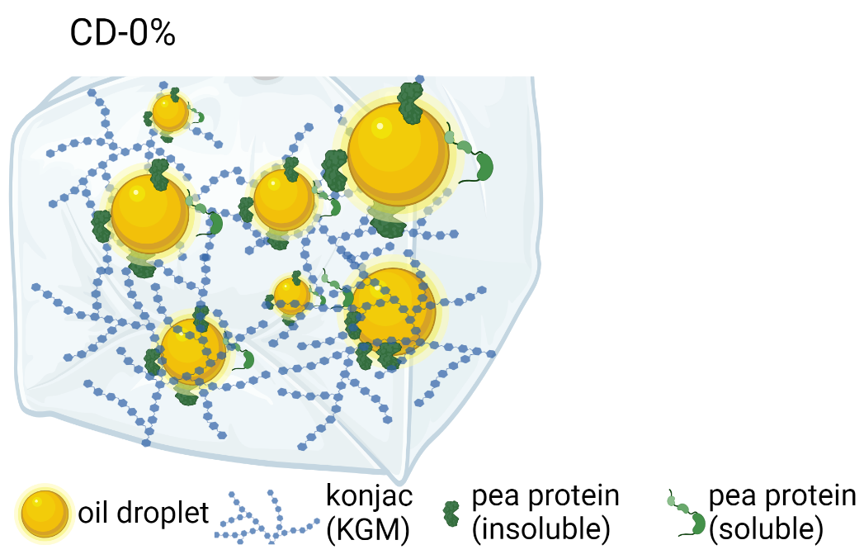

Figure S3. Average synchrotron-FTIR spectra as picked from the representative protein-rich, polysaccharide-rich, and lipid-rich areas from the mapping results, as influenced by the oil concentration. All the samples contain signature peaks for the three components.
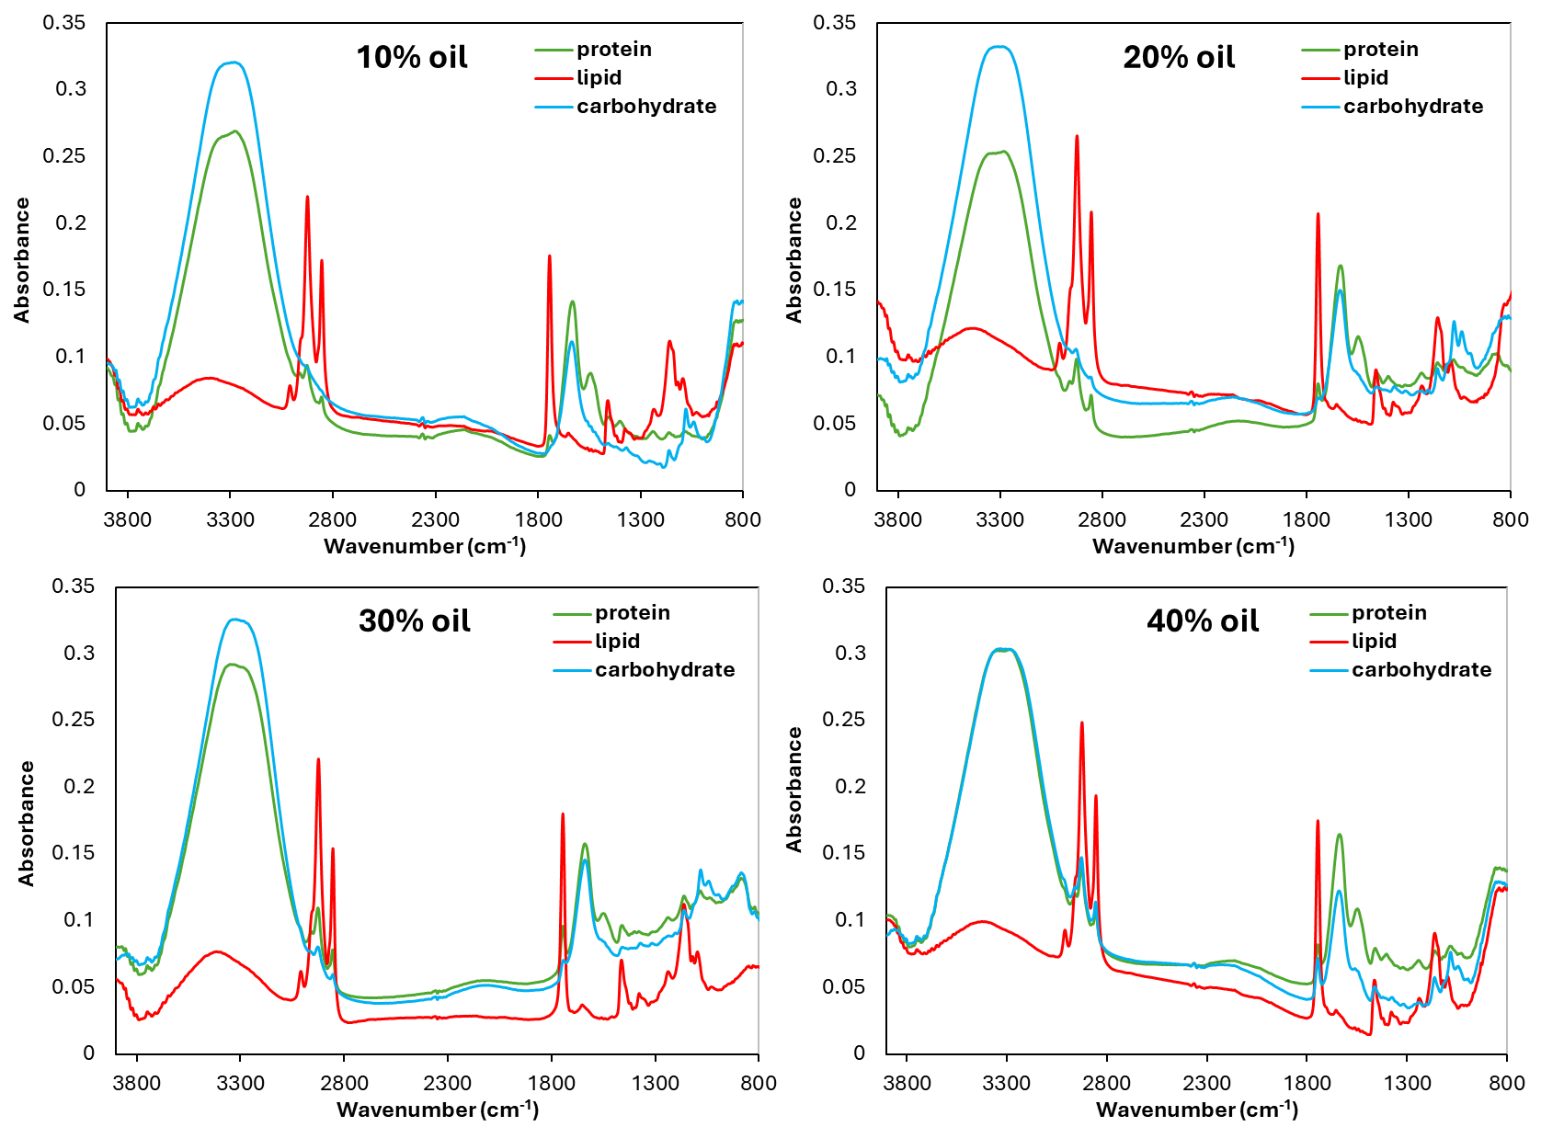
The lab-based Fourier-transform infrared (FT-IR) spectra of raw ingredients were obtained using a FT-NIR/IR spectrometer (Bruker IFS66/S, Billerica, USA) in the wavelength range of 400-4000 cm⁻¹ by the acquisition of 32 scans at a resolution of 4cm⁻¹.
Figure S4. Laboratory-based FTIR spectra of the key ingredients used in the emulsion gels (canola oil, curdlan gum, konjac glucomannan, and pea protein).
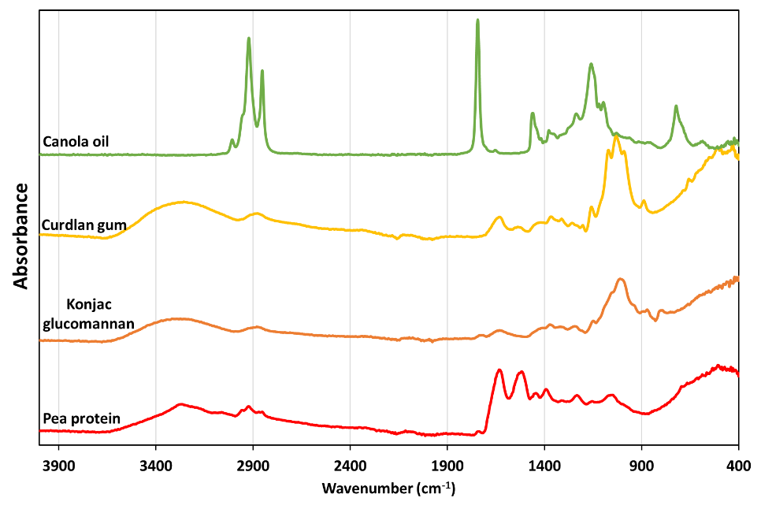
The results showed that both curdlan gum and konjac glucomannan have similar signature peaks, despite a minor difference around 900 cm⁻¹. We tried to use this unique peak to differentiate curdlan from KGM in the emulsion gel network, but the resolution is not significant enough. Therefore, we didn’t include separated results for curdlan and KGM in current study, but instead using carbohydrate as the category. It will be interesting to further investigate the differences between curdlan and KGM in emulsion gels, should suitable characterisation techniques be being available.

Figure S5. Complex viscosity of emulsion gels with different oil concentration upon heating and cooling (A); the Tan Delta value upon isothermal at 85 ºC and cooling down to 25 ºC (B).

Figure S6. Effects of heating temperatures on the gelling behaviour of emulsion gels (no KGM or no PPI) upon heating (up to 85 ºC), cooling (to 25 ºC) and isothermal (at 50 ºC and 85 ºC respectively): A. Storage modulus; B. Loss modulus; C. Tan Delta for heating and isothermal stages.

Figure S7. Complex viscosity from frequency sweep with SAOS range on emulsion gels with different oil concentrations (A), or different polysaccharide concentration (PS) (B).

Figure S8. Strain sweep curves of curdlan/KGM/pea protein emulsion gels in LAOS regime at different oil concentration; large strain modulus of emulsion gels (A); thickening ratio of emulsion gels (B).

