Supporting Information

Sc/Mg co-doping in Na₃Zr₂Si₂PO₁₂ Solid-state Electrolytes Enable Outstanding Performance of Sodium Metal Batteries

Xin Wang, Jiayang Li, Zewei Hu, Xinghan Li, Liyang Liu, Jiazhao Wang, Jung Ho Kim, Weijie Li*, Wei Kong Pang*, and Bernt Johannessen*

X. Wang, J. Li, X. Li, J. H. Kim, W. K. Pang, B. Johannessen
Faculty of Engineering and Information Sciences, University of Wollongong
NSW 2500, Australia
E-mail: wkpang@uow.edu.au

B. Johannessen
Australian Synchrotron, ANSTO, Clayton
VIC 3168, Australia
E-mail: berntj@ansto.gov.au

Z. Hu, L. Liu, W. Li
State Key Laboratory for Powder Metallurgy, Central South University
Changsha 410083, China
E-mail: li-306@csu.edu.cn

J. Wang
Wenzhou University Technology Innovation Institute for Carbon Neutralization
Wenzhou 325035, China

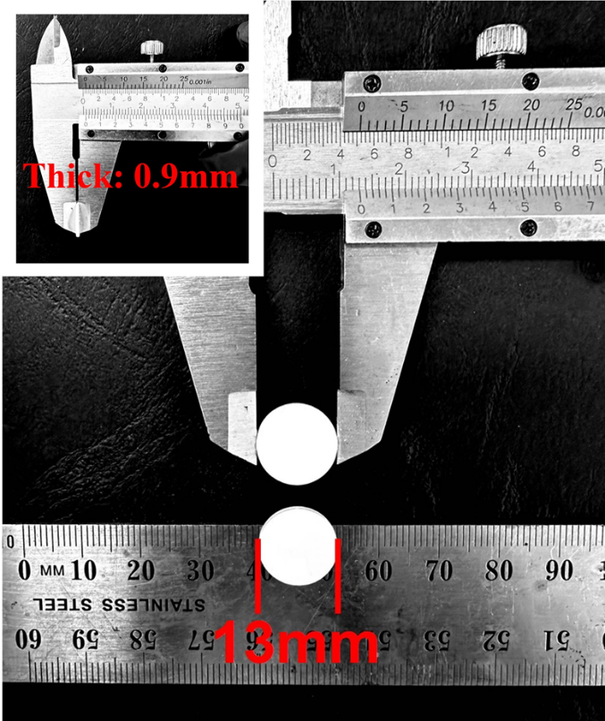
Figure S1. Diameter and thickness of obtained NZSP SSEs pellets

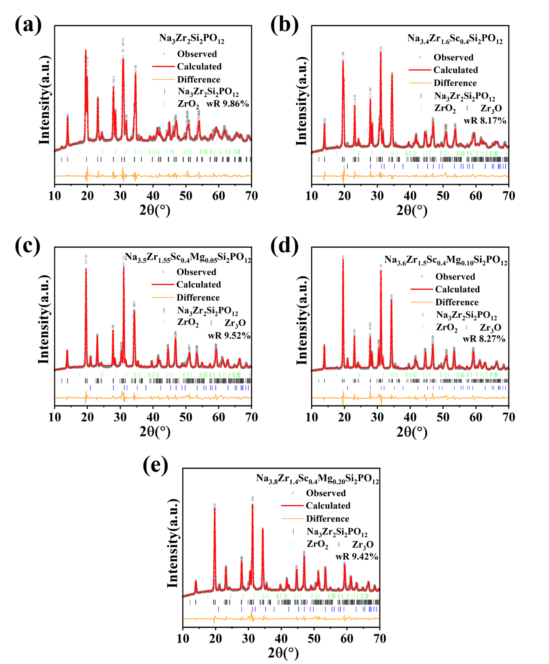
Figure S2. XRD Rietveld refinement of (a) Na₃Zr₂Si₂PO₁₂; (b) Na_{3.4}Zr_{1.6}Sc_{0.4}Si₂PO₁₂; (c) Na_{3.5}Zr_{1.55}Sc_{0.4}Mg_{0.05}Si₂PO₁₂; (d) Na_{3.6}Zr_{1.5}Sc_{0.4}Mg_{0.10}Si₂PO₁₂; (e) Na_{3.8}Zr_{1.4}Sc_{0.4}Mg_{0.20}Si₂PO₁₂ samples.

Table S1. Unit cell lattice parameters for the all samples obtained from XRD refinement analysis.
Solid state electrolytes | a (Å) | b (Å) | c (Å) | β (°) | V (Å³) | wR
NZSP | 15.634 | 8.988 | 9.278 | 124.765 | 1071.084 | 9.86%
NSZSP | 15.636 | 9.048 | 9.142 | 124.517 | 1065.648 | 8.17%
NSZSP-0.05Mg | 15.668 | 9.108 | 9.099 | 124.858 | 1065.460 | 9.52%
NSZSP-0.10Mg | 15.707 | 9.100 | 9.125 | 124.995 | 1068.475 | 8.27%
NSZSP-0.15Mg | 15.741 | 9.120 | 9.120 | 125.233 | 1069.317 | 9.44%
NSZSP-0.20Mg | 15.726 | 9.115 | 9.115 | 125.153 | 1068.503 | 9.42%

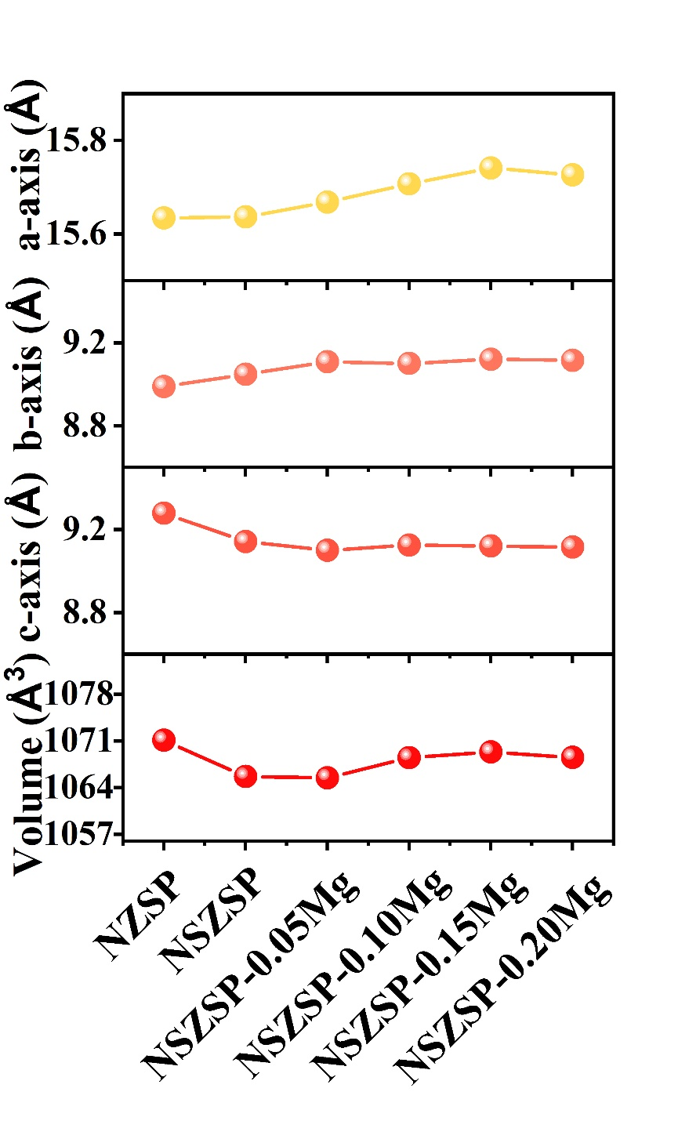
Figure S3. Variations in undoped and doped NZSP unit cell lattice parameters.

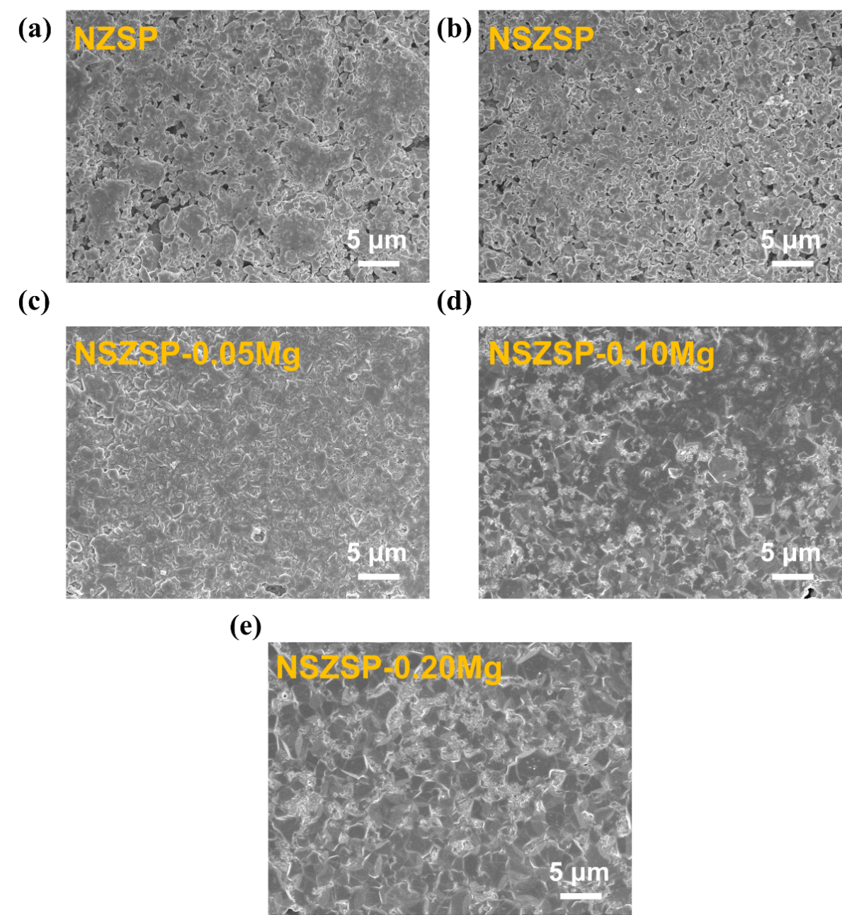
Figure S4. Top-view surface SEM images of (a) Na₃Zr₂Si₂PO₁₂; (b) Na_{3.4}Zr_{1.6}Sc_{0.4}Si₂PO₁₂; (c) Na_{3.5}Zr_{1.55}Sc_{0.4}Mg_{0.05}Si₂PO₁₂; (d) Na_{3.6}Zr_{1.5}Sc_{0.4}Mg_{0.10}Si₂PO₁₂; (e) Na_{3.8}Zr_{1.4}Sc_{0.4}Mg_{0.20}Si₂PO₁₂ samples.

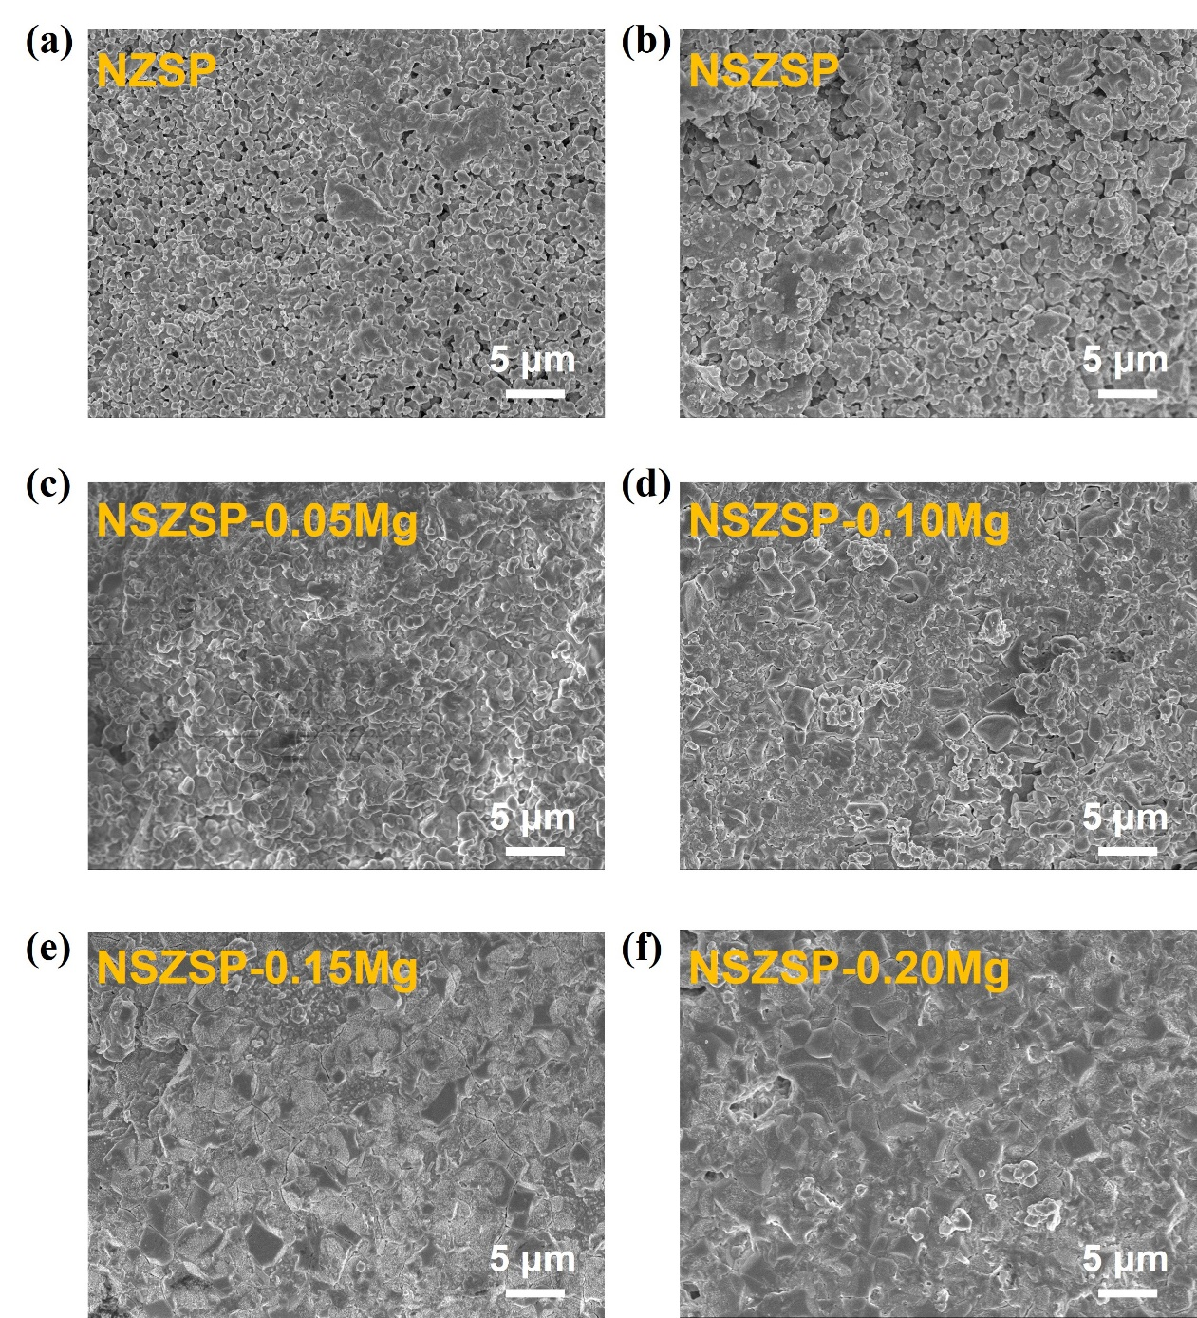
Figure S5. Cross-section view SEM images of (a) Na₃Zr₂Si₂PO₁₂; (b) Na_{3.4}Zr_{1.6}Sc_{0.4}Si₂PO₁₂; (c) Na_{3.5}Zr_{1.55}Sc_{0.4}Mg_{0.05}Si₂PO₁₂; (d) Na_{3.6}Zr_{1.5}Sc_{0.4}Mg_{0.10}Si₂PO₁₂; (e) Na_{3.7}Zr_{1.45}Sc_{0.4}Mg_{0.15}Si₂PO₁₂ ;(f) Na_{3.8}Zr_{1.4}Sc_{0.4}Mg_{0.20}Si₂PO₁₂ samples.

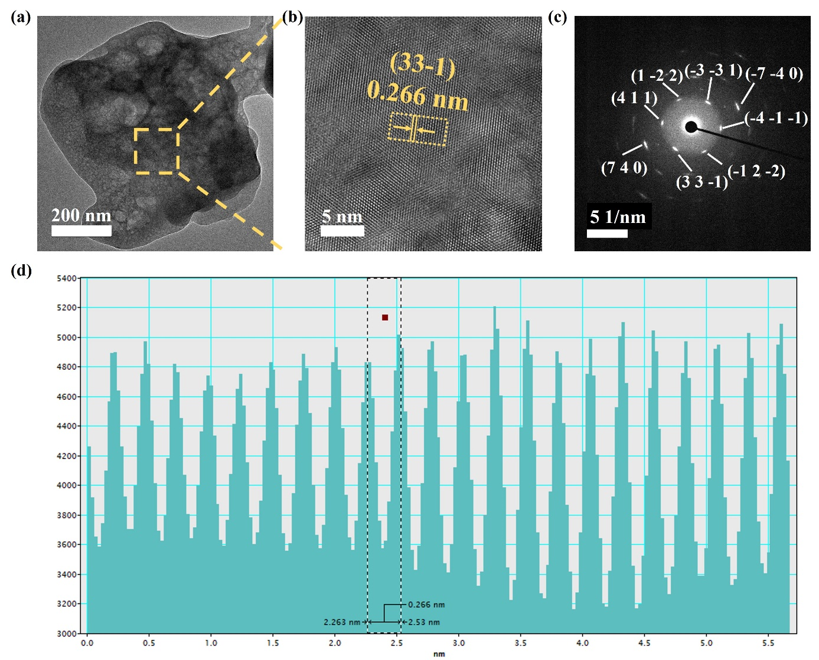
Figure S6. (a) TEM and (b) HRTEM of NSZSP-0.15Mg SSE. (c) SAED pattern. (d) The interplanar distances of (3 3 -1) planes.

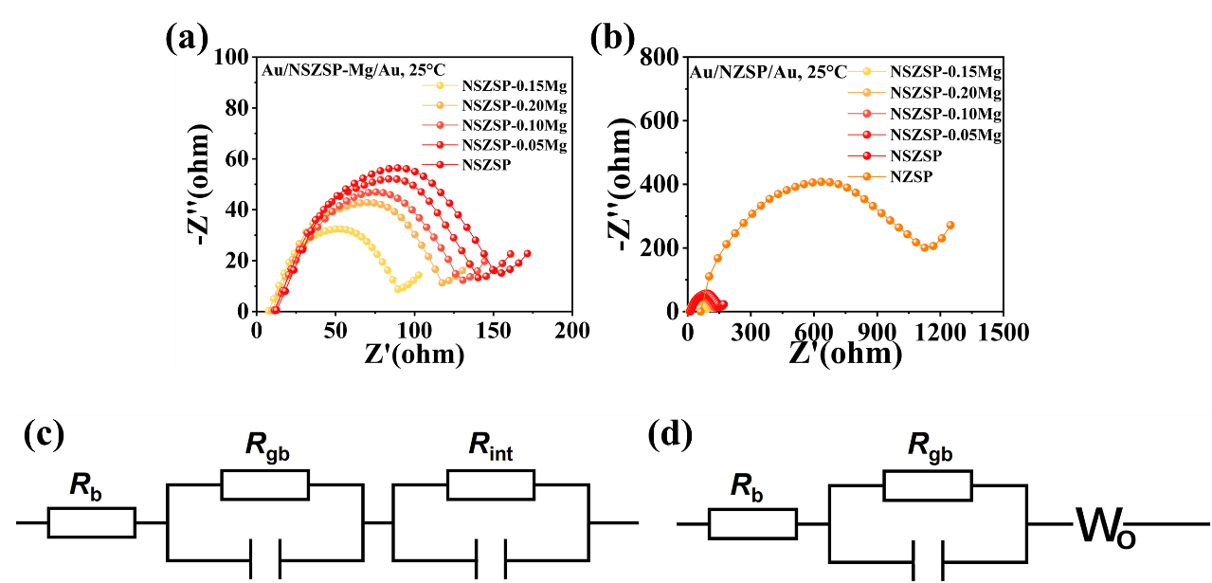
Figure S7. EIS measurements of the (a) NSZSP-xMg pellets and (b) NZSP pellet using Au film as blocking electrode for the determination of the conductivity. (c) and (d) Equivalent circuits for the battery cells.

Table S2. The resistances (R_{b}, R_{gb}, R_{t}) and conductivities (σ_{b}, σ_{gb}, σ_{t}) of the NSZSP-xMg and bare NZSP samples at 25℃.
Solid state electrolyte | NZSP | NSZSP | NSZSP-0.05Mg | NSZSP-0.10Mg | NSZSP-0.15Mg | NSZSP-0.20Mg
Bulk grain resistance (R_{b}) | 61.2 | 12.6 | 11.6 | 11.1 | 7.5 | 9.8
Grain boundary resistance (R_{gb}) | 1064.6 | 142.5 | 128.7 | 119.5 | 82 | 107.7
Total resistance (R_{t}) | 1125.8 | 155.1 | 140.3 | 130.6 | 89.5 | 117.5
Bulk conductivity (σ_{b}) | 1.9×10⁻³ | 9.1×10⁻³ | 9.9×10⁻³ | 1.0×10⁻² | 1.5×10⁻² | 1.2×10⁻²
Grain boundary conductivity (σ_{gb}) | 1.1×10⁻⁴ | 8.0×10⁻⁴ | 8.9×10⁻⁴ | 9.6×10⁻⁴ | 1.4×10⁻³ | 1.1×10⁻³
Total conductivity (σ_{t}) | 1.0×10⁻⁴ | 7.4×10⁻⁴ | 8.2×10⁻⁴ | 8.8×10⁻⁴ | 1.3×10⁻³ | 9.8×10⁻⁴

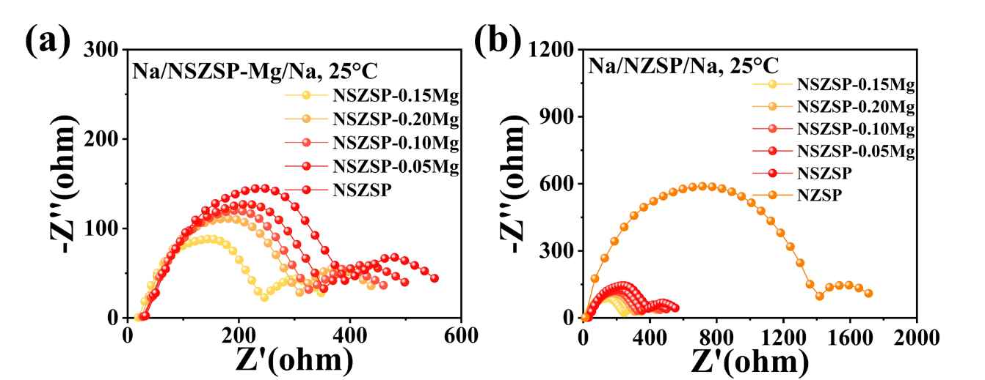
Figure S8. EIS measurements of the (a) NSZSP-Mg and (b) NZSP Na//NZSP//Na symmetric batteries at room temperature.

Table S3. The resistances (R_{b}, R_{gb}, R_{int}, R_{t}) of the Na//NZSP-xMg//Na and Na//NZSP//Na symmetric batteries at 25℃.
Solid state electrolyte | NZSP | NSZSP | NSZSP-0.05Mg | NSZSP-0.10Mg | NSZSP-0.15Mg | NSZSP-0.20Mg
Bulk grain resistance (R_{b}) | 11.6 | 32.6 | 29.8 | 27.7 | 19.4 | 24.8
Grain boundary resistance (R_{gb}) | 1406.0 | 358.1 | 323.1 | 298.1 | 226.7 | 284.8
Interface resistance (R_{int}) | 292.9 | 161.2 | 145.4 | 134.2 | 102.0 | 128.2
Total resistance (σ_{t}) | 1710.5 | 551.9 | 498.3 | 460.0 | 348.1 | 437.8

Table S4. The Time-resolved resistances (R_{b}, R_{gb}, R_{int}, R_{t}) of the NSZSP-0.15Mg and bare NZSP samples at 25℃.
Solid state electrolyte | NSZSP-0.15Mg Fresh | NSZSP-0.15Mg 2nd day | NSZSP-0.15Mg 4th day | NSZSP-0.15Mg 6th day | NSZSP-0.15Mg 8th day | NSZSP-0.15Mg 20th day | NZSP Fresh | NZSP  20th day
Bulk grain resistance (R_{b}) | 19 | 21 | 23 | 23 | 23 | 29 | 5 | 23
Grain boundary resistance (R_{gb}) | 246 | 270 | 295 | 300 | 302 | 369 | 567 | 2835
Interface resistance (R_{int}) | 102 | 112 | 122 | 124 | 126 | 153 | 117 | 586
Total resistance (σ_{t}) | 367 | 403 | 440 | 447 | 451 | 551 | 689 | 3444

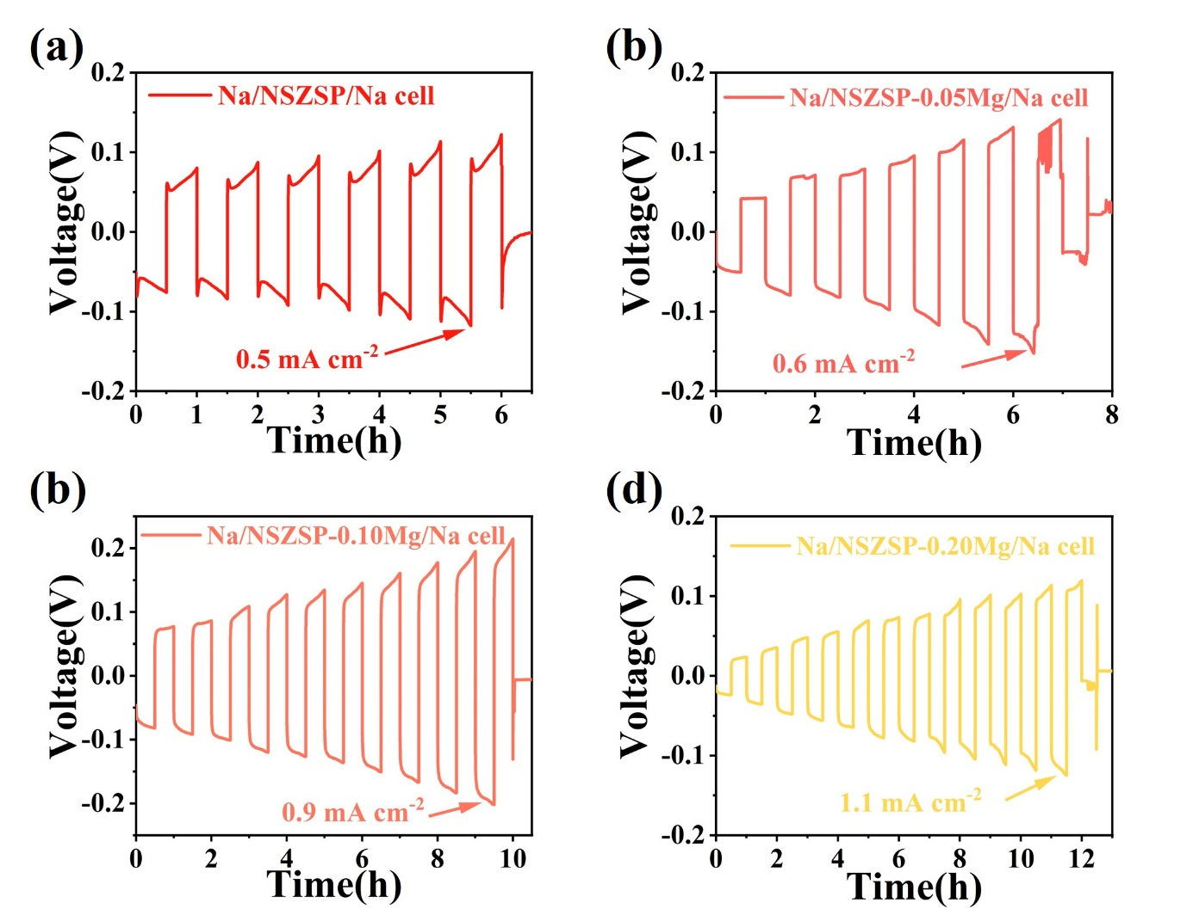
Figure S9. Critical current density test profile for the (a) NSZSP, (b) NSZSP-0.05Mg, (c) NSZSP-0.10Mg, (d) NSZSP-0.20Mg SSEs.

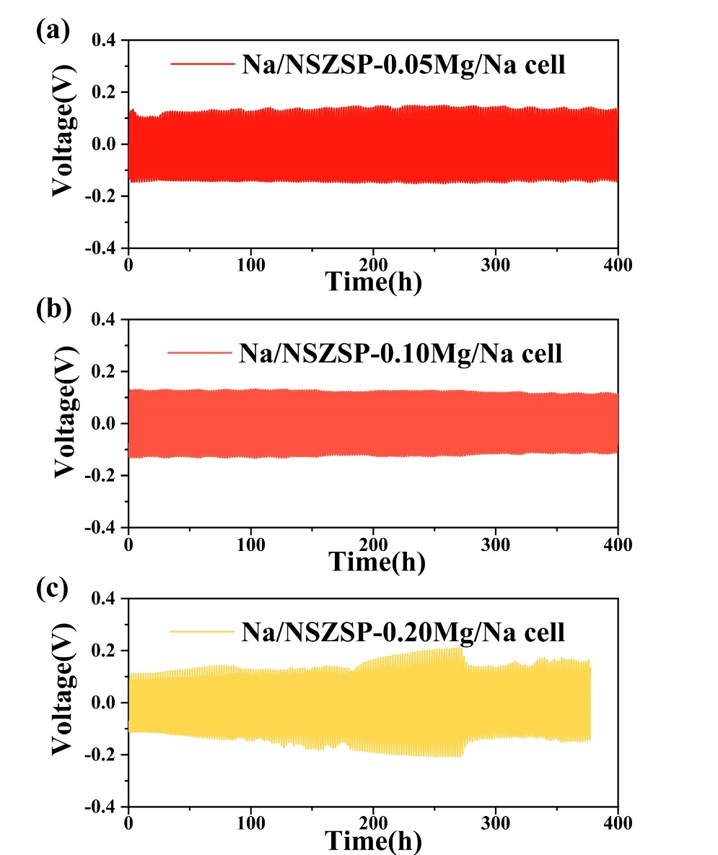
Figure S10. Galvanostatic cycling of Na//NZSP//Na symmetric battery with (a) NSZSP-0.05Mg, (b) NSZSP-0.10Mg and (c) NSZSP-0.20Mg SSEs at a current density of 0.5 mA cm⁻².

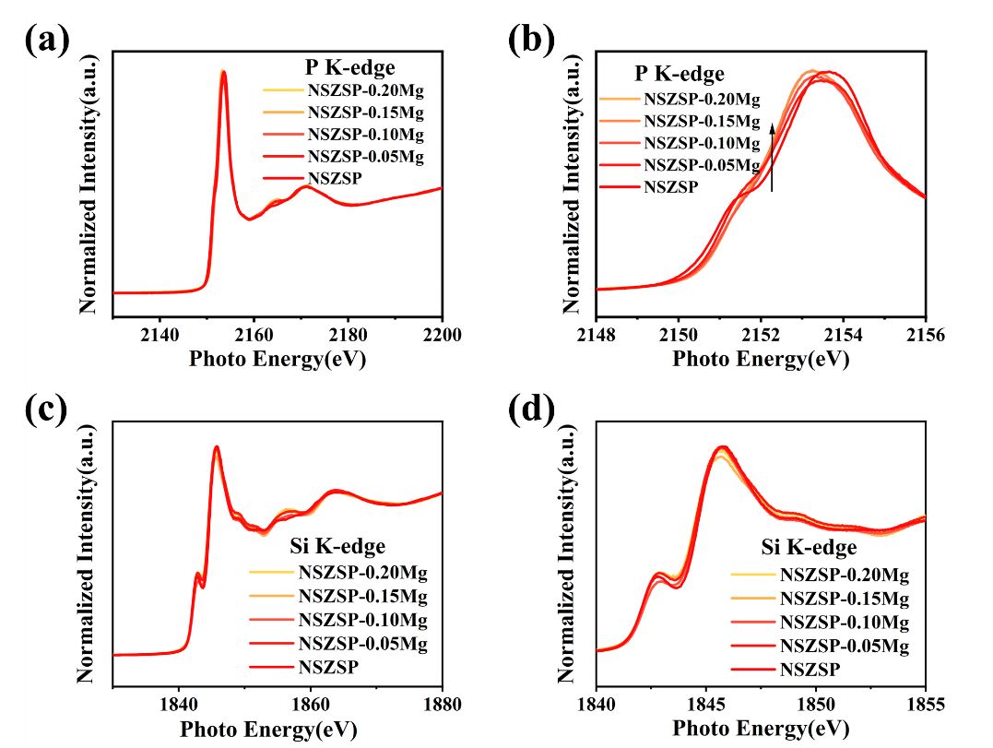
Figure S11. (a) P K-edge XANES spectra for NSZSP-Mg and (b) a magnified view of the selected energy region in P K-edge spectra. (c) Si K-edge XANES spectra for NSZSP-Mg and (d) a magnified view of the selected energy region in Si K-edge spectra.

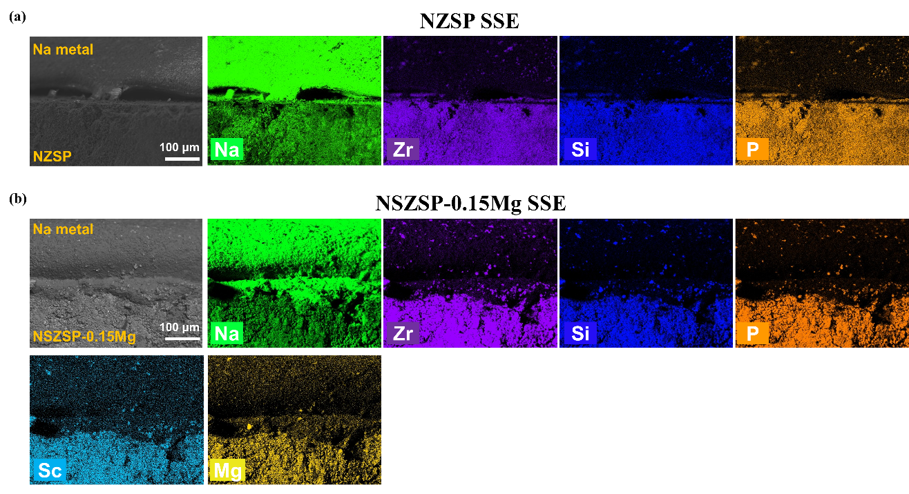
Figure S12. Cross-section elemental mapping images of the disassembled (a) Na//NZSP//Na cell and (b) Na//NSZSP-0.15Mg//Na cell after charge/discharge cycling.

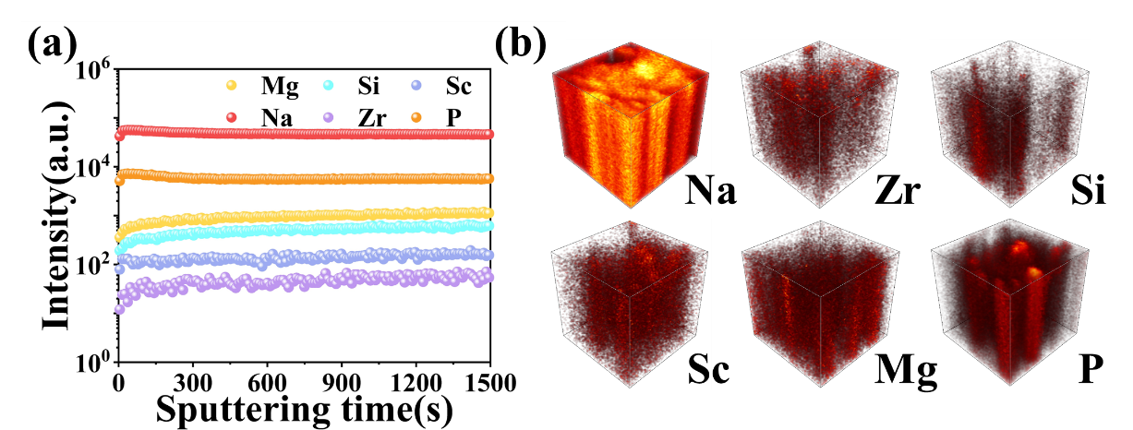
Figure S13. (a) In-depth ToF-SIMS profile of NSZSP-0.15Mg surface before Na plating/stripping cycles and (b) the corresponding 3D model images of Na, Zr, Si, Sc, Mg, P species.

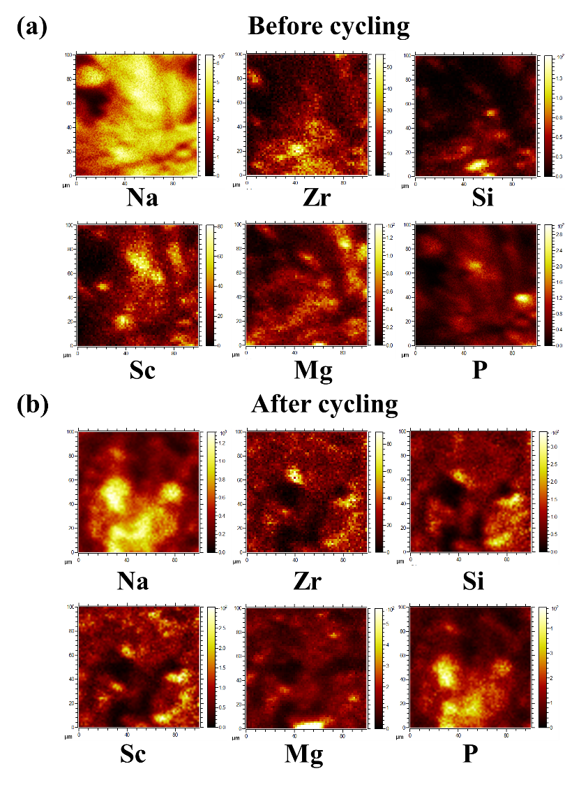
Figure S14. Integrated images of NSZSP-0.15Mg surface (a) before and (b) after Na plating/stripping cycles.

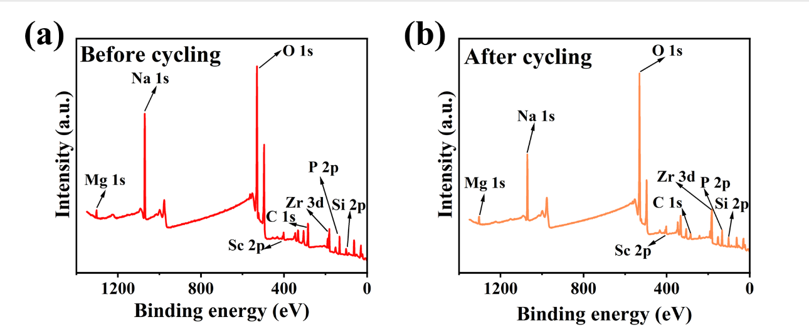
Figure S15. XPS survey spectra of (a) Before cycling and (b) After cycling.

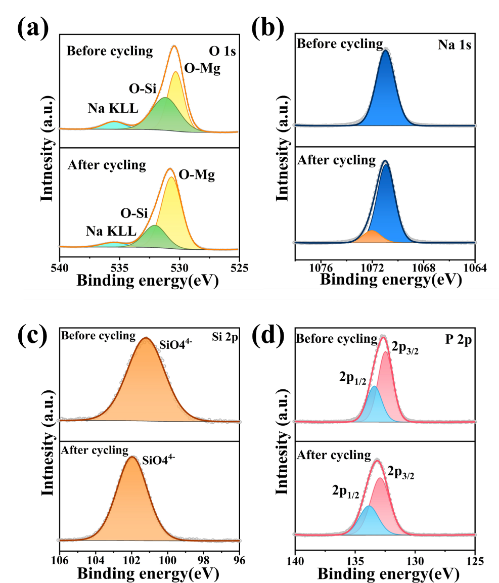
Figure S16. XPS spectra of NSZSP-0.15Mg before and after Na stripping/plating cycling: (a) O 1s; (b) Na 1s; (c) Si 2p; (d) P 2p.

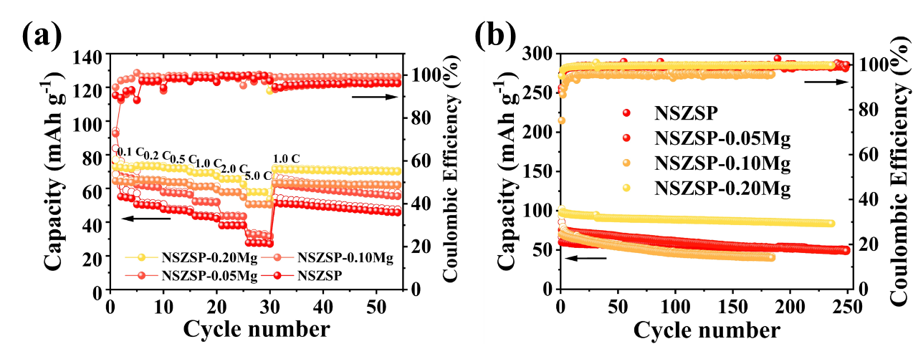
Figure S17. (a) Rate performance in the range of 0.1-5 C measured at 25℃. (b) Cycling performance comparison between NSZSP, NSZSP-0.05Mg, NSZSP-0.10Mg and NSZSP-0.20Mg SSEs.

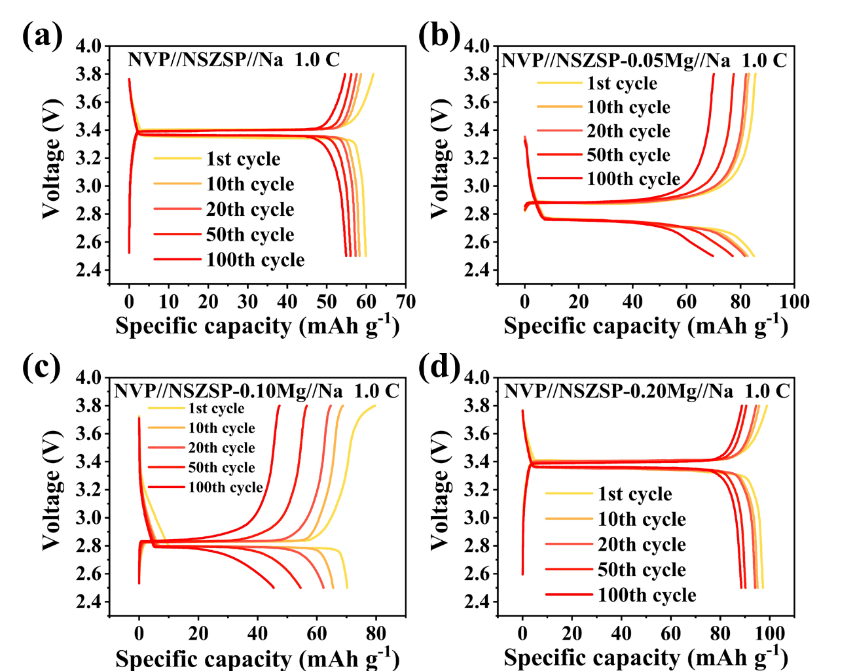
Figure S18. Galvanostatic charge/discharge cycling profile for the selected cycles of (a) NSZSP, (b) NSZSP-0.05Mg, (c) NSZSP-0.10Mg and (d) NSZSP-0.20Mg solid electrolytes at the rate of 0.1 C.

Table S5 The resistances (R_{SE}, R_{ct}, R_{cathode}, R_{t}) of the NSZSp-0.15Mg and bare NZSP samples at 25℃ before and after rating.
Solid state electrolyte | NSZSP-0.15Mg  Before rating | NZSP  Before rating | NSZSP-0.15Mg  After Rating | NZSP  After Rating
Bulk grain resistance (R_{b}) | 10 | 64 | 12 | 99
Grain boundary resistance (R_{gb}) | 209 | 533 | 756 | 1052
Interface resistance (R_{int}) | 896 | 2292 | 1500 | 2641
Total resistance (σ_{t}) | 1115 | 2889 | 2268 | 3792

Table S6 Performance of SSMBs using Na₃Zr₂Si₂PO₁₂-based solid-state electrolytes.
Cell configuration | Doping element | Synthesis method | Cycling performance | Rate performance | Ref.
Na₃V₂(PO₄)₃//Na_{2.9}Zr_{1.95}Mo_{0.05}Si₂PO₁₂//Na | Mo | Solid-state reaction | 92.6 mAh g⁻¹ at 100 mA g⁻¹ after 1600 cycles | ~40 mAh g⁻¹ at 500 mA g⁻¹ | [1]
Na₃V₂(PO₄)₃//Na_{2.7}Ca_{0.15}Zr₂Si₂PO₁₂//Na | Ca | Solid-state reaction | 96.8 mAh g⁻¹ at 0.2C after 250 cycles | 88.95 mAh g⁻¹ at 2C | [2]
Na_{0.99}Zn_{0.22}Fe_{0.3}Mn_{0.48}O₂//Na_{3.1}Zr_{1.9}Sb_{0.1}Si₂PO₁₂//Na | Sb | Sol-gel method | 95.96 mAh g⁻¹ at 0.1C after 50 cycles | 72.3 mAh g⁻¹ at 0.3C | [3]
Na₃V₂(PO₄)₃//Na_{3.4}Zr_{1.8}Mn_{0.2}Si₂PO₁₂//Na | Mn | Solid-state reaction | 84.2 mAh g⁻¹ at 0.1C after 260 cycles | 67.2 mAh g⁻¹ at 1C | [4]
Na₃V₂(PO₄)₃//Na_{3.65}Zr_{1.675}Zn_{0.2}Mg_{0.125}Si₂PO₁₂//Na | Zn, Mg | Solid-state reaction | 76.56 mAh g⁻¹ at 0.2C after 300 cycles | 32 mAh g⁻¹ at 2C | [5]
Na₃V₂(PO₄)₃//Na_{3.4}Zr_{1.8}Ca_{0.2}Si₂PO₁₂-G//Na | Ca | Solid-state reaction | 79.64 mAh g⁻¹ at 1C after 500 cycles | 76.39 mAh g⁻¹ at 1C | [6]
Na_{0.67}Mn_{0.47}Ni_{0.33}Ti_{0.2}O₂//Na_{3.12}Zr_{1.94}Cu_{0.06}Si₂PO₁₂//Na | Cu | Solid-state reaction | 75.8 mAh g⁻¹ at 0.5C after 275 cycles | 52.7 mAh g⁻¹ at 4C | [7]
Na₃V₂(PO₄)₃//Na_{3.4}Zr_{1.6}Sc_{0.4}Si₂PO₁₂//Na | Sc | Solid-state reaction | 98.7 mAh g⁻¹ at 1C after 300 cycles | 89.6 mAh g⁻¹ at 1C | [8]
NaCrO₂-PCE//Na_{3.4}Zr_{1.8}Cu_{0.2}Si₂PO₁₂//Na | Cu | Solid-state reaction | 72.1 mAh g⁻¹ at 1C after 660 cycles | 74.5 mAh g⁻¹ at 10C | [9]
Na₃V_{1.5}Al_{0.5}(PO₄)₃//Na_{3.3}Zr_{1.85}Ca_{0.15}Si₂PO₁₂-G//Na | Ca | Solid-state reaction | 102.6 mAh g⁻¹ at 0.5C after 275 cycles | 102 mAh g⁻¹ at 0.5C | [10]
NaCrO₂//Na_{3.4}Zr_{1.8}Mg_{0.2}Si₂PO₁₂//Na | Mg | Solid-state reaction | 97.6 mAh g⁻¹ at 1C after 1755 cycles | 102.6 mAh g⁻¹ at 5C | [11]
Na₃V₂(PO₄)₃//Na_{3.2}Zr_{1.9}Ca_{0.1}Si₂PO₁₂//Na | Ca | Sol-gel method | 94.9 mAh g⁻¹ at 1C after 450 cycles | 80.5 mAh g⁻¹ at 4C | [12]
Na₃V₂(PO₄)₃//Na₃Zr_{1.92}Ru_{0.08}Si₂PO₁₂//Na | Ru | Solid-state reaction | 75.69 mAh g⁻¹ at 0.3C after 100 cycles | 71 mAh g⁻¹ at 0.5C | [13]
Na₃V₂(PO₄)₃//Na₃Zr_{1.9}Te_{0.1}Si₂PO₁₂//Na | Te | Solid-state reaction | 105.49 mAh g⁻¹ at 1C after 200 cycles | 104 mAh g⁻¹ at 2C | [14]
Na₃V₂(PO₄)₃//Na_{3.3}Zr_{1.85}Zn_{0.15}Si₂PO₁₂//Na | Zn | Solid-state reaction | 98.93 mAh g⁻¹ at 0.5C after 200 cycles | 98.7 mAh g⁻¹ at 2C | [15]
Na₃V₂(PO₄)₃//Na_{3.1}Zr₂La_{0.1}Si₂PO₁₂//Na | La | Solid-state reaction | 101.3 mAh g⁻¹ at 100 mA g⁻¹ after 750 cycles | 117.3 mAh g⁻¹ at 200 mA g⁻¹ | [16]
Na_{0.9}Zn_{0.22}Fe_{0.3}Mn_{0.48}O₂//Na_{3.2}Zr_{1.9}Sn_{0.1}Si_{2.2}P_{0.8}O₁₂//Na | Sn | Sol-gel method | 76.7 mAh g⁻¹ at 0.1C after 300 cycles | 24.16 mAh g⁻¹ at 1C | [17]
Na₃V₂(PO₄)₃//Na_{3.7}Zr_{1.45}Sc_{0.4}Mg_{0.15}Si₂PO₁₂//Na | Sc, Mg | Solid-state reaction | 75 mAh g⁻¹ at 2C after 3000 cycles | 92.6 mAh g⁻¹ at 5C | This work

Supplementary References
[1] J. He, S. Yang, X. Xiao, D. Fang, R. Miao, C. Wang, L. Chen, N. Li, J. Li, Y. Su, H. Jin, Energy Storage Materials 2025, 75, 104037.
[2] S. Guan, J. Lu, Y. Li, D. Xie, C. Zhuang, W. Zhang, Ceramics International 2025, 51, 1172.
[3] M. Akbar, M. Kim, I. Moeez, A. H. Umar Bhatti, Y. H. Kim, J. Jeong, J.-Y. Kim, J.-H. Park, S. Yu, K. Y. Chung, Chemical Engineering Journal 2025, 504, 158860.
[4] Y. Zhang, T. Gao, J. Yu, Y. Zhang, Y. Zhang, S. Chen, N. Xue, X. Zhang, Q. Yuan, L. Wang, W. Liu, ACS Applied Materials & Interfaces 2025, 17, 10722.
[5] P. W. Jaschin, C. R. Tang, E. D. Wachsman, Energy & Environmental Science 2024, 17, 727.
[6] J. Jia, T. Liu, Y. Li, J. Yang, H. He, X. Zhu, X. Yao, ChemSusChem 2024, 17, e202400481.
[7] W. Wang, W. Yuan, Z. Zhao, D. Zou, P. Zhang, Z. Shi, J. Weng, P. Zhou, Journal of Electroanalytical Chemistry 2023, 937, 117405.
[8] Q. Wang, C. Yu, L. Li, X. Liu, X. Zhang, G. Gao, Y. Wang, G. Li, Energy Storage Materials 2023, 54, 135.
[9] D. Li, C. Sun, C. Wang, J. Li, Z. Wang, H. Jin, Energy Storage Materials 2023, 54, 403.
[10] H. Jin, X. Xiao, L. Chen, Q. Ni, C. Sun, R. Miao, J. Li, Y. Su, C. Wang, Advanced Science 2023, 10, 2302774.
[11] C. Wang, Z. Sun, Y. Zhao, B. Wang, C. Shao, C. Sun, Y. Zhao, J. Li, H. Jin, L. Qu, Small 2021, 17, 2103819.
[12] Y. Lu, J. A. Alonso, Q. Yi, L. Lu, Z. L. Wang, C. Sun, Advanced Energy Materials 2019, 9, 1901205.
[13] M. Dinachandra Singh, D. Kumar Gorai, K. Brajesh, P. Singh, V. Ranawade, A. Vijay Shinde, M. Jareer, R. Gupta, A. Garg, V. Agarwal, K. S. Nalwa, Chemical Engineering Journal 2024, 489, 151330.
[14] L. Wang, S. Huo, Y. Lin, Y. Liu, Z. Wu, J. Song, C. Zhang, L. Liu, Journal of Power Sources 2024, 624, 235604.
[15] L. Yang, H. Wang, Q. Liu, Z. Mei, L. Duan, H. Guo, Journal of the European Ceramic Society 2023, 43, 4443.
[16] S. Yang, J. Liang, J. He, D. Fang, Y. Zhao, Y. Ding, A. Yin, Y. Li, C. Wang, J. Li, H. Jin, ACS Applied Energy Materials 2024, 7, 9863.

