Supporting Information

Stable Dual Metal Oxide Matrix for Tuning Selectivity in Acidic Electrochemical Carbon Dioxide Reduction

Ziling Zhangª, Thành Trần-Phú^{b, *}, Jodie Yuwono^{c, *}, Zhipeng Ma^{d}, Yuwei Yang^{d}, Josh Leverett^{d}, Rosalie K. Hocking^{e}, Bernt Johannesson^{f}, Priyank Kumar^{d}, Rose Amal^{d, *}, and Rahman Daiyan^{a, *}

ªSchool of Minerals and Energy Resources Engineering, The University of New South Wales Sydney, Sydney, NSW 2052, Australia
^{b}Chemistry and Nanoscience Center, National Renewable Energy Laboratory, Golden, CO, USA.
^{c}School of Chemical Engineering, The University of Adelaide, Adelaide, South Australia 5005 Australia
^{d}School of Chemical Engineering, The University of New South Wales Sydney, Sydney, NSW 2052, Australia
^{e}School of Science, Computing and Engineering Technologies, Swinburne University of Technology, Hawthorn, VIC 3122, Australia
^{f}Australia’s Nuclear Science and Technology Organisation, 800 Blackburn Road, Clayton, VIC 3168, Australia

* Corresponding authors.
E-mail addresses: r.daiyan@unsw.edu.au (R. Daiyan), r.amal@unsw.edu.au (R. Amal), jodie.yuwono@adelaide.unsw.edu.au (J. Yuwono), thanh.tran@nrel.gov (T. Tran-Phu)
1. Experimental Details
Electrochemical Measurements: The CO₂RR performance of the as-prepared catalysts was tested in a three-electrode flow cell (Figure S11). Ag/AgCl electrode stored in saturated KCl (Gauss Union) was used as the reference electrode in the catholyte chamber, and commercial Iridium oxide/ionomer mixture coated on carbon paper (Dioxide MaterialsTM) was used as the counter electrode. The pretreated Nafion 117 membrane (Gauss Union) was used as the proton exchange membrane to separate the cathode and anode compartments. To prepare the working electrode, catalyst ink was prepared by mixing 15 mg of catalyst, 15 mg of conductive carbon powder, 1.5 mL of DI water, 1.44 mL of iso-propanol, and 60 μL of Nafion solution (Sigma, 5 wt%) and sonicated for 30 minutes. The ink was spray coated onto hydrophobically treated carbon paper on a heating plate using an airbrush and cut into 4 pieces of squares (2 × 2 cm²) to make the working electrode. CO₂-saturated 0.5 M KCl and H₂SO₄, H₃PO₄, and HClO₄ were used as the catholyte, respectively, and 0.5 M H₂SO₄ was used as the anolyte. The pH of catholyte was adjusted by adding 0.1 M of corresponding acid and measured by a pH meter (Edge dedicated pH, 230 V). Prior to each test, the catholyte was purged with CO₂ gas (Coregas, 99.95%) for at least 20 minutes to saturate with CO₂ (pH 2). The volume of the electrolyte circulated within the system is 30 mL for both catholyte and anolyte, with a flowrate of 10 mL min⁻¹ controlled by peristaltic pumps (Kamoer DIP 1500), and the CO₂ gas flowrate was controlled at 100 mL min⁻¹ at the gas chamber outlet, measured using a flowmeter (Agilent ADM Flow Meter).
Electrochemical measurements were conducted with an Autolab M204 and Booster 10 A (Metrohm Autolab) electrochemical workstation. The CO₂RR performance was evaluated using the chronoamperometry method, with at least 3 measurements carried out for each applied potential with independent electrodes, and each test ran for 600 s. The potential reported was converted to the reversible hydrogen electrode (RHE) reference scale using the following equation:
$$E_{RHE} \left(V\right)= E_{Ag/AgCl} \left(V\right)+0.197\left(V\right)+0.0591×pH$$
The linear sweeping voltammetry curves were collected with a step of 2.44 mV at a scan rate of 5 mV s⁻¹ from 0 to -1.3 V vs. RHE. The cyclic voltammetry (CV) for the electrochemically active surface area (ECSA) estimation was measured within the potential range of -0.14 to -0.24 V vs. RHE at scan rate of 20, 40, 60, 80, and 100 mV s⁻¹. The difference between the cathodic and anodic sweeps in the CV curves at -0.18 V vs. RHE plotted against the scan rate was fit with a linear function, which slope represent a reasonable estimate of the double-layer capacitance (C_{dl}). The ECSA per geometric surface area of the electrode was estimated as ECSA = C_{dl} / (A × Cs), where A is the geometric surface area of the electrode and Сs is a specific capacitance estimated to be 40 μF cm⁻², a reference of blank glassy carbon.[1]
Product Quantification: The gas products were collected from the gas outlet of the flow-cell and injected into gas chromatograph (GC, Shimadzu, Model 2010 Plus) for quantification. Gas products (H₂, CO, and CH₄) were detected using the GC equipped with a thermal conductivity detector (TCD) and a flame ionization detector (FID). Calibration curves (Figure S20) obtained from standard gases (Coregas Pty Ltd.) were used for quantification. The CO₂RR liquid products quantification was carried out using ¹H nuclear magnetic resonance (Bruker Avance III 600 MHz NMR). The testing samples were prepared by mixing 800 µL catholyte and 200 µL deuterium oxide solution (D₂O), and 600 µL of such mixture was transferred to the NMR tube for testing at 25°C. 100 mmol mL⁻¹ sodium acetate (Sigma Aldrich, ≥ 99%) was used as the external standard for quantification analysis.
The Faradaic efficiency (FE) and yield rate of the liquid products were calculated using equations 1 and 2.
$${FE}_{liquid}\text{ (\%) =}\frac{\text{z × F × }{\text{C}}_{\text{Product}}\text{ × }\text{V}}{\text{Q}}×100\%$$ | (1)
where z is the number of electrons transferred, F is the Faraday constant (96485.33 C mol⁻¹), V is the volume of catholyte solution (L), C_{Product} is the concentration of product (M), and Q is the total charge passed (C).
$${\text{Yield}}_{\text{Product}}\text{ (nmol }s^{-1}{cm}^{-2}\text{)=}\frac{ {\text{C}}_{\text{Product}}\text{ × }\text{V} }{\text{t}\text{ × }\text{A} }$$ | (2)
where t is duration of the electrolysis (s) and A is the geometric surface area of the working electrode (cm²).

The Faradaic efficiency of gas product was calculated by the equation:
$${FE}_{gas}\text{ (\%) =}\frac{\text{z × F × x × q}}{j×A×V_{g}}×100\%$$ | (3)
Where x is the volume of the gas produced, q is the gas flowrate at the flow cell outlet (mL min⁻¹), j is the current density (A cm⁻²), and V_{g} is the unit molar volume of gas at room temperature and pressure (24.0 L mol⁻¹).
Ex-situ Material Characterization: X-ray diffraction (XRD) patterns were carried out using a D2 Phaser Bruker instrument with Cu Kα radiation (λ = 1.54 Å) in a scan range of 10° to 80°. The morphology of the catalyst was examined using the scanning electron microscope (SEM, FEI Nova NanoSEM 450) operating at 3 kV. The high-resolution transmission electron microscopy (HR-TEM) and scanning transmission electron microscopy- energy dispersive X-ray spectroscopy (STEM-EDS) were obtained using a JEOL JEM-F200 instrument, operating at 200 kV. To prepare samples for TEM, the material was carefully scraped from the surface of the electrode and dispersed onto holey carbon-coated gold grids with a mesh size of 200. X-ray photoelectron spectroscopic (XPS) analysis was undertaken using a Thermo ESCALAB250Xi spectrometer. Analysis was undertaken using a monochromated Al Kα source at a power of 180 W (15 kV × 12 mA) and a hemispherical analyser operating in a fixed analyser transmission mode.
In-situ Material Characterization: The in situ X-ray absorption spectroscopy (XAS) spectra were recorded at the Australian Synchrotron ANSTO, operating at 3.0 GeV with a current of 500 mA, at the Copper K-edge (8980eV) and Bismuth L-edge (eV). Data were acquired in fluorescence mode using three N₂-filled ionization chambers in series as detectors. Spectra were acquired under room temperature, using an in-house designed cell. as shown in Figure S21. Energy calibration was achieved by simultaneously recording the spectrum of copper foil, for which the energy of the first maximum in the first derivative is 8980 eV.[2] XAS data were processed and analyzed using the Demeter software package.[3] A linear function was subtracted from the pre-edge region, and then the edge jump was normalized using the Athena program. The χ(k) data was isolated by subtracting a smooth, third-order polynomial approximating the absorption background of an isolated atom. The k3-weighted χ(k) data were Fourier transformed into R-space after applying a Hanning window function. All Fourier-transformed EXAFS spectra are displayed without phase correction.[4]
The in-situ synchrotron radiation – Fourier transfer infrared transmission (SR-FTIR) measurements were carried out at the Australian Synchrotron ANSTO using SR-FTIR setup equipped with a ZnSe crystal as the infrared transmission window (cut-off energy 625 cm⁻¹) and a specific designed FTIR cell (Figure S15). The cell was connected to an electrochemical workstation to supply voltage. The open circuit potential (OCP) refers to the state that the cell is filled with electrolyte but without applied potential. An infrared microscope (Bruker Hyperion 3000 with an x20 objective) was coupled with an FTIR spectrometer (Bruker 70 v s⁻¹) equipped with a KBr beam splitter and liquid-nitrogen-cooled mercury cadmium telluride detector. Infrared absorption spectrum was acquired by averaging 256 scans at a resolution of 2 cm⁻¹.
Density Functional Theory (DFT) calculations:
Density functional theory (DFT) calculations were performed using the Projector Augmented Wave (PAW) method[5, 6] as implemented in the Vienna Ab initio Simulation Package (VASP)[7, 8]. The calculations were completed with a plane-wave cut-off energy of 500 eV and a single Gamma k-point mesh. The electronic self-consistent calculation was converged to 1×10⁻⁵ eV and ionic relaxation steps were performed using the conjugate-gradient method (IBRION=2) and continued until the total force on each atom dropped below a tolerance of –0.05 eV/Å. The generalized gradient approximation (GGA) was used for the exchange correlation functionals as parameterized by Perdew-Burke-Ernzerhof (PBE).[9]The slab model of hybrid Cu₂O (111) surface and Bi (002) surface were used with a vacuum thickness of 20 Å in z-direction. Bulk-surface interaction was introduced by relaxing only atoms in the two uppermost layers and fixing atoms in other layers to their bulk coordinates. Free energy diagrams were calculated by including the correction of entropy and zero-point energy. The dispersion correction was also included in this study by using DFT D-3 method.[10]

2. Supplementary Table
Table S1. Comparison for the reported formic acid production of the CuO_{x}/BiO_{x} catalyst in acidic electrolyte
Catalysts | Electrolyte | FE (%) | Potential at FE_{max}  V vs. RHE | J  mA cm⁻² | Stability  h
This Work | H₂SO₄, pH = 2 | 97 | -2.7 | -130 | 20
Bi Nanosheet[11] | H₂SO₄, pH ≤ 1 | 92.2 | -1.23 | -237.1 | 8
Bi distributed-3D porous electrode (TDPE)[12] | H₂SO₄, pH = 2.7 | 89.2 | 3.0 V Cell Voltage | -60.7 | 24
PTFE/SnBi alloy[13] | H₂SO₄, pH = 1 | >90 | - | -100 | 125
SnO₂/C[14] | H₂SO₄, pH = 1.5 | 88 | -1.4 | -356.8 | -
Sn (S)-H[15] | H₂SO₄, pH = 3 | 92.15 | - | -400 | 13
Cs₃Bi₂Br[16] | H₂SO₄, pH = 2.5 | 92 | -0.95 | -145.3 | 20
Tin (IV) oxide[17] | K₂SO₄, pH = 3.4 | 86.5 | - | -200 | -

Table S2. Best-fit parameters extracted from Cu-K-edge EXAFS spectra of the CuO_{x}/BiO_{x} catalyst during the CO₂RR in pH = 2, [K⁺] = 0.5 M sulfuric acid electrolyte. Parameters included are the coordination numbers (CN), the bond lengths (r), Debye-Waller factors (σ²).
 | Cu-O |  |  |  | Cu-Cu
 | CN | R (Å) | σ² (Å²) |  | CN | R (Å) | σ² (Å²)
Dry | 4.44 | 1.94 | 0.0054 |  | 1.24 | 2.90 | 0.0054
OCP | 4.89 | 1.95 | 0.0082 |  | 1.65 | 2.92 | 0.0082
-0.6 V | 1.99 | 1.91 | 0.0113 |  | 5.70 | 2.53 | 0.0113
-0.8 V | 1.32 | 1.93 | 0.0115 |  | 7.42 | 2.53 | 0.0115
-1.0 V | 0.95 | 2.05 | 0.0121 |  | 9.52 | 2.53 | 0.0121
After | 3.53 | 1.82 | 0.0081 |  | 6.55 | 3.00 | 0.0081

Table S3. Best-fit parameters extracted from Bi L₃-edge EXAFS spectra of the CuO_{x}/BiO_{x} catalyst during the CO₂RR in pH = 2, [K⁺] = 0.5 M sulfuric acid electrolyte. Parameters included are the coordination numbers (CN), the bond lengths (r), Debye-Waller factors (σ²).
 | Bi-O1 |  |  |  | Bi-O2
 | CN | R (Å) | σ²*10⁻³(Å²) |  | CN | R (Å) | σ²*10⁻³(Å²)
Dry | 2.30 | 2.10 | 5.3 |  | - | - | -
OCP | 1.80 | 2.01 | 8.4 |  | 1.95 | 2.70 | 8.4
-0.6 V | 0.75 | 2.09 | 4.8 |  | 0.86 | 2.36 | 4.8
-0.8 V | 0.38 | 2.10 | 15.5 |  | 0.48 | 2.24 | 15.5
-1.0 V | 0.51 | 2.15 | 4.4 |  | - | - | -
After | 0.54 | 2.11 | 3.0 |  | - | - | -
 | Bi-O3 |  |  |  | Bi-Bi
 | CN | R (Å) | σ²*10⁻³(Å²) |  | CN | R (Å) | σ²*10⁻³(Å²)
Dry | - | - | - |  | - | - | -
OCP | - | - | - |  | - | - | -
-0.6 V | - | - | - |  | - | - | -
-0.8 V | 0.59 | 2.96 | 15.5 |  | - | - | -
-1.0 V | - | - | - |  | 0.63 | 3.04 | 4.4
After | - | - | - |  | 0.89 | 3.34 | 4.4

3. Supplementary Figures
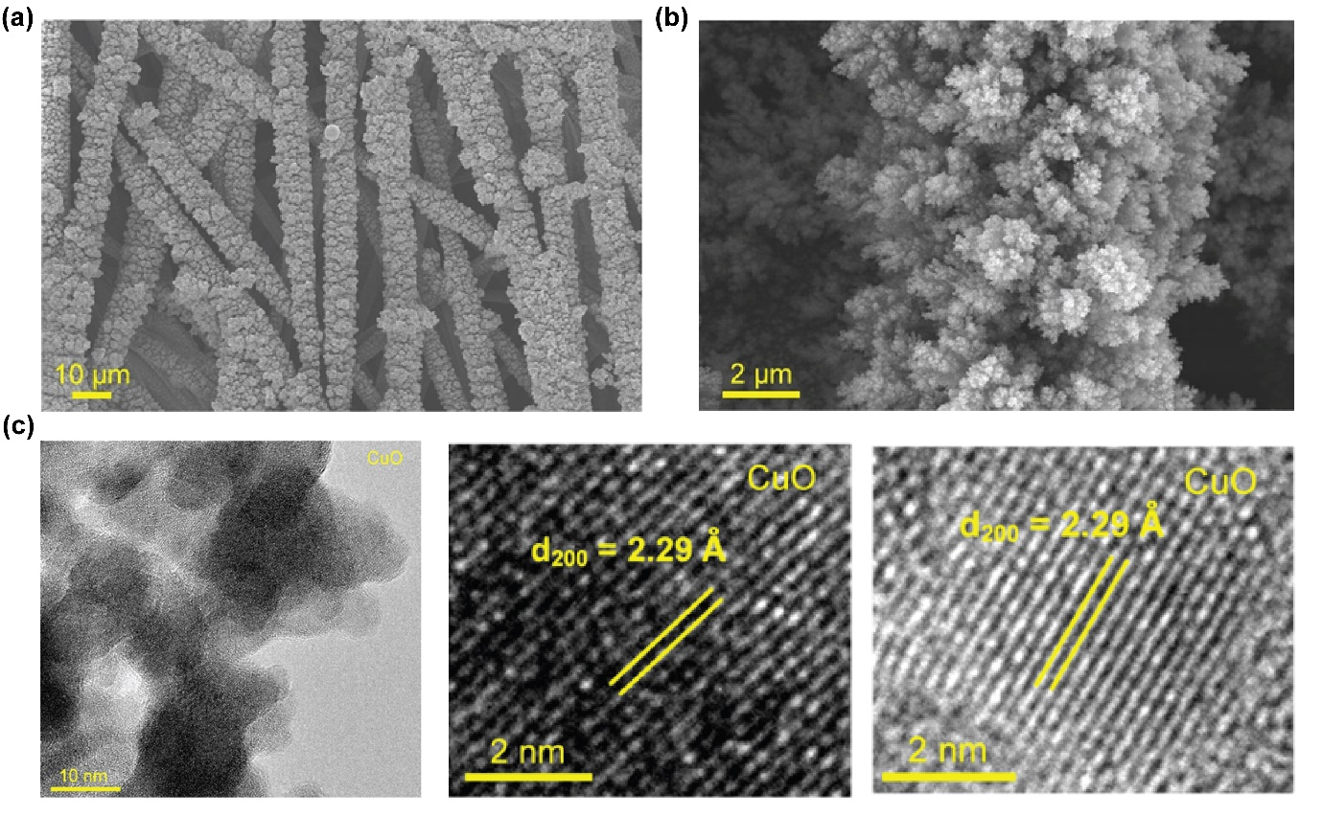
Figure S1. (a,b) SEM images of CuOx at (a), low and (b) high magnifications. (c) Transmission electron microscopy (TEM) image of CuO_{x}, with a closer inspection showing the presence of the 2.29 Å lattice spacing, corresponding to (200) facet, consistent with the dominant peak seen in the X-ray diffraction patterns (Figure S4).

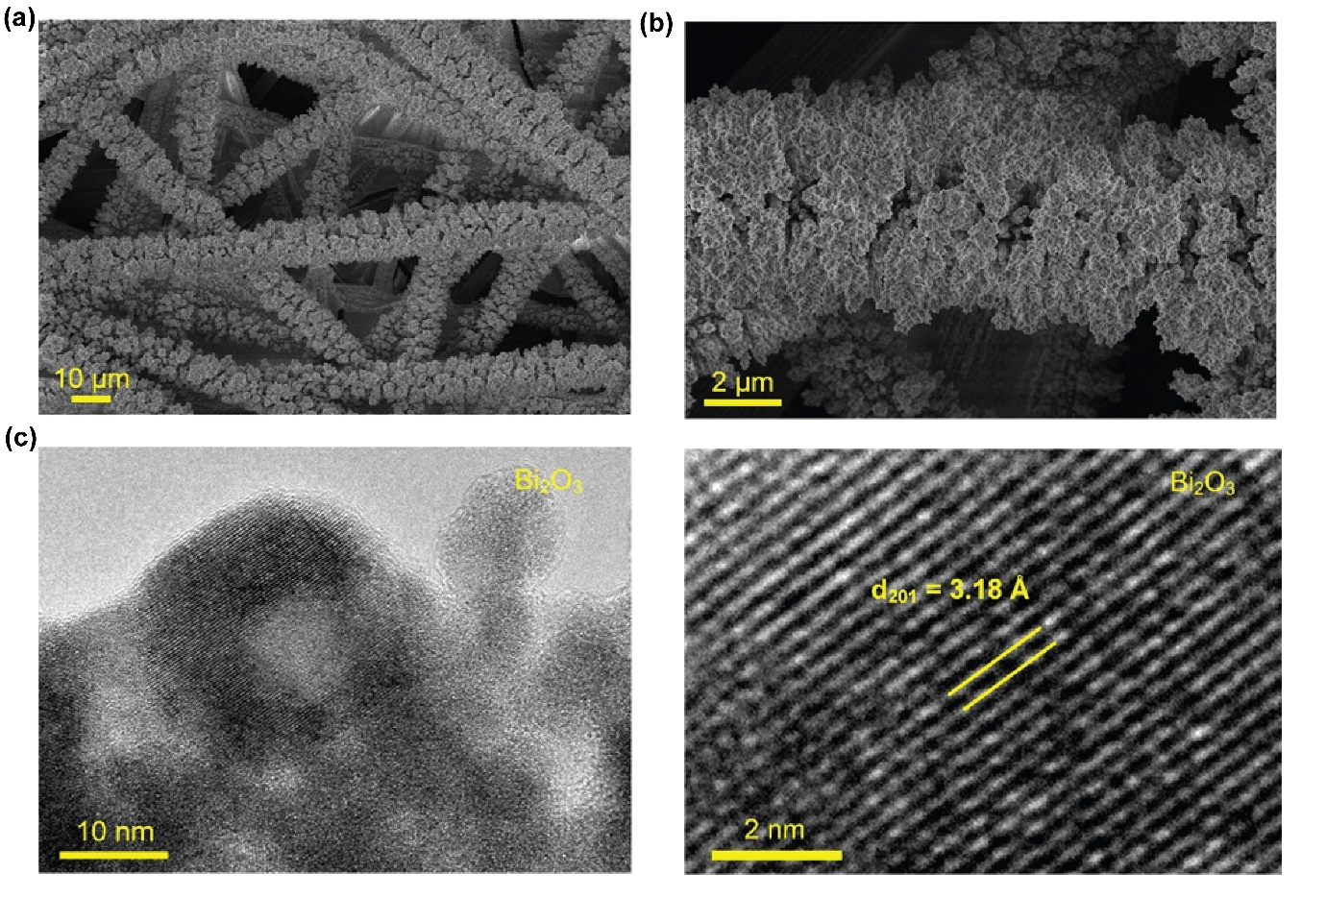
Figure S2. (a,b) SEM images of BiOx at (a) low and (b) high magnifications. (c) TEM image of Bi₂O₃, a closer inspection showing the existance of (201) facet, with a specific lattice space of 3.18 Å, in good agreement with the X-ray diffraction patterns (Figure S4).
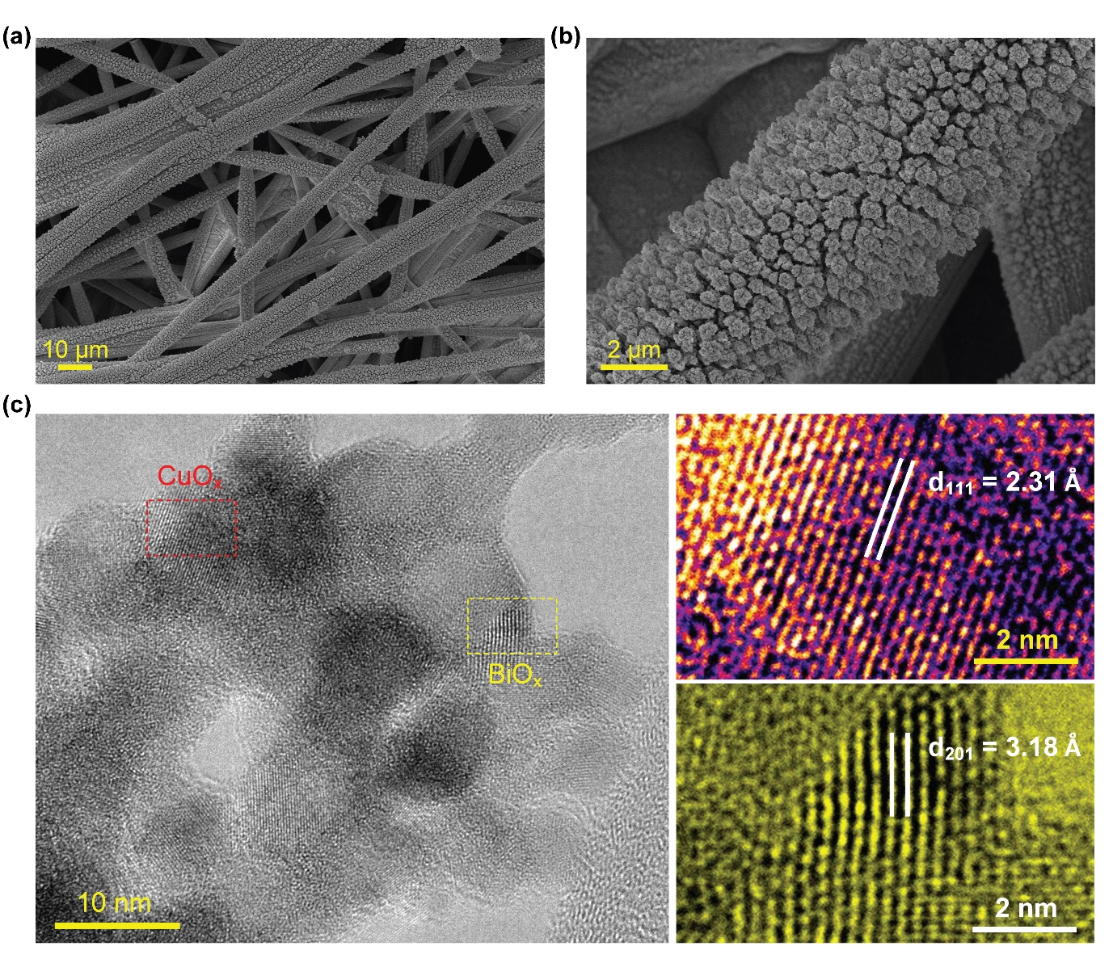
Figure S3. (a,b) SEM images of CuO_{x}/BiO_{x} at (a) low and (b) high magnifications (c) TEM image of CuO_{x}/BiO_{x}, a closer inspection revealed the presence of both CuO_{x} (red) and BiO_{x} (yellow) nanoparticles with lattice spacing of 2.31 Å and 3.18 Å, corresponding to the CuO_{x} (111) facet and BiO_{x} (201) facets, respectively.

Figure S4. The XRD patterns of a) BiO_{x}, b) CuO_{x}, and c) CuO_{x}/BiO_{x}. The XRD pattern of BiO_{x} is attributed to the tetragonal β-Bi₂O₃ (ICDD 78-1793) which shows major peaks at 28.5°, 32.3°, 33.3°, 46.7°, 56.0°, and 58.3°, corresponding to the (201), (002), (201), (222), (213), and (402) planes respectively. The CuO_{x} catalyst exhibits major peaks at 35.9°, 39.3°, 49.0°, 58.8°, 66.4°, and 68.4°, which corresponds to the (002), (111), (-202), (202), (022) and (220) planes of CuO (ICDD 41-0254). The CuO_{x}/BiO_{x} catalyst shows a mixture of peaks that presented in CuO_{x} and BiO_{x}. The 28.5°, 32.3°, 33.3°, 46.6°, 56.0°, and 58.1° peaks belong to the (201), (201), (222), (213), and (402) planes of β-Bi₂O₃, while 35.9° and 39.1° peaks can be attributed to (002) and (111) planes of CuO.

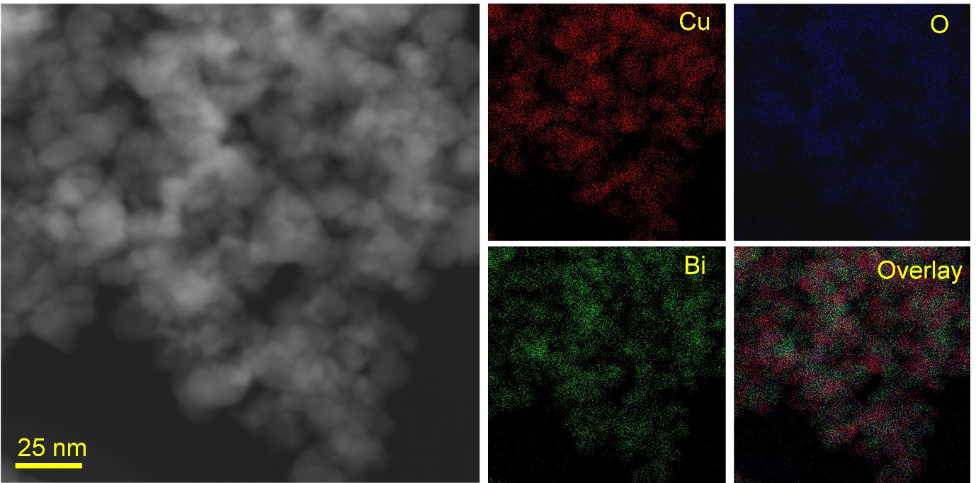
Figure S5. Scanning tranmision electron microscope (STEM) image of CuO_{x}/BiO_{x} and the corresponding energy dispersive X-ray spectroscopy (EDS) elemental mapping, showing the evenly distributed Cu (red), Bi (green), and O (blue) elements.

Figure S6. The X-ray photoelectron spectroscopy (XPS) characterizations of the pre-reaction CuO_{x}/BiO_{x} catalyst. (a) Survey spectra. The presence of the F element is due to the Nafion binder used for preparing electrode. (b) High-resolution XPS Cu 2p_{3/2} spectra. (c) High-resolution XPS Bi 4f spectra. The Bi 4f_{7/2} signal at around 159.2 eV and the Bi 4f_{5/2} peak at around 164.6 eV (differed by 5.3 eV) are ascribed to Bi³⁺.[18] (d) High-resolution XPS O 1s spectra. The peak at 530.3 eV represents the lattice oxygen in CuO,[19] and the peaks at 532 eV, 533.5 eV, and 535.5 eV are ascribe to the non-lattice or absorbed oxygen.[20] The composition ratio of Cu/Bi in atomic % is approximately 1:1.

Figure S7. Stability comparison of CuO_{x} and CuO_{x}/BiO_{x} conducted in sulfuric acid (pH 2) in the flow cell electrolyzer at -2.7 vs. RHE. The results indicate a stable performance of CuO_{x}/BiO_{x} compared to CuO_{x}.

Figure S8. XRD patterns of CuO_{x} on GDE carbon paper: a) before reaction, b) after reaction, and c) pristine GDE carbon paper. The CuO_{x} catalyst exhibits major peaks at 36.0°, 39.8°, 51.6°, 57.6°, and 67.6°, which corresponds to the (-111), (200), (-202), (202) and (220) planes of CuO (ICDD 41-0254). The background pattern matches that of the GDE carbon paper, which features a distinct peak at 25°, representing the conventional carbon black.[21] For the XRD pattern collected after the reaction, the majory of the characteristics peaks of CuO disappear and the emergence of a peak at 37° can be attributed to Cu₂O (111) plan (ICDD 75-1531), confirming the reduction of CuO_{x} during electrolysis.

Figure S9. Stability test of CuO catalyst in the H-cell for 24 hours using pH 2 H₂SO₄ and additional cation [K⁺] = 0.5 M as the catholyte. The current density continuously flucturates with a decreasing trend during the first 10 hours of operation, and stablized at around -50 mA cm⁻² after 10 hours.

Figure S10. The ex situ XAS characterization of pre-reaction CuO_{x}/BiO_{x} catalyst recorded at the Cu K-edge. (a) The XANES spectra between 8800 – 9500 eV. (b) The XANES spectra between 8960 – 9030 eV. (c) The k³-weighted EXAFS spectra. (d) The FT-EXAFS spectra. The EXAFS of the CuO_{x}/BiO_{x} catalyst is in great agreement of the pattern of CuO reference. The FT-EXAFS clearly presents the Cu-O coordination of at around 1.6 Å, evidence of the existence of CuO and no Cu-Cu coordination corresponding to metallic Cu is presented.

Figure S11. The ex situ XAS characterization of pre-reaction CuO_{x}/BiO_{x} catalysts at Bi L₃-edge. (a) The full XANES spectra. (b) The XANES spectra between 13350 – 13550 eV. (c) The k³-weighted EXAFS spectra. d) The FT-EXAFS spectra. The XANES and EXAFS of Bi L₃-edge show that the BiO_{x} in the catalyst exhibits a similar feature to Bi₂O₃ reference, indicating an oxidation state of 3⁺.

Figure S12. The in situ XAS characterization of CuOx/BiOx catalysts during the electrochemical CO₂RR in sulfuric acid (pH 2, cation addition [K⁺] = 0.5 M). a) The k³-weighted EXAFS spectra collected at the Cu K-edge. b) The k³-weighted EXAFS spectra collected at the Bi L₃-edge. The Cu K-edge EXAFS spectra shows that the catalyst exhibits CuO features at dry and OCP status, while gradually reduces to a combination of Cu and Cu₂O. Similarly, from the Bi L₃-edge spectra, the catalyst exhibits Bi₂O₃ features and reduced to Bi⁰ during the reaction.

Figure S13. XRD patterns of CuO_{x}/BiO_{x} on GDE carbon paper: a) before reaction, b) after reaction, and c) pristine GDE carbon paper.

Figure S14. a) Schematic illustration of the flow-cell electrolyzer configuration. b) Pictures of the flow cell viewed from the front and the top showing its different components.

Figure S15. The XPS spectra of CuO_{x}/BiO_{x} catalyst before and after the reaction in H₂SO₄ (pH 2, cation concentration [K⁺] = 0.5 M). (a) Survey spectra. (b) The high-resolution XPS C 1s spectra. The C 1s peaks for all catalysts are calibrated to 284.8 eV. (d) The Bi 4f signal at 158.8 and 164.2 eV are attributed to Bi³⁺ 4f_{7/2} and Bi³⁺ 4f_{5/2}, respectively. The observed peaks remain the same position before and after the reaction.[22, 23]

Figure S16. Simplified three-parameter fitting of the Cu K-edge FT EXAFS spectra for the CuO_{x}/BiO_{x} catalyst during the CO₂RR in sulfuric acid electrolyte (pH 2, additional cation concentration [K⁺] = 0.5 M). The simulation shows that the Cu(II) substantially reduced to both Cu and Cu(I) when potentials are applied.

Figure S17. Simplified three-parameter fitting of the Bi L₃-edge FT EXAFS spectra for the CuO_{x}/BiO_{x} catalyst during the CO₂RR in sulfuric acid electrolyte (pH 2, additional cation [K⁺] = 0.5 M). The simulation shows that the Bi(III) substantially reduced to Bi⁰ when potentials are applied, and the system becomes more disordered.

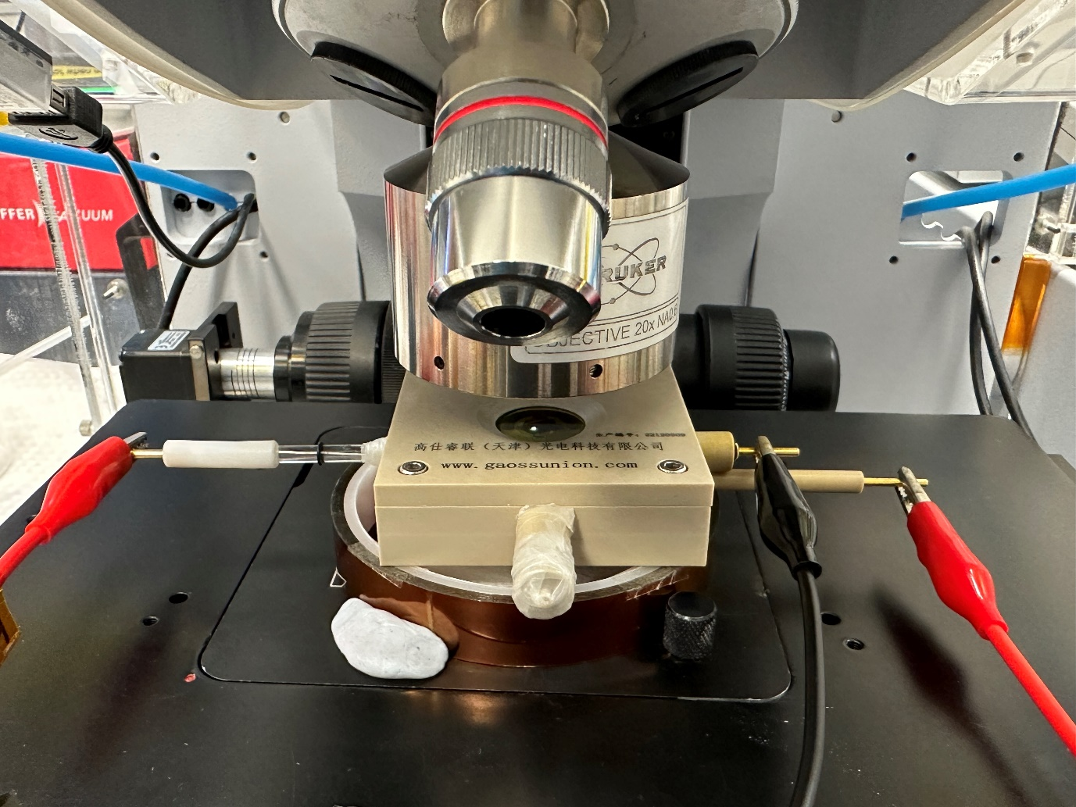
Working electrode
Counter electrode
Reference electrode
Electrocatalyst
IR beam
Figure S18. Photo of the in-situ cell for the SR-FTIR experiment.

Figure S19. In situ FTIR spectrum of CuO_{x}/BiO_{x} in pH 2 H₂SO₄ with 0.5 M KCl, from -0.3 to -1.5 V_{RHE}. The peak at 943 and 1090 cm⁻¹ corresponds to the adsorption of sulfate species.[24]

Figure S20. The DFT calculation of (a) Cu₂O and (b) Cu towards different products of HCOOH and *CHO.

Figure S21. Current density of CuO_{x}/BiO_{x} in H₂SO₄, H₃PO₄, and HClO₄ electrolytes of different pH at -2.2 V vs. RHE.

Figure S22. The XPS spectra of CuO_{x}/BiO_{x} catalyst before and after the reaction in different pH 3 acidic electrolytes (H₂SO₄, H₃PO₄, and HClO₄) with additional cation [K⁺] = 0.5 M. (a) Survey, (b) high-resolution C 1s (C 1s peaks for all catalysts are calibrated to 284.8 eV), (c) Bi 4f, and (d) O 1s spectra. Obvious shifts towards higher binding energy from Bi 4f and O 1s were observed for CO₂RR in phosphoric acid buffer.

Figure S23. The GC calibration curve for a) H₂ and b) CO.

Figure S24. The customized Spectro electrochemical cell for in situ XAS.

Supporting References
[1] Z. Ma, C. Tsounis, C.Y. Toe, P.V. Kumar, B. Subhash, S. Xi, H.Y. Yang, S. Zhou, Z. Lin, K.-H. Wu, R.J. Wong, L. Thomsen, N.M. Bedford, X. Lu, Y.H. Ng, Z. Han, R. Amal, Reconstructing Cu Nanoparticle Supported on Vertical Graphene Surfaces via Electrochemical Treatment to Tune the Selectivity of CO2 Reduction toward Valuable Products, ACS Catalysis, 12 (2022) 4792-4805.
[2] R.D. Deslattes, E.G.K. Jr., P. Indelicato, L.d. Billy, E. Lindroth, J. Anton, J.S. Coursey, D.J. Schwab, J. Chang, R. Sukumar, K. Olsen, R.A. Dragoset, X-Ray Transition Energies Database, NIST, Physical Measurement Laboratory, 2005.
[3] B. Ravel, M. Newville, ATHENA, ARTEMIS, HEPHAESTUS: data analysis for X-ray absorption spectroscopy using IFEFFIT, J Synchrotron Radiat, 12 (2005) 537-541.
[4] L. Li, J.A. Chalmers, S.R. Bare, S.L. Scott, F.D. Vila, Rigorous Oxidation State Assignments for Supported Ga-Containing Catalysts Using Theory-Informed X-ray Absorption Spectroscopy Signatures from Well-Defined Ga(I) and Ga(III) Compounds, ACS Catalysis, 13 (2023) 6549-6561.
[5] P.E.J.P.r.B. Blöchl, Projector augmented-wave method, 50 (1994) 17953.
[6] G. Kresse, D.J.P.r.b. Joubert, From ultrasoft pseudopotentials to the projector augmented-wave method, 59 (1999) 1758.
[7] G. Kresse, J.J.C.m.s. Furthmüller, Efficiency of ab-initio total energy calculations for metals and semiconductors using a plane-wave basis set, 6 (1996) 15-50.
[8] G. Kresse, J.J.P.r.B. Furthmüller, Efficient iterative schemes for ab initio total-energy calculations using a plane-wave basis set, 54 (1996) 11169.
[9] J.P. Perdew, K. Burke, M.J.P.r.l. Ernzerhof, Generalized gradient approximation made simple, 77 (1996) 3865.
[10] S. Grimme, J. Antony, S. Ehrlich, H.J.T.J.o.c.p. Krieg, A consistent and accurate ab initio parametrization of density functional dispersion correction (DFT-D) for the 94 elements H-Pu, 132 (2010).
[11] Y. Qiao, W. Lai, K. Huang, T. Yu, Q. Wang, L. Gao, Z. Yang, Z. Ma, T. Sun, M. Liu, C. Lian, H. Huang, Engineering the Local Microenvironment over Bi Nanosheets for Highly Selective Electrocatalytic Conversion of CO2 to HCOOH in Strong Acid, ACS Catalysis, 12 (2022) 2357-2364.
[12] T. Yan, H. Pan, Z. Liu, P. Kang, Phase-Inversion Induced 3D Electrode for Direct Acidic Electroreduction CO2 to Formic acid, Small, 19 (2023) 2207650.
[13] L. Li, Z. Liu, X. Yu, M. Zhong, Achieving High Single-Pass Carbon Conversion Efficiencies in Durable CO2 Electroreduction in Strong Acids via Electrode Structure Engineering, Angewandte Chemie International Edition, 62 (2023) e202300226.
[14] J. Gu, S. Liu, W. Ni, W. Ren, S. Haussener, X.J.N.C. Hu, Modulating electric field distribution by alkali cations for CO2 electroreduction in strongly acidic medium, 5 (2022) 268-276.
[15] H. Shen, H. Jin, H. Li, H. Wang, J. Duan, Y. Jiao, S.-Z. Qiao, Acidic CO2-to-HCOOH electrolysis with industrial-level current on phase engineered tin sulfide, Nature Communications, 14 (2023) 2843.
[16] Y. Wang, C. Wang, Y. Wei, F. Wei, L. Kong, J. Feng, J.-Q. Lu, X. Zhou, F. Yang, Efficient and Selective Electroreduction of CO2 to HCOOH over Bismuth-Based Bromide Perovskites in Acidic Electrolytes, Chemistry – A European Journal, 28 (2022) e202201832.
[17] M. Oßkopp, A. Löwe, C.M.S. Lobo, S. Baranyai, T. Khoza, M. Auinger, E. Klemm, Producing formic acid at low pH values by electrochemical CO2 reduction, Journal of CO2 Utilization, 56 (2022) 101823.
[18] C.D. Wagner, A.V. Naumkin, A. Kraut-Vass, J.W. Allison, C.J. Powell, J.R. Rumble, Jr., NIST Standard Reference Database 20, Version 3.4 (web version), 2003.
[19] T. Tran-Phu, R. Daiyan, Z. Fusco, Z. Ma, R. Amal, A. Tricoli, Nanostructured β-Bi2O3 Fractals on Carbon Fibers for Highly Selective CO2 Electroreduction to Formate, 30 (2020) 1906478.
[20] C. Boruban, E.N. Esenturk, Activated carbon-supported CuO nanoparticles: a hybrid material for carbon dioxide adsorption, Journal of Nanoparticle Research, 20 (2018) 59.
[21] S.-M. Lee, S.-H. Lee, J.-S.J.C. Roh, Analysis of activation process of carbon black based on structural parameters obtained by XRD analysis, 11 (2021) 153.
[22] T. Tran-Phu, Z. Fusco, I. Di Bernardo, J. Lipton-Duffin, C.Y. Toe, R. Daiyan, T. Gengenbach, C.-H. Lin, R. Bo, H.T. Nguyen, G.M.J. Barca, T. Wu, H. Chen, R. Amal, A. Tricoli, Understanding the role of vanadium vacancies in BiVO4 for efficient photoelectrochemical water oxidation, Chem Mater, 33 (2021) 3553-3565.
[23] R. Daiyan, T. Tran-Phu, P. Kumar, K. Iputera, Z.Z. Tong, J. Leverett, M.H.A. Khan, A.A. Esmailpour, A. Jalili, M. Lim, A. Tricoli, R.S. Liu, X.Y. Lu, E. Lovell, R. Amal, Nitrate reduction to ammonium: from CuO defect engineering to waste NOx-to-NH3 economic feasibility, Energ Environ Sci, 14 (2021) 3588-3598.
[24] M. Futamata, L. Luo, C. Nishihara, ATR–SEIR study of anions and water adsorbed on platinum electrode, Surface Science, 590 (2005) 196-211.

