Supplementary Info
Table of Contents
Figure S1. Absorption spectra of HBpep in different pHs collected over a wavelength range of 400-800 nm. 2
Figure S2. DLS measurements of HBpep coacervates size as a function of time for different peptide concentrations collected at three different pHs: (A) pH 6 (B) pH 7.4 and (C) pH 8 3
Figure S3. Spherical entities below the resolution limit of the microscope were not included while counting the total number of coacervates in Figure 2D-E, as illustrated above. 4
Figure S4. Coacervates counted in Figure 2D are highlighted with red circles. 4

Figure S1. Absorption spectra of HBpep in different pHs collected over a wavelength range of 400-800 nm.
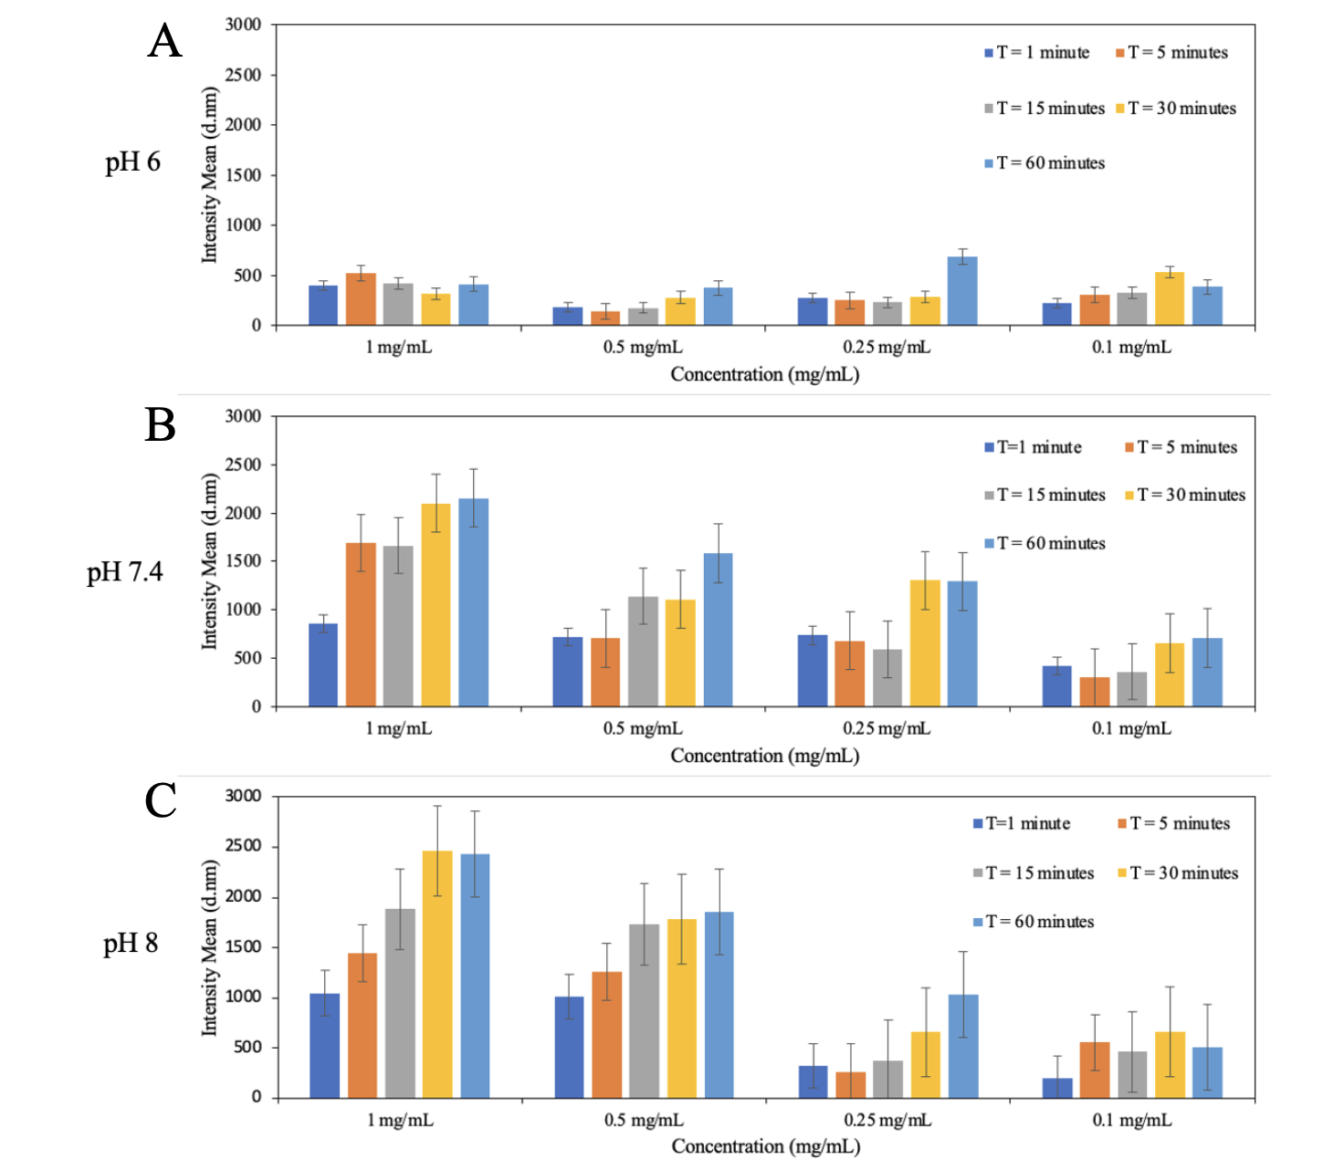

Figure S2. DLS measurements of HBpep coacervates size as a function of time for different peptide concentrations collected at three different pHs: (A) pH 6 (B) pH 7.4 and (C) pH 8

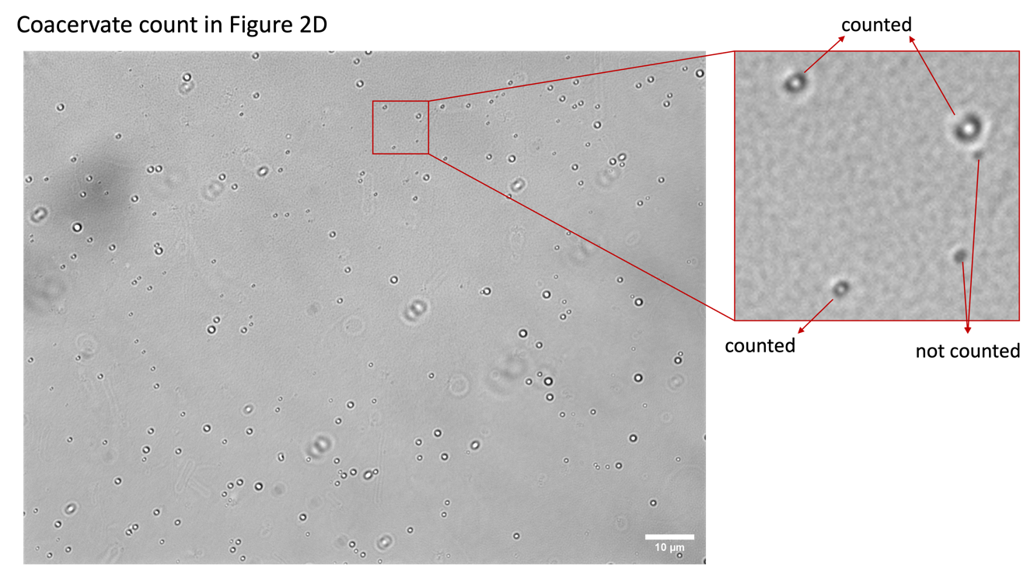

Figure S3. Spherical entities below the resolution limit of the microscope were not included while counting the total number of coacervates in Figure 2D-E, as illustrated above.

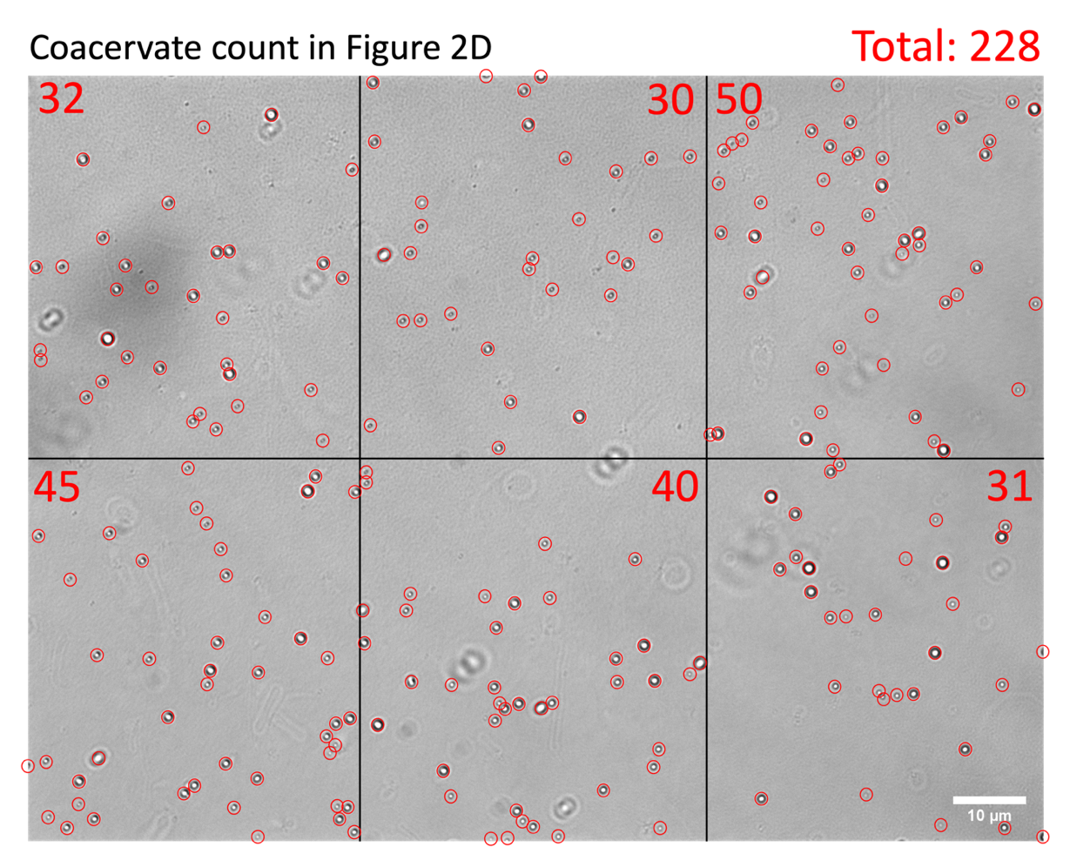

Figure S4. Coacervates counted in Figure 2D are highlighted with red circles.

