Supplementary Information

Lipidic drug delivery systems are responsive to the human microbiome
Jonathan Caukwell^{ab}, Salvatore Assenza^{cde}, Karl A. Hassanª, Brett A. Neilanª, Andrew J. Clulow^{f,j}, Livia Salvati Manni^{bfh*}, Wye-Khay Fong^{ab*}.

ª School of Environmental and Life Sciences, University of Newcastle, Callaghan 2308, NSW, Australia.
^{b} School of Chemistry, Monash University, Clayton 3800, VIC, Australia.
^{c} Departamento de Física Teórica de la Materia Condensada, Universidad Autónoma de Madrid, E-28049 Madrid, Spain.
^{d} Condensed Matter Physics Center (IFIMAC), Universidad Autónoma de Madrid, E-28049 Madrid, Spain.
^{e} Instituto Nicolás Cabrera, Universidad Autónoma de Madrid, E-28049 Madrid, Spain.
^{f} Australian Synchrotron, ANSTO, 800 Blackburn Road, Clayton, VIC 3168, Australia.
^{j} Drug Delivery, Disposition & Dynamics, Monash Institute of Pharmaceutical Sciences, 381 Royal Parade, Parkville, VIC 3052, Australia.
^{h} School of Chemistry and University of Sydney Nano Institute, The University of Sydney, NSW 2006, Australia.
*Corresponding author: khay.fong@monash.edu.

Section 1. Effect of microbial strains on monoolein liquid crystal phase behaviour

Table S1. Live bacteria study: pH Data
Table S1: pH of monoolein dispersions after 24 h incubation with bacterial subcultures. 37 °C, 50 mg/mL lipid.
Bacterial culture (in LB) | Control | MO cubosomes | MO hexosomes
Control | 6.8 | 6.7 | 5.6
S. aureus | 7.0 | 5.8 | 5.6
P. aeruginosa | 6.9 | 6.0 | 5.9
E. coli | 8.8 | 6.0 | 6.2
Bacterial culture (in MRS) | Control | MO cubosomes | MO hexosomes
Control | 5.1 | 5.0 | 5.0
L. rhamnosus | 4.0 | 3.9 | 3.9

Table S2. Live bacteria study: DLS Data
Table S2: Mean particle diameter and particle dispersity index (PDI) for monoolein cubosomes and hexosomes in LB and MRS used in initial investigation; mean ± σ, n = 3.
Lipid nanoparticle | Dispersion medium | Diameter (nm) | PDI
MO Cubosomes | LB | 217.5 ± 7.0 | 0.368 ± 0.048
MO Cubosomes | MRS | 180.8 ± 2.7 | 0.378 ± 0.012
MO Hexosomes | LB | 223.7 ± 6.0 | 0.267 ± 0.018
MO Hexosomes | MRS | 180.0 ± 1.3 | 0.179 ± 0.008

Table S3. Lattice parameters; Dispersed phases
Table S3: Lattice parameters of monoolein cubosomes and hexosomes after overnight incubation with bacterial subcultures. Mean ± σ; n = 3, 3 and 8 for V₂ (Im3m), H₂ and I₂ (Fd3m), resp.
 | MO cubosomes |  | MO hexosomes
Bacterial culture (in LB) | LC phase | Lattice parameter (Å) | LC phase | Lattice parameter (Å)
Control | Im3m | 122.4 ± 0.1 | H₂ | 55.3 ± 0.1
S. aureus | H₂ | 50.8 ± 0.4 | Fd3m | 156.6 ± 0.9
P. aeruginosa | Im3m | 117.5 ± 0.3 | H₂ | 54.2 ± 0.1
E. coli | Im3m | 121.6 ± 0.2 | H₂ | 54.6 ± 0.1
Bacterial culture (in MRS) | LC phase | Lattice parameter (Å) | LC phase | Lattice parameter (Å)
Control | Im3m | 124.1 ± 0.2 | H₂ | 54.4 ± 0.1
L. rhamnosus | Im3m | 122.4 ± 1.6 | H₂ | 52.2 ± 0.1

Figure S1: Schematic of Quartz capillaries
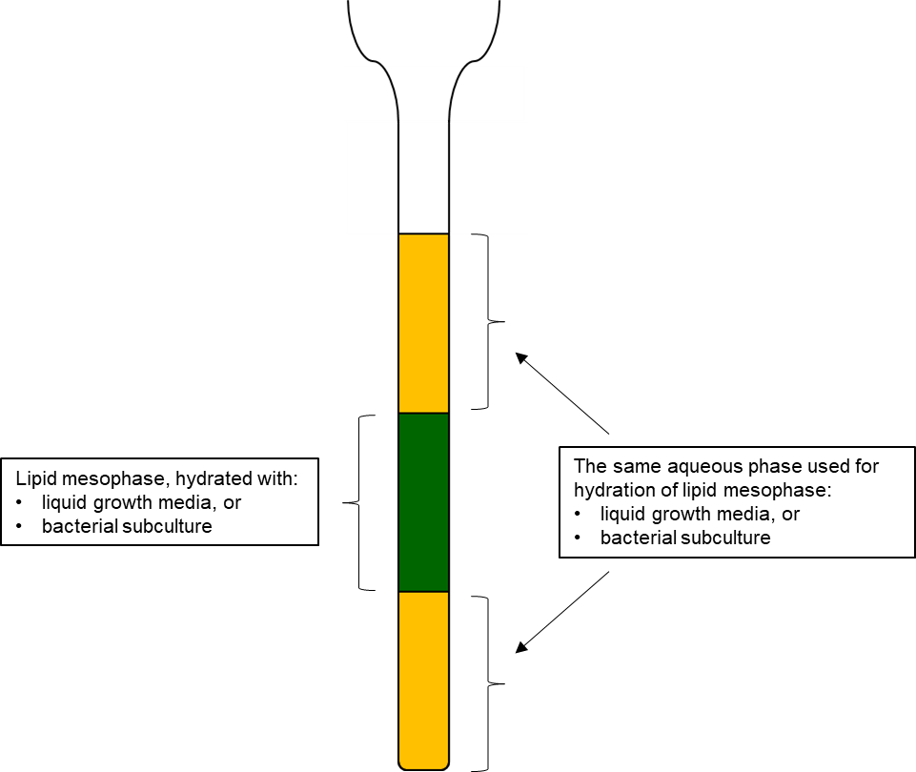
40 mg
30 μL
30 μL
Figure S1: Schematic of 1.5 mm SAXS capillary samples containing lipid mesophase gels.

Table S4. Lattice parameters; Bulk phase
Table S4: Lattice parameters (LP) of monoolein cubic phase gels after overnight incubation with bacterial subcultures. Mean ± σ; n = 3 and 6 for H₂ and V₂ (Pn3m), resp.
Bacterial cultures (in LB) | LC phase | Lattice parameter (Å)
Control | Pn3m | 88.2 ± 0.1
S. aureus | H₂ | 60.7 ± 0.0
S. aureus | Pn3m | 84.2 ± 0.1
P. aeruginosa | Pn3m | 87.3 ± 0.1
E. coli | Pn3m | 85.2 ± 0.1
Bacterial cultures (in MRS) | LC phase | Lattice parameter (Å)
Control | Pn3m | 85.9 ± 0.1
L. rhamnosus | Pn3m | 84.7 ± 0.2

Section 2: Exploring the mechanism driving structural transformation

Table S5. Mixing study: DLS and pH Data
Table S5: Physicochemical properties of dispersed lipid formulations used in dynamic Synchrotron study. Particle diameter (Z-ave) & PDI: mean ± σ, n = 3.
Lipid particle | pH | Diameter (nm) | PDI
MO cubosomes | 7.1 | 275.5 ± 16.7 | 0.359 ± 0.023
Cell lipid particles | 6.9 | - | -

Table S6. Mixing Study: Lattice parameters
Table S6: Lattice parameter of monoolein cubosomes throughout mixing with isolated cell membrane lipid dispersion over time. Mean ± σ; n = 3.
Sample | LC phase | Lattice parameter (Å)
Control | Im3m | 122.6 ± 0.6
t=0 | Im3m | 119.9 ± 0.1
t=+37min | Im3m | 120.7 ± 0.6
t=+37min | H₂ | 75.7 ± 0.7
t=+133min | Im3m | 118.4 ± 0.3
t=+133min | H₂ | 76.8 ± 0.2
t=+133min | H₂ | 73.7 ± 0.4

Table S7: DLS data: MO cubosomes treated with size-separated bacterial culture fractions.
Table S7: Particle size and polydispersity of monoolein cubosomes after overnight incubation with E. coli and S. aureus size-separated culture fractions (μ ± σ; n = 3).
Sample | Diameter (nm) | Polydispersity
Control (in PBS) | 177.0 ± 2.9 | 0.140 ± 0.016
E. coli (10 – 450 nm) | 150.0 ± 1.8 | 0.132 ± 0.010
E. coli (1 – 10 nm) | 150.3 ± 2.2 | 0.117 ± 0.011
E. coli (<1 nm) | 149.5 ± 2.7 | 0.115 ± 0.025
S. aureus (10 – 450 nm) | 193.6 ± 5.4 | 0.178 ± 0.037
S. aureus (1 – 10 nm) | 177.9 ± 7.2 | 0.194 ± 0.013
S. aureus (<1 nm) | 145.5 ± 3.7 | 0.130 ± 0.038

Table S8: Relative concentration of size-separated bacterial culture fractions.
Table S8: Concentration of size-separated fractions relative to their concentration in the starting culture.
Bacterial culture | Size fraction (nm) | Relative concentration (%)
E. coli | 10 – 450 | 6.79
E. coli | 1 – 10 | 6.79
E. coli | <1 | 0.10
S. aureus | 10 – 450 | 7.08
S. aureus | 1 – 10 | 7.08
S. aureus | <1 | 0.10

Table S9: Lattice parameters: monoolein cubosomes treated with size-separated bacterial culture fractions.
Table S9: Lattice parameters of monoolein cubosomes after overnight incubation with E. coli and S. aureus size-separated culture fractions.
Sample | Phase 1 | Lattice Parameter (Å) | Phase 2 | Lattice Parameter (Å)
Control | Pn3m | 115.0 ± 3.5 | Im3m | 116.3 ± 2.6
E. coli (10 - 450 nm) | Pn3m | 113.8 ± 5.5 | Im3m | 116.3 ± 2.6
E. coli (1 - 10 nm) | Pn3m | 114.9 ± 5.3 | Im3m | 117.0 ± 3.9
E. coli (<1 nm) | Pn3m | 113.4 ± 6.1 | Im3m | 116.2 ± 2.7
S. aureus (10 - 450 nm) | Fd3m | 148.8 ± 1.3 | - | -
S. aureus (1 - 10 nm) | H₂ | 56.9 ± 0.2 | - | -
S. aureus (<1 nm) | Pn3m | 114.4 ± 5.5 | Im3m | 116.7 ± 4.0

Section 3: Kinetics of structural transformation

Figure S2. cPLM images: MO gel + S. aureus culture; replicates.
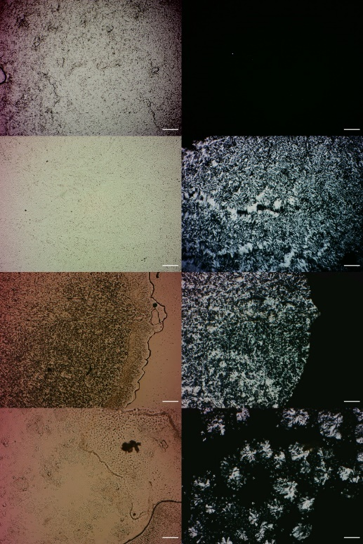
Figure S2: Monoolein cubic phase gels under bright-field (left column) and cross-polarized (right column) light, before (row 1) and after (rows 2–4) overnight incubation with S. aureus. Scalebar: 100 µm.

Movie 1. cPLM time-lapse: MO cubic gel + S. aureus.
Movie 1: cPLM timelapse of MO cubic phase gel incubated with S. aureus; the formation of H₂ phase spreads radially throughout the gel. 1 s of footage ≈ 1 hr of incubation. Scale bar = 200 µm.

Figure S3. cPLM images: MO gel, sterile control.
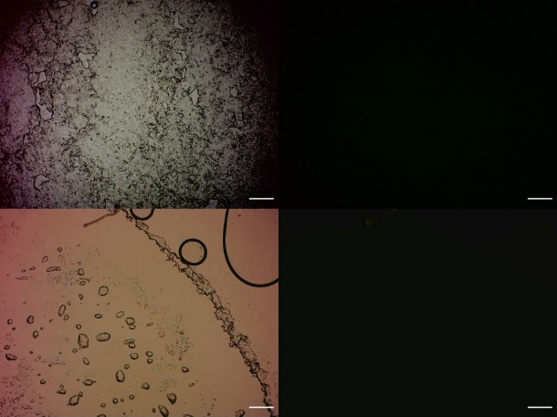
Figure S3: Bulk monoolein cubic phase under bright-field (left column) and cross-polarized (right column) light, before and after overnight incubation in sterile culturing media (top and bottom rows, respectively). Scalebar: 100 µm.

Figure S4. cPLM images: S. aureus control
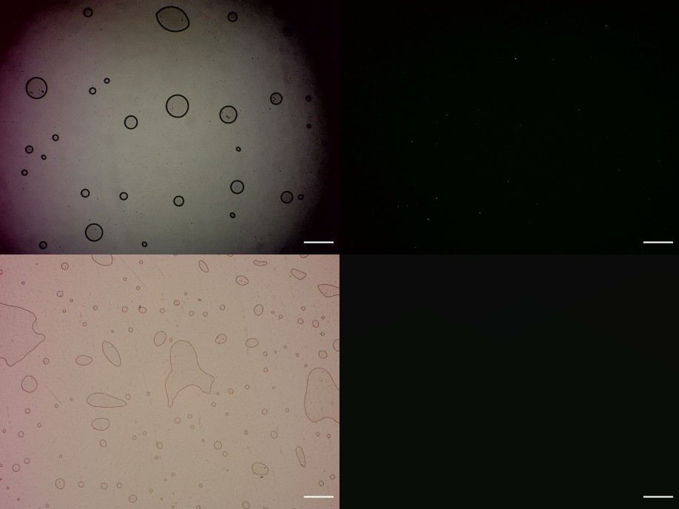
Figure S4: S. aureus culture under bright-field (left column) and cross-polarized (right column) light, before and after overnight incubation (top and bottom rows, respectively). Scalebar: 100 µm.

Figure S5. SAXS pattern: MO cubic gel; sterile & S. aureus
Figure S5: SAXS patterns for the drug release study gels after incubation with sterile media or S. aureus culture.

Figure S6: DRS: SAXS pattern: MO hexagonal gel; sterile
Figure S6: SAXS pattern of the H₂ drug release study gel after incubation in sterile media.

Table S10. DRS: Lattice parameters
Table S10: Lattice parameters of dye-loaded monoolein liquid crystalline gels used in drug release study. Cubic phase gels exposed to S. aureus were incubated in inoculated culture media for 43 hrs prior to sample acquisition). Mean ± σ; n = 3 and 6 for H₂ and V₂ (Pn3m), resp.
Sample | LC phase | Lattice parameter (Å)
Sterile – cubic phase gel | Pn3m | 93.9 ± 0.5
Sterile – hexagonal phase gel | H₂ | 56.4 ± 0.0
S. aureus – cubic phase gel | H₂ | 49.9 ± 0.1

Figure S7: Minibeaker Schematic
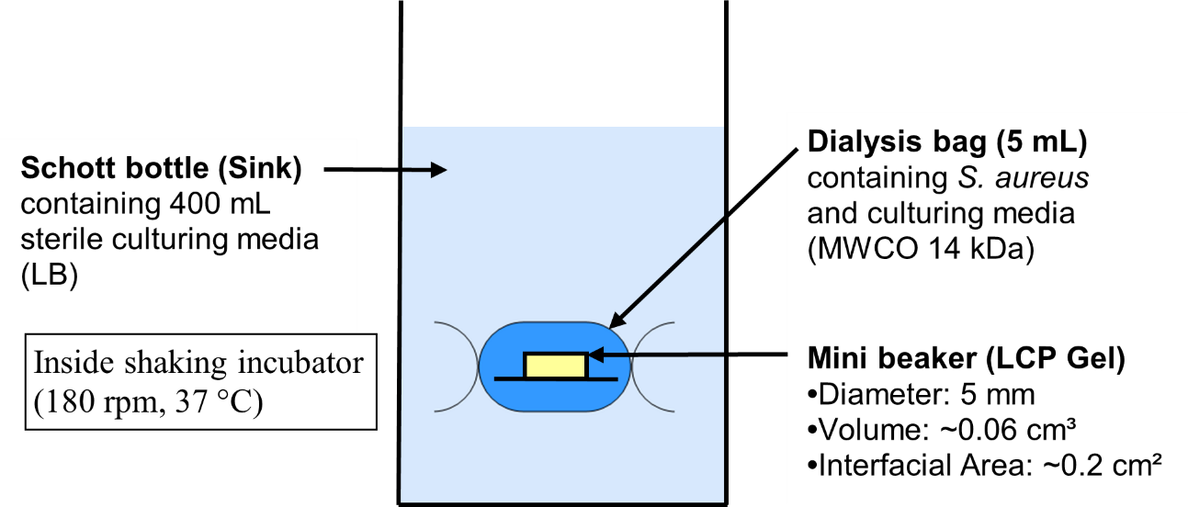
Figure S8: Schematic of minibeakers used in drug release studies.

