High Density Lipoprotein Function is Modulated by the SARS-CoV-2 Spike Protein in a Lipid-Type Dependent Manner
Supporting Information

Scheme 1: Synthesis of PLPC-d₆₂. Reagents and conditions: (a) (i) Bu₂SnO, iPrOH, reflux 1 h, (ii) palmitoyl chloride-d₃₁ Et₃N, rt, 30 mins, 47%; (b) Linoleic acid-d₃₁, 4-PyOH, DCC, CHCl₃, rt, 40 h, 74%.

Scheme 2: Synthesis of POPC-d₆₄. Reagents and conditions: (a) (i) Bu₂SnO, iPrOH, reflux 1 h, (ii) palmitoyl chloride-d₃₁ Et₃N, rt, 30 mins, 47%; (b) Oleic acid-d₃₃, 4-PyOH, DCC, CHCl₃, rt, 40 h, 68%.

Experimental section
General
All reactions were performed under an atmosphere of nitrogen unless otherwise specified. Chemicals and reagents of the highest grade were purchased from Sigma-Aldrich (Sydney, Australia) and were used without further puriﬁcation. Solvents were purchased from Sigma-Aldrich and Merck. NMR solvents were purchased from Cambridge Isotope Laboratories Inc. (MA, USA) and Sigma-Aldrich and were used without further puriﬁcation. Anhydrous dichloromethane was obtained from a LC Technology Solutions Inc. SP-1 Stand Alone Solvent Purification System. Analytical thin-layer chromatography (TLC) was performed using Merck aluminium backed silica gel 60 F₂₅₄ (0.2 mm) plates, which were visualised with shortwave (254 nm) ultraviolet light or with potassium permanganate, vanillin or Hanessian’s stains. Flash column chromatography was performed using Merck Kieselgel 60 (230-400 mesh) silica gel, with the eluent mixture reported as the volume:volume ratio.
Methods and data-analysis
Electrospray ionization mass spectra (ESI-MS) were recorded on a 4000 QTrap AB SCIEX Mass Spectrometer. The overall percent deuteration of the molecules was calculated by ER-MS (enhanced resolution – MS) using the isotope distribution analysis of the different isotopologues by analysing the area under each MS peak which corresponds to a defined number of deuterium atoms. The contribution of the carbon-13 (natural abundance) to the value of the area under each X+1 MS signal is subtracted based on the relative amount found in the protonated version. ¹H NMR (400 MHz), ¹³C NMR (100.6 MHz) and ²H NMR (61.4 MHz) spectra were recorded on a Bruker 400 MHz spectrometer at 298 K. Chemical shifts, in ppm, were referenced to the residual signal of the corresponding NMR solvent. Deuterium NMR was performed using the probe’s lock channel for direct observation.

Synthesis of PLPC-d₆₂:
1-Palmitoyl-sn-glycero-3-phosphocholine-d₃₁
The 2-lyso lipid was synthesised using previously reported methods (Fasoli, E.; et al. Org. Biomol. Chem. 2006, 4, 2974-2978.) using L-α-glycerophosphorylcholine (3.2 g, 12.44 mmol) and palmitoyl chloride-d₃₁ (4.95 g, 16.17 mmol). The crude product was recrystallised from ethanol, to obtain the title compound (3.1 g, 47%) as a white powder.
¹H NMR (400 MHz, CDCl₃, MeOD) δ 4.33-4.22 (2H, m), 4.08 (2H, d, J = 5.6 Hz), 4.00-3.89 (2H, m), 3.89-3.79 (1H, m), 3.69-3.62 (2H, m), 2.25 (residual), 1.51 (residual), 1.15 (residual), 0.78 (residual) ppm.
²H NMR (61.4 MHz, CDCl₃, MeOD) δ 2.23 (2D, bs), 1.50 (2D, bs), 1.32-1.00 (24D, m), 0.77 (3D, s) ppm.
³¹P NMR (161.9 MHz, CDCl₃, MeOD) δ 0.045 ppm.
¹³C{¹H} NMR (100.6 MHz, CDCl₃, MeOD) δ 174.3, 68.9 (d, J = 5.4 Hz), 67.1 (d, J = 5.7 Hz), 66.5 (m), 64.9, 59.2 (d, J = 5.3 Hz), 53.4 (t, J = 3.4 Hz), 28.2 (m) ppm.
ESI-MS: [M+Na]⁺ 549.9 m/z (major isotopologue), 45.3% d31; 36.0% d30, 13.8% d29, 3.8% d28, 0.8% d27, 0.3% d26.

1-Palmitoyl-2-linoleoyl-glycero-3-phosphocholine-d₆₂
A solution of linoleic acid-d₃₁ (100 mg, 0.32 mmol) and 1-palmitoyl-sn-glycero-3-phosphocholine-d₃₁ (161 mg, 0.31 mol) in anhydrous chloroform (4 mL) was cooled to 0 °C and treated with 4-hydroxypyridine (145 mg, 1.53 mmol) followed by a solution of N,N′-dicyclohexylcarbodiimide (95 mg, 0.46 mmol) in chloroform ( 2 mL), dropwise. The mixture was warmed to room temperature and stirred for 40 hours in the absence of light. The volatiles were removed under a stream of nitrogen and the residue purified by flash column chromatography using methanol with 0.4% water, dichloromethane (0:1 to 3:7) as an eluent to obtain the title compound (185 mg, 74%) as a colourless solid.
R_{f} = 0.15, 3:7 MeOH with 0.4% H₂O, CH₂Cl₂).
¹H NMR (400 MHz, CDCl₃) δ 5.37-5.28 (residual), 5.21-5.12 (1H, m), 4.37 (1H, dd, J = 2.5, 12.2 Hz), 4.33-4.22 (2H, m), 4.10 (1H, dd, J = 7.4, 12.1 Hz), 4.10-3.83 (2H, m), 3.80-3.70 (2H, m), 3.33 (9H, s), 2.27-2.20 (residual), 2.00-1.96 (residual), 1.55-1.48 (residual), 1.33-1.14 (residual), 0.90-0.77 (residual) ppm.
²H NMR (61.4 MHz, CDCl₃) δ 5.55-5.22 (4D, m), 2.72 (2D, bs), 2.25 (4D, bs), 1.99 (4D, bs), 1.51 (4D, bs), 1.41-0.96 (38D, bs), 0.82 (6D, s) ppm.
³¹P NMR (161.9 MHz, CDCl₃) δ -1.037 ppm.
¹³C{¹H} NMR (100.6 MHz, CDCl₃) δ 173.8, 173.4, 70.6 (d, J = 8.0 Hz), 66.4 (m), 63.5 (d, J = 4.5 Hz), 63.1, 59.5 (d, J = 5.6 Hz), 54.5, 28.3 (m) ppm.
¹³C{¹H, ²H} NMR (100.6 MHz, CDCl₃) δ 173.8, 173.4, 129.8, 129.5, 127.6, 127.5, 70.6 (d, J = 8.0 Hz), 66.4 (m), 63.5 (d, J = 3.7 Hz), 63.1, 59.5 (d, J = 5.6 Hz), 54.5, 33.6, 33.5, 30.6, 30.2, 28.6, 28.5, 28.5, 28.5, 28.4, 28.2, 28.1, 28.1, 28.0, 28.0, 28.0, 26.3, 26.2, 24.9, 24.0, 23.9, 21.5, 21.4, 13.1, 13.0 ppm.
ESI-MS: [M+Na]⁺ 843 m/z 16.7% d₆₂; 31.2% d₆₁, 26.4% d₆₀, 14.8% d₅₉, 6.3% d₅₈, 2.8% d₅₇, 1.1% d₅₆, 0.7% d₅₅.

Synthesis of POPC-d₆₄:
1-Palmitoyl-2-oleoyl-glycero-3-phosphocholine-d₆₄
A solution of oleic acid-d₃₃ (1.0 g, 3.18 mmol) and 1-palmitoyl-sn-glycero-3-phosphocholine-d₃₁ (1.59 g, 3.03 mmol) in anhydrous chloroform (40 mL) was cooled to 0 °C and treated with 4-hydroxypyridine (1.44 g, 15.1 mmol) followed by a solution of N,N′-dicyclohexylcarbodiimide (0.94 g, 4.54 mmol) in chloroform (20 mL), dropwise. The mixture was warmed to room temperature and stirred for 40 hours in the absence of light. The volatiles were removed under a stream of nitrogen and the residue purified by flash column chromatography using methanol with 0.4% water, dichloromethane (0:1 to 3:7) as an eluent to obtain a gummy mass, which was freeze dried to obtain the title compound (1.7 g, 68%) as a colourless solid, R_{f} = 0.1, 3:7 (MeOH with 0.4% H₂O, CH₂Cl₂).
¹H NMR (400 MHz, CDCl₃) δ 5.30 (1H, bs), 5.21-5.12 (1H, m), 4.37 (1H, dd, J = 2.7, 12.1 Hz), 4.32-4.22 (2H, m), 4.1 (1H, dd, J = 7.3, 12.0 Hz), 3.98-3.82 (2H, m), 3.81-3.72 (2H, m), 3.34 (9H, s), 2.27-2.19 (residual), 1.98-1.91 (residual), 1.59-1.47 (residual), 1.32-1.11 (residual), 0.79 (residual) ppm.
²H NMR (61.4 MHz, CDCl₃) δ 5.35 (1D, bs), 2.23 (4D, bs), 1.94 (4D, bs), 1.50 (4D, bs), 1.19 (44D, bs), 0.81 (6D, s) ppm; ³¹P NMR (161.9 MHz, CDCl₃) δ -0.921 ppm.
¹³C{¹H} NMR (100.6 MHz, CDCl₃) δ 173.7, 173.3, 129.6, 70.6 (d, J = 7.4 Hz), 66.4 (d, J = 6.0 Hz), 63.4 (d, J = 5.7 Hz), 63.1, 59.4 (d, J = 5.0 Hz), 54.4, 28.4 (m) ppm.
¹³C{¹H, ²H} NMR (100.6 MHz, CDCl₃) δ 173.7, 173.3, 129.7, 129.6, 70.6 (d, J = 7.4 Hz), 66.4 (d, J = 6.0 Hz), 63.4 (d, J = 5.7 Hz), 63.1, 59.4 (d, J = 5.0 Hz), 54.4, 33.6, 33.4, 30.6, 30.6, 28.6, 28.6, 28.5, 28.4, 28.4, 28.3, 28.3, 28.1, 28.1, 28.1, 28.1, 28.0, 28.0, 27.9, 26.3, 26.3, 24.0, 23.9, 21.5, 21.5, 13.0 ppm.
ESI-MS: [M+H]⁺ 824 m/z, 94.2±2%D overall, isotopologue distribution 4.4% d₆₃; 19.0% d₆₂, 26.0% d₆₁, 23.1% d₆₀, 14.0% d₅₉, 7.6% d₅₈, 3.4% d₅₇, 1.5% d₅₆, 0.9% d₅₅.

Spectral Data:
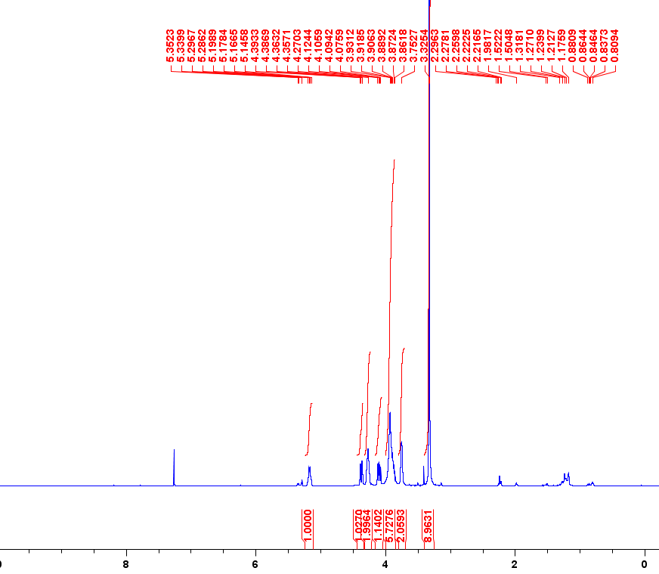
Figure 1. ¹H NMR 400 MHz (CDCl₃) spectrum of PLPC-d₆₂.

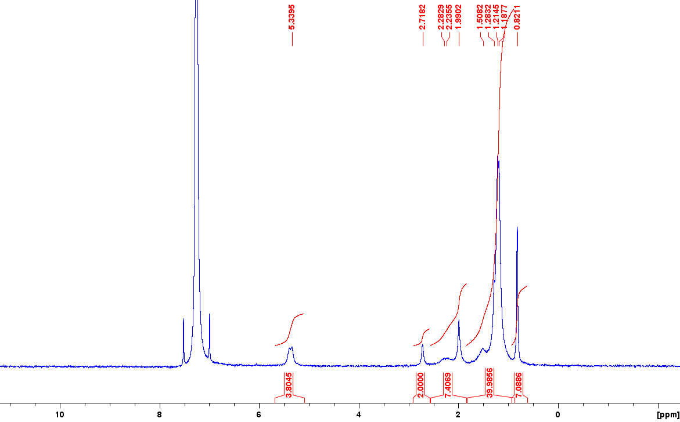
Figure 2. ²H NMR 61.4 MHz (CDCl₃) spectrum of PLPC-d₆₂.
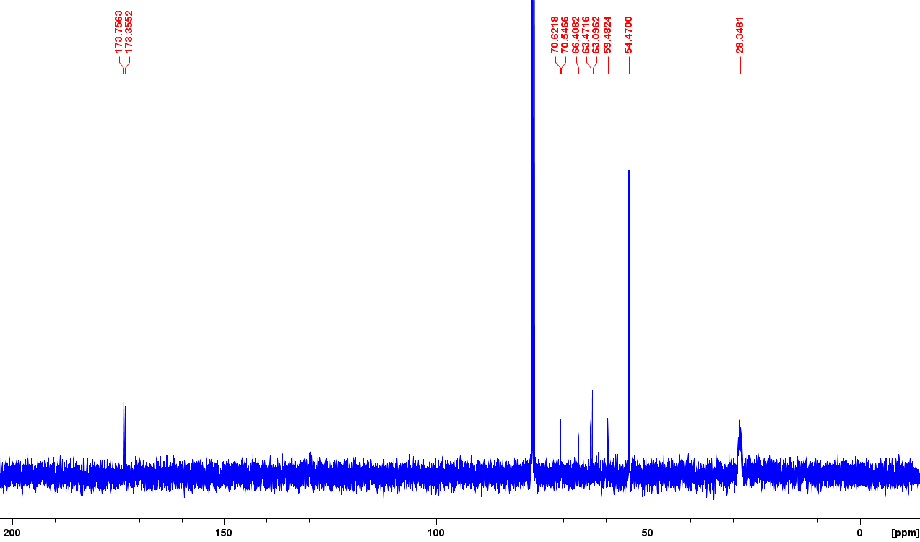
Figure 3. ¹³C {¹H} NMR (CDCl₃) spectrum of PLPC-d₆₂.

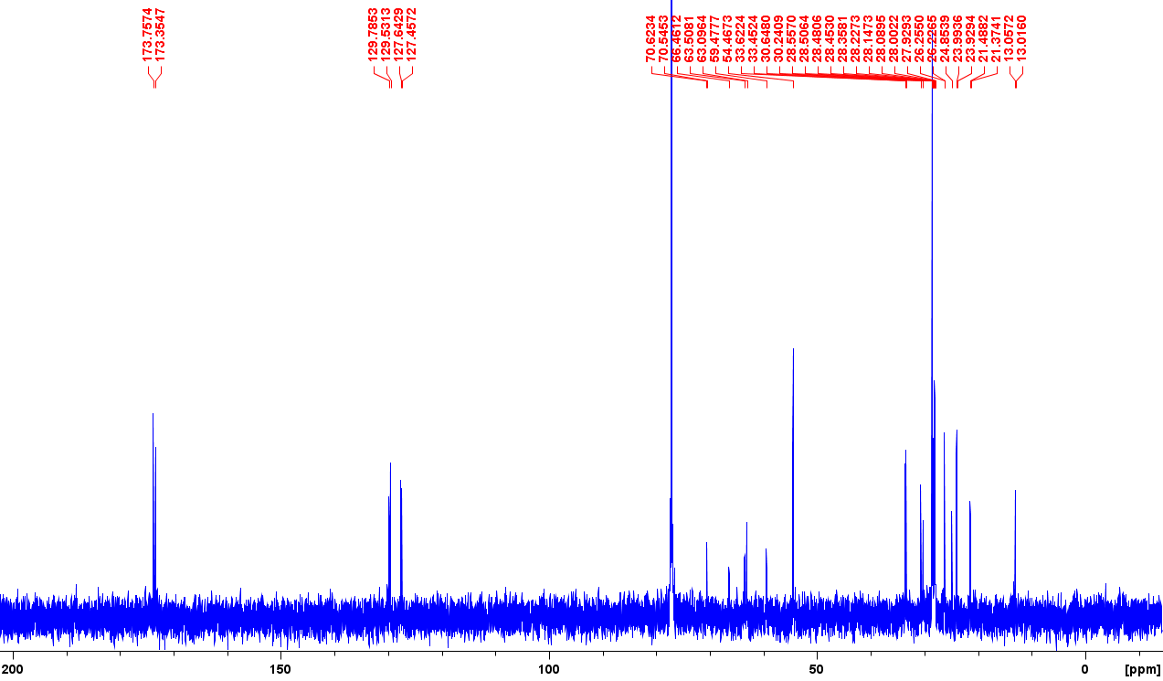
Figure 4. ¹³C NMR {¹H, ²H} (CDCl₃) spectrum of PLPC-d₆₂.

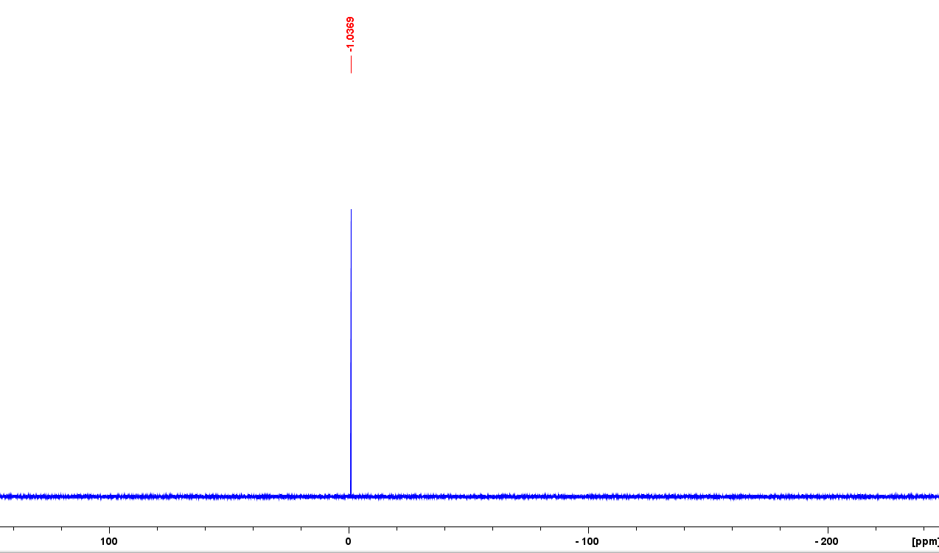
Figure 5. ³¹P NMR 161.9 MHz (CDCl₃) spectrum of PLPC-d₆₂ showing single peak.

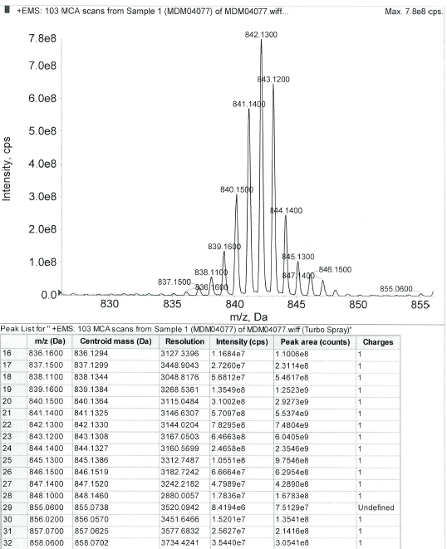
Figure 6. ESI-MS: Spectrum of PLPC-d₆₂ [M+Na]⁺

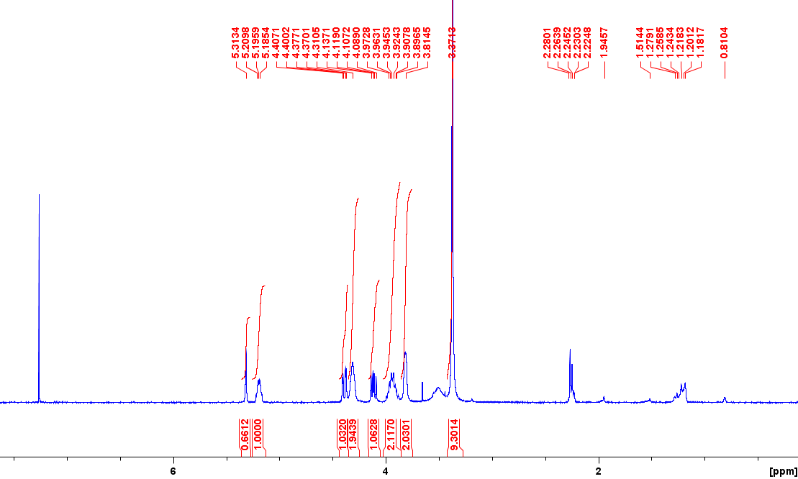
Figure 7: ¹H NMR 400 MHz (CDCl₃) spectrum of POPC-d_{64.}

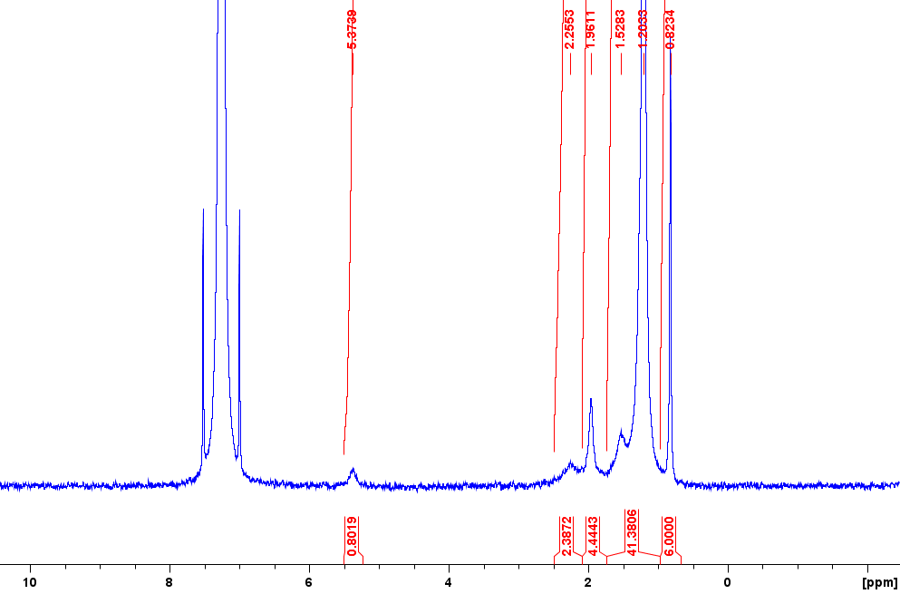
Figure 8: ²H NMR 61.4 MHz (CDCl₃) of POPC-d_{64.}

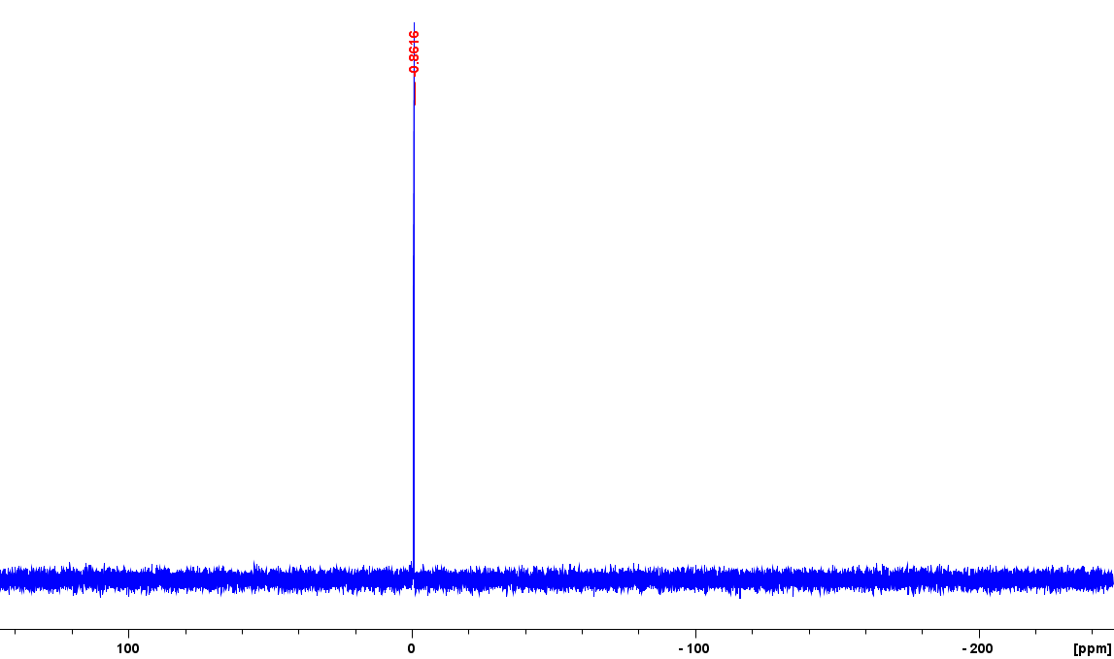
Figure 9: ³¹P NMR 161.9 MHz (CDCl₃) of POPC-d₆₄

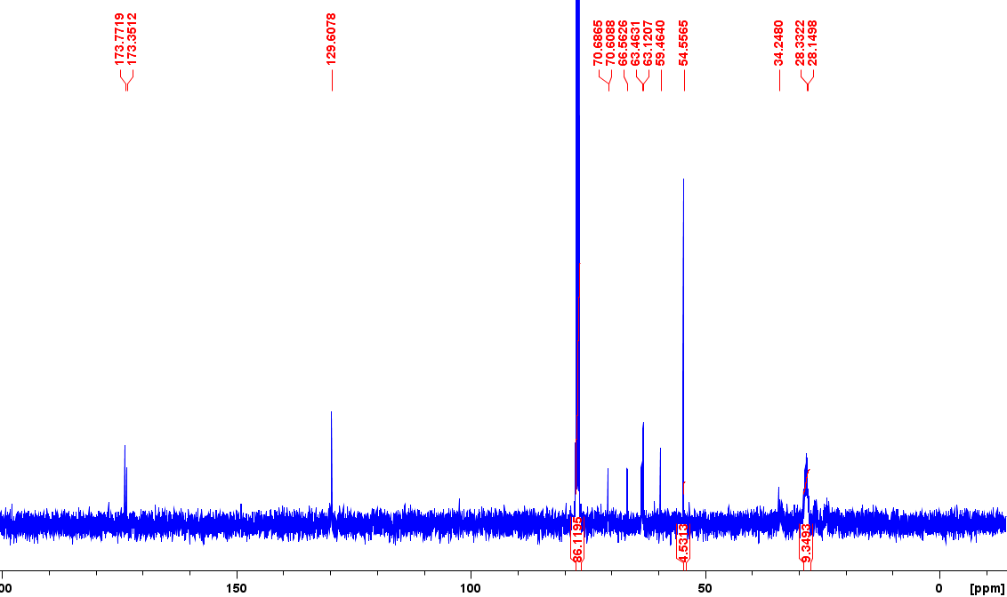
Figure 10: ¹³C {¹H} NMR 100.6 MHz (CDCl₃) of POPC-d₆₄.

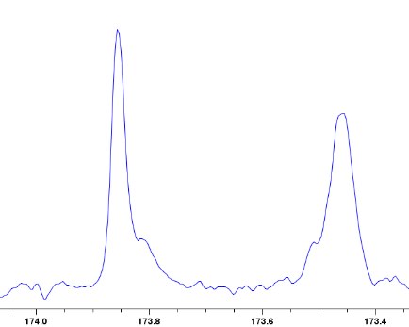
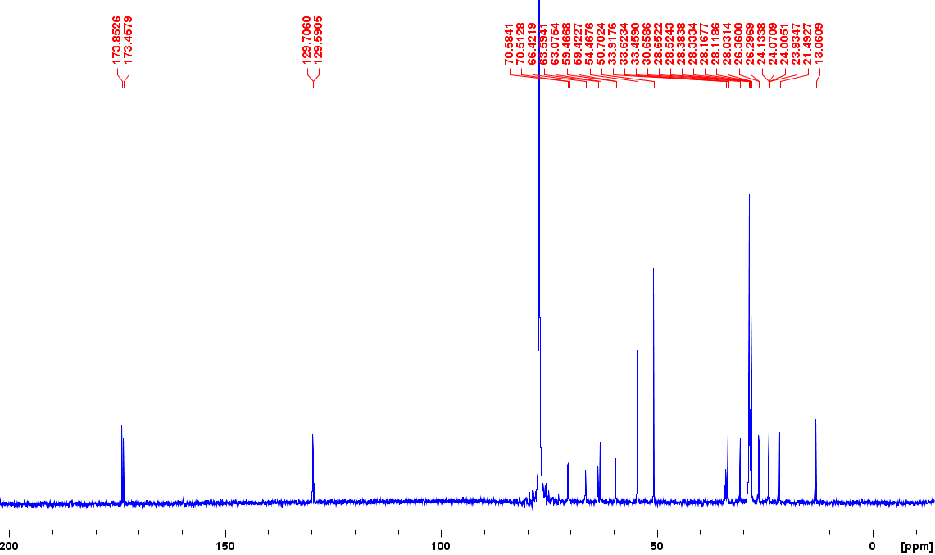
Figure 11: ¹³C {¹H, ²H} NMR 100.6 MHz (CDCl₃) of POPC-d₆₄. Showing zoomed in carbonyl region. Two major signals provides evidence for POPC being the major regioisomer present.

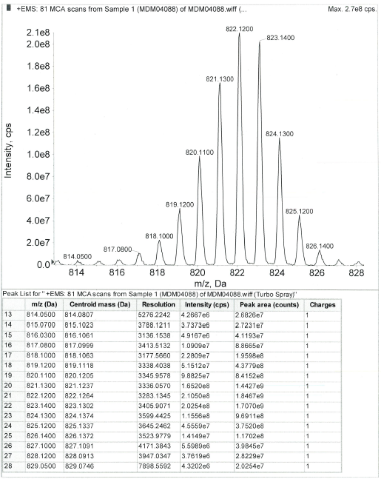
Figure 12: ESI-MS: Spectrum of POPC-d₆₄ [M+H]⁺.

Quantification of regioisomeric purity:
The analysis was performed using previously reported mass spectrometry methods (Moir, M. et al. Adv. Synth. Catal. 2022, 364, 1–13.)

Table 1: Calculated regioisomeric purity of PLPC-d₆₂ and POPC-d₆₄ via CID/OzID and enzyme digestion (PLA1) mass spectrometry methods.
PLPC (%) |  | POPC (%)
CID/OzID | PLA1 | CID/OzID | PLA1
86 ± 2 | 89 ± 2 | 87 ± 2 | 89 ± 3

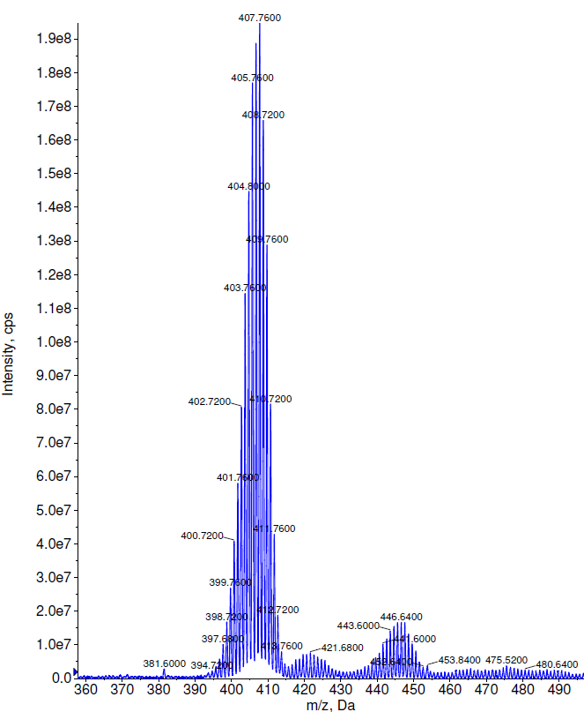
Figure 13. ESI-MS: Spectrum of cholesterol-d₄₅ [M–H₂O+H]⁺. 0.1% d₄₅, 0.2% d₄₄, 0.4% d₄₃, 1.3% d₄₂, 3.6% d₄₁, 6.4% d₄₀, 9.7% d₃₉, 12.4% d₃₈, 13.1% d₃₇, 12.7% d₃₆, 11.1% d₃₅, 8.9% d₃₄, 6.5% d₃₃, 4.6% d₃₂, 3.4% d₃₁, 2.2% d₃₀, 1.3% d₂₉, 0.9% d₂₈, 0.5% d₂₇, 0.3% d₂₆, 0.3% d₂₅. Overall deuteration level calculated as 80±2%.
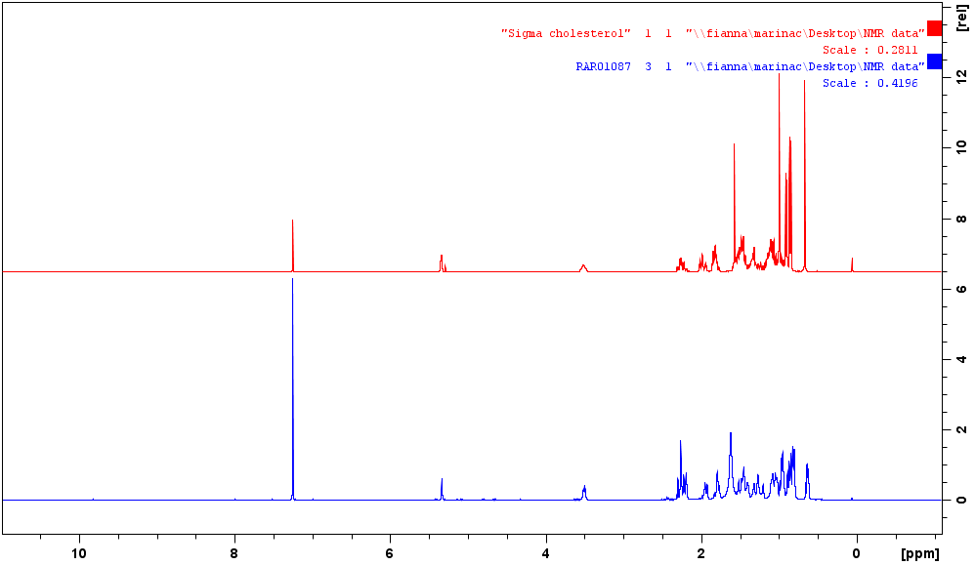
Figure 14. Stacked view of ¹H NMR (400 MHz, CDCl₃) spectra of protiated cholesterol (top, red) and cholesterol-d₄₅ (bottom, blue).
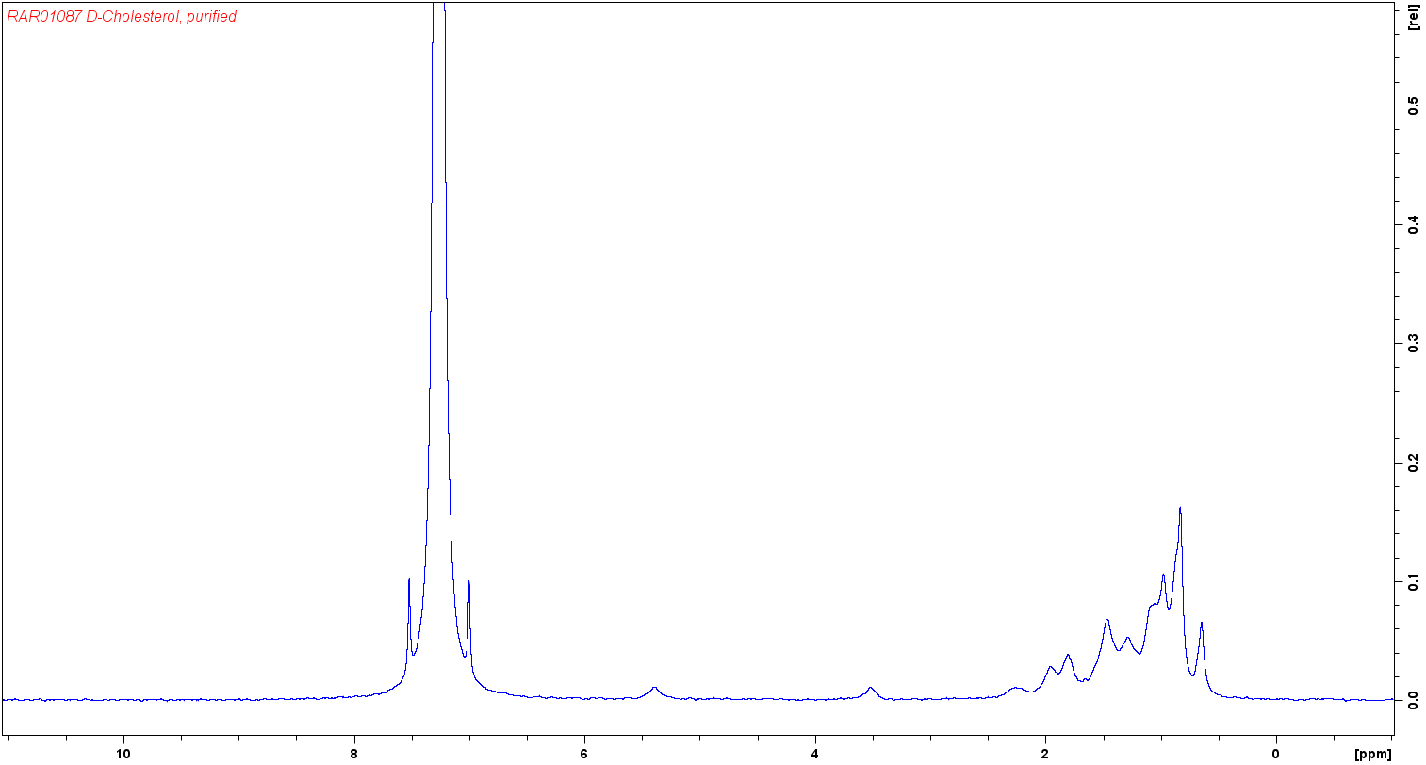
Figure 15. ²H NMR (61.4 MHz, CDCl₃) spectrum of cholesterol-d₄₅.
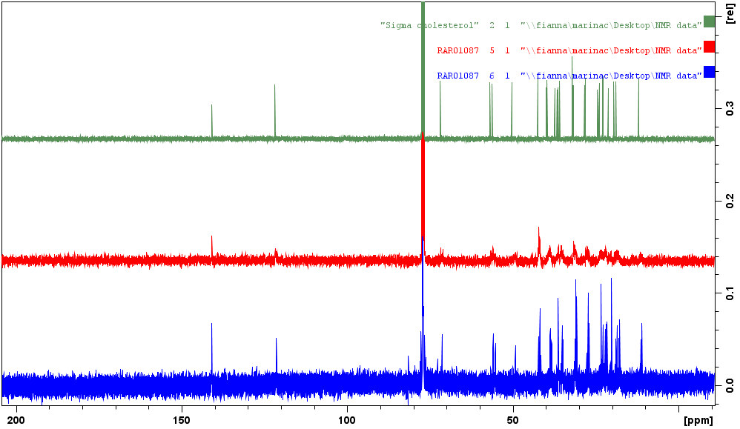
Figure 16. Stacked view of ¹³C{¹H} NMR (101 MHz, CDCl₃) spectra of protiated cholesterol (top, green) and cholesterol-d₄₅ (middle, red) and ¹³C{¹H, ²H, d1 = 20 s} NMR (101 MHz, CDCl₃) spectrum of cholesterol-d₄₅ (bottom, blue).

Supporting data and analysis for main text
Table S1. Parameters used for fitting
 | SLD *10⁻⁶ (Å⁻²) | Volume (Å³)
Si | 2.07
SiO₂ | 3.47
d -DM tails | 6.5* | 779,8
PC | 1.89 | 320,9
d-cholesterol (ANSTO) | 5.6 * [1] | 622
d-cholesterol (ILL) | 6.9* [2] | 633
HDL | 2.02 [3]
d-PL | 6.5* | 926
d-PO | 6.6* | 937
Spike protein | 3.1 (D₂O) – 1.9 (H₂O) | 173138
*Calculated from MS spectral distribution.
Table S2. Lipid composition for each model membrane exposed to either HDL (0.132 mg/mL), S protein (0.05 mg/mL) or a mixture of both HDL and S protein (0.132 and 0.05 mg/mL, respectively). Capital letters indicate the nature of the sample that was incubated (A= HDL, B= spike protein, C= HDL + Spike protein), and numbers indicate the lipid composition of the bilayer (1= d-DMPC, 2=80% d-POPC: 20% d-cholesterol, 3= 80% d-PLPC: 20% d-cholesterol and 4= 80% d-DMPC:20% d-cholesterol).
 | Type of HDL | FIGARO | Spatz | D17
Pooled | HDL | A1 | A2, A3
Pooled | Spike protein + HDL | C1 | C2, C3
Individuals | HDL LTLC |  |  | A^{LTLC}4
Individuals | HDL LTLC + Spike protein |  |  | C^{LTLC}4
Individuals | HDL LTHC |  |  | A^{LTHC}4
Individuals | HDL LTHC + Spike protein |  |  | C^{LTHC}4
Individuals | HDL HTHC |  |  | A^{HTHC}4
Individuals | HDL HTHC + Spike protein |  |  | C^{HTHC}4
 | Spike protein | B1 | B2, B3

Table S3. Fitting parameters for pristine SLBs. Fixed values are marked with * and errors were calculated after Bayesian MCMC estimation. For fitting the data, five layers were used to model the SLBs. These 5 layers correspond to SiO₂, water layer, inner heads, tails, and outer heads. It was assumed that the SLBs were symmetric across each leaflet. This means that the thickness and coverage for the inner and outer head group were linked to each other. The SLD for the lipid core of lipid mixtures containing deuterated cholesterol were allowed to vary slightly to take into consideration slight variations in cholesterol content as described previously [4] [5].
Samples | layer | Before Incubation
 |  | SLD (*10⁻⁶ Å⁻²) | Thickness (Å) (E±0.1-0.3 ) | Solvent (%)(E ±0.1-0.3 ) | MMA | Linked Roughness across leaflet (Å)
A1 | Inner heads | 1.89* | 9.0 | 32.0 | 54 ± 2 | 5.0
A1 | tails | 6.50* | 26.0 | 0 | 59.8 ± 0.5 | 5.0
A1 | Outer heads | 1.89* | 9.0 | 32.0 | 54 ± 2 | 5.0
B1 | Inner heads | 1.89* | 10.0 | 38.0 | 53 ± 2 | 4.6
B1 | tails | 6.50* | 25.7 | 0 | 60.7 ± 0.5 | 4.6
B1 | Outer heads | 1.89* | 10.0 | 38.0 | 53 ± 2 | 4.6
C1 | Inner heads | 1.89* | 7.0 | 36.0 | 47 ± 3 | 6.0
C1 | tails | 6.50* | 25.9 | 1.0 | 61 ± 3 | 6.0
C1 | Outer heads | 1.89* | 7.0 | 36.0 | 47 ± 3 | 6.0
A2 | Inner heads | 1.89* | 6.7 | 1.0 | 60 ± 3 | 6.0
A2 | tails | 6.59* | 29.8 | 1.0 | 63.7 ± 0.5 | 6.0
A2 | Outer heads | 1.89* | 6.7 | 1.0 | 60 ± 3 | 6.0
B2 | Inner heads | 1.89* | 6.6 | 1.0 | 50 ±2 | 5
B2 | tails | 6.59* | 31.2 | 1.4 | 55.9 ± 0.3 | 5
B2 | Outer heads | 1.89* | 6.6 | 1.0 | 50 ± 2 | 5
C2 | Inner heads | 1.89* | 6.4 | 1.0 | 51 ± 4 | 6.5
C2 | tails | 6.59* | 30.6 | 5.0 | 64.1 ± 0.6 | 6.5
C2 | Outer heads | 1.89* | 6.4 | 1.0 | 51 ± 4 | 6.5
A3 | Inner heads | 1.89* | 6.7 | 30.0 | 69 ±3 | 2
A3 | tails | 6.36 | 31.2 | 5.0 | 61 ± 2 | 2
A3 | Outer heads | 1.89* | 6.7 | 30.0 | 69 ± 3 | 2
B3 | Inner heads | 1.89* | 6.4 | 35.0 | 78 ± 7 | 2
B3 | tails | 6.16 | 33.0 | 1.0 | 56.0 ± 0.5 | 2
B3 | Outer heads | 1.89* | 6.4 | 35.0 | 78 ± 7 | 2
C3 | Inner heads | 1.89* | 8.1 | 35 | 62 ± 6 | 7
C3 | tails | 6.88 | 26.9 | 0 | 68 ± 5 | 7
C3 | Outer heads | 1.89* | 8.1 | 35 | 62 ± 6 | 7
A^{LTLC}4 | Inner heads | 1.89* | 6.2 | 17.0 | 53 ± 2 | 4.6
A^{LTLC}4 | tails | 6.64* | 29.8 | 4.0 | 51.3 ± 0.3 | 4.6
A^{LTLC}4 | Outer heads | 1.89* | 6.2 | 17.0 | 53 ± 2 | 4.6
C^{LTLC}4 | Inner heads | 1.89* | 8.3 | 30.0 | 56 ± 2 | 5.0
C^{LTLC}4 | tails | 6.64* | 31.4 | 1.0 | 48.1 ± 0.2 | 5.0
C^{LTLC}4 | Outer heads | 1.89* | 8.3 | 30.0 | 57 ± 2 | 5.0
A^{LTHC}4 | Inner heads | 1.89* | 7.2 | 7.0 | 49 ± 2 | 5.0
A^{LTHC}4 | tails | 6.64* | 28.8 | 1.0 | 52.5 ± 0.2 | 5.0
A^{LTHC}4 | Outer heads | 1.89* | 7.2 | 7.0 | 49 ± 2 | 5.0
C^{LTHC}4 | Inner heads | 1.89* | 7.5 | 17.1 | 52 ± 2 | 4.3
C^{LTHC}4 | tails | 6.64* | 29.5 | 1.0 | 51.9 ± 0.2 | 4.3
C^{LTHC}4 | Outer heads | 1.89* | 7.5 | 17.1 | 52 ± 2 | 4.3
A^{HTHC}4 | Inner heads | 1.89* | 7.5 | 17.1 | 52 ± 2 | 4.6
A^{HTHC}4 | tails | 6.64* | 29.1 | 1.0 | 51.7 ± 0.2 | 4.6
A^{HTHC}4 | Outer heads | 1.89* | 7.5 | 17.1 | 52 ± 2 | 4.6
C^{HTHC}4 | Inner heads | 1.89* | 9.4 | 31.0 | 50 ± 2 | 5.5
C^{HTHC}4 | tails | 6.64* | 29.1 | 1.0 | 51.9 ± 0.2 | 5.5
C^{HTHC}4 | Outer heads | 1.89* | 9.4 | 31.0 | 50 ± 2 | 5.5

Table S4. Parameters for SLBs after 5 hours incubation and extensive rinse with buffer. Fixed values are marked with * and errors were calculated after Bayesian MCMC estimation.

Samples | layer | After Incubation
 |  | SLD (*10⁻⁶ Å⁻²) | Thickness (Å) (E±0.1-0.4 ) | Solvent (%)(E ±0.1-0.3 ) | MMA |  | Linked Roughness across leaflet (Å) | % Lipids removed | % Lipids deposited
A1 | Inner heads | 1.89* | 6.3 | 28 | 72 ± 6 | 3 |  | 23.8 ± 0.3 | 16.1 ± 0.4
A1 | tails | 5.4 | 28.9 | 7 | 59 ± 1 | 3 |  | 23.8 ± 0.3 | 16.1 ± 0.4
A1 | Outer heads | 1.89* | 8.8 | 43 | 66 ± 6 | 3 |  | 23.8 ± 0.3 | 16.1 ± 0.4
A1 | HDL | 2.02* | 50* | 99 |  | 3 |  | 23.8 ± 0.3 | 16.1 ± 0.4
B1 | Inner heads | 1.89* | 10.0 | 39 | 53 ± 2 | 4 |  | 0.9 ± 0.1
B1 | tails | 6.50* | 25.7 | 1.0 | 62.1 ± 0.5 | 4 |  | 0.9 ± 0.1
B1 | Outer heads | 1.89* | 10.0 | 39 | 53 ± 2 | 4 |  | 0.9 ± 0.1
C1 | Inner heads | 1.89* | 5.5 | 10 | 60 ± 6 | 6 |  | 17.9 ± 0.1 | 8.8 ± 0.2
C1 | tails | 5.9 | 27.46 | 10 | 63 ± 2 | 6 |  | 17.9 ± 0.1 | 8.8 ± 0.2
C1 | Outer heads | 1.89* | 7.9 | 24 | 54 ± 6 | 6 |  | 17.9 ± 0.1 | 8.8 ± 0.2
C1 | HDL + S | 2.02* | 50* | 99 |  | 6
A2 | Inner heads | 1.89* | 6.9 | 1 | 58 ±3 | 6 |  | 8.0 ± 0.1 | 0.209 ± 0.002
A2 | tails | 6.58 | 29.8 | 9.2 | 64.5 ± 0.5 | 6 |  | 8.0 ± 0.1 | 0.209 ± 0.002
A2 | Outer heads | 1.89* | 6.9 | 1 | 58 ± 3 | 6 |  | 8.0 ± 0.1 | 0.209 ± 0.002
A2 | HDL | 2.02* | 64.4 | 98 |  | 6 |  | 8.0 ± 0.1 | 0.209 ± 0.002
B2 | Inner heads | 1.89* | 6.6 | 1 | 49 ± 2 | 6 |  | 0.791 ± 0.03
B2 | tails | 6.59* | 31.6 | 2.1 | 56.4 ± 0.3 | 6 |  | 0.791 ± 0.03
B2 | Outer heads | 1.89* | 6.6 | 1 | 49 ± 2 | 6 |  | 0.791 ± 0.03
C2 | Inner heads | 1.89* | 7.3 | 33 | 67 ± 3 | 2 |  | 8.49 ± 0.06 | 11.59 ± 0.08
C2 | tails | 6.03 | 34.7 | 2 | 51.3 ± 0.2 | 2 |  | 8.49 ± 0.06 | 11.59 ± 0.08
C2 | Outer heads | 1.89* | 7.3 | 33 | 67 ± 3 | 2 |  | 8.49 ± 0.06 | 11.59 ± 0.08
C2 | HDL + S | 2.02* | 55.6 | 97 |  | 2 |  | 8.49 ± 0.06 | 11.59 ± 0.08
A3 | Inner heads | 1.89* | 6.6 | 34 | 75 ± 4 | 2 |  | 4.6 ± 0.2 | 3.8 ±0.2
A3 | tails | 6.12 | 33.2 | 6.0 | 58.5 ± 0.3 | 2 |  | 4.6 ± 0.2 | 3.8 ±0.2
A3 | Outer heads | 1.89* | 6.6 | 34 | 75 ± 4 | 2 |  | 4.6 ± 0.2 | 3.8 ±0.2
A3 | HDL | 2.02* | 54.3 | 98 |  | 2 |  | 4.6 ± 0.2 | 3.8 ±0.2
B3 | Inner heads | 1.89* | 6.5 | 30 | 71 ± 5 | 2 |  | 18.6 ± 0.3
B3 | tails | 6.19* | 33.4 | 1 | 56 ± 1 | 2 |  | 18.6 ± 0.3
B3 | Outer heads | 1.89* | 6.5 | 30 | 71 ± 5 | 2 |  | 18.6 ± 0.3
B3 | S |  | 64.9 | 91 |  | 2 |  | 18.6 ± 0.3
C3 | Inner heads | 1.89* | 8.4* | 45 | 71 ± 4 | 6 |  | 9 ± 1 | 5.7 ± 0.6
C3 | tails | 6.48 | 27.6 | 3 | 68 ± 6 | 6 |  | 9 ± 1 | 5.7 ± 0.6
C3 | Outer heads | 1.89* | 8.4* | 45 | 71 ± 4 | 6 |  | 9 ± 1 | 5.7 ± 0.6
C3 | HDL + S | 2.02* | 40* | 98 |  | 6 |  | 9 ± 1 | 5.7 ± 0.6
A^{LTLC}4 | Inner heads | 1.89* | 5.6 | 37 | 94 ± 7 | 4 |  | 21.1 ± 0.2 | 20.0 ± 0.5
A^{LTLC}4 | tails | 5.31 | 31.0 | 5 | 51.0 ± 0.5 | 4 |  | 21.1 ± 0.2 | 20.0 ± 0.5
A^{LTLC}4 | Outer heads | 1.89* | 13.0 | 51 | 51 ± 2 | 4 |  | 21.1 ± 0.2 | 20.0 ± 0.5
A^{LTLC}4 | HDL | 2.02* | 61.1 | 96 |  | 4 |  | 21.1 ± 0.2 | 20.0 ± 0.5
C^{LTLC}4 | Inner heads | 1.89* | 7.3 | 29 | 63 ± 2 | 4 |  | 16.9 ± 0.2 | 13.6 ± 0.5
C^{LTLC}4 | tails | 6.00 | 32.6 | 26 | 50.0 ± 0.5 | 4 |  | 16.9 ± 0.2 | 13.6 ± 0.5
C^{LTLC}4 | Outer heads | 1.89* | 12.2 | 30 | 37 ± 1 | 4 |  | 16.9 ± 0.2 | 13.6 ± 0.5
C^{LTLC}4 | HDL + S | 2.02* | 80.8 | 99 |  | 4 |  | 16.9 ± 0.2 | 13.6 ± 0.5
A^{LTHC}4 | Inner heads | 1.89* | 5.8 | 30 | 80 ± 3 | 6 |  | 14.0 ± 0.1 | 11,1 ± 0.2
A^{LTHC}4 | tails | 5.9 | 27.6 | 4 | 58.9 ± 0.7 | 6 |  | 14.0 ± 0.1 | 11,1 ± 0.2
A^{LTHC}4 | Outer heads | 1.89* | 12.7 | 50 | 51 ± 1 | 6 |  | 14.0 ± 0.1 | 11,1 ± 0.2
A^{LTHC}4 | HDL | 2.02* | 58.0 | 99 |  | 6 |  | 14.0 ± 0.1 | 11,1 ± 0.2
C^{LTHC}4 | Inner heads | 1.89* | 5.5 | 36 | 92 ± 1 | 2 |  | 19.7 ± 0.1 | 13.6 ± 0.3
C^{LTHC}4 | tails | 5.73 | 31.5 | 7 | 51.0 ± 0.4 | 2 |  | 19.7 ± 0.1 | 13.6 ± 0.3
C^{LTHC}4 | Outer heads | 1.89* | 12.0 | 54 | 59 ± 1 | 2 |  | 19.7 ± 0.1 | 13.6 ± 0.3
C^{LTHC}4 | HDL + S | 2.02* | 67.6 | 99 |  | 2 |  | 19.7 ± 0.1 | 13.6 ± 0.3
A^{HTHC}4 | Inner heads | 1.89* | 6.0 | 35 | 83 ± 5 | 5 |  | 26.6 ± 0.2 | 14.5 ±
A^{HTHC}4 | tails | 5.68 | 30.0 | 13 | 57.1 ± 0.7 | 5 |  | 26.6 ± 0.2 | 14.5 ±
A^{HTHC}4 | Outer heads | 1.89* | 10.7 | 44 | 47 ± 2 | 5 |  | 26.6 ± 0.2 | 14.5 ±
A^{HTHC}4 | HDL | 2.02* | 68.5 | 99 |  | 5 |  | 26.6 ± 0.2 | 14.5 ±
C^{HTHC}4 | Inner heads | 1.89* | 7.0 | 47 | 87 ± 5 | 5 |  | 17.7 ± 0.2 | 14.6 ± 0.4
C^{HTHC}4 | tails | 5.66 | 31.3 | 4 | 49.5 ± 0.7 | 5 |  | 17.7 ± 0.2 | 14.6 ± 0.4
C^{HTHC}4 | Outer heads | 1.89* | 8.8 | 40 | 70 ± 7 | 5 |  | 17.7 ± 0.2 | 14.6 ± 0.4
C^{HTHC}4 | HDL + S | 2.02* | 65.2 | 99 |  | 5 |  | 17.7 ± 0.2 | 14.6 ± 0.4

Figure S1. Right panel: Neutron Reflection profiles including best fits for model membranes composed of (A) d-DMPC, (B) d-PLPC: d-cholesterol, (C) d-DMPC: d-cholesterol, and (D) d-POPC: d-cholesterol at a molar ratio of 80:20 mol% before (Δ-CmSI, О-d-TBS and ◊-h-TBS) and after (▲-CmSI, ●-d-TBS and ♦-h-TBS), exposure to a mixture of 0.132 mg/mL HDL and 0.05 mg/ml S protein measured at 37 °C in d-TBS, h-TBS and CmSi-Tris. Left panel: SLD profiles (E) d-DMPC, (F) d-PLPC: d-cholesterol, (G) d-DMPC: d-cholesterol, and (H) d-POPC: d-cholesterol before (short dash) and after (solid line) incubation.
Figure S2. Right panel: Neutron Reflection profiles including best fits for model membranes composed of (A) d-DMPC, (B) d-PLPC: d-cholesterol, (C) d-DMPC: d-cholesterol, and (D) d-POPC: d-cholesterol at a molar ratio of 80:20 mol% before (Δ-CmSI, О-d-TBS and ◊-h-TBS) and after (▲-CmSI, ●-d-TBS and ♦-h-TBS), exposure to 0.05 mg/mL S protein measured at 37 °C in d-TBS, h-TBS and CmSi-Tris. Left panel: SLD profiles (E) d-DMPC, (F) d-PLPC: d-cholesterol, (G) d-DMPC: d-cholesterol, and (H) d-POPC: d-cholesterol before (short dash) and after (solid line) incubation. Data corresponding to Figure C was replotted with permission from ref [6].

Figure S3. Right panel: Neutron Reflection profiles including best fits for model membranes composed of (A) d-DMPC, (B) d-PLPC: d-cholesterol, (C) d-DMPC: d-cholesterol, and (D) d-POPC: d-cholesterol at a molar ratio of 80:20 mol% before (Δ-CmSI, О-d-TBS and ◊-h-TBS) and after (▲-CmSI, ●-d-TBS and ♦-h-TBS), exposure to 0.132 mg/mL HDL measured at 37 °C in d-TBS, h-TBS and CmSi-Tris. Left panel: SLD profiles (E) d-DMPC, (F) d-PLPC: d-cholesterol, (G) d-DMPC: d-cholesterol, and (H) d-POPC: d-cholesterol before (short dash) and after (solid line) incubation. Data corresponding to Figure C was replotted with permission from ref [6].
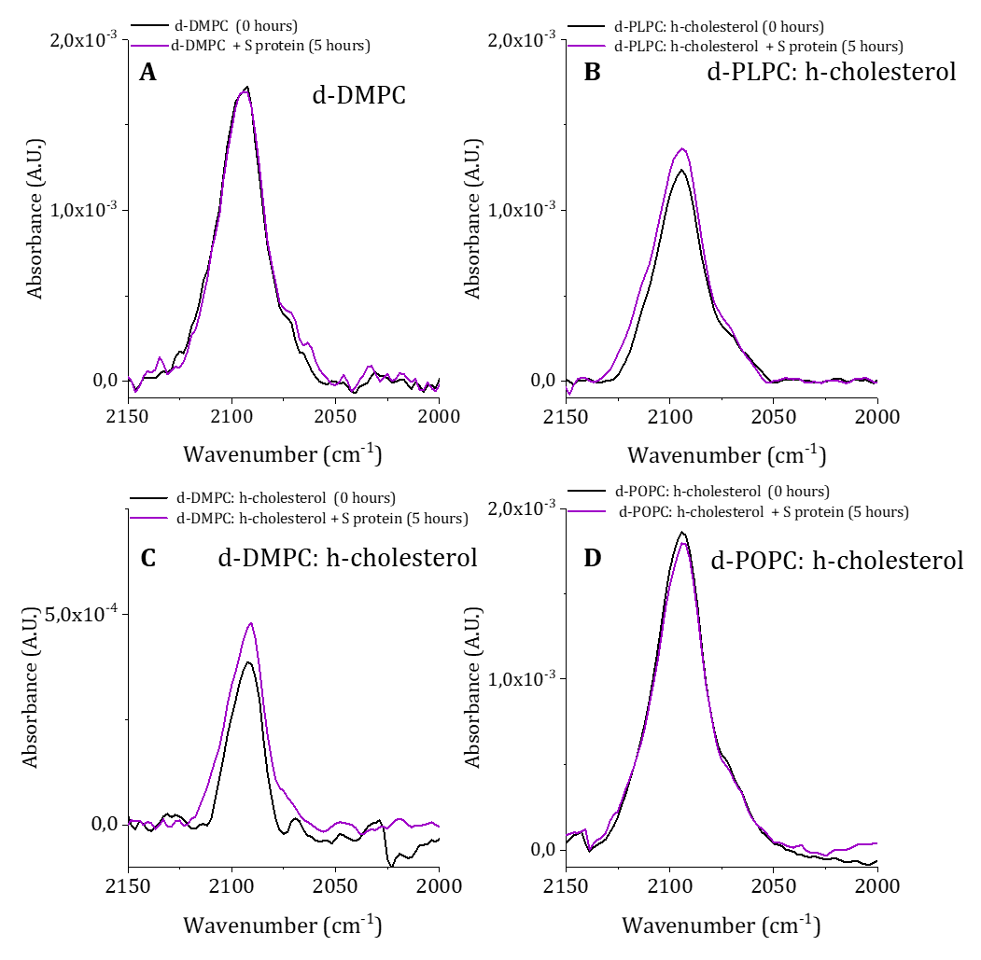
Figure S4. ATR-FTIR spectra for model membranes composed of (A) d-DMPC, (B) d-PLPC: h-cholesterol, (C) d-DMPC: h-cholesterol, and (D) d-POPC: h-cholesterol at a molar ratio of 80:20 mol%, before (black) and after 5 hours of exposure to 0.05 mg/mL S protein (purple). (Data corresponding to Figure A and C were replotted with permission from ref [6]). Spectra were collected using a Thermo Nicolet spectrophotometer with a resolution of 4 cm⁻¹.
Table S5. Plasma Lipid profile values from individuals used to produce the HDL pooled sample in Neutron Reflection Experiments.
Sample | Tot Chol (mmol/L) | TG (mmol/L) | Comments
HTLC | 3.08 | 3.34 | High TG, low TC
HTLC | 4.73 | 4.44 | High TG, low TC
LTHC | 6.4 | 1.4 | low TG, high TC

Figure S5. Neutron reflection profiles include best fits for a model membrane composed of d-DMPC: d-cholesterol at a molar ratio of 80:20 mol% exposed to 0,132 mg/mL HDL LTHC, HTHC, and LTLC (Figures A, C, and E, respectively) and a mix of 0.05 mg/ml S protein with 0.132 mg/mL HDL LTHC, HTHC and LTLC (Figures B, D, and F) in h-TBS at 37 °C after 5 hours of incubation and upon rinsing with excess h-TBS. (Only the q-values between 0,02 and 0,1 Å⁻¹ are shown).
Figure S6. Right panel: Neutron Reflection profiles including best fits for model membranes composed of d-DMPC: d-cholesterol at a molar ratio of 80:20 mol% before (Δ-CmSI, О-d-TBS and ◊-h-TBS) and after (▲-CmSI, ●-d-TBS and ♦-h-TBS), exposure to 0.132 mg/mL HDL LTHC, HTHC and LTLC (Figures A, B, and C) measured at 37 °C in d-TBS, CmSi-Tris and h-TBS. Left panel: SLD profiles (D) HDL LTHC, (E) HDL HTHC and (F) HDL LTLC before (short dash) and after (solid line) incubation.

Figure S7. Right panel: Neutron Reflection profiles including best fits for model membranes composed of d-DMPC: d-cholesterol at a molar ratio of 80:20 mol% before (Δ-CmSI, О-d-TBS and ◊-h-TBS) and after (▲-CmSI, ●-d-TBS and ♦-h-TBS), exposure to a mixture of 0.132 mg/mL and 0.05 mg/mL S protein HDL LTHC + S, HTHC + S and LTLC + S (Figures A, B, and C) measured at 37 °C in d-TBS, CmSi-Tris and h-TBS. Left panel: SLD profiles (D) HDL LTHC + S, (E) HDL HTHC + S and (F) HDL LTLC + S before (short dash) and after (solid line) incubation.
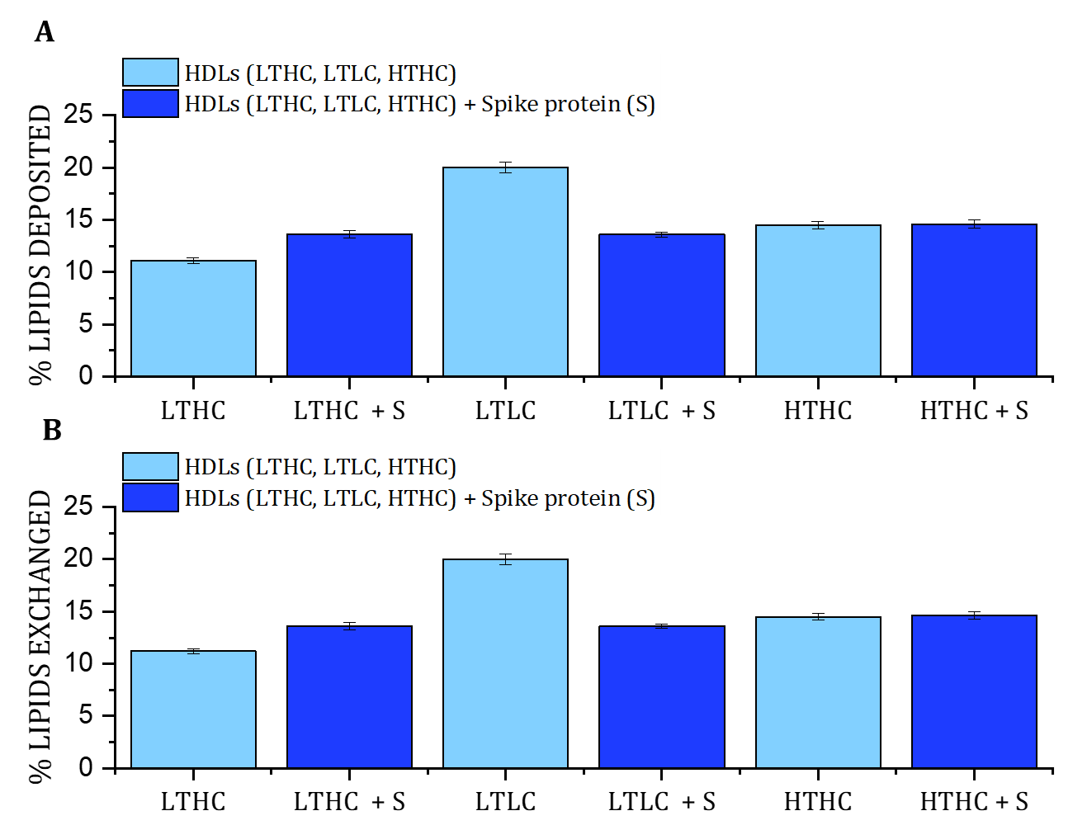
Figure S8. Effect of the S protein on -HDL capacity to deposit and exchange lipids on HDL samples from individuals with low triglycerides/high cholesterol (LTHC), low triglycerides/low cholesterol (LTLC), and high triglycerides/ high cholesterol (HTHC) plasma levels: A) lipids deposited and B) Lipids Exchanged by NR defined as the average between the lipids deposited and removed by HDL. The lipid donor is a model membrane composed of d-DMPC: d-cholesterol 80:20 mol%. Experiments were carried out at 37 °C upon 5 hours of incubation.

Figure S9. Examples of DLS size distribution of HDL samples used in this work. DLS were collected using a Malvern Panalytical Zetasizer instrument.

Analysis of model used after incubation with the samples.
The models used for HDL, and HDL + S protein assume that there is no protein penetration into the bilayer according to previous reports [32]. The starting point is as of a 6-layer model, that is one additional layer as compared to the pristine SLB. The number of parameters allowed to vary was minimized, and in the fitting process we increased this number stepwise until a suitable fit was obtained.
Model 1: This model was used to fit the following samples A₂, A₃, C₂ and C₃. It consisted in allowing lipid exchange between the HDL and HDL + Spike with the SLB. Only the solvent content, the roughness and the SLD of the lipid tails was allowed to change. The rest of the parameters were constrained across the bilayer and the headgroups were kept as symmetric.
Model 2: This model was applied for samples A1, C1 and HDL from Individuals with distinct lipid serum profile. It follows as for Model 1 but, in this case, the thickness of the head groups was allowed to vary asymmetrically.
Model 3: This model was used for fitting SLB after exposure to S protein. It was assumed that the S protein could remove lipids from the bilayers and can be or not adsorb on the top of the SLB, in some cases the model was good enough assuming no additional layer of S protein (d-DMPC and d-POPC: d-cholesterol) since forcing one layer on the top of the SLB, the coverage tended to go to zero. There was not lipid exchange and, this means that the SLD of the lipid core region does not change. Only the SLB coverage was allowed to change.
Lipid removal and lipid exchanged are determined using the following equations:
$$\% Lipid exchanged=\frac{SLD deuterated tails \left(SLB after incubation\right)-SLD deuterated tails (pristine SLB)}{SLD hydrogenated tails\left(nanodisc\right)-SLD deuteratedtails (pristine SLB)}*100$$
$$\% Lipid removal=\% Lipid exchanged-\left(\frac{Tails coverage \left(after incubation\right)-Tails coverage (pristine SLB)}{Tails coverage (pristine SLB)}*100\right)$$
This implies that the % of Lipid removal is the sum of both the exchanged and the further removal (solvent replacement) while the % of hydrogenated lipids deposited by the proteins is equal to the lipid exchanged.
References
[1] F. Sebastiani, M. Yanez Arteta, M. Lerche, L. Porcar, C. Lang, R.A. Bragg, C.S. Elmore, V.R. Krishnamurthy, R.A. Russell, T. Darwish, H. Pichler, S. Waldie, M. Moulin, M. Haertlein, V.T. Forsyth, L. Lindfors, M. Cárdenas, Apolipoprotein E Binding Drives Structural and Compositional Rearrangement of mRNA-Containing Lipid Nanoparticles, ACS Nano. 15 (2021) 6709–6722. https://doi.org/10.1021/acsnano.0c10064.
[2] M. Moulin, G.A. Strohmeier, M. Hirz, K.C. Thompson, A.R. Rennie, R.A. Campbell, H. Pichler, S. Maric, V.T. Forsyth, M. Haertlein, Perdeuteration of cholesterol for neutron scattering applications using recombinant Pichia pastoris, Chem. Phys. Lipids. 212 (2018) 80–87. https://doi.org/10.1016/j.chemphyslip.2018.01.006.
[3] K.L. Browning, T.K. Lind, S. Maric, G.N. Fredrikson, Human Lipoproteins at Model Cell Membranes : Effect of Lipoprotein Class on Lipid Exchange, Sci. Rep. 7 (2017) 1–11. https://doi.org/10.1038/s41598-017-07505-0.
[4] S. Waldie, M. Moulin, L. Porcar, H. Pichler, G.A. Strohmeier, M. Skoda, V.T. Forsyth, M. Haertlein, S. Maric, The Production of Matchout- Deuterated Cholesterol and the Study of Bilayer-Cholesterol Interactions, Sci. Rep. 9 (2019) 5118. https://doi.org/10.1038/s41598-019-41439-z.
[5] S. Waldie, F. Sebastiani, K. Browning, S. Maric, T.K. Lind, N. Yepuri, T.A. Darwish, M. Moulin, G. Strohmeier, H. Pichler, M.W.A. Skoda, A. Maestro, M. Haertlein, V.T. Forsyth, E. Bengtsson, M. Malmsten, M. Cárdenas, Lipoprotein ability to exchange and remove lipids from model membranes as a function of fatty acid saturation and presence of cholesterol, Biochim. Biophys. Acta - Mol. Cell Biol. Lipids. 1865 (2020) 158769. https://doi.org/10.1016/j.bbalip.2020.158769.
[6] Y. Correa, S. Waldie, M. Thépaut, S. Micciulla, M. Moulin, F. Franck, H. Michael, P. Harald, V.T. Forsyth, C. Marité, SARS-CoV-2 spike protein removes lipids from model membranes and interferes with the capacity of high density lipoprotein to exchange lipids, J. Colloid Interface Sci. 602 (2020) 732–739. https://doi.org/https://doi.org/10.1016/j.jcis.2021.06.056.

