Tumor-Activated Nanocomplex Reprograms Cancer and Macrophage Metabolism in Opposite Directions to Overcome Immune Suppression
Zan Dai*^{1,2}, Qiaoyun Wang*^{1,3}, Ming Zhang⁴, Yiru Shi⁵, Yannan Yang⁵, Hao Song¹, Runming Wang⁶, Bernt Johannessen⁷, Xu Zhen⁸, Chengzhong Yu*¹
¹Australian Institute for Bioengineering and Nanotechnology, The University of Queensland, Brisbane, QLD 4072, Australia.
²Children’s Cancer Institute, School of Medicine and Health, UNSW Sydney, Sydney 2052, Australia.
³School of Chemistry, UNSW Sydney, Sydney 2052, Australia.
⁴School of Chemical Engineering, UNSW Sydney, Sydney 2052, Australia.
⁵South Australian ImmunoGENomics Cancer Institute, Faculty of Health and Medical Sciences, The University of Adelaide, Adelaide, South Australia, 5005, Australia
⁶Institute of Biopharmaceutical and Health Engineering, Shenzhen International Graduate School, Tsinghua University, Shenzhen, China
⁷Australian Synchrotron, Australian Nuclear Science and Technology Organization, Clayton, VIC 3168 Australia
⁸MOE Key Laboratory of High Performance Polymer Materials & Technology, School of Chemistry& Chemical Engineering, Nanjing University, Nanjing 210023, P. R. China
Experiment
Materials
Zn(NO₃)₂·6H₂O, FeSO₄·7H₂O, Fe(NO₃)₃·9H₂O, 2-methylimidazole (HmIM, 99%), glutaraldehyde, and methanol (99.9%) were purchased from Sigma-Aldrich and used without further purification. NHS-Cy5.5 were purchased from Lumiprobe Corp. Roswell Park Memorial Institute (RPMI) 1640 medium, and fetal bovine serum (FBS) were obtained from Gibco (Grand Island, NY, USA). Programmed cell death 1 ligand 1 antibody (anti-PDL1) was purchased from Sigma-Aldrich (Merck KGaA, Darmstadt, Germany). All other chemicals were purchased from Sigma-Aldrich (Merck KGaA, Darmstadt, Germany) and used as received.
Synthesis of FZNCs
The Fe and Zn nanocomplexes (FZNCs) were synthesized by a low temperature self-assembly process. Firstly, 1.46 g of Zn(NO₃)₂·6H₂O (4.9 mmol) and 1.98 g of Fe(NO₃)₃·9H₂O (4.9 mmol) were added into 100 mL methanol. After sonication for 10 mins, the solution was transferred to 4 degrees under stirring. Then, 100 mL of 2-HmIM solution (0.84 M in methanol) was rapidly added into above mixture and kept stirring for another 2 h at 4 °C. The ZIF-8 white precipitate was obtained by centrifugation (10,000 rpm, 10 min) and rinsed with methanol for 3 times. The final FZNCs product was obtained by dring at 70 °C overnight.
The FZNCs-L and FZNCs-H were synthesized via a similar process by adjusting the Zn-to-Fe molar ratio to 3:7 and 7:3, respectively. The total content of Zn and Fe was maintained at 9.8 mmol. The synthesis of Fe-HmIM was achieved by using 9.8 mmol of Fe(NO₃)₃·9H₂O, while keeping all other conditions the same to above method.
Synthesis of ZIF-8 and Fe²⁺ doped ZIF-8
ZIF-8 nanoparticles were synthesized according to a previously described method.¹ Typically, 2.9 g of Zn(NO₃)₂·6H₂O (9.8 mmol) was dissolved in 100 mL methanol. Then, 100 mL of 2- HmIM (0.84 M in methanol) was added into above solution under stirring for another 2 h at room temperature. The as-prepared precipitates were separated by three rounds of centrifugation (10,000 rpm, 10 min), washed thrice with methanol, and dried overnight in vacuum at 70 °C.
A modified method was used to synthesize Fe²⁺ doped ZIF-8 nanoparticles. Equal molar amounts of Zn (NO₃)₂·6H₂O (1.46 g, 4.9 mmol) and FeSO₄·7H₂O (1.36 g, 4.9 mmol) were dissolved in 100 mL methanol in a three-necked flask. To this solution, 69 g of 2-HmIM (84 mmol) dissolved in 100 mL methanol was added. Subsequently, vigorous stirring was conducted at room temperature for 2 h under nitrogen bubbling to avoid oxidation. The as-prepared precipitates were separated by three rounds of centrifugation (10,000 rpm, 10 min), washed thrice with methanol, and dried overnight in vacuum at 70 °C.
Characterizations
The morphology of the samples was visualized by high-angle annular dark-field scanning transmission electron microscopy (HAADF-STEM) and scanning electron microscope (SEM) imaging by Hitachi HF5000 Cs-STEM/TEM and JEOL JSM-7800F, respectively. Energy-dispersive X-ray spectroscopy (EDX) elemental mapping was performed by Hitachi HF5000 Cs-STEM. Dynamic light scattering (DLS) measurements were conducted using a Malvern Instrument Zetasizer nano series instrument equipped with a 4.0 mW He-Ne laser operating at 633 nm and a detection angle of 173°. The number-averaged particle diameters were obtained from analysis of the autocorrelation functions using the method of cumulants. At least three measurements at 25 °C were made for each sample with an equilibrium time of 2 min before starting the measurement. The XRD patterns were collected on a Bruker New D8-Advance diffractometer using a Cu Kα radiation X-ray source. Raman spectra were obtained using a Thermo Scientific™ DXR Raman Microscope. The Brunauer–Emmett–Teller (BET) specific surface area and pore size were quantified using nitrogen adsorption/desorption analysis (ASAP2020). The pH value during the synthesis process was monitored using a SevenExcellence™ pH/conductivity meter produced by Mettler Toledo Instruments Co. Ltd. X-ray absorption fine spectroscopy (XAFS) was performed in the transmittance and fluorescent detection mode at beamline 6D and 7D in Pohang Accelerator Laboratory (PAL). The obtained XAS data, including XANES and EXAFS, were analyzed using the ATHENA and ARTEMIS programs of the IFEFFIT package. NMR spectra were collected on a Bruker Avance 400 MHz spectrometer at 298 K using CDCl3, DMSO-d6, or D₂O as solvents. All chemical shifts are reported in ppm (δ) relative to tetramethylsilane (TMS). The X-ray photoelectron spectroscopy (XPS) data were acquired on a Kratos Axis Ultra XPS incorporating a 165 mm hemispherical electron energy analyzer. The incident radiation was monochromatic Al Kα X-ray (1486.6 eV) at 150 W (15 kV, 10 mA). Survey (wide) scans were taken at an analyzer pass energy of 160 eV and multiplex (narrow) high-resolution scans at 20 eV. Survey scans were carried out over a binding energy range of 1200–0 eV with 1.0 eV steps and a dwell time of 100 ms. Narrow high-resolution scans were run with 0.05 eV steps and 250 ms dwell time. The base pressure in the analysis chamber was 5.0 × 10^{–9}, and 3.0 × 10^{–8} Torr during sample analysis. The composition and chemical bond state of Zn 2p and Fe 2p were detected. Casa XPS software was used to collect and analyze the data.
H₂S reactivity evaluation
The reactivity of FZNCs with H₂S was evaluated under different pH conditions (7.4 and 6.5) and temperatures (24 °C and 37 °C). Na₂S was used as an H₂S donor for investigating the H₂S consumption mediated by FZNCs. The reaction was carried out by firstly dispersing Na₂S in PBS at 1 mM (pH 7.4) and 395 µM (pH 6.5). Then, FZNCs solution with different concentrations (25, 50, and 100 µg/mL) was added into the solution under stirring for 3 h. The H₂S consumption was monitored by measuring dissolved H₂S concentration using the Unisense hydrogen sulfide microelectrode. Photos of the solution were taken just before and 3 h after adding the FZNCs.
Cell lines and cell culture
CT26 cells from America Type Culture Collection (ATCC) were used in this investigation. CT26 cells were routinely cultured in Roswell Park Memorial Institute (RPMI, Life Technologie)-1640 Medium supplemented with 10% (v/v) fetal bovine serum (FBS, Sigma Aldrich), 1% L-glutamine (Sigma Aldrich), and 1% penicillin-streptomycin (Invitrogen, Carlsbad, CA, USA). Bone marrow-derived macrophages (BMDMs) were isolated from 6-8 weeks old BALB/c mice and then cultured in Dulbecco's Modified Eagle's Medium (DMEM, Life Technologie) supplemented with 10% FBS (Sigma Aldrich), 1% L-glutamine (Sigma Aldrich), 1% penicillin-streptomycin (Invitrogen, Carlsbad, CA, USA) and 30% conditioned medium of L929 cell line (enriched in CSF‐1). Both cells were cultured at 37 °C in a 5% CO₂ humidified incubator and subcultured when they reached 80% confluency.
Bio-transmission electron microscopy
CT26 and BMDMs cells were seeded in 6-well plates at a density of 1 × 10⁵ cells per well. Cells were allowed to adhere overnight under standard culture conditions (37 °C, 5% CO₂). On the following day, CT26 cells and BMDMs cells were incubated with FZNCs (100 µg/mL) at 37 °C for 3 hours under different pH conditions (7.4 and 6.5). After treatment, CT26 cells and BMDMs were washed 3 times with PBS and then fixed in 3% glutaraldehyde for 24 h at 4 °C. The fixed samples were processed and embedded according to our previous protocol, performed by the Centre for Microscopy and Microanalysis at the University of Queensland.² Briefly, samples were post-fixed in 1% osmium tetroxide, dehydrated through graded ethanol and acetone, embedded in EPON 812 resin, sectioned, stained with 2% uranyl acetate and 3% lead citrate, and examined using a HT7700 transmission electron microscope (Hitachi, Japan).
Cellular uptake and endo-/lysosome escape of FZNCs
For the cellular uptake study, CT26 cells and BMDMs were pre-seeded into a six-well plate at a density of 2 × 10⁵ cells per well. After 24 h incubation, the medium was replaced with fresh medium (pH 7.4 or 6.5) containing Cy5.5-labeled FZNCs (100 µg/mL) and incubated for 3 h at 37 °C, 5% CO₂. Subsequently, the medium was drained, and the cells were washed 3 times with PBS to remove the extracellular NPs. CT26 cells were harvested by trypsinization (0.25% Trypsin, Beyotime), while BMDMs were detached by gentle pipetting with ice-cold PBS. Finally, the cells were centrifuged (400 × g for 5 min at 4 °C) and re-suspended in 500 µL ice-cold PBS (kept on ice) before flow cytometry measurements.
For endo-/lysosome escape analysis, CT26 cells were seeded in glass-bottom confocal dish at a density of 2.5 × 10⁴ cells per well and cultured for 24 h. The medium was replaced with fresh medium (pH 7.4 or 6.5) containing FZNCs (100 µg/mL), then the cells were further incubated for 6 h at 37 °C. After washing with PBS, cells were stained with LysoTracker green (Cell Signaling Technology) at 37 °C for 25 min for lysosomal labelling, followed by nuclear counterstaining with p-[5-(4-methyl-1-piperazinyl)(2,5'-bi-1H-benzimidazol)-2'-yl]phenol trihydrochloride (Hoechst 33342) for 15 min. Finally, cells were maintained in Live Cell Imaging Solution (Thermo Fisher) and imaged using Leica SP8 confocal laser scanning microscopy (CLSM).
Cell toxicity of FZNCs
The cell toxicity of FZNCs was evaluated using the MTT assay. Typically, CT26 cells and BMDMs were seeded in 96-well plates at a density of 5 × 10⁴ cells per well and incubated for 24 h. The medium was then replaced with 100 µL fresh medium containing FZNCs at different concentrations (25, 50, 100, 200 and 300 µg/mL). After 24 h of incubation, the medium was aspirated. Then, 100 µL of fresh medium containing 20 µL of MTT reagent (5 mg/mL in PBS) was added into each well. After a further 4 h incubation at 37 °C, the medium was removed, and 100 µL dimethyl sulfoxide (DMSO) was added to dissolve the formazan crystals, followed by gentle shaking for 5 minutes. The absorbance was measured at 570 nm using a Tecan Infinite M200 plate reader.
Cellular H₂S depletion analysis
Intracellular H₂S was detected using the fluorescent probe WSP-5 (Washington State Probe-5, Cayman Chemical), which contains a disulfide-based reactive group that rapidly and specifically reacts with H₂S to generate a fluorescent signal (Ex/Em = 502/525 nm). CT26 and BMDM cells (2 × 10⁴) were seeded in confocal glass-bottom dish and cultured overnight. To simulate intracellular H₂S levels, cells were pretreated with GYY4137 (100 μM), an intracellular H₂S donor, for 12 h, followed by incubation with FZNCs (100 µg/mL) at pH 7.4 or pH 6.5 for 6 h. Subsequently, cells were incubated with WSP-5 (50 μM) at 37 °C for 20 min. Fluorescence images were acquired using Leica SP8 CLSM (excitation at 502 nm, emission at 525 nm and 40 nm band pass width).
In vivo imaging of FZNCs biodistribution and H₂S depletion
The biodistribution study was conducted at The University of Queensland using female BALB/c mice (6–8 weeks of age) obtained from Biological Resource Facility. All animal procedures were approved by The University of Queensland Animal Ethics Committee and performed in accordance with institutional guidelines (Approval No. AIBN/489/16).
CT26 tumors were established by subcutaneously injecting 5 × 10⁵ CT26 cells into the right flank of each mouse. Fluorescence imaging was performed when tumor volumes reached approximately 100 mm³. To assess the biodistribution of FZNCs, mice bearing CT26 tumors were injected with Cy5.5-labeled FZNCs, Cy5.5-labeled Fe²⁺-ZIF-8 and Cy5.5-labeled PEG-FZNCs (10 mg kg⁻¹, 100 µL). Whole-body fluorescence images were acquired at 3, 6, 9, 12, 24, and 48 h post-injection using the IVIS Lumina II imaging system (Ex: 650 nm, Em: 700 nm). At 48 h post-injection, mice were humanely euthanized, then major organs and tumors were harvested. Samples were rinsed with saline and immediately subjected to ex vivo fluorescence imaging using the IVIS Lumina II system. Zinc and iron concentrations in tissues were quantified using inductively coupled plasma–optical emission spectrometry (ICP-OES).
In vivo H₂S imaging was performed in the same CT26 tumor-bearing mouse model. Mice were intravenously injected with either FZNCs or I194496, a potent cystathionine γ-lyase inhibitor, (10 mg kg⁻¹, 100 µL). At 6 and 12 h post-treatment, the fluorescent H₂S probe DSP-3 (AdipoGen, 10 mg/kg in 100 µL PBS) was administered intravenously to visualize endogenous or treatment-responsive H₂S production. Whole-body imaging was conducted using the IVIS system. At 12 h, mice were euthanized, and liver and tumor tissues were harvested. H₂S levels in liver and tumor were assessed by quantifying the fluorescence intensity of DSP-3 signals.
In vitro metabolic analysis
Oxygen consumption rate (OCR), extracellular acidification rate (ECAR), and ¹³C-glucose flux were measured in CT26 and BMDMs cells treated under various conditions, including the presence or absence of H₂S (H₂S^{-/+}), acidity (pH 6.5 or 7.4, acidity^{-/+}), and FZNCs (FZNCs^{-/+}). To induce intracellular H₂S, cells were pretreated with GYY4137 (100 µM). To exclude the influence of acidity on metabolic measurements, pH 6.5 was achieved by pre-treating FZNCs in pH 6.5 PBS for 3 h. FZNCs were applied at a final concentration of 100 µg/mL.
The OCR and ECAR measurements were analyzed using the Seahorse XF^{e}96 extracellular flux analyzer (Agilent, Santa Clara, CA, US) according to the manufacturer's protocol. Briefly, CT26 and BMDMs cells were seeded at density of 3 × 10⁴ cells/well in 80 µL of complete medium and cultured overnight (5% CO₂, 37 °C). The following day, the culture medium was replaced with fresh medium containing the indicated treatment conditions. After 12 h of treatment under the specified conditions (H₂S^{-/+}, acidity^{-/+}, and FZNCs^{-/+}), cells were washed twice with Seahorse XF Base Medium (supplemented for mitochondrial respiration assay with 10 mM glucose, 1 mM sodium pyruvate, 2 mM L-glutamine, and supplemented for glycolysis assay with 2 mM glutamine), and incubated at 37 °C in a non-CO₂ incubator for 1 h to equilibrate prior to measurement. For OCR, oligomycin (10 µM), carbonyl cyanide 4-(trifluoromethoxy) phenylhydrazone (FCCP, 10 µM), rotenone (1 µM), and antimycin A (1 µM) were sequentially injected. For RCAR, final concentrations of glucose (10 mM), oligomycin (1 µM) and 2-deoxyglucose (2-DG, 50 mM) were injected. Raw data were normalized to cell numbers and analyzed using GraphPad Prism 10.
For ¹³C-glucose metabolic flux analysis, CT26 and BMDMs cells were first treated for 12 h under the indicated conditions (H₂S^{-/+}, acidity^{-/+}, and FZNCs^{-/+}). After treatment, cells were washed with PBS, and the medium was replaced with glucose-free RPMI (for CT26) or DMEM (for BMDMs), supplemented with a 1:1 mixture of 12.5 mM d-[U-¹³C]-glucose (CLM-1396, Cambridge Isotope Laboratories) and 12.5 mM unlabelled glucose. Cells were incubated for an additional 3 h to allow ¹³C incorporation. Culture media were collected to determine the actual [U-¹³C]-glucose enrichment, ensuring accurate tracer input values for subsequent metabolic flux analysis. Cells were then washed with ice-cold PBS and gently detached using chilled PBS with pipetting. The cell suspension was immediately centrifuged at 650 × g for 5 min at 4 °C, and pellets were stored at −80 °C until metabolite extraction.
To determine the isotopic enrichment of [U-¹³C]-glucose in the culture medium, samples were analyzed by gas chromatography–mass spectrometry (GC-MS) as previously reported.³ Briefly, glucose was extracted by the addition of 500 µL of ice-cold ethanol to 50 µL of culture medium. After vortexing and incubation on ice for 30 min, samples were centrifuged at 14,000 rpm for 10 min at 4 °C. The supernatant was transferred to GC-MS vials and evaporated to dryness in a SpeedVac evaporator. Glucose was derivatized to its pentaacetate form by reacting with 150 µL of acetic anhydride in pyridine (2:1, v/v) at 60 °C for 30 min, followed by evaporation and reconstitution in 80 µL of ethyl acetate. Samples were injected in duplicate, and mass ions m/z 331–337 (corresponding to M0–M+6 isotopomers) were monitored. Enrichment was calculated as the ratio of M+6 to the sum of M0–M6 (M+6 / ΣM0–M6).
For intracellular metabolite profiling, frozen cell pellets were homogenized in 600 µL of Folch solution (chloroform/methanol, 2:1, v/v) on dry ice. After addition of 0.4 volumes of ice-cold water, cells were re-homogenized and incubated on ice for 30 min. The mixture was centrifuged at 14,000 rpm for 10 min at 4 °C. The upper aqueous (methanol/water) phase was collected and transferred to GC-MS vial. The remaining organic layer was re-extracted by adding 120 µL of water and 200 µL of methanol. Then the above extraction steps were repeated for 1 time. Combined aqueous layers were evaporated to dryness in Speedvac evaporator at 4 °C. Dried samples were derivatized to MOX-TMS (trimethylsilyl) derivative by reacting with bis(trimethylsilyl) trifluoroacetamide and 10% trimethylchlorosilane (Regisil) at 60 °C for 20 min. Samples were then analyzed by GC-MS.
To minimize direct effects of extracellular pH variation on cellular metabolism, the acidity⁺ condition was implemented by pre-incubating FZNCs in medium adjusted to pH 6.5 for 3 h prior to cellular treatment. This step ensured pH stabilization and prevented transient fluctuations during exposure.
In vitro metabolomics LC–MS analysis
CT26 cells and BMDM) were seeded in 6 cm cell culture plates in complete medium and cultured overnight (5% CO₂, 37 °C). The following day, cells were treated with PBS or FZNCs (final concentration: 100 µg/mL) for 12 h. After treatment, culture medium was removed and collected, and cells were rapidly quenched on dry ice by the addition of 1 mL of ice-cold methanol:acetonitrile:water (2:2:1, v/v/v) extraction solvent (pre-cooled to −80 °C). Plates were incubated on dry ice for 15 min, and cells were then scraped and transferred to 1.5 mL centrifuge tubes. Samples were vortexed for 1 min and centrifuged at 16,200 × g for 15 min at 4 °C. The supernatant was collected and dried in a vacuum concentrator. Dried extracts were reconstituted in 100 µL of acetonitrile:water (1:1, v/v), sonicated for 10 min (50 Hz, 4 °C), and centrifuged again at 16,200 × g for 15 min at 4 °C to remove insoluble material. The supernatant was transferred to HPLC glass vials and stored at −80 °C prior to LC-MS analysis. Cell culture medium was processed using the same protocol.
LC-MS analysis was performed using a Q Exactive mass spectrometer (Thermo Fisher Scientific) coupled to a Dionex U3000 UHPLC system. Chromatographic separation was carried out using a Sequant ZIC-pHILIC column (150 mm × 2.1 mm) with a guard column (20 mm × 2.1 mm) (Merck Millipore), maintained at 40 °C. The mobile phases consisted of 20 mM ammonium carbonate with 0.1% ammonium hydroxide in water (solvent A) and acetonitrile (solvent B). The flow rate was 200 µL/min, and the gradient was applied as previously described⁴. The mass spectrometer was operated in full MS mode with polarity switching. Data were processed using XCalibur Qual Browser and Quan Browser software (Thermo Fisher Scientific). For metabolomic heatmap generation, raw data were normalized to total ion count, and missing values were imputed using half of the minimum detected value for each metabolite. Z-scores were calculated, and hierarchical clustering heatmaps were generated using the heatmap.2 function in the gplots R package.
In vivo metabolomics LC–MS analysis
To profile the in vivo metabolic response of cancer cells and tumor-associated macrophages (TAMs), CT26 tumor-bearing BALB/c mice were intravenously injected with FZNCs when tumors reached ~500 mm³. After 24 h, tumors were immediately harvested and immersed in ice-cold HBSS. After trimming off peripheral tissue, the tumor core was bisected: one half was used for EpCAM⁺ MicroBeads (Miltenyi Biotec) isolation of CT26 cancer cells, and the other half for F4/80⁺ MicroBeads (Miltenyi Biotec) isolation of TAMs. Each half was minced and digested with Collagenase IV (1 mg/mL) and DNase I (0.2 mg/mL) in RPMI 1640 (DMEM) for 15 minutes at 37 °C, followed by cold quenching with 2% FBS in HBSS. Single-cell suspensions were filtered through 70 µm strainers, and cells were isolated using magnetic-activated cell sorting positive selection under cold conditions. Immediately after selection, cell pellets were quenched in 80% ice-cold methanol, snap-frozen in liquid nitrogen, and stored at −80°C for subsequent LC–MS analysis. The LC-MS analysis was performed using the same method to the in vitro test. To analyze the influence of tissue digestion and cell sorting on metabolites stability, control experiments using in vitro cultured CT26 cells and BMDMs were included.
Immunogenicity of FZNCs-treated cancer cells and BMDMs.
The secretion of immunoregulating molecular patterns from CT26 cancer cells were first evaluated. CT26 cells were seeded in 6-well plates at a density of 2 × 10⁵ cells per well and treated with either GYY4137 (100 µM, Sigma) or FZNCs (100 µg/mL) under pH 7.4 or pH 6.5 for 24 h. After treatment, the supernatant was taken to test the extracellular levels of lactate, adenosine, kynurenine and ATP. The Lactate-Glo assay®, adenosine (Biovision, USA), and kynurenine (Fine Biotech Co., Ltd.) ELISA kit and CellTiter-Glo® Luminescent ATP assay kit were used following the manufacturers’ instructions. The CRT exposure on CT26 cells was evaluated by CLSM. Specifically, cells were washed and incubated with Alexa Fluor 488- CRT antibody for 0.5 h, fixed with 4% PFA, stained with DAPI, and observed under CLSM using 405 nm and 488 nm lasers for visualizing nuclei and CRT exposure on the cell membrane, respectively.
Dendritic cell (DC) maturation was evaluated by co-culturing DCs with CT26 cancer cells pre-treated with GYY4137 or FZNCs. After GYY4137 or FZNCs treatments, the cells were washed, detached and resuspended in fresh medium. DCs were generated from 6-8 weeks old BALB/c mice. Treated CT26 cells suspension was added to the immature DC culture at a CT26: DC ratio of 2:1 and co-culture carried out for 6 h at 37 °C. After co-culture, cells were gently detached by using ice cold PBS and washed twice with FACS buffer. Cells were resuspended in FACS buffer and stained for surface markers at 4 °C for 30 min in the dark using the following fluorochrome-conjugated antibodies: anti-CD11c to gate DCs, and anti-CD80 and anti-CD86 to gate mature DCs.
BMDMs polarization was tested after treatment with GYY4137 or FZNCs. The M2 macrophages were marked using anti-CD206 and M1 macrophages were labelled with anti-CD80 and anti-IL-12, respectively. For intracellular staining of IL-12, cells were fixed in 4% PFA and permeabilized with 0.1% Triton X-100. After staining, cells were washed and resuspended in FACS buffer, then analyzed using a flow cytometer (BD FACSCanto II). Data was processed with FlowJo software. All the antibodies used were from Biolegend. For cytokine quantification, supernatants were collected and analyzed using ELISA kits for IL-10 (Beyotime), IL-6 (Beyotime), IL-12 (Multi Sciences), and IL-1β (Beyotime), following the manufacturers’ protocols.
In vivo performance of FZNCs
Female BALB/c (6–8 weeks of age) mice were purchased from Biological Resource Facility, The University of Queensland. All experiments were approved by the Institutional Animal Ethics Committee (Approval No. AIBN/489/16) and performed in accordance with institutional guidelines.
The CT26 tumor was established by subcutaneously injecting 5 × 10⁵ CT26 cells into the right flank of mice on day −7. On day 0 and 2, FZNCs (10 mg kg⁻¹, 100 µL) were injected intravenously via the tail vein. On day 1 and 3, PDL1 (2.5 mg kg⁻¹, 100 µL PBS) was administered intraperitoneally. Body weight and tumor volume were both recorded. Tumor volume (V_{tumor}) was calculated using the formula: V_{tumor} = L*W²/2 (L, maximum diameter of the tumor; W, minimum diameter of the tumor, both were measured using a digital Vernier calliper).
After 15 days, all mice were euthanized, and tumors along with major organs were harvested for histological analysis. To perform tissue staining, the major organs and tumors were washed with PBS and then fixed with 10% formalin at 4 °C for 24 h. Sections were processed for hematoxylin and eosin (H&E) staining. Tumor sections were further stained with antibodies against CD31 and IDO (immunohistochemistry), and Ki-67 (immunofluorescence). Stained tissues were visualized using either an optical microscope or confocal laser scanning microscopy (CLSM). To evaluate the antitumor immunity effect, a part of the tumor tissue was prepared as single-cell suspension for flow-analysis of T cells infiltration.
To further assess the in vivo immune-regulatory effect of FZNCs, we also conducted an immune response analysis at 96 hours after a single FZNCs injection. Tumor tissues were collected for flow cytometry to assess CD8⁺IFNγ ⁺ T cell infiltration, and the levels of cytokines including tumor necrosis factor-alpha (TNF-α) and interleukin-12p40 (IL-12p40) were quantified using ELISA kits.
Survival rate
To evaluate therapeutic efficacy, survival studies were conducted using the same CT26 tumor model, with 20 mice per group (Control, PDL1, FZNCs, and FZNCs + PDL1). Mice were monitored for survival up to 42 days post-tumor inoculation.
Statistical analysis
All in vitro and in vivo experiments were performed in triplicate unless otherwise stated. One-way analysis of variance (ANOVA) was used. The P value for other data was calculated by t-test. n.s. = non-significant, *P < 0.05, **P < 0.01, ***P < 0.005, ****P < 0.001.

Figure S1. The SEM image of FZNCs.

Figure S2. The size distribution and polydispersity index of FZNCs measured by dynamic light scattering in the aqueous suspension.
Figure S3. XRD pattern of FZNCs.

Figure S4. The pH of reaction solutions during the reaction of FZNCs synthesis.

Figure S5. XANES spectra at the Fe K-edge of FZNCs and Fe³⁺-HmIM complex.

Figure S6. Fe and Zn K edge FT-EXAFS curve-fitting of ZIF-8, FZNCs and Fe-HmIM in K and R space.

Figure S7. (A) XRD pattern and (B) TEM image of FZNCs synthesized with divalent Fe at N₂ atmosphere.

Figure S8. (A) XRD pattern and (B) TEM image of FZNCs synthesized at room temperature.
Figure S9. TEM image of FZNCs after incubation at pH 6.5 for 12 h.

Figure S10. ¹H NMR spectrum of HmIM linker. The integrated area of peaks of b, b’ and a were used for quantifying HmIM release in testing solution.

Figure S11. FTIR spectra of Fe²⁺-ZIF-8 and FZNCs. Pure ZIF-8 and HmIM linker were also characterized as control.
Figure S12. TEM images of Fe²⁺-doped ZIF-8, FZNCs with low (FZNCs-L) and high (FZNCs-H) Fe³⁺ content.
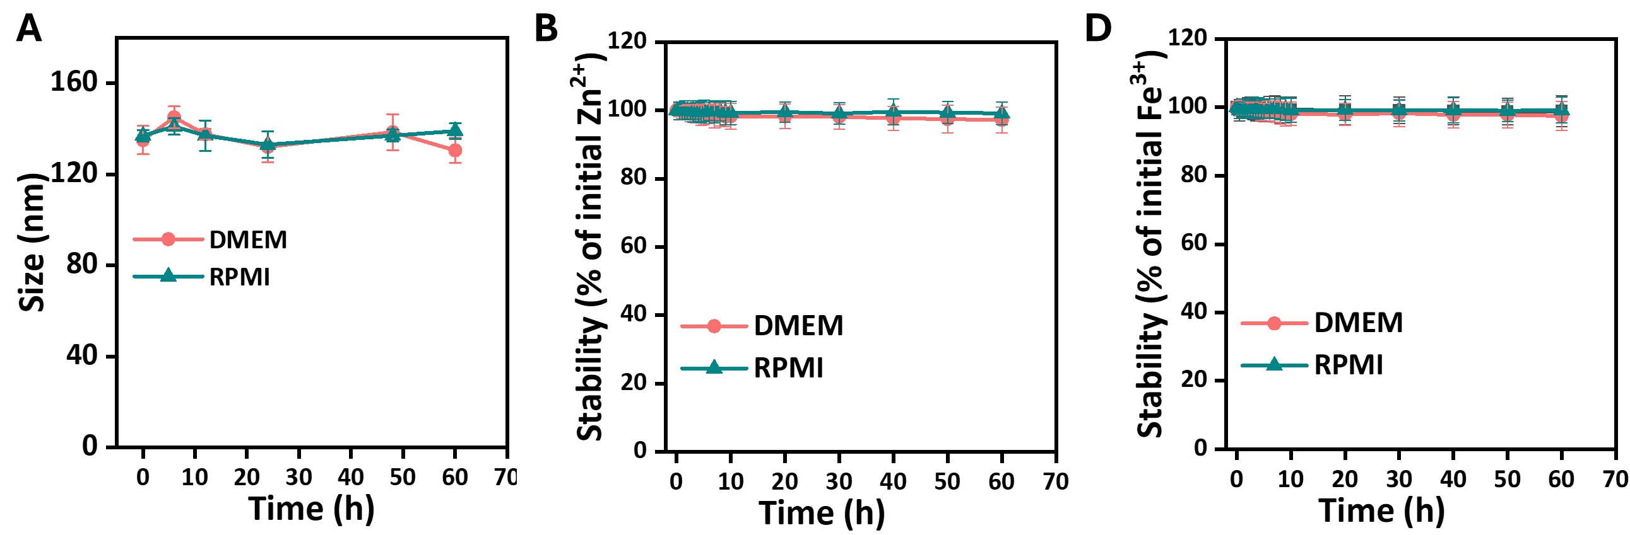
Figure S13. (A) Hydrodynamic size and (B) Zn²⁺ and (C) Fe³⁺ leakage from FCZNs in DMEM supplemented with 10% FBS and RPMI 1640 medium supplemented with 10% FBS at 37 °C for 60 h.

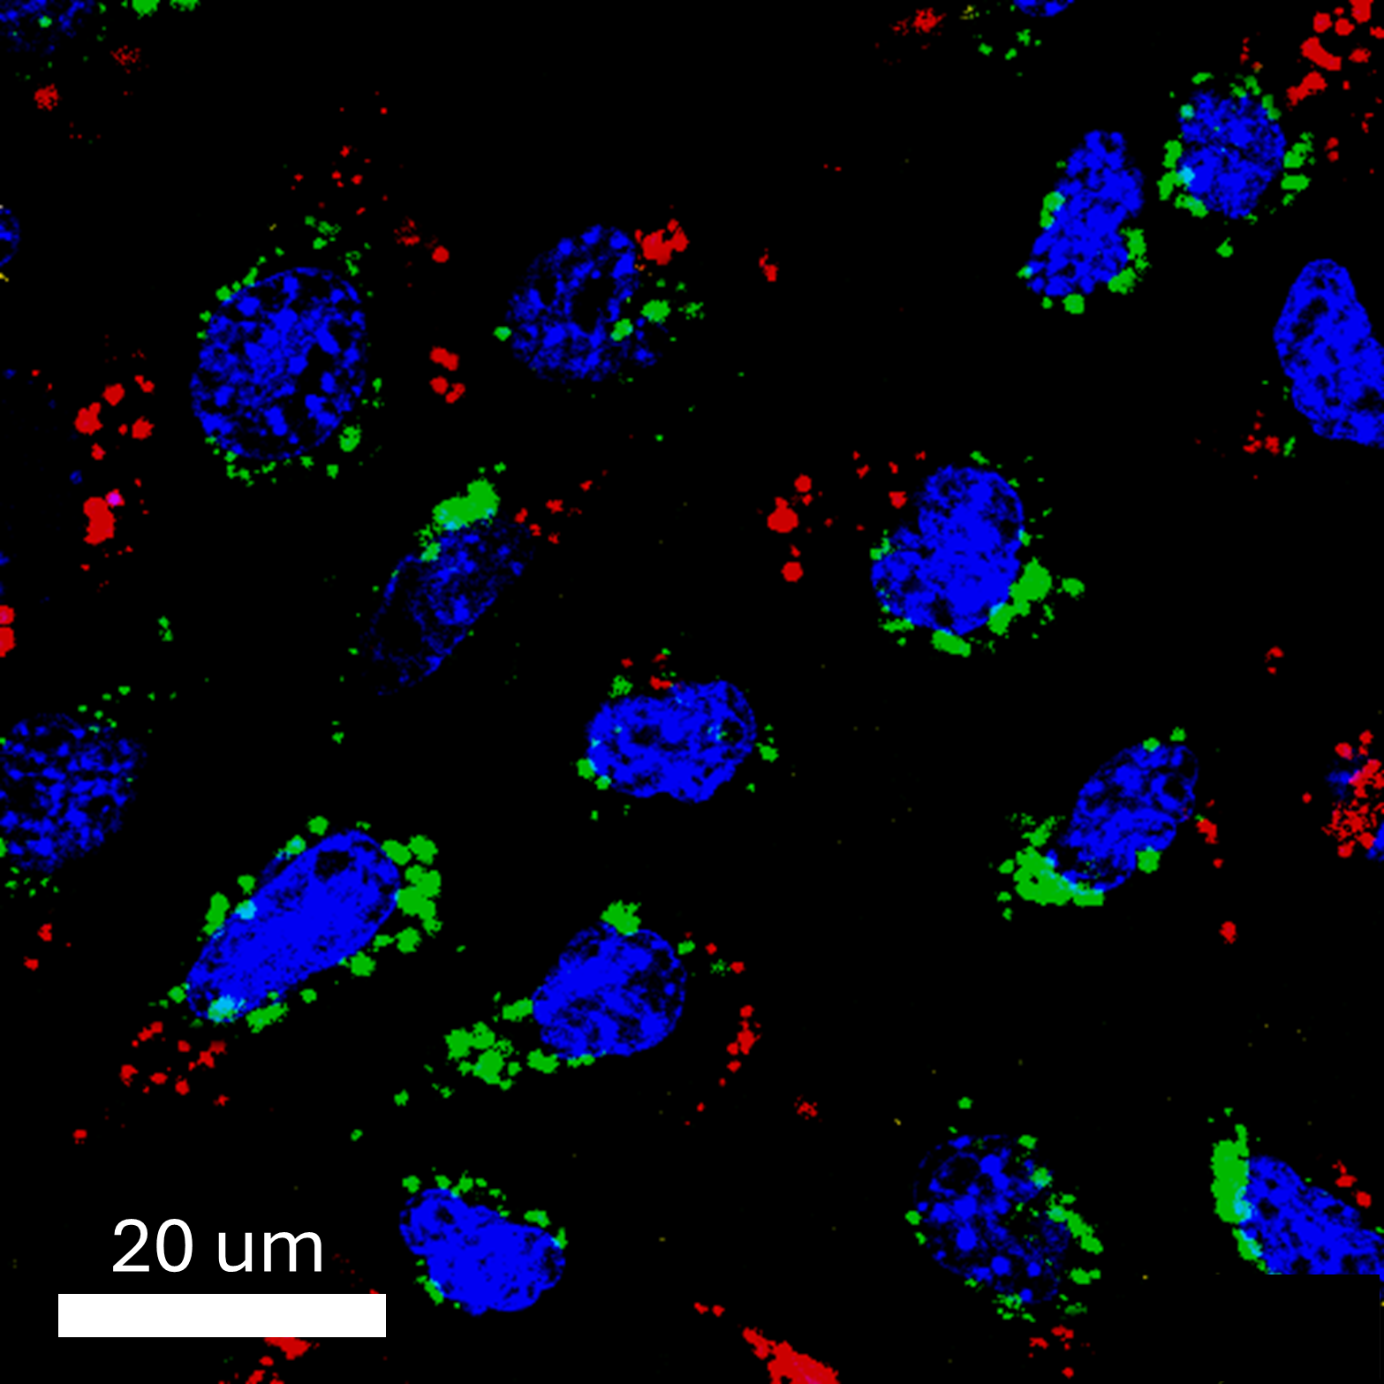
Figure S14. Lysosome-escape CLSM images of FZNCs in CT26 cancer cells after 2 h of incubation; nuclei stained with Hoechst (blue), lysosomes with Lysotracker (green), and FZNCs with Cy5.5 (red).

Figure S15. Cytotoxicity assay in CT26 cells and BMDMs after incubation with different concentrations of FZNCs for 24 h. All statistical data are represented as mean ± standard deviation (SD) (n = 3).

Figure S16. Cytotoxic effect of GYY4137 on cultured CT26 cells and BMDMs after 12 h incubation. All statistical data are represented as mean ± standard deviation (SD) (n = 3).

Figure S17. Flow cytometry of DC maturation frequency (gated on CD11⁺) after incubation with pre-treated CT26 cancer cells.
Figure S18. Flow cytometry of EpCAM expression in CT26 cells.
Figure S19. Untargeted metabolite profiles in CT26 cells and BMDMs after simulated tissue digestion and magnetic sorting procedures.
Figure S20. Untargeted metabolite profiles in tumor-associated CT26 cells and TAMs.

Figure S21. (A) Colloidal stability of FZNCs after 72 h incubation in mice serum. (B) Zeta potential of FZNCs after acid treatment for different time intervals. The test was conducted in neutral PBS.

Figure S22. (a) IVIS imaging of PEGylated FZNCs-Cy5.5 in CT26 tumor-bearing mice at various time points post-injection. (b) Ex vivo imaging of PEGylated FZNCs-Cy5.5 in tumor and major organs, harvested at 48 h.

Figure S23. H&E staining images of dissected major organs including heart, liver, spleen, lung, and kidney from different groups for in vivo biosafety evaluation after 15 days of treatments.

Figure S24. Staining images of CD31, Ki-67 and IDO in CT26 tumor tissue.

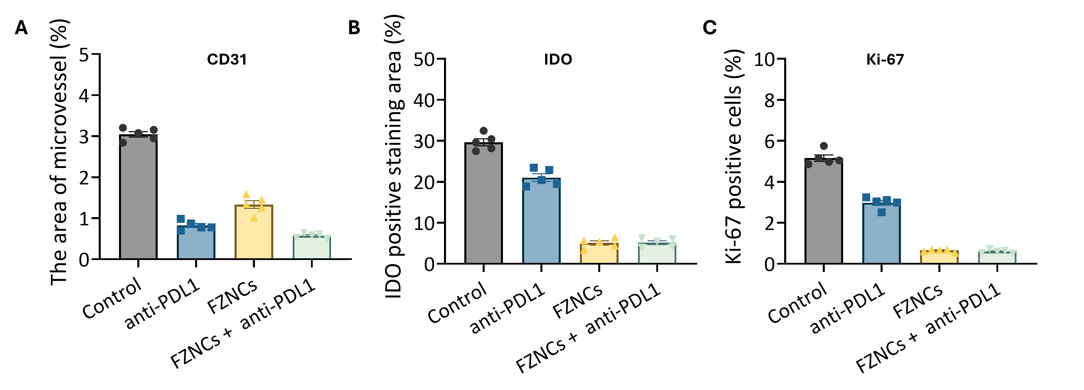
Figure S25. Quantification of (A) CD31, (B) IDO, and (C) Ki-67 positive area in tumor tissue staining results in Figure 7I and S21.

Figure S26. Flow cytometry of tumor-infiltrated cytotoxic T cells (gated on CD3⁺CD8⁺).

Figure S27. Flow cytometry of tumor-infiltrated regulatory T cells (gated on CD3⁺CD4⁺FoxP3⁺).
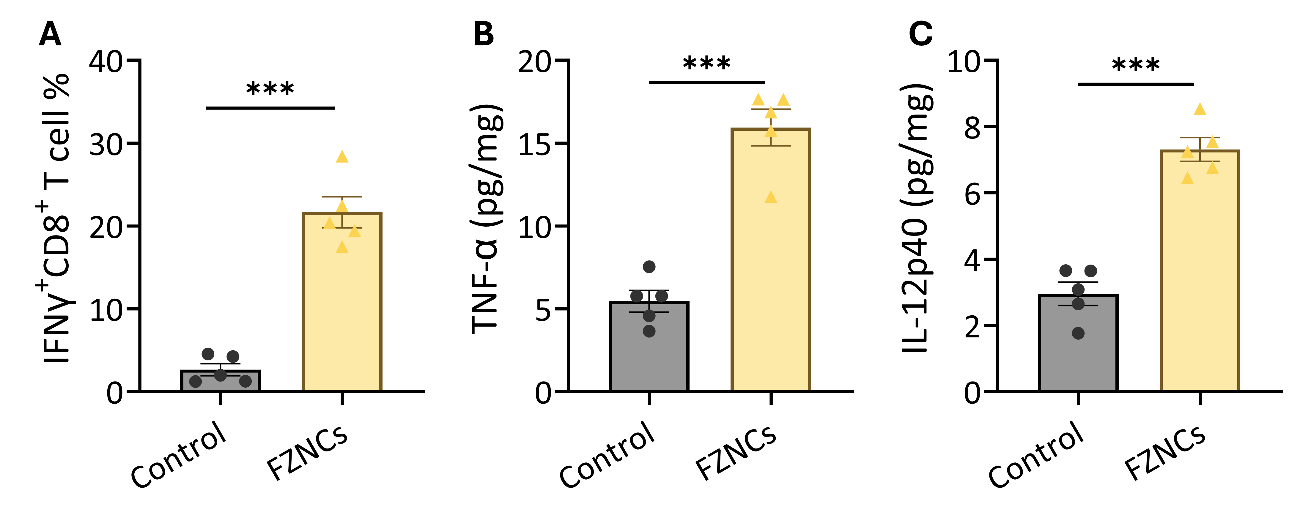
Figure S28. (A) The infiltrated CD8⁺IFNγ⁺ T cells, (B) TNF-α and (C) IL-12p40 in tumors at 96 h after FZNCs treatment. 5 mice were used in each group.

Table S1. Fe content, BET specific surface area, pore size of ZIF-8 and FZNCs.
Sample | Fe contentª  (Fe/Zn molar ratio) | Specific Surface area^{b}  (m²/g) | Pore size  (nm)
5 min | 0.01 | 1649.53 |  | 1.88
10 min | 0.17 | 1490.41 |  |  | 2.68
20 min | 0.59 | 1313.42 |  |  | 3.71
30 min | 0.80 | 1178.48 |  |  | 4.76
FZNCs-L | 0.41 | - |  |  | -
FZNCs-H | 1.76 | - |  |  | -
ª ICP-OES analysis the mass percentage. ^{b} BET specific surface areas.

Table S2. Fe K-edge EXAFS curve fitting parameters of FZNCs and Fe-HmIM.
Sample | Shell | CNª | R+ΔR (Å) | δ²(Å)² | R factor
FZNCs | Fe-N | 5.7 (0.8) | 2.01 (0.01) | 0.010 | 0.0171
Fe³⁺-HmIM | Fe-N | 5.6 (0.6) | 2.02 (0.01) | 0.010 | 0.0090

CN: coordination number. δ²: Debye-Waller factors. R factor: the goodness of fit. The obtained XAFS data was processed in Athena for background, pre/post-edge line calibration. The Fourier transformed fitting was carried out in Artemis. The corresponding weighting, k-range of 2.6–11.4 Å^{–1}, and R range of 1–2.4 Å were used for fitting. The amplitude reduction factor S₀² was defined at 0.803 obtained by the fitting result from standard Fe foil k³-weighted FT-EXAFS spectra. Coordination number, bond length, Debye-Waller factor, and E₀ (inner potential correction) shift (ΔE₀) were fitted without being fixed or constrained by anyone.

Table S3. Zn K-edge EXAFS curve fitting parameters of ZIF-8 and FZNCs.
Sample | Shell | CNª | R+ΔR (Å) | δ²(Å)² | R factor
ZIF-8 | Zn-N | 4.1 (1.1) | 1.99 (0.00) | 0.004 | 0.0080
ZIF-8 | Zn-C | 4.3 (0.3) | 3.02 (0.02) | 0.004 | 0.0080
FZNCs | Zn-N | 4.9 (0.2) | 1.99 (0.00) | 0.002 | 0.0026
FZNCs | Zn-C | 1.5 (0.3) | 2.95 (0.01) | 0.002 | 0.0026

CN: coordination number. δ²: Debye-Waller factors. R factor: the goodness of fit. The obtained XAFS data was processed in Athena for background, pre/post-edge line calibration. The Fourier transformed fitting was carried out in Artemis. The corresponding weighting, k-range of 2.6–14 Å^{–1}, and R range of 1.2–2.75 Å were used for fitting. The amplitude reduction factor S₀² was defined at 0.991 obtained by the fitting result from standard Fe foil k³-weighted FT-EXAFS spectra. Coordination number, bond length, Debye-Waller factor, and E₀ (inner potential correction) shift (ΔE₀) were fitted without being fixed or constrained by anyone.
Table S4. The full name of the metabolites in Figure 4B and 6D.
Abbreviation | Full Name
GLC | Glucose
G6P | Glucose-6-phosphate
F6P | Fructose 6-phosphate
FBP | Fructose-1,6-Bisphosphate
G3P | Glycerldehyde-3-phosphate
3PG | 3-Phosphoglycerate
PEP | Phosphoenolpyruvate
PYR | Pyruvate
LAC | Lactate
CIT | Citrate
ISO | Isocitrate
AKG | Alpha-Ketoglutarate
A-CoA | Acetyl Coenzyme A
B-CoA | Butyryl Coenzyme A
FA | Fatty Acid
S-CoA | Succinyl Coenzyme A
SUC | Succinate
FUM | Fumarate
MAL | Malate
OAA | Oxaloacetate
GLY | Glycine
ASP | Aspartate
LYS | Lysine
ALCAR | Acetyl carnitine
C4-CAR | Butyryl carnitine

Reference
1. Wang, Q., Yu, Y., Chang, Y., Xu, X., Wu, M., Ediriweera, G.R., Peng, H., Zhen, X., Jiang, X., Searles, D.J. and Fu, C., 2023. Fluoropolymer-MOF hybrids with switchable hydrophilicity for ¹⁹F MRI-monitored cancer therapy. ACS Nano, 17(9), pp.8483-8498.
2. Dai, Z., Wang, Q., Tang, J., Qu, R., Wu, M., Li, H., Yang, Y., Zhen, X. and Yu, C., 2022. A Sub-6 nm MnFe₂O₄-dichloroacetic acid nanocomposite modulates tumor metabolism and catabolism for reversing tumor immunosuppressive microenvironment and boosting immunotherapy. Biomaterials, 284, p.121533.
3. Gao, X.H., Krokowski, D., Guan, B.J., Bederman, I., Majumder, M., Parisien, M., Diatchenko, L., Kabil, O., Willard, B., Banerjee, R. and Wang, B., 2015. Quantitative H₂S-mediated protein sulfhydration reveals metabolic reprogramming during the integrated stress response. elife, 4, p.e10067.
4. Mackay, G.M., Zheng, L., Van Den Broek, N.J. and Gottlieb, E., 2015. Analysis of cell metabolism using LC-MS and isotope tracers. Methods in enzymology, 561, pp.171-196.

