Supplementary Material

Oxide Ion Conduction in Apatite-type Oxide of Lanthanum Silicate Doped by Antimony

Wenhao Li ¹, Wang Hay Kan ^{2,3*}, Sumei Lin ¹, Lulu Jiang ¹, Maxim Avdeev ^{4,5}, Donglin Han ^{1,6,7*}

¹ College of Energy, Soochow University, No 1 Shizi Street, Gusu District, Suzhou 215006, China
² Spallation Neutron Source Science Center, Dongguan, Guangdong, 523803, China
³ Institute of High Energy Physics, Chinese Academy of Sciences, Beijing, 100049, China
⁴ Australian Centre for Neutron Scattering, Australian Nuclear Science and Technology Organisation (ANSTO), New Illawarra Road, Lucas Heights, New South Wales 2234, Australia
⁵ School of Chemistry, University of Sydney, Sydney, New South Wales 2006, Australia
⁶ Provincial Key Laboratory for Advanced Carbon Materials and Wearable Energy Technologies, Soochow University, No 1 Shizi Street, Gusu District, Suzhou 215006, China
⁷ Jiangsu Key Laboratory of Advanced Negative Carbon Technologies, Soochow University, Suzhou 215123, China

* Corresponding authors:
Wang Hay Kan (jianhx@ihep.ac.cn)
Donglin Han (dlhan@suda.edu.cn)
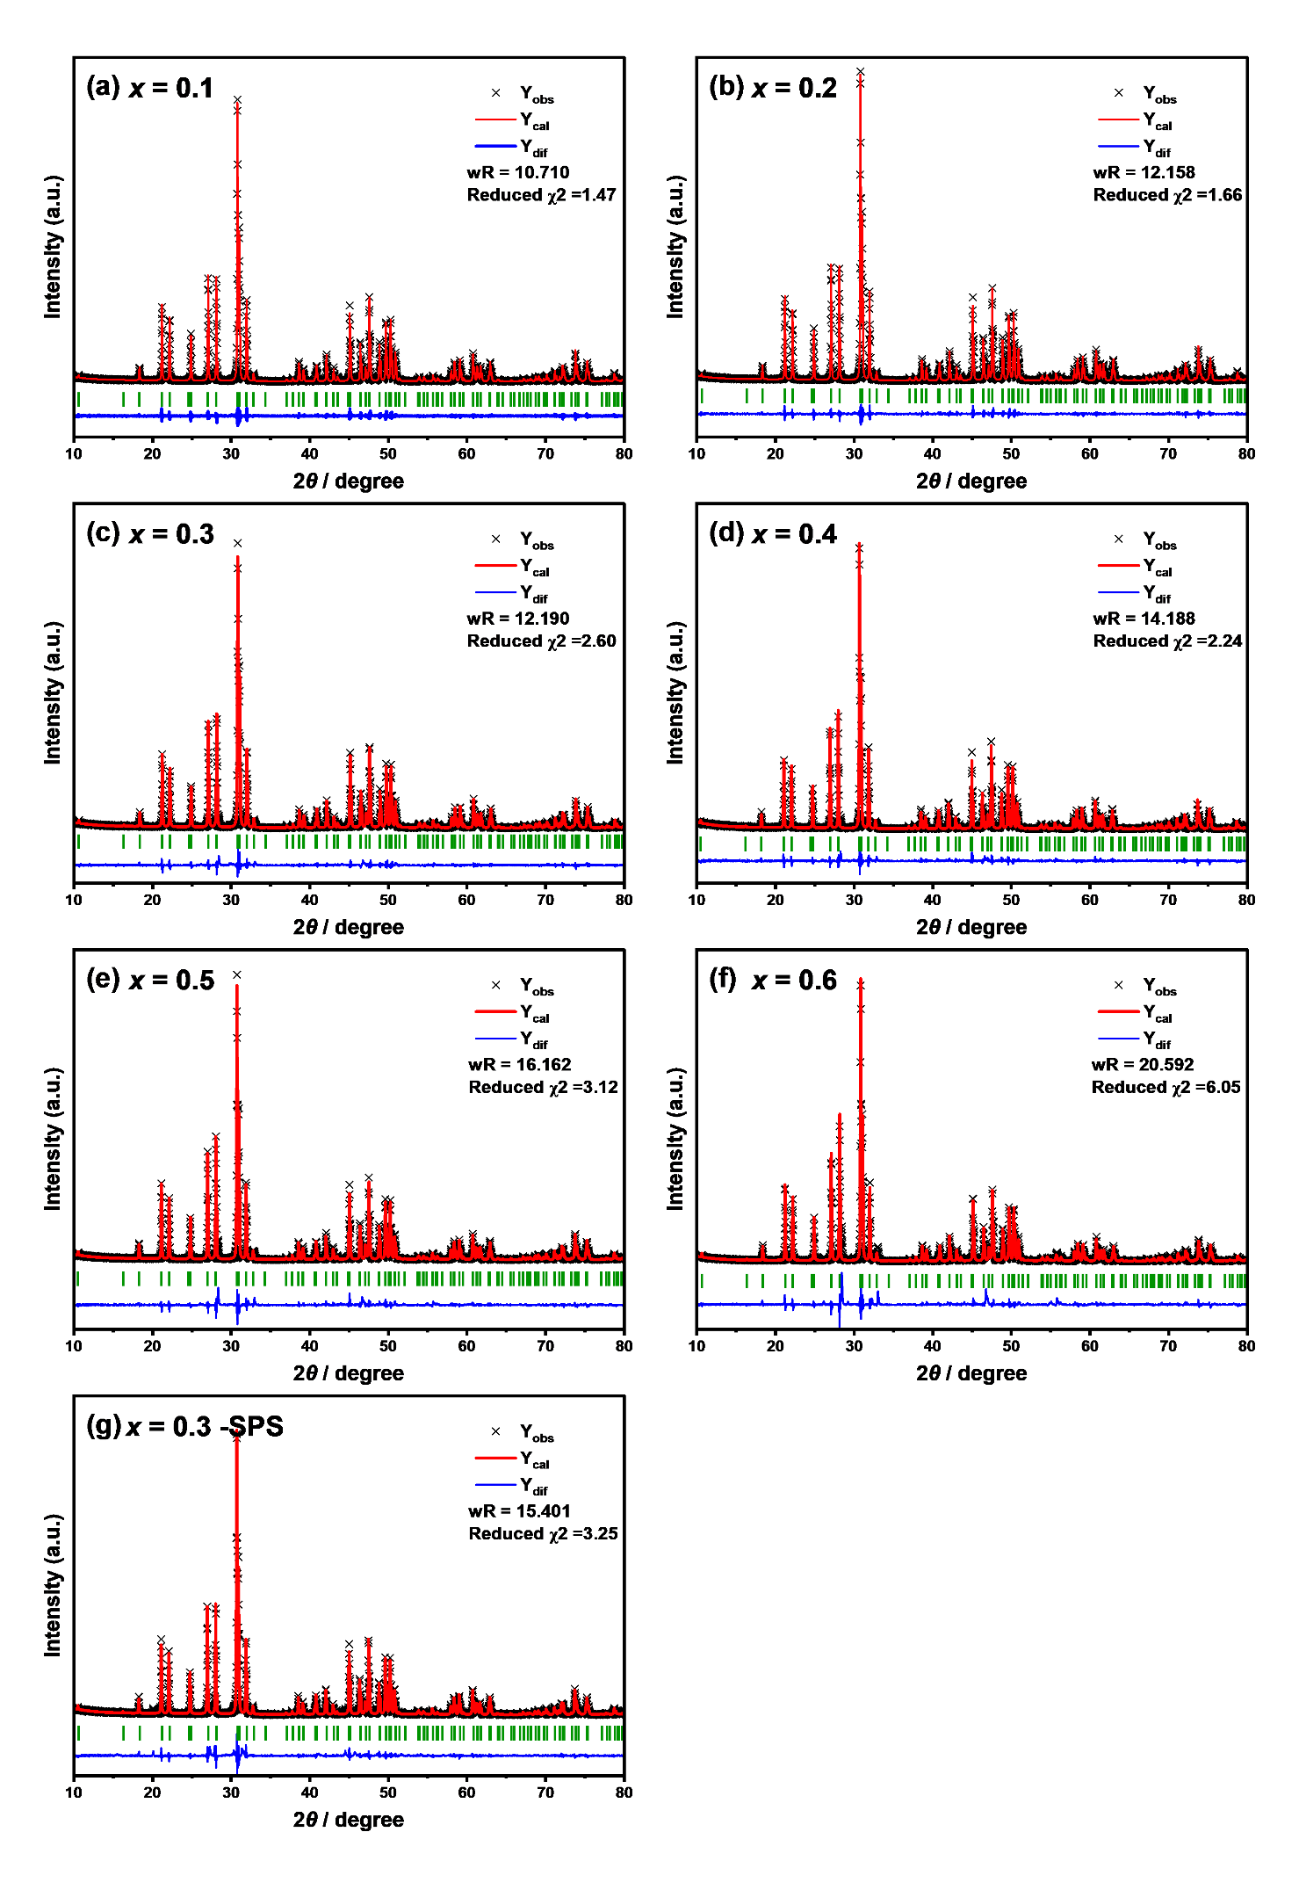
Figure S1 Rietveld fitting results of the powder XRD patterns of La_{9.33}Si_{6-x}Sb_{x}O_{26+x/2} with (a) x = 0.1, (b) x = 0.2, (c) x = 0.3, (d) x = 0.4, (e) x = 0.5, and (f) x = 0.6, which were prepared by a conventional sintering method by heating at 1600 °C for 4 h, and (g) La_{9.33}Si_{5.7}Sb_{0.3}O_{26.15} which was prepared by the SPS method at 1600 °C for 90 min.
Figure S2 SEM-EDS elemental mapping of La_{9.33}Si_{5.7}Sb_{0.3}O_{26.15} sample: (a) SEM image, and distribution of (b) La, (c) Sb, and (d) Si.

Figure S3 Impedance spectra of pristine La_{9.33}Si₆O₂₆ collected in dry Ar-20% O₂ at (a) 300 °C, (b) 400 °C, (c) 500 °C, (d) 600 °C, (e) 700 °C, and (f) 800 °C. The sample was prepared by the solid state reaction method, and sintered at 1600 °C for 4 h.

Figure S4 Impedance spectra of La_{9.33}Si_{5.9}Sb_{0.1}O_{26.05} collected in dry Ar-20% O₂ at (a) 300 °C, (b) 400 °C, (c) 500 °C, (d) 600 °C, (e) 700 °C, and (f) 800 °C. The sample was prepared by the solid state reaction method, and sintered at 1600 °C for 4 h.

Figure S5 Fourier Difference Map of La_{9.33}Si_{5.7}Sb_{0.3}O_{26.15} calculated from Rietveld refinement on neutron diffraction. The yellow contour represents the residual nuclear density (0.012 Å²).

Figure S6 Maximum Entropy Method Analysis of La_{9.33}Si_{5.7}Sb_{0.3}O_{26.15} with different cross section along a-direction on bc- plane. The yellow contour represents the nuclear density (0.012 Å²). The colors of oxygen atoms were light blue, pink, purple, brown, and red for O1, O2, O3, O4, and O5, respectively.

Table S1 Structural solution of the Rietveld refinement on neutron diffraction for La_{9.33}Si_{5.7}Sb_{0.3}O_{26.15}.
La_{9.33}Si_{5.7}Sb_{0.3}O_{26.15}, P6₃/m, a = 9.7155(9) Å, c = 7.1745(3) Å, V = 586.49(8) Å,
wR_{p} = 5.833%
Atom | Position |  |  | Occupancy | Uiso | Multiplicity
La1 | 0.33333 | 0.66667 | 0.0031(5) | 0.8325 | 0.0100(5) | 4
La2 | 0.01234(29) | 0.24177(24) | 0.25 | 1 | 0.0100(5) | 6
Sb1 | 0.4019(5) | 0.3715(4) | 0.25 | 0.05 | 0.0104(9) | 6
Si1 | 0.4019(5) | 0.3715(4) | 0.25 | 0.95 | 0.0104(9) | 6
O1 | 0.3231(3) | 0.4850(4) | 0.25 | 1 | 0.0152(5) | 6
O2 | 0.5965(3) | 0.4718(4) | 0.25 | 1 | 0.0152(5) | 6
O3 | 0.35240(30) | 0.25704(31) | 0.06544(31) | 0.851(2) | 0.0152(5) | 12
O4 | 0.2925(16) | 0.2406(18) | 0.0946(17) | 0.2 | 0.0152(5) | 12
O5 | 0 | 0 | 0.25 | 0.772(10) | 0.0152(5) | 2

