 | AIC
_{Metric} ^{Order} | 2nd | 3rd | 4th | 5th | 6th
Total Wetted Area | 247.86 | 172.71 | 144.56 | 146.56 | 132.52
Total Wetted Perimeter | -2784.95 | -2816.12 | -2833.5 | -2831.98 | -2852.87
Total Wetted Length | 2307.79 | 2282.05 | 2276.95 | 2278.95 | 2270.39
Number of Pools | 3379.80 | 3378.87 | 3374.7 | 3376.09 | 3360.31
AWMSI | 1910.97 | 1888.68 | 1890.42 | 1891.1 | 1892.03
AWRe | -2077.32 | -2084.42 | -2082.51 | -2080.58 | -2078.59
AWMPA | 207.88 | 120.78 | 108 | 109.98 | 106.03
AWMPL | 2283.38 | 2228.39 | 2230.39 | 2232.39 | 2234.36
AWMPW | -2452.52 | -2512.02 | -2526.45 | -2524.49 | -2525.11
APSEC | 3053.96 | 2978.82 | 2950.69 | 2952.68 | 2938.64
LPSEC | 4460.54 | 4434.80 | 4429.71 | 4431.70 | 4423.15
PF | 5747.44 | 5740.73 | 5742.62 | 5744.62 | 5746.48
PLF | 2305.39 | 2300.34 | 2302.30 | 2304.09 | 2306.08
Supplementary Material
Table 1 – Akaike Information Criteria (AIC) scores for each metric and polynomial order.

 | ΔAIC
_{Metric} ^{Order} | 2nd | 3rd | 4th | 5th | 6th
Total Wetted Area |  |  |  |  | 0.0
Total Wetted Perimeter |  |  |  |  | 0.0
Total Wetted Length |  |  |  |  | 0.0
Number of Pools |  |  |  |  | 0.0
AWMSI |  | 0.0 | 1.74 | 2.41 | 3.35
AWRe |  | 0.0 | 1.91 | 3.84
AWMPA |  |  | 1.98 | 3.95 | 0.0
AWMPL |  | 0.0 | 2.0 | 4.0
AWMPW |  |  | 0.0 | 1.96 | 1.33
APSEC |  |  |  |  | 0.0
LPSEC |  |  |  |  | 0.0
PF |  | 0.0 | 1.89 | 3.89
PLF |  | 0.0 | 1.96 | 3.75
Table 2 – ∆AIC values for each metric and polynomial order.

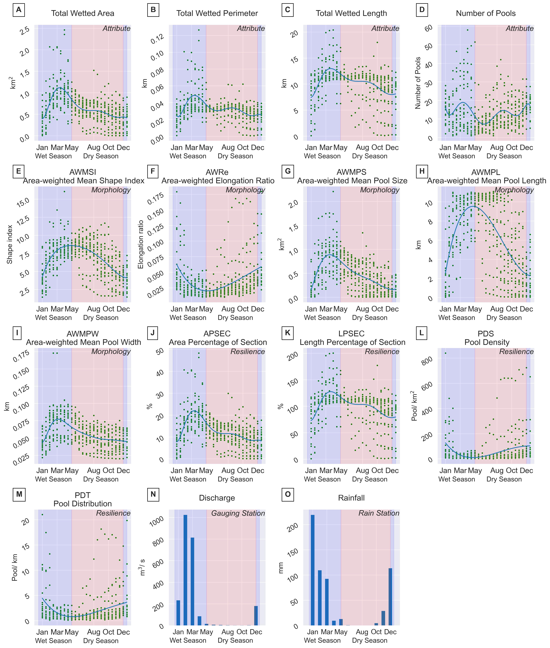
Fig 1 – Seasonal changes for each attribute and metric for all river sections combined. Each panel shows a different metric or attribute and whether the metric is relevant to morphology or resilience with all points used to fit the polynomial lines. The last two panels of the graph show monthly averaged gauged river discharge and rainfall. For each panel a light blue background indicates the wet season, and a pale red background indicates the dry season.

