Non-glandular trichomes of sunflower are important in the absorption and translocation of foliar-applied Zn
Cui Li^{1*}, Jingtao Wu², F. Pax C. Blamey², Linlin Wang¹, Lina Zhou¹, David J. Paterson³, Antony van der Ent², Victoria Fernández⁴, Enzo Lombi⁵, Yuheng Wang^{1*}, Peter M. Kopittke²
¹Northwestern Polytechnical University, School of Ecology and Environment, Xi’an 710072, China. ²The University of Queensland, School of Agriculture and Food Sciences, St Lucia, Queensland, 4072, Australia. ³Australian Synchrotron, Clayton, Victoria, 3168, Australia. ⁴School of Forest Engineering, Forest Genetics and Ecophysiology Research Group, Technical University of Madrid, 28040 Madrid, Spain. ⁵University of South Australia, Future Industries Institute, Mawson Lakes, South Australia, 5095, Australia
Author for correspondence:
Cui Li, Email: cui.li@nwpu.edu.cn, Tel: +86 18629483629
Yuheng Wang, Email: yuheng.wang@nwpu.edu.cn, Tel: +86 18571576778

Supplementary Discussion
Differentiation of the non-glandular trichomes (NGTs) on the adaxial and abaxial leaf side of sunflower
Firstly, the NGTs are on both side of the sunflower leaf, and the adaxial side (Zn applied side) were facing the detector when examined at the XFM beamline (Fig. S1). As shown in Fig. 1 (in the main text) and Fig. S1H-N, the stalk of the NGTs had high concentration of Ca. However, as the Kα emission lines of Ca are 3,691.68 and 3,688.09 eV, the emissions of Ca in the NGTs on the abaxial leaf side were been blocked by the leaf and did not reach the detector, as shown in Fig. S2H, the white arrows are pointing to the NGTs on the adaxial leaf side. But the Kα emission lines of Zn are 8,638.86 and 8,615.78 eV, these are higher than the Ca emissions, hence the Zn on the abaxial leaf side were also detected. Therefore in Fig. S2A-J, apart from the NGTs on the adaxial leaf side, there were also some bright circles alike NGT bases as shown in Fig. S2B pointed by the yellow arrows (in Fig. S2H-N, there were Zn but no Ca), as they were the NGTs on the abaxial leaf side.

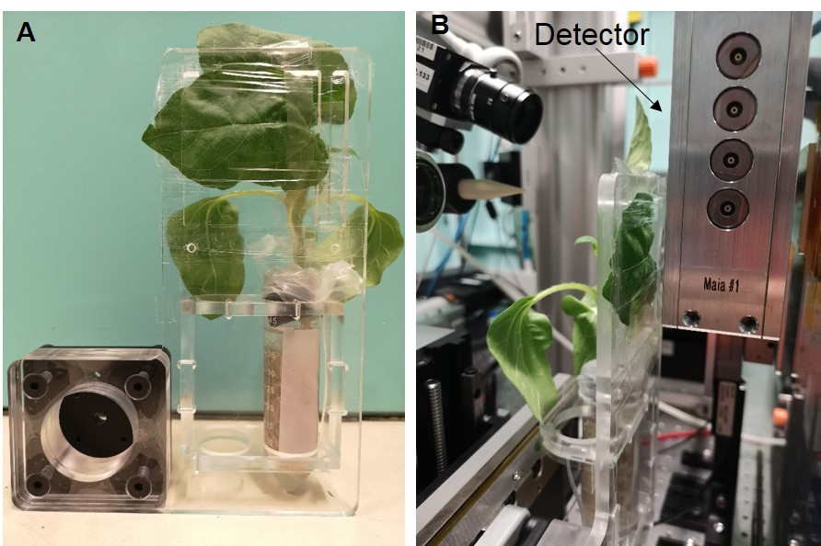
Fig. S1 Images showing the set-up for the time resolved XFM analyses of a living sunflower plant. (A) a two weeks old sunflower was transferred in a 50 ml falcon tube and put in a specialized sample hold. The leaf for analysis was mounted as flat as possible. (B) Image showing how the living plant was analyzed on the XFM beamline.

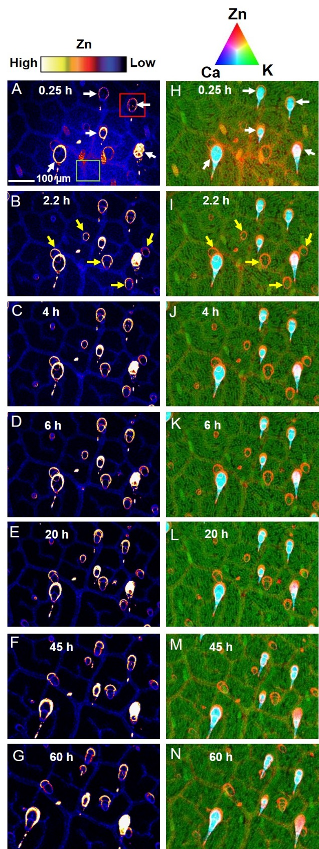
Fig. S2 A-G are showing the distribution of Zn, with brighter colours having higher Zn concentrations. H-N are tri-colour images of the time resolved scans which corresponding to A-G to differentiate the trichomes on the adaxial and abaxial side of the leaf. The colours are comparable in A-G and H-N respectively. The scale bar in A applies to all the images. The white arrows are the NGTs on the adaxial side and the yellow arrows are the NGTs on the abaxial leaf side.

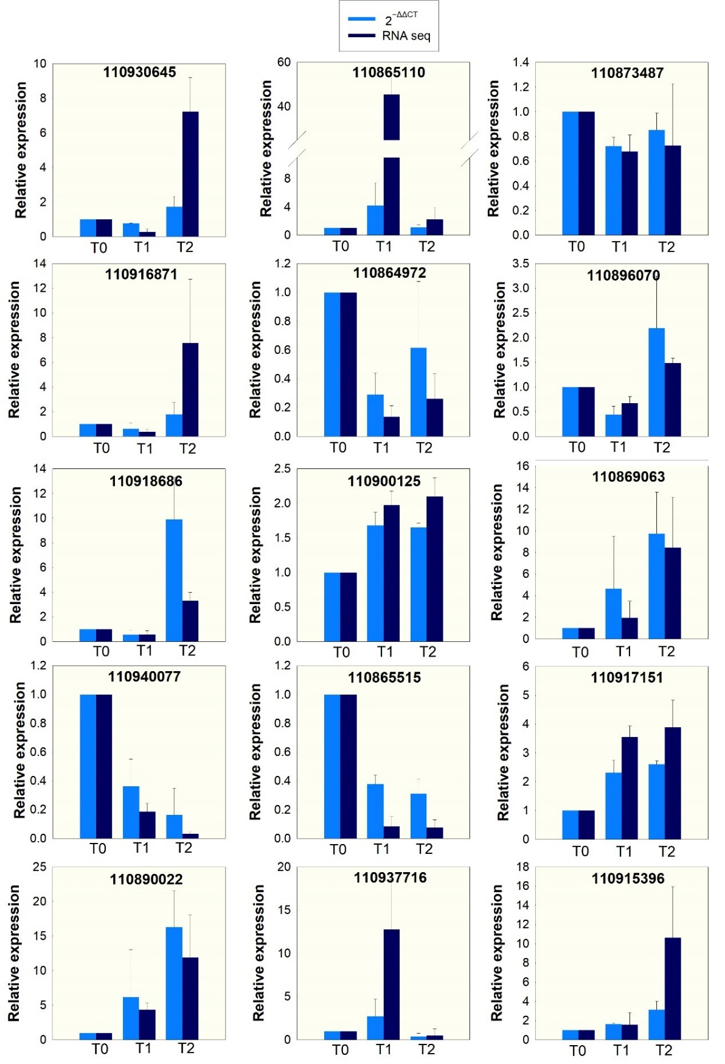
Fig. S3 Results of the qRT-PCR validation, actin and ubiquitin were used as internal controls. The number in each diagram refers the gene ID. Expression is relative to T0, with the value of which set as 1, data are means ± SD.

Table S1 Previous studies reporting leaf trichomes can absorb water
Plant species | Family | Reference
Tillandsia usneoides | Bromeliaceae | (Martin et al., 2013)
Tillandsia usneoides | Bromeliaceae | (Herppich et al., 2018)
Tillandsia ionantha | Bromeliaceae | (Ohrui et al., 2007)
Beech (Fagus sylvatica L.) | Fagaceae | (Schreel et al., 2020)
Croton | Euphorbiaceae | (Vitarelli et al., 2016)
Cactus | Cactus | (Ju et al., 2012)
Oak tree | Fagaceae | (Fernández et al., 2014)
Combretum leprosum | Combretaceae | (Pina et al., 2016)
Mimosa caesalpiniifolia, Combretum leprosum, Libidibia ferrea and Cynophalla  flexuosa. | Fabaceae, combretaceae, and capparaceae | (Holanda et al., 2019)

Table S2 Primers used for qRT-PCR
Gene ID | Gene Description | Accession number | Forward | Reverse
110930645 | uncharacterized | XM_022173993.2 | AATGAGCAGAAGGCGTGGAA | GGGCTGTGCATAGTCCATGA
110916871 | uncharacterized | XM_022161525.2 | CCTTCATCGGTGTAGGACGG | CACAGCCGACATTTTCCCAT
110918686 | ubiquinol oxidase | XM_022162965.2 | GACAATGGTGGAGCTCGTGA | GTGCGCTAGTTTCGGGGATA
110940077 | abscisic acid 8'-hydroxylase 2 | XM_022181633.2 | GCCACCATGCTTTCATCACTC | GGAGTCTCCCTGGTGATGTG
110890022 | ABC transporter G family member 11-like | XM_022137590.2 | ATGGGTTATGGTGCGGGATG | TGGATTTGCCGGAACCAGAA
110865110 | sugar transporter ERD6-like 16 | XM_022114325.2 | CCCCTGTTTGCTCTGTTTGC | AGCGGCTCGATCAAGTCTTC
110864972 | ABC transporter I family member 19-like | XM_022114143.2 | TGTTGTGCGGGTGCTAGATT | GGTCGATACCTTCAACGCCA
110900125 | palmitoyl-protein thioesterase 1 | XM_022147026.2 | CCTTTTGAGGACCAGGTTGA | GTGCTCCGTCACAAAACTCA
110865515 | abscisic acid 8'-hydroxylase 2-like | XM_022114773.2 | CTTCCTTCACCAACCTCCGT | GTGGTTCCTCCGCTTGAGTT
110937716 | wound-induced proteinase inhibitor 1 | XM_022180180.2 | TCCATCTCCGCTACCATTTC | GGCTTATCTTCGACGGAACA
110873487 | probable sodium/metabolite cotransporter BASS3 chloroplastic | XM_022122429.2 | CCCCACCTTTCAGTAACCCC | CCACCCCACTTTTCCGATCA
110896070 | ATP-citrate synthase alpha chain protein 1 | XM_022143500.2 | CCGGAATATGCAAACAGGCG | TGACCCGCAATTTGTCCCTT
110869063 | zinc transporter 6 chloroplastic | XM_022118359.2 | GTAACGATGGGGATGTCGCA | GCTATTCCCATCGGTGTCGT
110917151 | heavy metal-associated isoprenylated plant protein 39-like | XM_022161753.2 | ATGCCACGACCGTATTACCC | ACACCCGTTTGGATTCTCCTC
110915396 | START domain-containing protein 10 | XM_022160084.2 | GCCAGCAACTAGGTCCACTT | GGGTGGAGGGACAATGGAAG
110903735 | actin | XM_022149519.2 | AGGGCGGTCTTTCCAAGTAT | ACATACATGGCGGGAACATT
110936586 | ubiquitin | XM_022178991.2 | AGCAAAGGCTCATCTTTGCAGG | GATAGTGTCCGAGCTCTCCA

Table S3 Overview of RNA sequential results and data quality assessment
Sample | Raw reads | Clean reads | Clean bases (GB) | Error rate (%) | Q20 (%) | Q30 (%) | GC content (%)
T0a | 43918176 | 43424830 | 6.51 | 0.03 | 96.92 | 92.46 | 42.75
T0b | 46302196 | 45522106 | 6.83 | 0.03 | 97.49 | 93.35 | 44.07
T0c | 46121554 | 45375350 | 6.81 | 0.03 | 97.62 | 93.70 | 44.10
T0 mean | 45447309 | 44774095 | 6.72 | 0.03 | 97.34 | 93.17 | 43.64
T1a | 41608644 | 40944650 | 6.14 | 0.03 | 97.76 | 93.57 | 43.63
T1b | 46898038 | 45996574 | 6.90 | 0.03 | 97.89 | 93.97 | 43.27
T1c | 46631336 | 45839160 | 6.88 | 0.03 | 97.99 | 94.07 | 43.69
T1 mean | 45046006 | 44260128 | 6.64 | 0.03 | 97.88 | 93.87 | 43.53
T2a | 40335780 | 39740892 | 5.96 | 0.03 | 97.89 | 93.95 | 44.97
T2b | 43881014 | 43134216 | 6.47 | 0.03 | 97.97 | 94.06 | 44.01
T2c | 45946042 | 45300652 | 6.80 | 0.03 | 97.96 | 94.10 | 44.43
T2 mean | 43387612 | 42725253 | 6.41 | 0.03 | 97.94 | 94.04 | 44.47
Q20 and Q30 refer to bases whose Phred>20 or 30 accounting to the total bases. GC (%) refers to the G and C bases accounting to the total bases.

Table S4 Mapping rates of the clean reads aligned to the genome of sunflower
Sample | Unique map | Multi map | Read1 map | Read2 map | Positive  map | Negative  map
T0a | 68.36% | 4.99% | 34.28% | 34.08% | 34.15% | 34.21%
T0b | 75.75% | 4.98% | 38.00% | 37.75% | 37.83% | 37.92%
T0c | 75.76% | 5.06% | 37.96% | 37.80% | 37.84% | 37.92%
T0 mean | 73.29% | 5.01% | 36.75% | 36.54% | 36.61% | 36.68%
T1a | 82.42% | 4.23% | 41.41% | 41.01% | 41.18% | 41.24%
T1b | 81.63% | 4.98% | 40.90% | 40.73% | 40.78% | 40.85%
T1c | 83.07% | 4.47% | 41.64% | 41.43% | 41.51% | 41.56%
T1 mean | 82.37% | 4.56% | 41.32% | 41.06% | 41.16% | 41.22%
T2a | 78.90% | 5.33% | 39.60% | 39.30% | 39.42% | 39.49%
T2b | 83.86% | 4.05% | 42.02% | 41.84% | 41.88% | 41.98%
T2c | 80.44% | 3.87% | 40.29% | 40.14% | 40.18% | 40.26%
T2 mean | 81.07% | 4.42% | 40.64% | 40.43% | 40.49% | 40.58%

Table S5 Pearson correlation (R²) between samples (calculated based on the FPKM values of each sample)
 | T0a | T0b | T0c | T1a | T1b | T1c | T2a | T2b | T2c
T0a | 1 | 0.83 | 0.83 | 0.744 | 0.767 | 0.757 | 0.717 | 0.686 | 0.72
T0b | 0.83 | 1 | 0.955 | 0.683 | 0.674 | 0.697 | 0.742 | 0.688 | 0.724
T0c | 0.83 | 0.955 | 1 | 0.683 | 0.674 | 0.698 | 0.742 | 0.688 | 0.724
T1a | 0.744 | 0.683 | 0.683 | 1 | 0.885 | 0.903 | 0.814 | 0.812 | 0.866
T1b | 0.767 | 0.674 | 0.674 | 0.885 | 1 | 0.912 | 0.777 | 0.732 | 0.798
T1c | 0.757 | 0.697 | 0.698 | 0.903 | 0.912 | 1 | 0.814 | 0.771 | 0.855
T2a | 0.717 | 0.742 | 0.742 | 0.814 | 0.777 | 0.814 | 1 | 0.874 | 0.846
T2b | 0.686 | 0.688 | 0.688 | 0.812 | 0.732 | 0.771 | 0.874 | 1 | 0.856
T2c | 0.72 | 0.724 | 0.724 | 0.866 | 0.798 | 0.855 | 0.846 | 0.856 | 1

References
Fernández V, Sancho-Knapik D, Guzmán P, Peguero-Pina JJ, Gil L, Karabourniotis G, Khayet M, Fasseas C, Heredia-Guerrero JA, Heredia A. 2014. Wettability, polarity, and water absorption of holm oak leaves: effect of leaf side and age. Plant Physiology 166, 168-180.
Herppich WB, Martin CE, Tötzke C, Manke I, Kardjilov N. 2018. External water transport is more important than vascular transport in the extreme atmospheric epiphyte Tillandsia usneoides (Spanish moss). Plant, Cell & Environment 42, 1645–1656.
Holanda AER, Souza BC, Carvalho ECD, Oliveira RS, Martins FR, Muniz CR, Costa RC, Soares AA. 2019. How do leaf wetting events affect gas exchange and leaf lifespan of plants from seasonally dry tropical vegetation? Plant Biology 21, 1097-1109.
Ju J, Bai H, Zheng Y, Zhao T, Fang R, Jiang L. 2012. A multi-structural and multi-functional integrated fog collection system in cactus. Nature communications 3, 1247.
Martin CE, Rux G, Herppich WB. 2013. Responses of epidermal cell turgor pressure and photosynthetic activity of leaves of the atmospheric epiphyte Tillandsia usneoides (Bromeliaceae) after exposure to high humidity. Journal of Plant Physiology 170, 70-73.
Ohrui T, Nobira H, Sakata Y, Taji T, Yamamoto C, Nishida K, Yamakawa T, Sasuga Y, Yaguchi Y, Takenaga H. 2007. Foliar trichome-and aquaporin-aided water uptake in a drought-resistant epiphyte Tillandsia ionantha Planchon. Planta 227, 47-56.
Pina AL, Zandavalli RB, Oliveira RS, Martins FR, Soares AA. 2016. Dew absorption by the leaf trichomes of Combretum leprosum in the Brazilian semiarid region. Functional Plant Biology 43, 851-861.
Schreel JD, Leroux O, Goossens W, Brodersen C, Rubinstein A, Steppe K. 2020. Identifying the pathways for foliar water uptake in beech (Fagus sylvatica L.): a major role for trichomes. The Plant Journal 103, 769-780.
Vitarelli NC, Riina R, Cassino MF, Meira RMSA. 2016. Trichome-like emergences in Croton of Brazilian highland rock outcrops: Evidences for atmospheric water uptake. Perspectives in Plant Ecology, Evolution and Systematics 22, 23-35.

