Supporting Information

Selective in situ phase segregation enabling efficient and stable protonic ceramic fuel cell cathode performance
Desheng Feng¹, Vanessa K. Peterson*^{,2}, Tianjiu Zhu¹, Rijia Lin¹, Anita M. D'Angelo³, Dominique Appadoo³, Xiaohe Tian⁴, Xiaoyang Du⁴, Zhonghua Zhu**^{,1}, Mengran Li***^{,4}
1. School of Chemical Engineering, The University of Queensland, Brisbane, 4072, Australia
2. Australian Centre for Neutron Scattering, Australian Nuclear Science and Technology Organisation, Sydney, New South Wales, Australia
3. Australian Synchrotron, Australian Nuclear Science and Technology Organization, Clayton, Victoria, 3168 Australia
4. Department of Chemical Engineering, the University of Melbourne, Melbourne, 3010, Australia

Corresponding authors:
V. K. Peterson: vanessa.peterson@ansto.gov.au
Z. Zhu: z.zhu@uq.edu.au
M. Li: aaron.li1@unimelb.edu.au

Methodology

Material synthesis
Cathode materials used in this study were synthesized using a conventional sol-gel method. Taking the synthesis of BCFZYLK as an example, stoichiometry amounts of Ba(NO₃)₂ (Sigma-Aldrich, 99%), Co(NO₃)₂·6H₂O (Sigma-Aldrich, 98%), Fe(NO₃)₃·9H₂O (Sigma-Aldrich, 98%), ZrO(NO₃)₂·xH₂O (Sigma-Aldrich, 99%), Y(NO₃)₃·6H₂O (Sigma-Aldrich, 99%), LiNO₃ (Sigma-Aldrich, 99%), and KNO₃(Sigma-Aldrich, 99%) were dissolved in deionized water. Citric acid (CA) (Sigma-Aldrich, 99.5%) was then added to the solution, followed by ethylenediaminetetraacetic acid (EDTA) (Sigma-Aldrich, 99%) dissolved in an ammonia solution. The metal cations: CA: EDTA were controlled to be 2: 3: 3. Ammonia solution was then added to the solution to adjust the pH to ~ 10, and the solution was placed on a hot plate at 80 °C to evaporate water until gel formed. The gel was then placed in an oven at 260 °C to obtain ash, which was sintered at 1000 °C for 2 h in a Labec BF 08/14 muffle furnace to obtain the cathode material.

Synchrotron X-ray powder diffraction
Synchrotron X-ray powder diffraction (SXRD) data of cathode materials in quartz capillaries of diameter 0.3 mm were collected using the Australian Synchrotron powder diffraction (PD) beamline at the Australian Nuclear Science and Technology Organisation (ANSTO). Data from the National Institute of Standards and Technology (NIST) 660b standard reference material was used to determine the wavelength (0.774641 Å) and instrumental parameters. For high-temperature measurements, open-end capillaries containing samples were stoppered with cigarette filters and 2 mL.min⁻¹ air supplied. Temperature control was achieved using a Cyberstar hot air blower with a heating rate of 5 °C.min⁻¹. Data were collected using a Mythen II detector at two positions each for 30 s. The temperature at the outlet of the hot air blower was recorded before the start of each measurement.
Data were analyzed using the GSAS-II software¹ with a starting crystal structure of BaZr_{0.5}Fe_{0.5}O₃². Structural refinements using SXRD data treat the indistinguishable Co and Fe as well as Zr and Y identically because of their close atomic number. Therefore, SXRD results provide the ratio of (Co+Fe) to (Zr+Y) in the material. The site occupancy of Ba was refined without any constraint. The site occupancy of Li, K, and O were first estimated and later compared to the results obtained from NPD data to ensure that the estimated site occupancies of these elements are within the range of standard deviation of the NPD results.

Neutron powder diffraction
NPD data were collected using the Wombat instrument³ at the Australian Centre for Neutron Scattering (ACNS) at the Open Pool Australian Lightwater (OPAL) reactor. Data for the NIST 660b standard reference material was used to determine the wavelength and instrumental parameters. Temperature control was achieved using a high temperature vacuum furnace with niobium elements, which contributed to the data as shown in Fig. S-1. Samples were placed in a quartz tube inserted into the furnace that allowed isolation from the vacuum and exposure to a stream of 3 vol.% D₂O in air produced using the Hidden XCS vapor delivery system which was flowed through the top of the sample to the bottom where it was vented to exhaust. NPD data were first collected under ambient conditions and then each minute as samples were heated to 600 °C at 5 °C.min⁻¹. The temperature was recorded using a thermocouple placed above the sample.
Data were analyzed using the GSAS-II software¹ with a starting crystal structure of BaZr_{0.5}Fe_{0.5}O₃². Structural refinements using NPD data treat the indistinguishable Zr and Y identically because of their similar coherent neutron scattering length⁴, and their site occupancy was fixed to that obtained using SXRD data. The site occupancy of Co and Fe are refined against the NPD data while the total site occupancy of Co and Fe is constrained to that obtained from the refinement using SXRD data. The site occupancy of Ba was fixed to the value obtained using SXRD data. The site occupancy of Li, K, and O was refined without constraint.

Symmetric and single cell fabrication
To fabricate symmetric cells, electrolyte powder was first dry pressed into pellets and then sintered at 1450 °C for 5 h in a Labec BF 08/14 muffle furnace to obtain dense electrolyte disks. Cathode materials were mixed with isopropanol and glycerol in a Planetary Mill PULVERISETTE 5/2 to produce cathode inks that were spray-coated onto the electrolyte disks and sintered at 950 °C for 2 h in a Labec BF 08/14 muffle furnace.
To fabricate anode-supported single cells, anode and electrolyte powder were co-pressed into half-cells, which were then sintered at 1450 °C for 5 h in a Labec BF 08/14 muffle furnace to densify the electrolyte layer. Cathode inks were spray-coated onto the electrolyte layer and sintered at 950 °C for 2 h in a Labec BF 08/14 muffle furnace.

Electrochemical characterization
Electrochemical impedance spectroscopy was performed using an Autolab Potentiostat to evaluate cell resistance. The open circuit voltage (OCV) of each cell was first measured, before a 10 mV sinusoidal alternating voltage was applied at a frequency ranging from 10⁶ Hz to 0.01 Hz. Linear sweep voltammetry was performed to characterize the performance of single cells, where the OCV was first measured using a four-probe method before the potential was swept to 0.2 V at 0.1 V s⁻¹ while the current was recorded. Chronoamperometry was performed to characterize cell durability using a constant current applied to the cell and the voltage recorded every 10 min.

Hydration content
The hydration content of samples was measured using a Perkin Elmer TGA 4000 analyzer. Approximately 200 mg samples were placed in an alumina crucible and heated to 400 °C. Samples were then equilibrated at 400 °C for at least 10 h in flowing dry N₂ before humid N₂ was supplied. The mass of samples in dry and humid N₂ was used to calculate the hydration content.

Fourier transform infrared (FTIR) spectroscopy
Powder samples were pretreated in air or 10.vol% CO₂ at 600 °C for 1 h. FT-IR spectra were recorded using a PerkinElmer Spectrum 100 FT-IR spectrometer operated in attenuated total reflectance (ATR) mode and at the THz/Far-IR beamline of the Australian Synchrotron, ANSTO, alongside simultaneously recorded spectra using a Bruker IFS 125/HR Fourier Transform (FT) spectrometer operated in ATR mode.

X-ray photoelectron spectroscopy (XPS)
Powder samples were first pretreated in air or 10.vol% CO₂ at 600 °C for 1 h. Wide-scan and high-resolution spectra were acquired using a Kratos Axis Supra Plus XPS at the Centre for Microscopy and Microanalysis (CMM) at the University of Queensland. XPS data were analyzed using the CasaXPS software and the adventitious carbon peak at 284.5 eV was used for calibration.

Inductively coupled plasma (ICP)
Powder samples were first treated in air or 10.vol% CO₂ at 600 °C for 1 h. After treatment, powder samples were placed in deionized water under ambient conditions for 30 min to dissolve cations on the sample surface. These solutions were then sent to the ALS Stafford laboratory for ICP-MS analysis. ALS then reported the ionic concentration in these solutions.

Scanning electron microscope (SEM)
Samples for SEM were first densified at 1150 °C in a Labec BF 08/14 muffle furnace. Samples were then treated in air or 10 vol.% CO₂ at 600 °C for 1 h. SEM figures were captured using a JEOL JSM-7800F in the CMM Hawken laboratory. Samples for SEM analysis were first decontaminated using ultraviolet and coated with carbon. The JEOL JSM-7800F was operated at 10 kV for morphology study and 20 kV for composition study.

Atomic force microscope (AFM)
Samples for AFM were first densified at 1150 °C in a Labec BF 08/14 muffle furnace. Samples were then treated in air or 10 vol.% CO₂ at 600 °C for 1 h. AFM figures were captured using a Bruker Dimension ICON XR in the Australian National Fabrication Facility (ANFF) Queensland node. The front end of the cantilever (ScanAsyst in Air probe with the spring constant 0.4 N/m) landed on the surface of the samples. The AFM scanning area ranged from 500nm × 500nm to 2µm × 2µm. AFM figures were captured by ANFF staff

Table S1. Crystallographic parameters of BCFZY under ambient conditions obtained using SXRPD data
Atom | Site Multiplicity | x | y | z | Occupancy | U_{iso} (Å²)
BCFZY-1, a = 4.11987(5) Å, $Pm\overline{3}m$, weight fraction 51.6(3)%ª
Ba | 1 | 0.5 | 0.5 | 0.5 | 1.0(1) | 0.0287(1)
Zr/Y^{b} | 1 | 0 | 0 | 0 | 0.22(1) | 0.0363(3)^{c}
Fe/Co^{d} | 1 | 0 | 0 | 0 | 0.78(1) | 0.0363(3)^{c}
O | 3 | 0.5 | 0 | 0 | 0.8 | 0.01e
BCFZY-2, a = 4.12385(5) Å, $Pm\overline{3}m$, weight fraction 48.4(3)%ª
Ba | 1 | 0.5 | 0.5 | 0.5 | 1.0(1) | 0.0287(1)
Zr/Y^{b} | 1 | 0 | 0 | 0 | 0.22(1) | 0.0363(3)^{c}
Fe/Co^{d} | 1 | 0 | 0 | 0 | 0.78(1) | 0.0363(3)^{c}
O | 3 | 0.5 | 0 | 0 | 0.8 | 0.01e
Goodness of fit (GOF) = 3.44
Weighted profile R-factor (wR) = 5.78%
BCFZY-1 R-Bragg Factor (RF²) = 7.13%
BCFZY-2 RF² = 6.59%
ª Data indicated a main phase of BCFZY or BCFZYLN with a distribution of lattice parameters that could not be fully resolved in the data and were modelled reasonably well using two $Pm\overline{3}m$ phases with all parameters of these phases constrained to be the same, except for the lattice constant.
^{b} Zr and Y are indistinguishable and combined.
^{c} Atomic displacement parameters are constrained to be equal for atoms at the same site.
^{d} Co and Fe are indistinguishable and combined.
^{e} Atomic displacement fixed to the literature value.⁵

Table S2 Crystallographic parameters of BCFZYLK under ambient conditions obtained using SXRPD data
Atom | Site Multiplicity | x | y | z | Occupancy | U_{iso} (Å²)
BCFZYLK-1, a = 4.10887(8) Å, $Pm\overline{3}m$, weight fraction 19.1(1)%ª
Ba | 1 | 0.5 | 0.5 | 0.5 | 0.96(5) | 0.0303(1)^{c}
Li | 1 | 0.5 | 0.5 | 0.5 | 0.02 | 0.0303(1)^{c}
K | 1 | 0.5 | 0.5 | 0.5 | 0.02 | 0.0303(1)^{c}
Zr/Y^{b} | 1 | 0 | 0 | 0 | 0.19(4) | 0.0403(3)^{c}
Fe/Co^{d} | 1 | 0 | 0 | 0 | 0.82(4) | 0.0403(3)^{c}
O | 3 | 0.5 | 0 | 0 | 0.75 | 0.01e
BCFZYLK-2, a = 4.12055(5) Å, $Pm\overline{3}m$, weight fraction 80.9(1)%ª
Ba | 1 | 0.5 | 0.5 | 0.5 | 0.96(5) | 0.0303(1)^{c}
Li | 1 | 0.5 | 0.5 | 0.5 | 0.02 | 0.0303(1)^{c}
K | 1 | 0.5 | 0.5 | 0.5 | 0.02 | 0.0303(1)^{c}
Zr/Y^{b} | 1 | 0 | 0 | 0 | 0.19(4) | 0.0403(3)^{c}
Fe/Co^{d} | 1 | 0 | 0 | 0 | 0.82(4) | 0.0403(3)^{c}
O | 3 | 0.5 | 0 | 0 | 0.75 | 0.01e
Goodness of fit (GOF) = 5.34
Weighted profile R-factor (wR) = 4.83%
BCFZYLK-1 R-Bragg Factor (RF²) = 3.59%
BCFZYLK-2 RF² = 3.52%
ª Data indicated a main phase of BCFZY or BCFZYLN with a distribution of lattice parameters that could not be fully resolved in the data and were modelled reasonably well using two $Pm\overline{3}m$ phases with all parameters of these phases constrained to be the same, except for the lattice constant.
^{b} Zr and Y are indistinguishable and combined.
^{c} atomic displacement parameters are constrained to be equal for atoms at the same site.
^{d} Co and Fe are indistinguishable and combined.
^{e} Atomic displacement fixed to the literature value.⁵

Table S3 Crystallographic parameters of BCFZY between 350 to 600 °C obtained using SXRPD data
Temperature  (°C) | BCFZY-1 lattice constant (Å) | BCFZY-1 weight fraction (%) | BCFZY-2 lattice constant (Å) | BCFZY-2 lattice constant (%) | wR (%)
350 | 4.13598(7) | 49.4(3) | 4.14300(7) | 50.6(3) | 9.57
400 | 4.13840(7) | 50.7(3) | 4.14502(7) | 49.3(3) | 9.01
450 | 4.14317(6) | 51.0(2) | 4.14970(6) | 49.0(2) | 9.00
500 | 4.14589(7) | 49.7(3) | 4.15209(7) | 50.3(3) | 9.18
550 | 4.15198(5) | 53.2(2) | 4.15845(5) | 46.8(2) | 7.95
600 | 4.15756(6) | 53.9(2) | 4.16404(6) | 46.1(2) | 8.34

Table S4 Crystallographic parameters of BCFZYLK between 350 to 600 °C obtained using SXRPD data
Temperature  (°C) | BCFZYLK-1 lattice constant (Å) | BCFZYLK-1 weight fraction (%) | BCFZYLK-2 lattice constant (Å) | BCFZYLK-2 lattice constant (%) | wR (%)
350 | 4.10747(4) | 41.7(3) | 4.11147(4) | 58.3(3) | 9.07
400 | 4.11305(4) | 43.1(3) | 4.11671(4) | 56.9(3) | 9.04
450 | 4.11556(6) | 33.9(5) | 4.11939(6) | 66.1(5) | 8.81
500 | 4.12415(6) | 45.1(5) | 4.12769(6) | 54.9(5) | 9.31
550 | 4.12602(5) | 35.7(3) | 4.13006(5) | 64.3(3) | 9.24
600 | 4.13318(5) | 47.1(4) | 4.13698(5) | 52.9(4) | 9.20

Table S5 Crystallographic parameters of BCFZY under ambient conditions obtained using NPD data
Atom | Site Multiplicity | x | y | z | Occupancy | U_{iso} (Å²)
BCFZY-1, a = 4.190(3) Å, $Pm\overline{3}m$, weight fraction 97.1(3)%ª
Ba | 1 | 0.5 | 0.5 | 0.5 | 1 | 0.0285(8)
Zr/Y^{b} | 1 | 0 | 0 | 0 | 0.22 | 0.0353(7)^{c}
Co | 1 | 0 | 0 | 0 | 0.39(1) | 0.0353(7)^{c}
Fe | 1 | 0 | 0 | 0 | 0.39(1) | 0.0353(7)^{c}
O | 3 | 0.5 | 0 | 0 | 0.791(7) | 0.0318(6)
BCFZY-2, a = 4.1204(3) Å, $Pm\overline{3}m$, weight fraction 3.9(3)%ª
Ba | 1 | 0.5 | 0.5 | 0.5 | 1 | 0.0285(8)
Zr/Y^{b} | 1 | 0 | 0 | 0 | 0.22 | 0.0353(7)^{c}
Co | 1 | 0 | 0 | 0 | 0.39(1) | 0.0353(7)^{c}
Fe | 1 | 0 | 0 | 0 | 0.39(1) | 0.0353(7)^{c}
O | 3 | 0.5 | 0 | 0 | 0.791(7) | 0.0318(6)
Goodness of fit (GOF) = 2.05
Weighted profile R-factor (wR) = 1.47%
BCFZY-1 R-Bragg Factor (RF²) = 17.43%
BCFZY-2 RF² = 17.53%
ª Data indicated a main phase of BCFZY or BCFZYLN with a distribution of lattice parameters that could not be fully resolved in the data and were modeled reasonably well using two $Pm\overline{3}m$ phases with all parameters of these phases constrained to be the same, except for the lattice constant.
^{b} Zr and Y are indistinguishable and combined.
^{c} Atomic displacement parameters are constrained to be equal for atoms at the same site.

Table S6 Crystallographic parameters of BCFZYLK under ambient conditions obtained using NPD data
Atom | Site Multiplicity | x | y | z | Occupancy | U_{iso} (Å²)
BCFZYLK-1, a = 4.1015(2) Å, $Pm\overline{3}m$, weight fraction 75(2)%ª
Ba | 1 | 0.5 | 0.5 | 0.5 | 0.96 | 0.0237(6)^{c}
Li | 1 | 0.5 | 0.5 | 0.5 | 0.02(1) | 0.0237(6)^{c}
K | 1 | 0.5 | 0.5 | 0.5 | 0.02(4) | 0.0237(6)^{c}
Zr/Y^{b} | 1 | 0 | 0 | 0 | 0.19 | 0.0317(6)^{c}
Co | 1 | 0 | 0 | 0 | 0.40(2) | 0.0317(6)^{c}
Fe | 1 | 0 | 0 | 0 | 0.42(6) | 0.0317(6)^{c}
O | 3 | 0.5 | 0 | 0 | 0.76(2) | 0.0307(4)
BCFZYLK-2, a = 4.1154(7) Å, $Pm\overline{3}m$, weight fraction 25(2)%ª
Ba | 1 | 0.5 | 0.5 | 0.5 | 0.96 | 0.0237(6)^{c}
Li | 1 | 0.5 | 0.5 | 0.5 | 0.02(1) | 0.0237(6)^{c}
K | 1 | 0.5 | 0.5 | 0.5 | 0.02(4) | 0.0237(6)^{c}
Zr/Y^{b} | 1 | 0 | 0 | 0 | 0.19 | 0.0317(6)^{c}
Co | 1 | 0 | 0 | 0 | 0.40(2) | 0.0317(6)^{c}
Fe | 1 | 0 | 0 | 0 | 0.42(6) | 0.0317(6)^{c}
O | 3 | 0.5 | 0 | 0 | 0.76(2) | 0.0307(4)
Goodness of fit (GOF) = 3.05
Weighted profile R-factor (wR) = 1.91%
BCFZYLK-1 R-Bragg Factor (RF²) = 15.38%
BCFZYLK-2 RF² = 15.53%
ª Data indicated a main phase of BCFZY or BCFZYLN with a distribution of lattice parameters that could not be fully resolved in the data and were modelled reasonably well using two $Pm\overline{3}m$ phases with all parameters of these phases constrained to be the same, except for the lattice constant.
^{b} Zr and Y are indistinguishable and combined.
^{c} Atomic displacement parameters are constrained to be equal for atoms at the same site.

Table S7 The oxygen content of BCFZY between 450 and 600 °C obtained using NPD data
Temperature (°C) | BCFZY oxygen  non-stoichiometry (δ) | Uncertainty | BCFZY-1 lattice parameter  (Å) | BCFZY-1 weight fraction  (%) | BCFZY-2 lattice parameter (Å) | BCFZY-2 weight fraction (%) | A-site U_{iso} (Å²) | B-site U_{iso} (Å²) | Oxygen ion U_{iso} (Å²) | wR(%)
450 | 0.639 | 0.007 | 4.138 | 95.20% | 4.201 | 4.80% | 0.052 | 0.033 | 0.046 | 1.786
453 | 0.634 | 0.007 | 4.139 | 97.40% | 4.207 | 2.60% | 0.050 | 0.034 | 0.046 | 1.697
455 | 0.635 | 0.008 | 4.139 | 96.50% | 4.204 | 3.50% | 0.051 | 0.032 | 0.047 | 1.859
457 | 0.635 | 0.007 | 4.139 | 96.30% | 4.206 | 3.70% | 0.050 | 0.034 | 0.046 | 1.759
459 | 0.631 | 0.007 | 4.139 | 95.70% | 4.206 | 4.30% | 0.051 | 0.034 | 0.047 | 1.775
461 | 0.632 | 0.008 | 4.138 | 94.60% | 4.204 | 5.40% | 0.051 | 0.032 | 0.045 | 1.840
463 | 0.628 | 0.007 | 4.141 | 95.80% | 4.204 | 4.20% | 0.051 | 0.032 | 0.047 | 1.812
465 | 0.629 | 0.008 | 4.140 | 95.40% | 4.204 | 4.60% | 0.052 | 0.033 | 0.044 | 1.785
468 | 0.628 | 0.007 | 4.139 | 95.40% | 4.205 | 4.60% | 0.050 | 0.033 | 0.047 | 1.786
470 | 0.623 | 0.007 | 4.140 | 94.40% | 4.203 | 5.60% | 0.053 | 0.032 | 0.049 | 1.761
472 | 0.632 | 0.008 | 4.141 | 91.30% | 4.193 | 8.70% | 0.051 | 0.033 | 0.047 | 1.838
474 | 0.631 | 0.007 | 4.141 | 94.00% | 4.205 | 6.00% | 0.051 | 0.035 | 0.046 | 1.749
476 | 0.635 | 0.007 | 4.141 | 93.40% | 4.200 | 6.60% | 0.052 | 0.034 | 0.047 | 1.764
478 | 0.632 | 0.007 | 4.142 | 94.40% | 4.203 | 5.60% | 0.052 | 0.034 | 0.046 | 1.729
480 | 0.634 | 0.008 | 4.142 | 91.90% | 4.198 | 8.10% | 0.053 | 0.034 | 0.047 | 1.787
482 | 0.639 | 0.008 | 4.142 | 95.00% | 4.205 | 5.00% | 0.052 | 0.034 | 0.046 | 1.796
485 | 0.641 | 0.007 | 4.143 | 94.70% | 4.202 | 5.30% | 0.051 | 0.034 | 0.047 | 1.793
487 | 0.641 | 0.008 | 4.143 | 94.30% | 4.199 | 5.70% | 0.052 | 0.034 | 0.047 | 1.818
489 | 0.642 | 0.008 | 4.143 | 94.60% | 4.203 | 5.40% | 0.052 | 0.033 | 0.047 | 1.825
491 | 0.643 | 0.007 | 4.142 | 91.40% | 4.186 | 8.60% | 0.053 | 0.035 | 0.047 | 1.752
493 | 0.645 | 0.008 | 4.144 | 93.30% | 4.200 | 6.70% | 0.052 | 0.034 | 0.048 | 1.828
495 | 0.647 | 0.008 | 4.144 | 93.80% | 4.204 | 6.20% | 0.052 | 0.034 | 0.048 | 1.873
497 | 0.650 | 0.008 | 4.143 | 95.80% | 4.204 | 4.20% | 0.052 | 0.035 | 0.048 | 1.789
500 | 0.645 | 0.007 | 4.143 | 94.60% | 4.203 | 5.40% | 0.054 | 0.034 | 0.048 | 1.725
502 | 0.641 | 0.008 | 4.143 | 93.60% | 4.201 | 6.40% | 0.054 | 0.034 | 0.047 | 1.851
504 | 0.638 | 0.007 | 4.144 | 93.50% | 4.204 | 6.50% | 0.052 | 0.034 | 0.048 | 1.769
506 | 0.642 | 0.007 | 4.144 | 91.10% | 4.200 | 8.90% | 0.053 | 0.034 | 0.049 | 1.751
508 | 0.643 | 0.007 | 4.143 | 94.90% | 4.205 | 5.10% | 0.052 | 0.034 | 0.049 | 1.721
510 | 0.641 | 0.008 | 4.145 | 85.50% | 4.174 | 14.50% | 0.054 | 0.035 | 0.049 | 1.822
513 | 0.640 | 0.008 | 4.146 | 97.10% | 4.207 | 2.90% | 0.054 | 0.033 | 0.050 | 1.830
515 | 0.637 | 0.008 | 4.145 | 97.20% | 4.210 | 2.80% | 0.055 | 0.036 | 0.051 | 1.804
517 | 0.642 | 0.008 | 4.145 | 94.90% | 4.201 | 5.10% | 0.055 | 0.034 | 0.048 | 1.758
519 | 0.647 | 0.007 | 4.144 | 95.80% | 4.206 | 4.20% | 0.052 | 0.035 | 0.049 | 1.736
521 | 0.649 | 0.008 | 4.145 | 95.30% | 4.206 | 4.70% | 0.055 | 0.035 | 0.049 | 1.768
523 | 0.654 | 0.008 | 4.146 | 94.00% | 4.204 | 6.00% | 0.053 | 0.035 | 0.048 | 1.807
525 | 0.655 | 0.008 | 4.145 | 93.10% | 4.198 | 6.90% | 0.053 | 0.034 | 0.049 | 1.808
527 | 0.661 | 0.007 | 4.145 | 91.20% | 4.193 | 8.80% | 0.053 | 0.034 | 0.048 | 1.710
530 | 0.658 | 0.008 | 4.145 | 94.20% | 4.204 | 5.80% | 0.054 | 0.035 | 0.052 | 1.788
532 | 0.663 | 0.008 | 4.148 | 96.00% | 4.210 | 4.00% | 0.054 | 0.036 | 0.050 | 1.835
534 | 0.662 | 0.008 | 4.147 | 97.20% | 4.211 | 2.80% | 0.053 | 0.036 | 0.048 | 1.803
536 | 0.662 | 0.008 | 4.146 | 92.00% | 4.198 | 8.00% | 0.053 | 0.036 | 0.050 | 1.755
538 | 0.664 | 0.008 | 4.148 | 93.00% | 4.203 | 7.00% | 0.054 | 0.035 | 0.049 | 1.749
541 | 0.666 | 0.007 | 4.147 | 92.80% | 4.195 | 7.20% | 0.053 | 0.035 | 0.050 | 1.704
542 | 0.665 | 0.008 | 4.147 | 92.80% | 4.202 | 7.20% | 0.055 | 0.036 | 0.050 | 1.753
545 | 0.667 | 0.008 | 4.147 | 95.50% | 4.207 | 4.50% | 0.053 | 0.037 | 0.050 | 1.752
547 | 0.664 | 0.008 | 4.147 | 93.60% | 4.201 | 6.40% | 0.054 | 0.037 | 0.050 | 1.719
549 | 0.662 | 0.008 | 4.149 | 95.90% | 4.207 | 4.10% | 0.054 | 0.035 | 0.049 | 1.737
551 | 0.658 | 0.007 | 4.148 | 92.40% | 4.202 | 7.60% | 0.053 | 0.036 | 0.050 | 1.712
553 | 0.659 | 0.008 | 4.149 | 94.60% | 4.210 | 5.40% | 0.054 | 0.038 | 0.048 | 1.767
556 | 0.658 | 0.008 | 4.148 | 94.90% | 4.206 | 5.10% | 0.056 | 0.035 | 0.049 | 1.703
558 | 0.657 | 0.008 | 4.150 | 95.20% | 4.204 | 4.80% | 0.054 | 0.039 | 0.050 | 1.844
560 | 0.659 | 0.008 | 4.150 | 94.70% | 4.205 | 5.30% | 0.056 | 0.037 | 0.051 | 1.789
562 | 0.659 | 0.008 | 4.149 | 96.40% | 4.212 | 3.60% | 0.056 | 0.036 | 0.050 | 1.829
564 | 0.662 | 0.008 | 4.150 | 93.80% | 4.209 | 6.20% | 0.055 | 0.037 | 0.050 | 1.764
566 | 0.661 | 0.007 | 4.149 | 95.90% | 4.207 | 4.10% | 0.055 | 0.039 | 0.050 | 1.669
568 | 0.667 | 0.008 | 4.150 | 97.20% | 4.213 | 2.80% | 0.055 | 0.037 | 0.049 | 1.792
571 | 0.669 | 0.008 | 4.150 | 94.50% | 4.207 | 5.50% | 0.054 | 0.037 | 0.051 | 1.806
573 | 0.673 | 0.008 | 4.150 | 95.60% | 4.211 | 4.40% | 0.056 | 0.037 | 0.051 | 1.839
575 | 0.670 | 0.008 | 4.149 | 92.20% | 4.200 | 7.80% | 0.056 | 0.035 | 0.050 | 1.757
577 | 0.672 | 0.008 | 4.152 | 94.30% | 4.206 | 5.70% | 0.055 | 0.038 | 0.050 | 1.776
579 | 0.672 | 0.008 | 4.152 | 94.30% | 4.207 | 5.70% | 0.057 | 0.037 | 0.052 | 1.817
581 | 0.672 | 0.008 | 4.152 | 94.20% | 4.204 | 5.80% | 0.055 | 0.037 | 0.051 | 1.718
583 | 0.665 | 0.008 | 4.151 | 92.60% | 4.199 | 7.40% | 0.056 | 0.036 | 0.050 | 1.702
586 | 0.669 | 0.008 | 4.151 | 95.50% | 4.210 | 4.50% | 0.054 | 0.037 | 0.051 | 1.723
588 | 0.669 | 0.008 | 4.152 | 95.80% | 4.212 | 4.20% | 0.056 | 0.037 | 0.050 | 1.726
590 | 0.669 | 0.007 | 4.153 | 90.00% | 4.197 | 10.00% | 0.054 | 0.038 | 0.051 | 1.694
592 | 0.667 | 0.008 | 4.152 | 92.90% | 4.199 | 7.10% | 0.056 | 0.038 | 0.051 | 1.734
594 | 0.672 | 0.008 | 4.153 | 93.40% | 4.206 | 6.60% | 0.057 | 0.037 | 0.052 | 1.714
596 | 0.667 | 0.008 | 4.152 | 94.50% | 4.209 | 5.50% | 0.056 | 0.037 | 0.052 | 1.716
599 | 0.665 | 0.008 | 4.153 | 94.50% | 4.205 | 5.50% | 0.058 | 0.038 | 0.055 | 1.772
600 | 0.670 | 0.008 | 4.153 | 94.40% | 4.204 | 5.60% | 0.055 | 0.038 | 0.050 | 1.722

Table S8 The oxygen content of BCFZYLK between 450 and 600 °C obtained using NPD data
Temperature (°C) | BCFZYLK oxygen  non-stoichiometry (δ) | Uncertainty | BCFZYLK-1 lattice parameter  (Å) | BCFZYLK-1 weight fraction  (%) | BCFZYLK-2 lattice parameter (Å) | BCFZYLK-2 weight fraction (%) | A-site U_{iso} (Å²) | B-site U_{iso} (Å²) | Oxygen ion U_{iso} (Å²) | wR(%)
450 | 0.801 | 0.004 | 4.135 | 46.8% | 4.122 | 53.2% | 0.044 | 0.033 | 0.042 | 2.057
452 | 0.783 | 0.004 | 4.136 | 39.8% | 4.123 | 60.2% | 0.046 | 0.033 | 0.042 | 2.096
454 | 0.764 | 0.004 | 4.135 | 46.9% | 4.123 | 53.1% | 0.045 | 0.033 | 0.042 | 2.023
456 | 0.780 | 0.004 | 4.136 | 41.7% | 4.124 | 58.3% | 0.046 | 0.033 | 0.042 | 2.020
458 | 0.773 | 0.004 | 4.136 | 41.3% | 4.124 | 58.7% | 0.046 | 0.033 | 0.043 | 2.107
460 | 0.788 | 0.004 | 4.138 | 34.0% | 4.125 | 66.0% | 0.045 | 0.033 | 0.043 | 2.059
463 | 0.775 | 0.004 | 4.138 | 36.4% | 4.125 | 63.6% | 0.046 | 0.033 | 0.043 | 2.141
465 | 0.780 | 0.004 | 4.136 | 44.5% | 4.124 | 55.5% | 0.045 | 0.033 | 0.043 | 2.109
467 | 0.794 | 0.004 | 4.137 | 36.8% | 4.125 | 63.2% | 0.046 | 0.034 | 0.043 | 2.076
469 | 0.780 | 0.004 | 4.136 | 44.9% | 4.123 | 55.1% | 0.046 | 0.033 | 0.043 | 2.041
471 | 0.784 | 0.004 | 4.139 | 34.0% | 4.126 | 66.0% | 0.046 | 0.033 | 0.044 | 1.987
473 | 0.790 | 0.004 | 4.137 | 42.5% | 4.126 | 57.5% | 0.046 | 0.034 | 0.044 | 2.085
475 | 0.794 | 0.004 | 4.138 | 38.7% | 4.125 | 61.3% | 0.045 | 0.034 | 0.043 | 2.055
477 | 0.791 | 0.004 | 4.139 | 37.6% | 4.126 | 62.4% | 0.047 | 0.033 | 0.043 | 2.060
480 | 0.765 | 0.004 | 4.140 | 31.6% | 4.127 | 68.4% | 0.046 | 0.033 | 0.044 | 2.114
482 | 0.795 | 0.004 | 4.139 | 39.0% | 4.127 | 61.0% | 0.045 | 0.034 | 0.044 | 2.153
484 | 0.794 | 0.004 | 4.141 | 31.4% | 4.128 | 68.6% | 0.047 | 0.034 | 0.044 | 2.039
486 | 0.783 | 0.004 | 4.138 | 42.3% | 4.126 | 57.7% | 0.046 | 0.034 | 0.043 | 1.995
488 | 0.798 | 0.004 | 4.139 | 41.4% | 4.126 | 58.6% | 0.047 | 0.034 | 0.043 | 2.064
490 | 0.775 | 0.004 | 4.141 | 30.5% | 4.128 | 69.5% | 0.047 | 0.034 | 0.044 | 2.122
493 | 0.789 | 0.004 | 4.142 | 28.2% | 4.128 | 71.8% | 0.046 | 0.034 | 0.044 | 2.138
495 | 0.785 | 0.005 | 4.140 | 39.9% | 4.127 | 60.1% | 0.047 | 0.034 | 0.044 | 2.142
497 | 0.773 | 0.004 | 4.139 | 46.4% | 4.127 | 53.6% | 0.046 | 0.034 | 0.044 | 2.023
499 | 0.810 | 0.004 | 4.140 | 41.9% | 4.128 | 58.1% | 0.046 | 0.034 | 0.044 | 2.105
501 | 0.808 | 0.004 | 4.140 | 38.0% | 4.128 | 62.0% | 0.047 | 0.034 | 0.044 | 2.084
503 | 0.781 | 0.004 | 4.142 | 33.1% | 4.129 | 66.9% | 0.047 | 0.033 | 0.044 | 2.074
505 | 0.777 | 0.004 | 4.141 | 39.4% | 4.128 | 60.6% | 0.047 | 0.034 | 0.044 | 2.080
507 | 0.791 | 0.004 | 4.142 | 36.5% | 4.129 | 63.5% | 0.047 | 0.034 | 0.044 | 2.060
510 | 0.802 | 0.005 | 4.140 | 44.1% | 4.128 | 55.9% | 0.047 | 0.034 | 0.045 | 2.117
512 | 0.794 | 0.004 | 4.141 | 38.4% | 4.129 | 61.6% | 0.047 | 0.034 | 0.044 | 2.000
514 | 0.799 | 0.004 | 4.141 | 41.2% | 4.128 | 58.8% | 0.048 | 0.035 | 0.045 | 2.085
516 | 0.798 | 0.004 | 4.141 | 43.3% | 4.129 | 56.7% | 0.048 | 0.034 | 0.045 | 2.056
518 | 0.802 | 0.004 | 4.143 | 34.8% | 4.130 | 65.2% | 0.047 | 0.034 | 0.045 | 2.112
520 | 0.781 | 0.004 | 4.143 | 37.5% | 4.130 | 62.5% | 0.048 | 0.035 | 0.045 | 2.058
522 | 0.795 | 0.004 | 4.142 | 40.1% | 4.129 | 59.9% | 0.047 | 0.034 | 0.044 | 2.078
525 | 0.804 | 0.005 | 4.142 | 44.0% | 4.129 | 56.0% | 0.047 | 0.035 | 0.044 | 2.097
527 | 0.796 | 0.004 | 4.142 | 41.7% | 4.130 | 58.3% | 0.048 | 0.034 | 0.045 | 1.966
529 | 0.792 | 0.005 | 4.142 | 43.0% | 4.129 | 57.0% | 0.048 | 0.035 | 0.045 | 2.087
531 | 0.803 | 0.004 | 4.143 | 38.9% | 4.130 | 61.1% | 0.048 | 0.036 | 0.045 | 2.066
533 | 0.800 | 0.004 | 4.143 | 37.4% | 4.130 | 62.6% | 0.048 | 0.035 | 0.044 | 2.072
535 | 0.791 | 0.005 | 4.141 | 47.8% | 4.129 | 52.2% | 0.047 | 0.035 | 0.045 | 2.028
538 | 0.819 | 0.005 | 4.143 | 39.6% | 4.131 | 60.4% | 0.048 | 0.035 | 0.045 | 2.093
540 | 0.785 | 0.005 | 4.143 | 44.0% | 4.131 | 56.0% | 0.049 | 0.036 | 0.045 | 2.073
542 | 0.780 | 0.004 | 4.144 | 37.4% | 4.131 | 62.6% | 0.048 | 0.036 | 0.046 | 2.116
544 | 0.792 | 0.004 | 4.145 | 32.1% | 4.132 | 67.9% | 0.049 | 0.036 | 0.046 | 2.032
546 | 0.795 | 0.005 | 4.143 | 41.5% | 4.130 | 58.5% | 0.048 | 0.035 | 0.044 | 2.125
548 | 0.802 | 0.004 | 4.144 | 40.1% | 4.131 | 59.9% | 0.049 | 0.036 | 0.045 | 2.043
551 | 0.796 | 0.004 | 4.144 | 39.4% | 4.132 | 60.6% | 0.048 | 0.035 | 0.045 | 1.970
553 | 0.798 | 0.004 | 4.145 | 35.5% | 4.132 | 64.5% | 0.048 | 0.035 | 0.046 | 2.059
555 | 0.803 | 0.004 | 4.145 | 40.6% | 4.132 | 59.4% | 0.049 | 0.036 | 0.046 | 2.019
557 | 0.817 | 0.005 | 4.143 | 48.6% | 4.130 | 51.4% | 0.049 | 0.036 | 0.046 | 2.128
559 | 0.781 | 0.004 | 4.145 | 41.6% | 4.132 | 58.4% | 0.048 | 0.036 | 0.046 | 2.031
561 | 0.819 | 0.004 | 4.145 | 43.5% | 4.133 | 56.5% | 0.049 | 0.036 | 0.046 | 2.031
563 | 0.808 | 0.005 | 4.144 | 45.2% | 4.131 | 54.8% | 0.049 | 0.036 | 0.045 | 2.043
566 | 0.803 | 0.004 | 4.147 | 39.4% | 4.134 | 60.6% | 0.049 | 0.035 | 0.047 | 2.068
568 | 0.812 | 0.004 | 4.146 | 38.1% | 4.133 | 61.9% | 0.049 | 0.036 | 0.047 | 2.010
570 | 0.801 | 0.004 | 4.148 | 35.0% | 4.134 | 65.0% | 0.049 | 0.036 | 0.046 | 2.002
572 | 0.802 | 0.005 | 4.146 | 41.9% | 4.133 | 58.1% | 0.051 | 0.036 | 0.046 | 2.063
574 | 0.787 | 0.004 | 4.147 | 37.7% | 4.134 | 62.3% | 0.049 | 0.036 | 0.046 | 2.052
576 | 0.819 | 0.005 | 4.147 | 37.6% | 4.134 | 62.4% | 0.050 | 0.036 | 0.046 | 2.114
579 | 0.796 | 0.004 | 4.149 | 34.7% | 4.135 | 65.3% | 0.049 | 0.037 | 0.046 | 2.057
581 | 0.811 | 0.005 | 4.146 | 42.9% | 4.134 | 57.1% | 0.050 | 0.036 | 0.048 | 2.050
583 | 0.800 | 0.004 | 4.148 | 34.8% | 4.135 | 65.2% | 0.050 | 0.036 | 0.046 | 2.057
585 | 0.808 | 0.004 | 4.149 | 33.1% | 4.135 | 66.9% | 0.050 | 0.037 | 0.046 | 1.977
587 | 0.812 | 0.005 | 4.148 | 40.1% | 4.135 | 59.9% | 0.050 | 0.037 | 0.048 | 2.122
589 | 0.815 | 0.005 | 4.147 | 43.1% | 4.134 | 56.9% | 0.050 | 0.037 | 0.047 | 2.130
591 | 0.803 | 0.004 | 4.150 | 34.4% | 4.136 | 65.6% | 0.049 | 0.037 | 0.047 | 2.067
594 | 0.826 | 0.005 | 4.149 | 41.0% | 4.135 | 59.0% | 0.050 | 0.037 | 0.047 | 2.065
596 | 0.790 | 0.005 | 4.148 | 38.1% | 4.136 | 61.9% | 0.052 | 0.037 | 0.047 | 2.119
598 | 0.793 | 0.005 | 4.147 | 43.9% | 4.134 | 56.1% | 0.052 | 0.036 | 0.048 | 2.010
600 | 0.782 | 0.005 | 4.148 | 41.7% | 4.136 | 58.3% | 0.050 | 0.037 | 0.047 | 2.032

Table S9 Crystallographic parameters of BCFZY after CO₂ treatment obtained using SXRPD data
Atom | Site Multiplicity | x | y | z | Occupancy | U_{iso} (Å²)
BCFZY-1, a = 4.1958(5) Å, $Pm\overline{3}m$, weight fraction 3.21(7)%ª
Ba | 1 | 0.5 | 0.5 | 0.5 | 1 | 0.0288(3)
Zr/Y^{b} | 1 | 0 | 0 | 0 | 0.2 | 0.0482(5)^{c}
Fe/Co^{d} | 1 | 0 | 0 | 0 | 0.8 | 0.0482(5)^{c}
O | 3 | 0.5 | 0 | 0 | 0.8 | 0.01e
BCFZY-2, a = 4.1184(1) Å, $Pm\overline{3}m$, weight fraction 88.1(2)%ª
Ba | 1 | 0.5 | 0.5 | 0.5 | 1 | 0.0288(3)
Zr/Y^{b} | 1 | 0 | 0 | 0 | 0.2 | 0.0482(5)^{c}
Fe/Co^{d} | 1 | 0 | 0 | 0 | 0.8 | 0.0482(5)^{c}
O | 3 | 0.5 | 0 | 0 | 0.8 | 0.01e
BaCO₃, a = 6.492(2) Å, b = 5.309(1) Å, c = 8.923(2) Å, Pmna, weight fraction 8.7(1)%
O1 | 4 | 0.08726 | 0.02653 | 0.31935 | 1 | 0.01
C | 4 | 0.08518 | 0.25 | 0.23789 | 1 | 0.01
O2 | 8 | 0.09557 | 0.25 | 0.07776 | 1 | 0.01
Ba | 4 | 0.23524 | 0.25 | 0.58211 | 1 | 0.01
Goodness of fit (GOF) = 8.22
Weighted profile R-factor (wR) = 8.47%
BCFZY-1 R-Bragg Factor (RF²) = 15.34%
BCFZY-2 RF² = 5.85%
BaCO₃ RF² = 15.60%
ª Data indicated a main phase of BCFZY or BCFZYLN with a distribution of lattice parameters that could not be fully resolved in the data and were modeled reasonably well using two $Pm\overline{3}m$ phases with all parameters of these phases constrained to be the same, except for the lattice constant.
^{b} Zr and Y are indistinguishable and combined.
^{c} Atomic displacement parameters are constrained to be equal for atoms at the same site.
^{d} Co and Fe are indistinguishable and combined.
^{e} Atomic displacement fixed to the literature value.⁵

Table S10 Crystallographic parameters of BCFZYLK after CO₂ treatment obtained using SXRPD data
Atom | Site Multiplicity | x | y | z | Occupancy | U_{iso} (Å²)
BCFZYLK-1, a = 4.11265(6) Å, $Pm\overline{3}m$, weight fraction 82.2(1)%ª
Ba | 1 | 0.5 | 0.5 | 0.5 | 0.95 | 0.0269(1)^{c}
Li | 1 | 0.5 | 0.5 | 0.5 | 0.025 | 0.0269(1)^{c}
K | 1 | 0.5 | 0.5 | 0.5 | 0.025 | 0.0269(1)^{c}
Zr/Y^{b} | 1 | 0 | 0 | 0 | 0.2 | 0.0367(2)^{c}
Fe/Co^{d} | 1 | 0 | 0 | 0 | 0.8 | 0.0367(2)^{c}
O | 3 | 0.5 | 0 | 0 | 0.8 | 0.01e
BCFZYLK-2, a = 4.12495(4) Å, $Pm\overline{3}m$, weight fraction 16.1(1)%ª
Ba | 1 | 0.5 | 0.5 | 0.5 | 0.95 | 0.0269(1)^{c}
Li | 1 | 0.5 | 0.5 | 0.5 | 0.025 | 0.0269(1)^{c}
K | 1 | 0.5 | 0.5 | 0.5 | 0.025 | 0.0269(1)^{c}
Zr/Y^{b} | 1 | 0 | 0 | 0 | 0.2 | 0.0367(2)^{c}
Fe/Co^{d} | 1 | 0 | 0 | 0 | 0.8 | 0.0367(2)^{c}
O | 3 | 0.5 | 0 | 0 | 0.8 | 0.01e
BaCO₃, a = 6.441(6) Å, b = 5.284(3) Å, c = 8.979(7) Å, Pmna, weight fraction 1.6(1)%
O1 | 4 | 0.08726 | 0.02653 | 0.31935 | 1 | 0.01
C | 4 | 0.08518 | 0.25 | 0.23789 | 1 | 0.01
O2 | 8 | 0.09557 | 0.25 | 0.07776 | 1 | 0.01
Ba | 4 | 0.23524 | 0.25 | 0.58211 | 1 | 0.01
Goodness of fit (GOF) = 4.33
Weighted profile R-factor (wR) = 4.41%
BCFZYLK-1 R-Bragg Factor (RF²) = 3.61%
BCFZYLK-2 RF² = 4.22%
BaCO₃ RF² = 21.14%
ª Data indicated a main phase of BCFZY or BCFZYLN with a distribution of lattice parameters that could not be fully resolved in the data and were modeled reasonably well using two $Pm\overline{3}m$ phases with all parameters of these phases constrained to be the same, except for the lattice constant.
^{b} Zr and Y are indistinguishable and combined.
^{c} atomic displacement parameters are constrained to be equal for atoms at the same site.
^{d} Co and Fe are indistinguishable and combined.
^{e} Atomic displacement fixed to the literature value.⁵

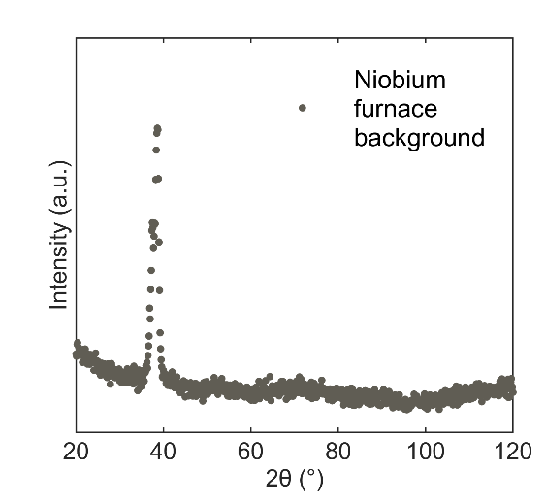
Figure S1-NPD data of the empty high temperature vacuum furnace.
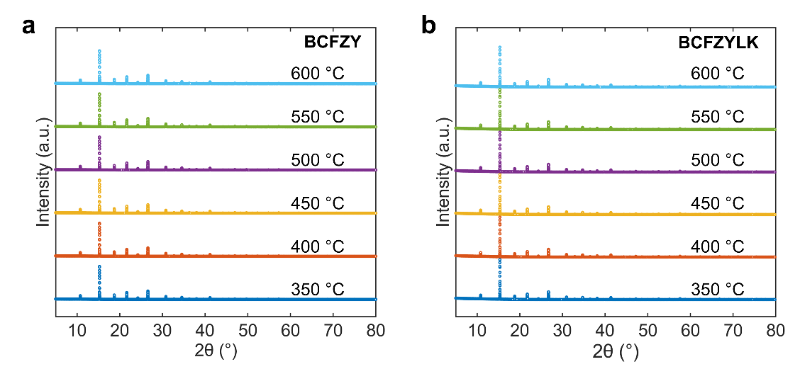
Figure S2-High-temperature SXRD pattern of a BCFZY and b BCFZYLK. The Y-axis are offset for clarity.
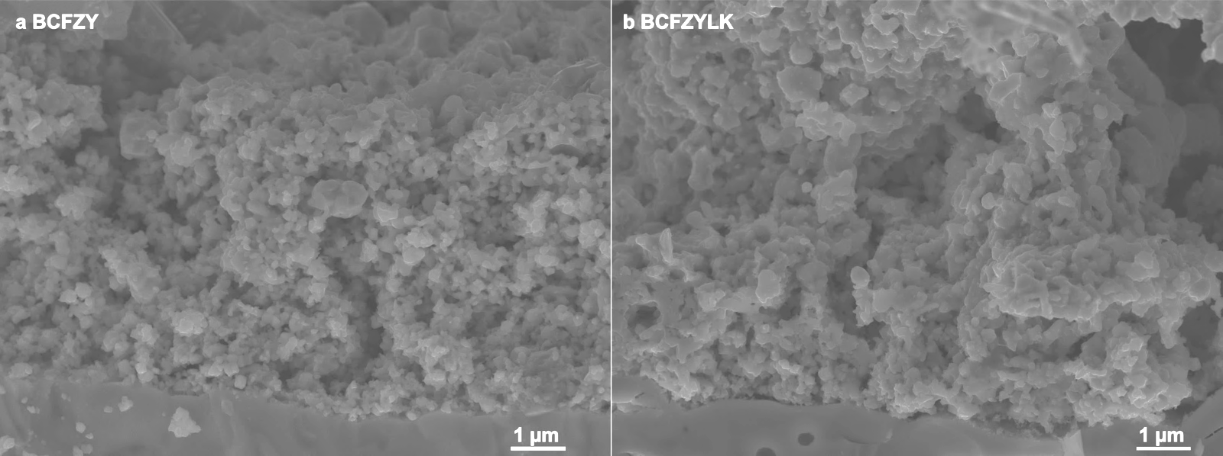
Figure S3-SEM images of a BCFZY and b BCFZYLK on symmetric cells

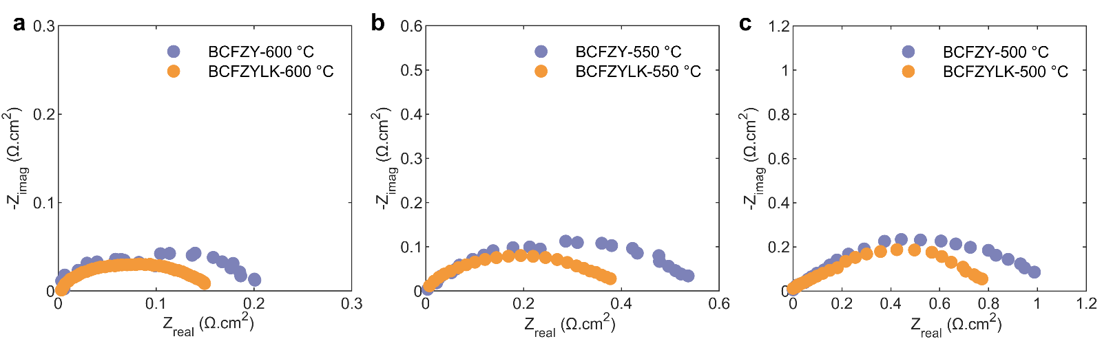
Figure S4-Impedance spectra of the BCFZYLK and BCFZY on symmetric cells at a 600 °C b 550 °C and c 500 °C
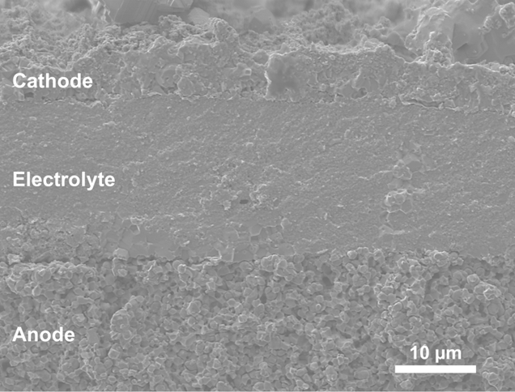
Figure S5-Morphology of the single cell with a BCFZYLK cathode
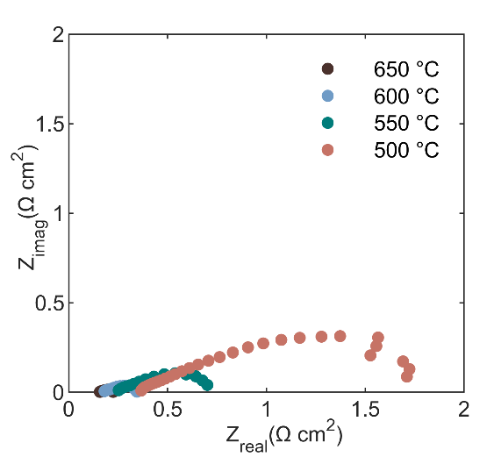
Figure S6-Impedance spectra of the BCFZYLK single-cell
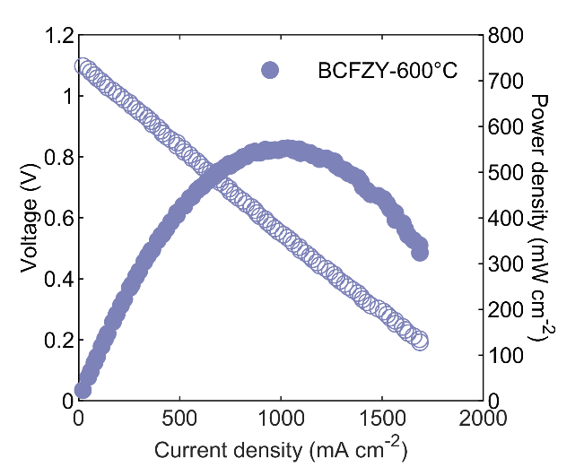
Figure S7-Current-Voltage-Power (I-V-P) diagram of the BCFZY single cell at 600 °C
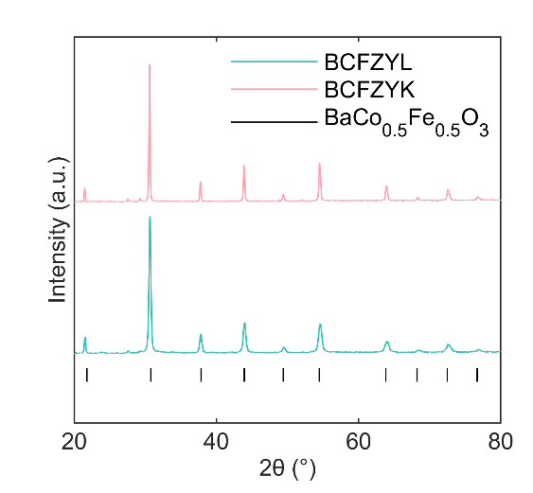
Figure S8- XRD data of Li- and K-doped BCFZY. Data are offset in the y axis for clarity.
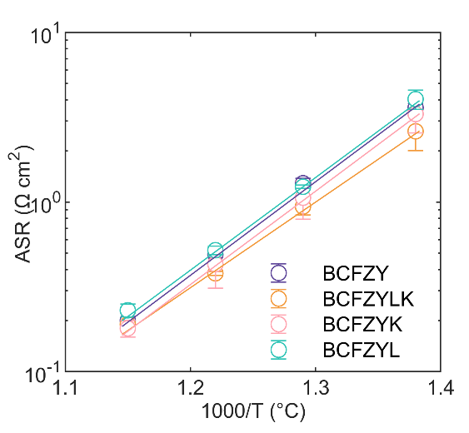
Figure S9-The area-specific resistance (ASR) of BCFZY, BCFZYL, BCFZYK and BCFZYLK between 600 and 450 °C.
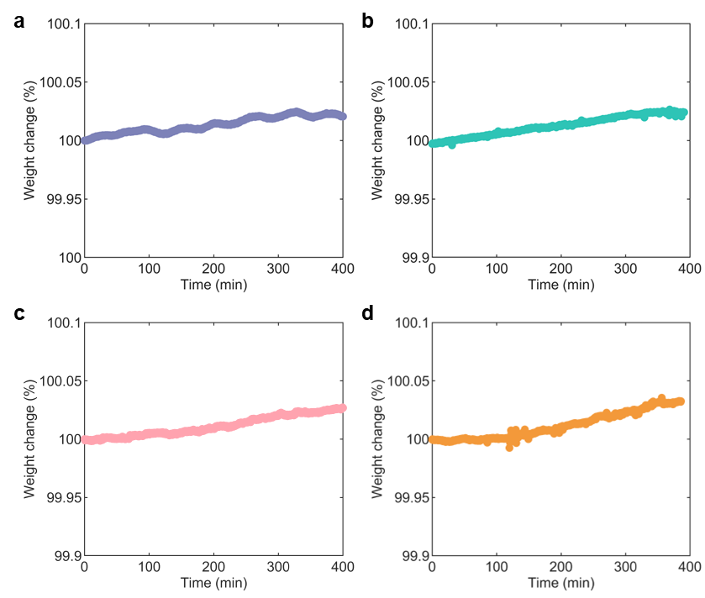
Figure S10-TGA results of a)BCFZY, b)BCFZYL, c)BCFZYK and d)BCFZYLK after humid N₂ exposure
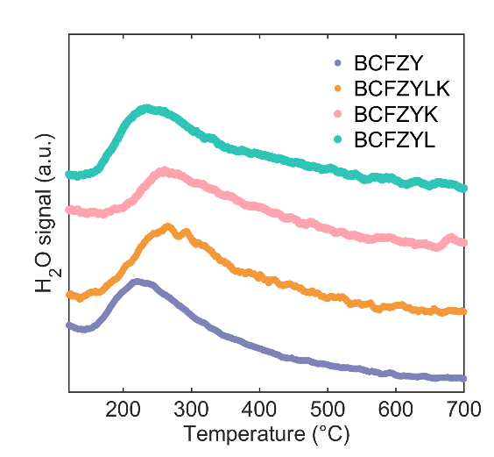
Figure S11-H₂O-TPD profile of BCFZY, BCFZYLK, BCFZYL and BCFZYK. Data are offset in the y-axis for clarity.

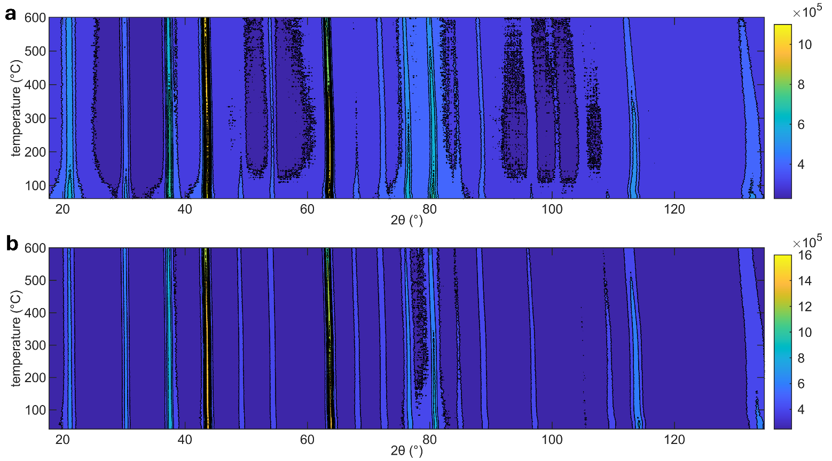
Figure S12-Contour plot of the NPD data for a BCFZY and b BCFZYLK from ambient temperature to 600 °C in 3 vol.% D₂O air.
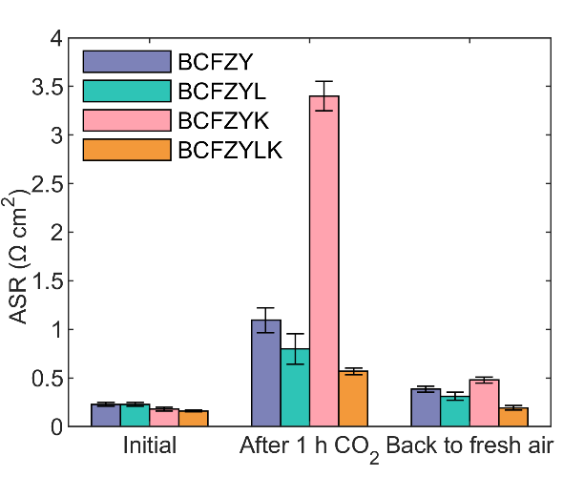
Figure S13-ASR of BCFZY and BCFZYLK before CO₂ conditioning, after exposure to 10% CO₂ for 1 h, and after 1 h re-exposure to wet CO₂-free air.
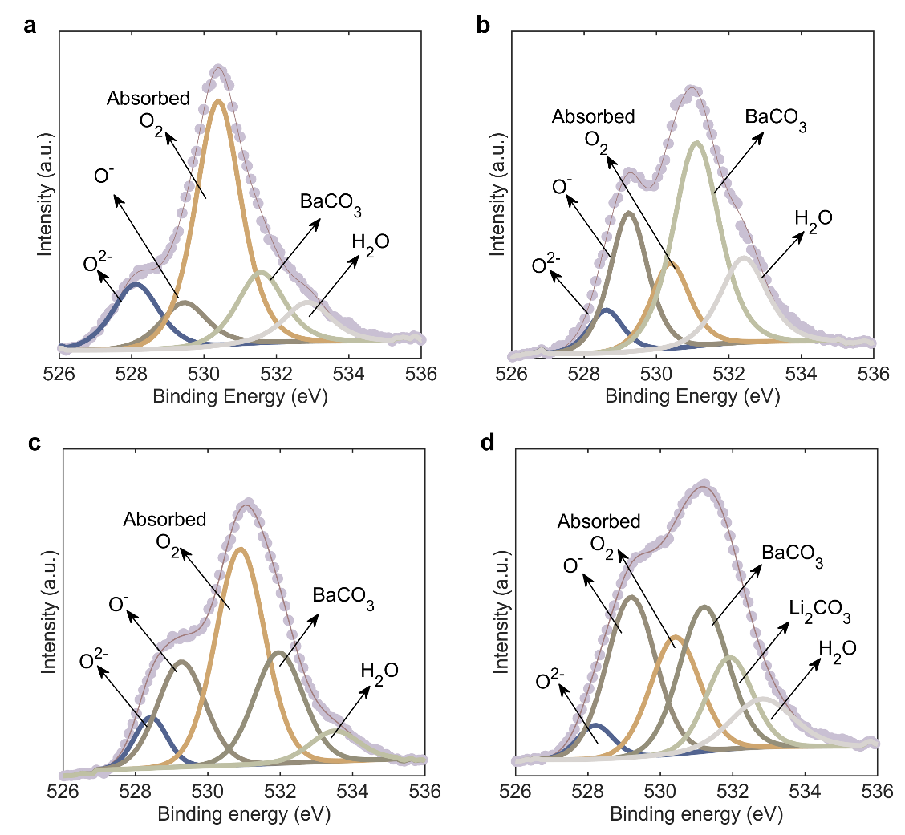
Figure S14-XPS O 1s spectrum of a BCFZY b BCFZY c BCFZYLK and d BCFZYLK exposed to CO₂

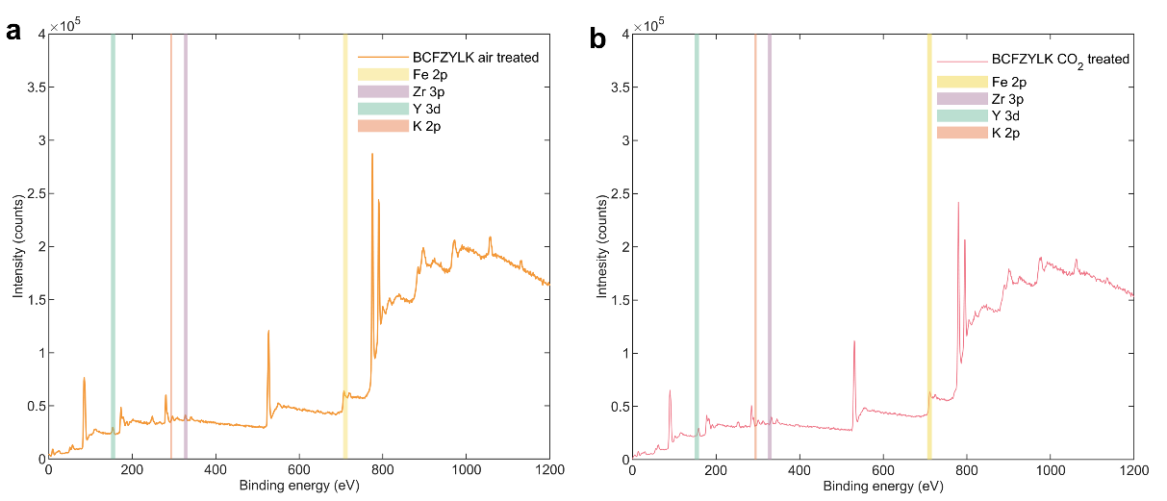
Figure S15-XPS survey scan of BCFZYLK after a air treatment and b CO₂ treatment.
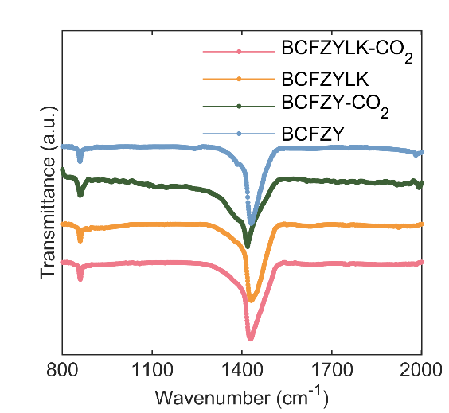
Figure S16- Laboratory-based FT-IR spectrum of BCFZY and BCFZYLK before and after exposure to CO₂. Data are shown offset in y for clarity.

Reference
1 Toby, B. H. & Von Dreele, R. B. GSAS-II: the genesis of a modern open-source all purpose crystallography software package. Journal of Applied Crystallography 46, 544-549, doi:doi:10.1107/S0021889813003531 (2013).
2 BaZr1−xFexO3, x= 0.50 (BaZr0.5Fe0.5O3) Crystal Structure: Datasheet from "PAULING FILE Multinaries Edition – 2022" in SpringerMaterials (https://materials.springer.com/isp/crystallographic/docs/sd_1244272) (Springer-Verlag Berlin Heidelberg & Material Phases Data System (MPDS), Switzerland & National Institute for Materials Science (NIMS), Japan).
3 Studer, A. J., Hagen, M. E. & Noakes, T. J. Wombat: The high-intensity powder diffractometer at the OPAL reactor. Physica B: Condensed Matter 385-386, 1013-1015, doi:https://doi.org/10.1016/j.physb.2006.05.323 (2006).
4 Sears, V. F. Neutron scattering lengths and cross sections. Neutron News 3, 26-37, doi:10.1080/10448639208218770 (1992).
5 Kiryukhin, V. et al. Uncorrelated and correlated nanoscale lattice distortions in the paramagnetic phase of magnetoresistive manganites. Physical Review B 70, 214424, doi:10.1103/PhysRevB.70.214424 (2004).

