Supplementary material for - Comparing results of X-ray diffraction, µ-Raman spectroscopy and neutron diffraction when identifying chemical phases in seized nuclear material, during a comparative nuclear forensics exercise

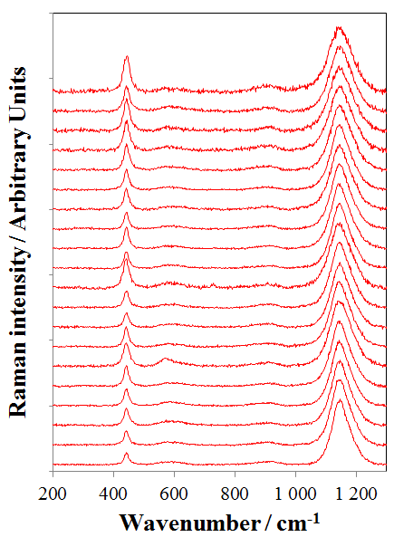
Fig. S1 Raman spectra obtained at CEA for 20 fragments from pellet ES2.

Fig. S2 Raman spectra obtained by FOI for one single measurement spot on ES3 during 30 minutes (60 s per measurement). No visible distortion of the Raman bands is observed during the measurements, contrary to the findings of Allen et al (Allen 1987).

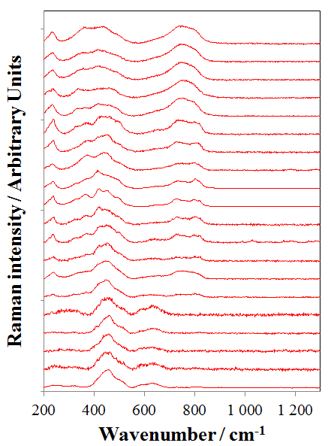
Fig. S3 Raman spectra obtained at CEA (left) and FOI (right) for 20 analysis of the sample ES1 (powder).

