Effect of Ti-metal addition on hot-isostatically pressed (HIPed) Synroc-C
Rifat Farzana¹, Pranesh Dayal¹, Anton Peristyy¹, Phillip Sutton¹, Zaynab Aly¹, Robert D. Aughterson¹, Thanh Ha Nguyen¹, Michelle Yeoh^{1,2}, Pramod Koshy², Daniel J. Gregg^{1,}*
¹ Australian Nuclear Science and Technology Organisation, Locked Bag 2001, Kirrawee DC, New South Wales, Australia
² School of Materials Science and Engineering, UNSW Sydney, NSW 2052, Australia
* Corresponding author. Tel.: +61 2 9717 7075; fax: +61 2 9717 9225.
E-mail address: dgg@ansto.gov.au

Table S1: Theoretical redox environment of Synroc C phases over varying Ti metal addition.
 | Effective oxidation state
Ti addition, % w/w | Before Calcination | After Calcination | 0% | 2% | 4% | 8%
Ru | 4 | 0 | 0 | 0
Pd | 2 | 0 | 0 | 0
Ni | 2 | 0 | 0 | 0
Ag | 1 | 0 | 0 | 0
Cs | 1 | 1 | 1 | 1
Ca | 2 | 2 | 2 | 2
Ba | 2 | 2 | 2 | 2
Sr | 2 | 2 | 2 | 2
Al | 3 | 3 | 3 | 3
Nd | 3 | 3 | 3 | 3
Gd | 3 | 3 | 3 | 3
Y | 3 | 3 | 3 | 3
Zr | 4 | 4 | 4 | 4
Cr | 3 | 3 | 3 | 2 or 0 | 0
Mo | 6 | 4 | 4 | 0
Fe | 3 | 2 | 2 | 0
Ce | 4 | 4 | 4 | 3
Ti | 4 | 4 | 4 | 3.937  (Ti₁₂O₂₃+20TiO₂) | 3.72  (Ti₇O₁₃) | 3.333  (Ti₃O₅)
Redox condition, pfO₂ |  |  | ~10⁻¹¹ | 10⁻¹³ | 10⁻¹⁴ | >10⁻¹⁶

Table S2: Phase compositions of the newly formed non-Synroc phases formed in the 8 wt.%Ti metal sample as determined from TEM-EDS analyses.
Name | Phase composition¹
Manetoplumbite (AB₁₂O₁₉)² | Ca(Al_{2.2}Ti_{7.5}Fe_{0.04}Y_{0.04}Zr_{1.67})O₁₉
Manetoplumbite (AB₁₂O₁₉)² | (Ba_{0.95}Ca_{0.1})(Al_{0.3}Ti_{10.3}Fe_{0.05}Zr_{0.5}Mo_{0.23})O₁₉
Loveringite (AB₂₁O₃₈)³ | (Ca_{0.8}Sr_{0.07}Nd_{0.1})(Al_{0.9}Ti_{18.6}Fe_{0.06}Zr₁Ag_{0.1}Mo_{0.5})O₃₈
Cs,Mo-rich phase (at.%) | Cs: ~3-5, Mo: ~2-5, Al: ~1-2, Ca: ~1-11, Ti: ~15-20 with minor Fe, Zr, Ce, Nd and Gd.
¹ Oxygen content was not measured, ² assuming a total of 1 cations on the A-sites, ³ assuming a total 1 cations on the A-sites.

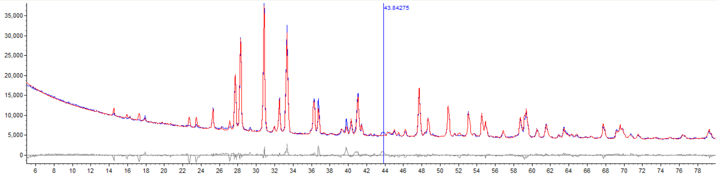
Fig. S1: Goodness of fit for quantitative analysis in the 0 wt.% Ti sample.

Fig. S2: High magnification SEM image showing the Cs and Mo rich compounds in the 0 wt.% Ti sample.

The following sample list is added for internal use only: the sample IDs are linked to the internal numbering system to simplify the sample identification for future.
Sample identification:
- L200044 (0 wt.% Ti)
- L200067 (2 wt.% Ti)
- L200068 (4 wt.% Ti)
- L200069 (8 wt.% Ti)

