Table 1: Input variables for the unsaturated Barnes and Allison (1988) model.

Parameter | Value |  | Comment
Temperature (°C) | 1°C to 26°C |  | Monthly mean minimum and maximum
Bulk density (g/cm³)
 | 0.6 |  | Peat
 | 1.1-1.2 |  | Organic sand/clay
 | 1.7 |  | Clean sand
 | 1.2 |  | Basal sand
Porosity
 | 0.9 |  | Peat
 | 0.7 |  | 20% peat and sand
 | 0.5 |  | 5% peat and sands
 | 0.38 |  | Sands
Tortuosity
 | 0.39 |  | Organic rich sandy soil
 | 0.66 |  | Medium-coarse sand
 | 0.48 |  | Medium sand
 | 0.21 |  | Fine sand
 | 0.19 |  | Clayey sand

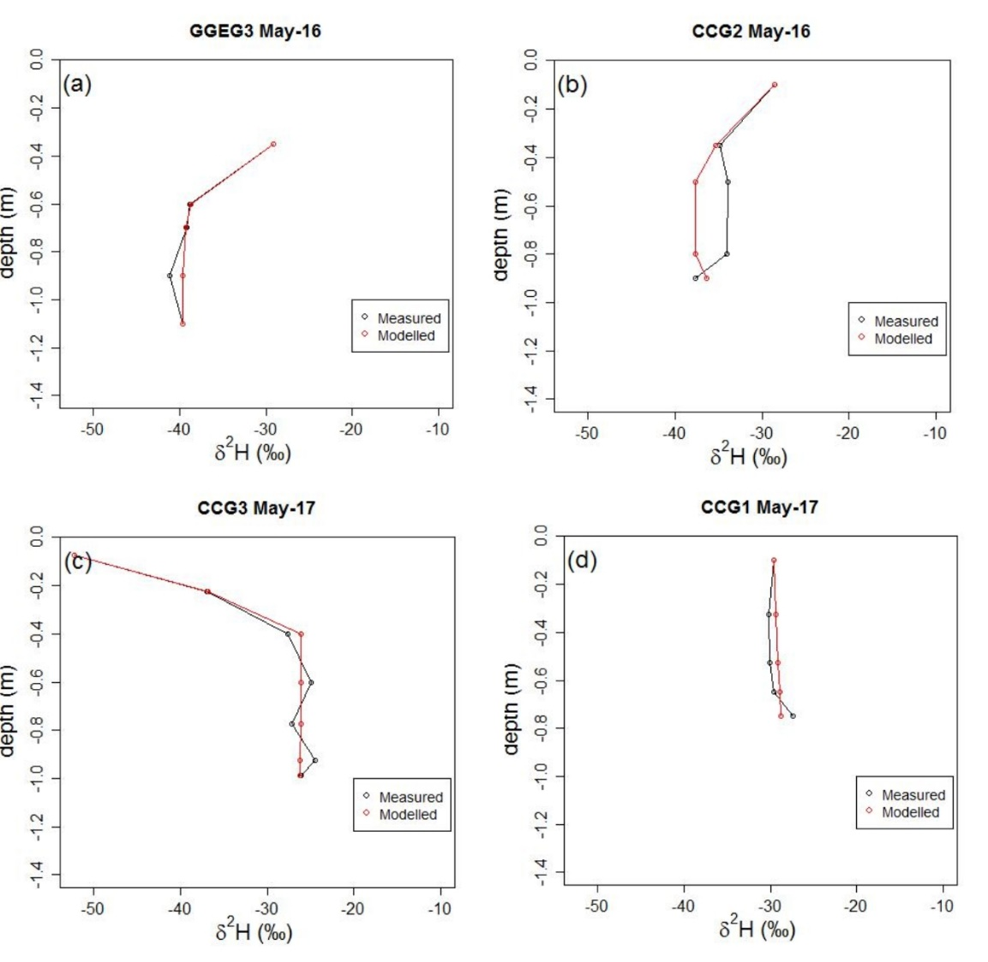
Figure 1: Modelled vs measured δ²H in unsaturated soil profile after dry period (a, b) and wet period (c,d)

