Supporting Information

Neodymium coordination polymers with propionate, succinate and mixed succinate-oxalate ligands: synthesis, structures and spectroscopic characterization

Nicholas Scales ª, Yingjie Zhang ^{a,}*, Mohan Bhadbhade ^{b}, Inna Karatchevtseva ª, Linggen Kong ª, Gregory R. Lumpkin ª, Feng Li ^{c}

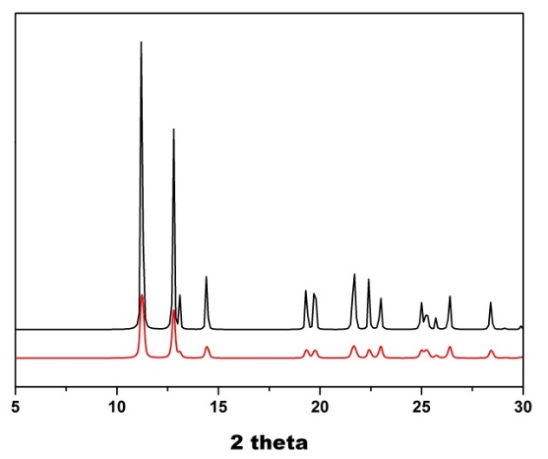
Fig. S1. PXRD patterns of 1 (left) and 3 (right) with the measured on top of the simulated ones.

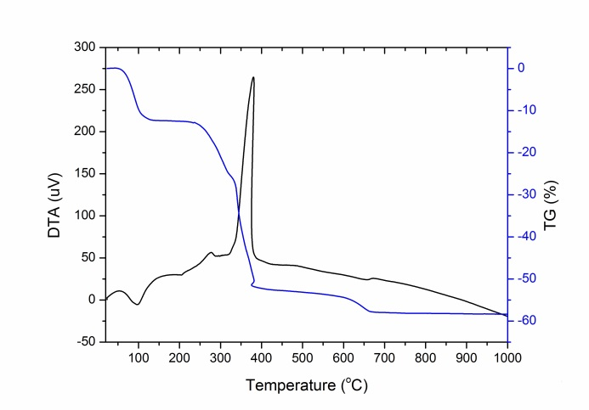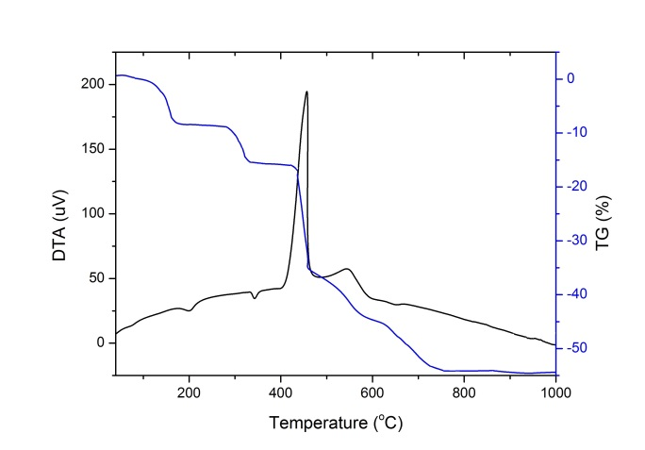
Fig. S2. Thermogravimetric and differential thermal analysis result of 1 (left) and 3 (right).

Table S1. Raman bands and assignments for 1, 2 and 3.
Raman band position (cm⁻¹) | Band assignment
Complex 1
1621 w, sh | Lattice water, δ (H−O−H) deformation vibration
1555 m, br | ν_{as} (COO⁻)
1451 s, a shoulder | δ_{as} (CH₃) + δ (CH₂) deformation vibrations (higher frequency shoulder)
1422 s | ν_{s} (COO⁻)
1377 m | δ_{s} (CH₃)
1301 m | δ (CH₂) wagging vibrations
1250 m | δ (CH₂) twisting vibrations
1077 s, 1029 s + 1009 sh, 899 vs | Skeletal ν (C−C−C) + ν (C−C) stretching vibrations
815 w | δ (OCO) in-plane bending vibrations
740 w | δ (CH₂) rocking vibrations
679 m | δ (OCO) out-of-plane bending vibrations
643 w, br | Vibrational modes of coordinated water molecules
513 w, br | δ (C−C) deformation vibrations
311 w | ν (M−O)
< 300 | δ (C−O−M) + δ (CH₃) (torsional vib) + lattice modes
Complex 2
∼1620 vw, sh | Lattice water, δ (H−O−H) deformation vibration
1589 w, 1534 and 1515 m-w, br | ν_{as} (COO⁻)
1461 s and 1440 sh | δ (CH₂) deformation vibrations
1409 and 1401 split peak, m | ν_{s} (COO⁻)
1327-1287 w | δ (CH₂) wagging vibrations
1216, 1167 m | δ (CH₂) twisting vibrations
1055 m, 1016, 1004, 982 m-s, 910, 901, 879 vs | Skeletal ν (C−C) stretching vibrations,  chain vibration, including CCC and CCCC
815 w | δ (OCO) in-plane bending vibrations
760 and 741 w | δ (CH₂) rocking vibrations
∼660 vw | Vibrational modes of coordinated water molecules
629 m | δ (OCO) out-of-plane bending vibrations
580 w | δ (OCO) rocking
522−456, vw | δ (C−C) deformation modes
324 w | ν (M−O)
< 300 | δ (C−O−M) + lattice modes
Complex 3
∼1620 vw, sh | Lattice water, δ (H−O−H) deformation vibration
1608 w, 1570 and 1525 m-w, br | ν_{as} (COO⁻)
1462 s | δ (CH₂) deformation vibrations and ν (C•••O) specific for oxalate ligand
1414 m | ν_{s} (COO⁻)
1326 - 1278 m-w | δ (CH₂) wagging vibrations
1222, 1178 m-w | δ (CH₂) twisting vibrations
1051 m, 1005, 971, 942 m, 902, 880 vs | Skeletal ν (C−C) stretching vibrations,  chain vibration, including CCC and CCCC
819 m | δ (OCO) in-plane bending vibrations
738 and 703 w | δ (CH₂) rocking vibrations
642 m | δ (OCO) out-of-plane bending vibrations
∼667 vw | Vibrational modes of coordinated water molecules
∼578 w | δ (OCO) rocking
519-456, w-m | δ (C−C) deformation modes
327 w | ν (M−O)
< 300 | δ (C−O−M) + lattice modes

